Cooperative Agricultural Pest Survey (CAPS) - Cooperative Agreement Work Plan Process

Background
Creating CAPS survey and infrastructure work plans and financial plans requires several steps and documents. Cooperators have different options for how they configure their survey and infrastructure work plans and financial plans. See Appendix 1 for an overview of agreement format options.
Creating CAPS survey and infrastructure work plans, and financial plans requires an interplay between:
- CAPS Resource and Collaboration website online resources:
  - Survey summary form (SSF)
  - Online financial plan
- Microsoft Word templates:
  - Survey work plans
  - Survey financial plans
  - Infrastructure work plans
  - Infrastructure financial plans
- Plant Protection and Quarantine (PPQ) Agreements PowerApps site
The process below is color coded to differentiate steps required in the CAPS Resource and Collaboration online resources (black) and all other steps, such those required in Microsoft Word templates (red).
State Survey Coordinators (SSC) create the CAPS Survey Summary Form (SSF) using these survey planning instructions. The SSC is the only person in a state who can create the CAPS SSF.
- In most cases, the Cooperator and the SSC represent the same entity. If they represent different entities, the cooperator is considered a non-traditional cooperator. See Appendix 2 for non-traditional cooperator guidance.
- Cooperators other than the SSC will enter their own financial information into the Financial Plan on the online interface.
- After the SSC creates the SSF, the cooperator can access the Survey Planning Tool.
This PowerPoint presentation provides step-by-step guidance for creating the SSF and online Financial Plan on the CAPS Resource and Collaboration website.

Cooperative Agreement Work Plan Process
- Complete the Infrastructure Work Plan using the Infrastructure Work Plan Template and the Infrastructure Financial Plan template. The Financial Plan Template provides instructions for filling it out. There is only one CAPS Infrastructure Work Plan and one CAPS Infrastructure Financial Plan per state.
- Go to the CAPS Resource and Collaboration website and complete the Infrastructure Financial Plan using the online interface. There is an Infrastructure link available for each state.
  - Click on the Infrastructure link to begin filling out the Infrastructure Financial Plan. The Infrastructure Financial Plan in the online interface can be completed before, after, or at the same time as the Survey work plan (CAPS website planning page).
- If you’re using the combined infrastructure and survey work plan option, there is also a link for the combined online financial work plan interface.
- If your state does not receive an Infrastructure agreement, there should not be an Infrastructure link in the online financial work plan interface (skip to step 3).
  - For Indirect Costs:
- Enter the applicable percentage rate.
- Choose an option for Indirect Cost Rate application from the dropdown menu (Direct, Personnel, etc.).
- Enter the dollar amount of the Indirect Cost Rate (the amount will not be auto calculated).
- The Total agreement amount will auto calculate as shown below:
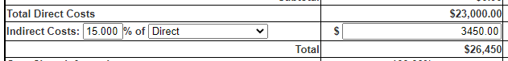
- Complete the SSF, accessible from the Survey Planning page. The SSC will enter all information into the SSF, including information for non-traditional cooperators.
  - Combined Survey Work Plans: The default setting under the SSF “Add Survey” function is the Combined Survey Work Plan, as shown below.
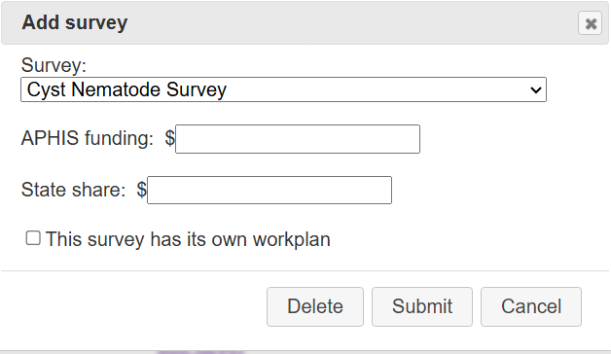
  - Individual Survey Work Plans:
- Some states must submit more than one survey work plan because they have multiple cooperators and require separate work plans and cooperative agreements.
- For states previously using individual work plans, your interface is set up with Individual Work Plan as an option.
- You must check the box indicating the survey will have a separate work plan, as shown below next to the red arrow.
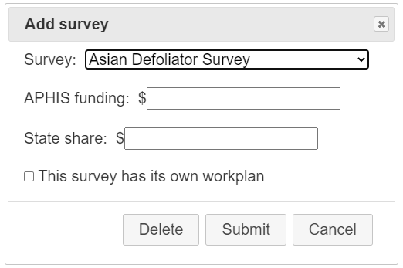
- Complete the Survey Work Plan using the Survey Work Plan Template.
- Complete the Financial Plan for the Survey work plan in the CAPS Resource and Collaboration website online interface.
- As a survey name is entered into the SSF, it unlocks the Financial Plan in the online work plan interface.
- To access the online financial work plan interface, after the SSF has been started, go to the lower left-hand corner of the Survey Planning page, and click on “Manage Plans”:
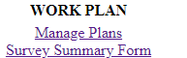
- If you’re using the individual survey and infrastructure work plan option, your menu choices will look like this:
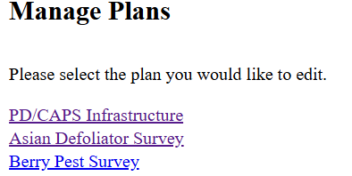
- Each individual survey work plan requires its own financial plan. Each workplan will result in a separate agreement.
- If you’re using the combined survey and infrastructure work plan option, your menu choices will look like this:
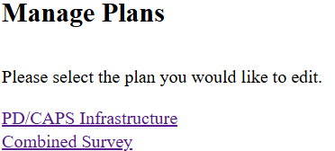
- The Financial Plan for a Combined Survey does not need to be broken down by individual survey. See Example of a Combined Survey Work Plan.
- The Cooperator must share draft versions of infrastructure and survey work plan(s) and infrastructure and survey financial plan(s) with their ADODR for review.
- Based on ADODR feedback, Cooperator and/or SSC:
  - Revises the SSF if needed.
  - Populate the final SSF into the table of the survey work plan.
  - Make any revisions to the infrastructure and/or survey work plan(s) templates as needed.
- ADODR and/or PSS reviews and approves SSF on the Survey Planning page.
- Cooperator: Create a .pdf of the completed Infrastructure and Survey work plan templates.
  - You will need to create one combined .pdf of your Survey Work Plan(s) and Financial Plans. To do this, you may either:
    - Export the Financial Plan out of the interface, add to your Work Plan Word document, and create one .pdf.
    - Or you may fill out the Financial Plan Template and combine this into one .pdf with your Work Plan.
- Recipient Organization’s Authorized Representative (ROAR) signature is required on the .pdf before sending to the ADODR for signature.
- ADODR: upload .pdf of work plans to PPQ Agreements PowerApps site.
- Pest Detection NOM: Reviews .pdfs of work plans on PPQ Agreements PowerApps site and the SSF on the CAPS R&C site.
  - If the NOM requests SSF revisions, the SSC performs revisions in the SSF. This is the process for managing revisions:
  - NOM rejects the SSF.
  - The SSC revises the SSF.
  - The SPHD/PSS approves the SSF, sending it back to the NOM.
  - ADODR returns to steps 9-10. ADODR uploads revised work/financial plan to PPQ Agreements PowerApps site.
  - The NOM deletes older version from PPQ Agreements PowerApps site.
  - If the NOM approves work plan:
- The NOM approves the work plan on the PPQ Agreements PowerApps site.
- The financial plan is now locked from change.
- The SPHD is notified that the work plan has been approved.
  - PPQ Agreements Specialist reviews work plan.
- If revisions are needed, the PPQ Agreements Specialist reaches out to the ADODR.
- The ADODR makes edits and sends a revised version via email to the PPQ Agreements Specialist.
- No edits are made in the online interface.
- A new version does not need to be posted to the PPQ Agreements PowerApps site.
  - PPQ Agreements Specialist: creates the opportunity in ezFedGrants.

Appendix 1. Cooperative Agreement Work Plan Format Options
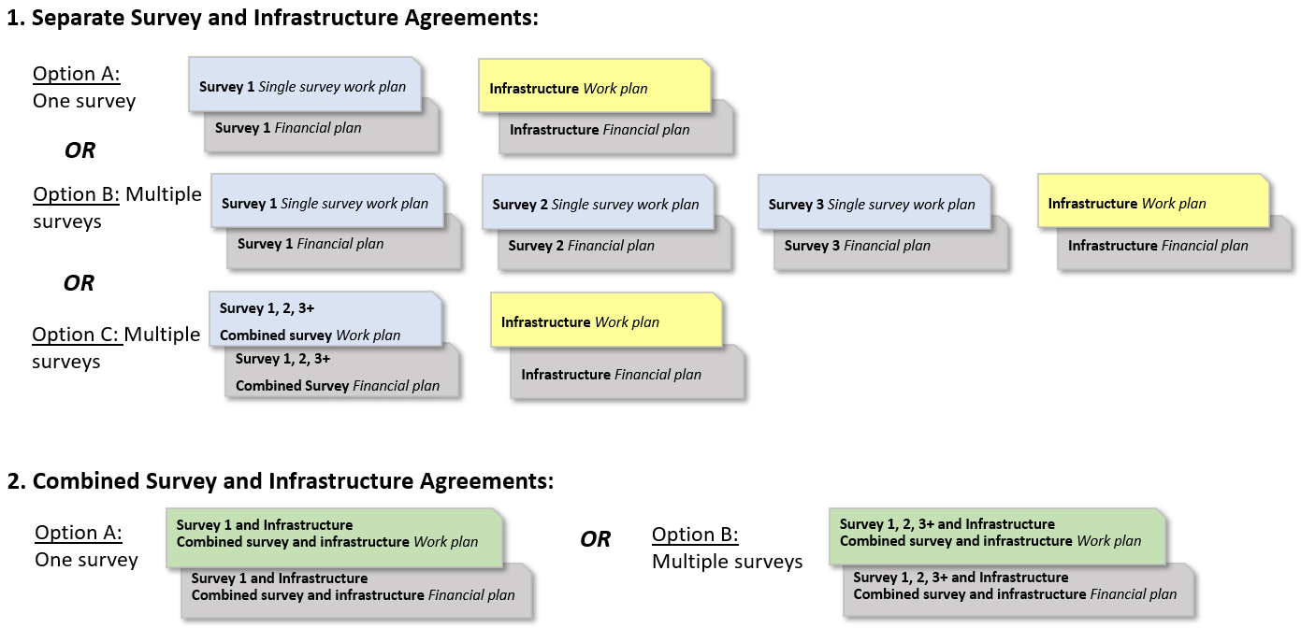

Appendix 2. Non-traditional Cooperator Guidance
If the Cooperator and State Survey Coordinator (SSC) are not the same entity, the Cooperator is considered a non-traditional cooperator. For CAPS surveys conducted by non-traditional cooperators, the Authorized Departmental Officer’s Designated Representative (ADODR) must work with the Cooperator and the SSC to enter data into the survey summary form (SSF).
Important dates and reminders:
- By July 20, 2026, the ADODR must:
- Provide the non-traditional cooperator’s contact information (name and email address) to the Cooperative Agricultural Pest Survey Information Services (CAPSIS) Support Team at capsis@purdue.edu. The CAPSIS Support Team will grant the cooperator access to the online work plan interface.
- Introduce the non-traditional cooperator to the SSC and outline their individual responsibilities.
- The SSC should work closely with the non-traditional cooperator to complete the SSF.

This is an example workflow for a state using individual work plans and multiple cooperators.
A non-traditional cooperator will do a Grape Survey:
- The Cooperator fills out the Survey Work Plan Template.
- The Cooperator sends the SSC their information for the SSF.
- The SSC enters the Grape Survey information into the SSF on behalf of the Cooperator.
- The SSC checks the box for “This survey has its own workplan”. Grape Survey opens in the online financial work plan interface for that state.
- The Cooperator completes the Financial Plan in the online interface and completes the Financial Work Plan in the Word template.
- The Pest Detection National Operations Manager (NOM) reviews the SSF entry for each survey and work plan separately.
The Grape Survey may proceed after all agreement obligations are met, even if the state has other survey agreements that have not yet been reviewed and/or approved.
If the state has an incomplete survey data accountability report, this would only affect the surveys under that cooperator (in other words, if State Y Department of Agriculture was missing data from last year’s survey, this would only affect approval of their current survey work plans. It would not affect another cooperator in the same state who has met all survey data accountability obligations).

