**Pest List Working Group (PLWG)**

**Issues for the 2013 Guidelines**

**Summary**

*Note: items in gray were discussed on the last PLWG but require further information/discussion by the PLWG. Please consider them as an FYI at this point.

|  |  |
| --- | --- |
| **Pest** | **Proposed Action** |
| 1. *Urocerus gigas gigas*  (Giant woodwasp) | Remove from the Pine Reference. |
| 2. *Unaspis yanonensis*  (Arrowhead Scale) | Refer back to the PLWG for further discussion. |
| 3. *Leucoptera malifoliella*  (Pear leaf blister moth) | 1. Keep the pest on the list. It is an important pest with trade implications.  2. Try to improve the survey method. |
| 4. *Copitarsia* spp.  (Noctuid moth) | Remove from Grape and Small Grains Survey Manuals. Pest will only be available for survey through Discretionary funding. |
| 5. *Planoccocus minor*  (Passionvine mealybug) | Wait for NPAG’s revised report. The report has been completed and is waiting for NPB’s approval. The report should be finalized by April, in time to make a decision for the 2013 Guidelines. |
| 6. *Hylurgops palliatus*  (Lesser Spruce Shoot Beetle) | Remove from the EWB/BB manual. Add to Additional Pests of Concern List. |
| 7. *Curculio elephas*  (Chestnut weevil) | 1. Lisa will investigate the oak host aspect.  2. Refer back to the PLWG for further discussion. |
| 8. *Sirex noctilio*  (Sirex woodwasp) | Keep in the EWB/BB manual for 2012. For 2013, remove from the manual. Pest will only be available for survey through Discretionary funding. |
| 9. Grape manual pest additions | Run the three verified pests of grape through the Pre-assessment. |
| 10. *Monilia polystroma*  (Asiatic brown rot) | 1. Wait for CPHST Beltsville to validate the multiplex-PCR that will distinguish all four brown rot fungi before adding *Monilia polystroma* to stone fruit survey. CPHST-level conversations occurring about this pest and other CAPS priority pests in February.  2. Run *Monilinia fructigena* through the Pre-assessment for possible inclusion on the AHP. |
| 11. *Geosmithia morbida* (Thousand Cankers disease) | Remove both *Geosmithia morbida* and Walnut Twig Beetle from the Additional Pests of Concern List. Pests will only be available for survey through Discretionary funding. |
| 12. Citrus disease support  A. Phoma tracheiphila (Mal Secco) | Take off the Additional Pests of Concern List. |
| B. Link new citrus diagnostics on CAPS Approved Methods site? | Yes. |
| 13. Torradoviruses | Don’t do anything until we can screen for them. Take off of the Additional Pests of Concern List. Add to CPHST methods development list. The OPIS virus group is looking at tomato torradovirus (no update available). |

**1. *Urocerus gigas gigas* (Giant woodwasp)**

Hymenoptera: Siricidae

Listed as *Urocerus gigas* in the Pine Reference. Not a Priority Pest.

**Issues:**

* Identification: The pest subspecies is difficult to differentiate from the native subspecies, *U. gigas flavicornis*.
* Pest status: The native subspecies is a secondary pest. *U. gigas gigas* is also a secondary pest in its native range. The economic damage is rated as low in the Mini Pest Risk Assessment.
* Survey: There is not an effective survey method for this pest.

**Background:**

* CAPS surveys: In 2011, NC and WA. In 2012, NC only.
* Categories from Mini Pest Risk Assessment that received:
* High rating:
* Establishment potential
* Host Availability
* Ecological suitability
* Medium rating:
* Environmental Impact
* Low rating:
* Survey methodology
* Taxonomic recognition
* Economic impact
* Entry potential
* **Email from Jim LaBonte 7/28/2011:**

“With regard to your question, it would not make sense to list the native subspecies as a target, as you implied.  The nominate subspecies, restricted to Europe and perhaps Asia, should be explicitly listed as the target.  FYI, there is no known way to distinguish those subspecies via external morphological characters.  Except in interceptions and similar regulatory circumstances, this suggests that it may not be practical to consider the nominate subspecies as a target for survey (especially since the North American subspecies is not known to be a primary pest).”

Lisa’s question to Jim: “I was just looking at your siricid woodwasp guide in hopes to answer a question that was posed to me. Looks like we had *Urocerus gigas* as a CAPS target in the past. We also had it listed as *Urocerus gigas gigas*. As it appears that we have at least one native subspecies, *Urocerus gigas flavicornis*, is it more appropriate for us to list *Urocerus gigas gigas* as a target?”

**Proposal:** Remove from the Pine Reference.

**2. *Unaspis yanonensis* (Arrowhead Scale)**

Hemiptera: Diaspididae

AHP

**Issues:**

* Is this a high risk pest?
* Is the pathway complete?

**Background:**

* Marina Zlotina (CPHST-PERAL, member of scale review panel for OPIS review) recommends removal. Says there is no pathway.
* Parul: The review group gave it a rating of A-. The numerical rating was on the high end.

Originally it had an “A” rating. Parul anticipates the pest staying on the OPIS list.

* Joel Floyd: This pest is intercepted a lot. Biocontrol would likely be the answer if the pest were to become established. An NPRG was never produced. It is a top-rated pest due to the high number of interception.
* CAPS surveys: no states are surveying for the pest in 2011 or 2012.

**Update 1/25/12:**

* Parul: It will remain on the OPIS pest list.

**Original Proposal:** We can wait until OPIS officially releases the results of the review.

**Updated Proposal:** Refer back to the PLWG for further discussion.

**3. *Leucoptera malifoliella* (Pear leaf blister moth)**

Lepidoptera: Lyonetiidae

AHP, Stone Fruit

**Issue:**

* Identification: PLBM adults are very tiny (1-2 mm max), and traps are filled with hundreds of non-targets of similar size. Sample processing it too time-consuming.

**Background:**

* Parul: The Lepidoptera group is reviewing this pest and it is still on the list.
* Joel Floyd: This pest is a big concern for export for WA and OR. The pupae are found on the calyx of apples.
* CAPS surveys: For 2011, only SC. For 2012, IL, MA, MI, SC, and WV.
* Dave L: The Otis lab could work on the pheromone and possibly a molecular ID tool.
* **Email from Steve Passoa 3/14/2011:**

Yes it is fine to share. Vic Mastro will remember all this since this memo, as I said, not too clearly, there are still a few interceptions. This may be enough to justify a survey, but if so, then not with sticky traps (leaf mines and pupae are better) I would be willing to look at a LIMITED (like 20) samples from apples of larvae/pupae. I do not want to get involved with adults. This year I started my retirement phase-out. Gracillariid larvae (common apple miners) look nothing like PLBM and they do not pupate in the same way. A quick call to Dave would help him write this up.

* **Email from Steve Passoa 6/16/2008:**

To **delete**!!! Pear leaf blister moth. Also known as the moth that almost killed sticky trap survey!! My understanding of it is the following:

At some point about 20 years ago a whole pile of PLBM infested fruit showed up in a New England port. PLBM adults are very tiny (1-2mm max), and traps are filled with hundreds of non-targets of similar size (mostly gracillariids). Rich Miller, then the domestic identifier, quit the job largely because of his frustration of trying to do this survey. This was outlined in a memo to Ron Johnson (then Regional Director or close to that) called the "folly of sticky traps". The other problem is that the major non-targets in the Lyonetiidae are poorly known, and they too are attracted to PLBM lures. Very few lepidopterists can distinguish genera of Lyonetiidae.

Well, after Rich quit I was hired. I did the survey, but that is all I did, and I mean 100% of my time all summer. We were able to concentrate our efforts on this because we had more funds and time back then. The results were in my Annual Reports.

* These compare the genitalia of PLBM to Proleucoptera (also a lyonetiid like PLBM) and list the 50+ most common non-target moths. Copies of all my Annual Reports were given to Eileen Welch and should by now be in the APHIS library for anyone to use- let me know if that never happened! Because there is no recent pathway, resources are limited, and it will take loads of time to do this survey, I have to wonder why this made the list. If there is a mini-PRA perhaps I should read that before shooting off my big mouth. But boy, this would be real low on my list. If there is a good reason to consider this pest, I could help do a screening aid that was better illustrated than the 1991 photocopied photos.

**Proposal:**

1. Keep the pest on the list. It is an important pest with trade implications.

2. Try to improve the survey method.

**Action Items:**

1. Find out how OR and WA are doing surveys. Are they surveying for larvae? Are they using hard-melt glues on sticky traps? How are they performing the ID of the samples?

2. Kristian will contact WSD.

3. Lisa or Joel Floyd will contact Eric LeGasa.

**4. *Copitarsia* spp. (Noctuid moth)**

Lepidoptera Noctuidae

Grape, Small Grains

**Issue:**

* Pest has a low risk of establishment and a very small range of potential establishment.

**Background:**

* Joel Floyd: It is a pest of quinoa in Peru. It is probably a tropical pest. We also get tons of interceptions from Mexico. We get it from lots of pathways. I think there was a general risk assessment done by PERAL on *Copitarsia*.
* CAPS surveys: From 2010 – 2012, only CO has surveyed for it.
* Dave and Joe: We have worked on the pheromones for the Peruvian species at Otis and it has been very frustrating. We get antennal responses but no behavioral response. Also, we have not seen responses in field trials in Peru.
* ID: Morphological: Adults can be identified through genitalia dissections. Larvae can only be identified to genus.
* The CAPS approved method is black light traps, so folks should be submitting adults.
* Melinda (in the Grape Manual) reports the two most economically important pest species seem to be *C. incommoda* and *C. decolora*. Maybe we could just run at the species level next year.

**Dave Lance:**

* "No functional pheromone, minimal risk. I don't know why our agency is so bugged about Copitarsia, I would take it right off the list. If it does have to be there, I guess they could use they could try blacklights, but blacklights are non-specific and Copitarsia are non-descript, medium-small noctuids to ID would be a problem. Not worth the effort."

**PERAL source:**

* A PRA on asparagus from Peru has been submitted, but is stalled.
* HQ thinks this is a pest; we have a long history of treating it as a high risk pest on multiple commodities.
* There is virtually no risk from the asparagus pathway.
* It can only establish in very small areas of FL and CA (see NAPPFAST maps below).
* Julie Gould (CPHST) did lab work on the pests and it was even too hot in those two areas…it can only survive in even smaller areas of the two areas.
* Treatment for asparagus was failing for 2 yrs and we never had an outbreak.
* In native range, under modern ag. techniques, it is not a problem.
* We have lots of natural predators in the U.S.
* It has never established anywhere outside of its native range.
* The reports of damage are from way back in the past (management practices have improved).

NAPPFAST maps show very small part of the country where it could be established.

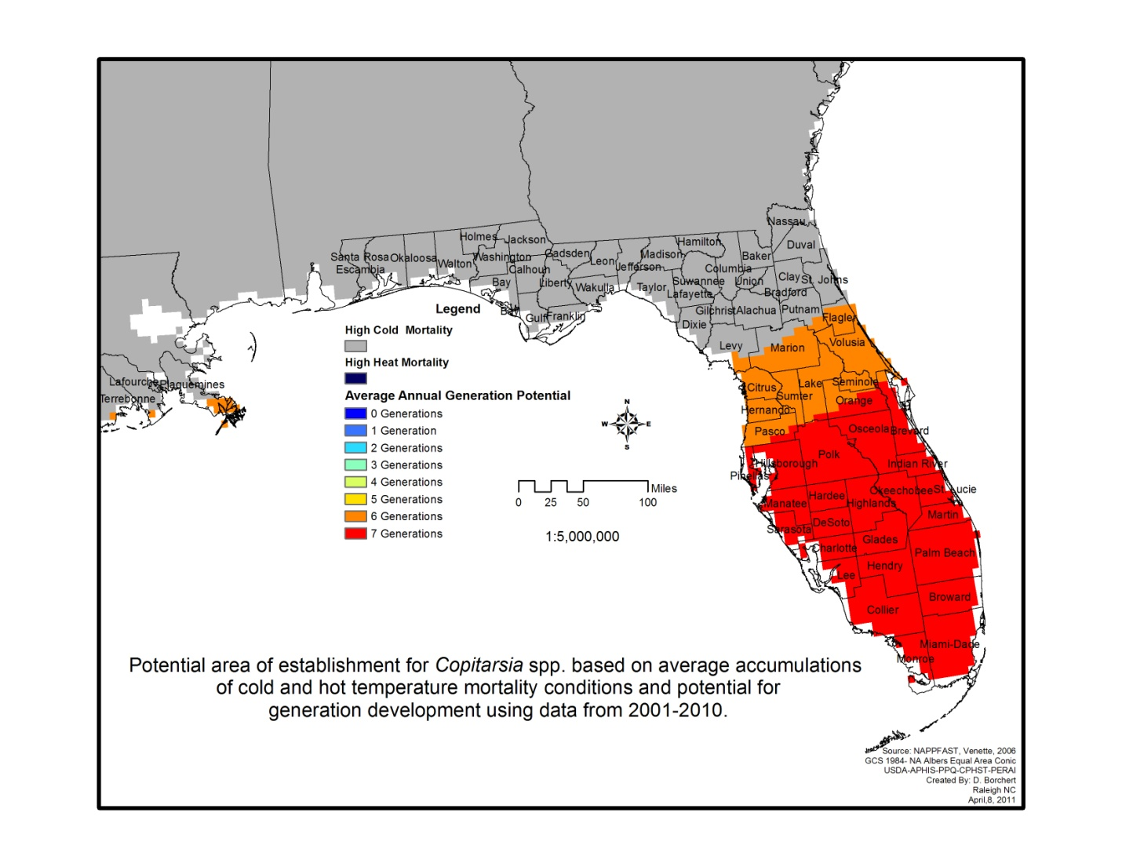

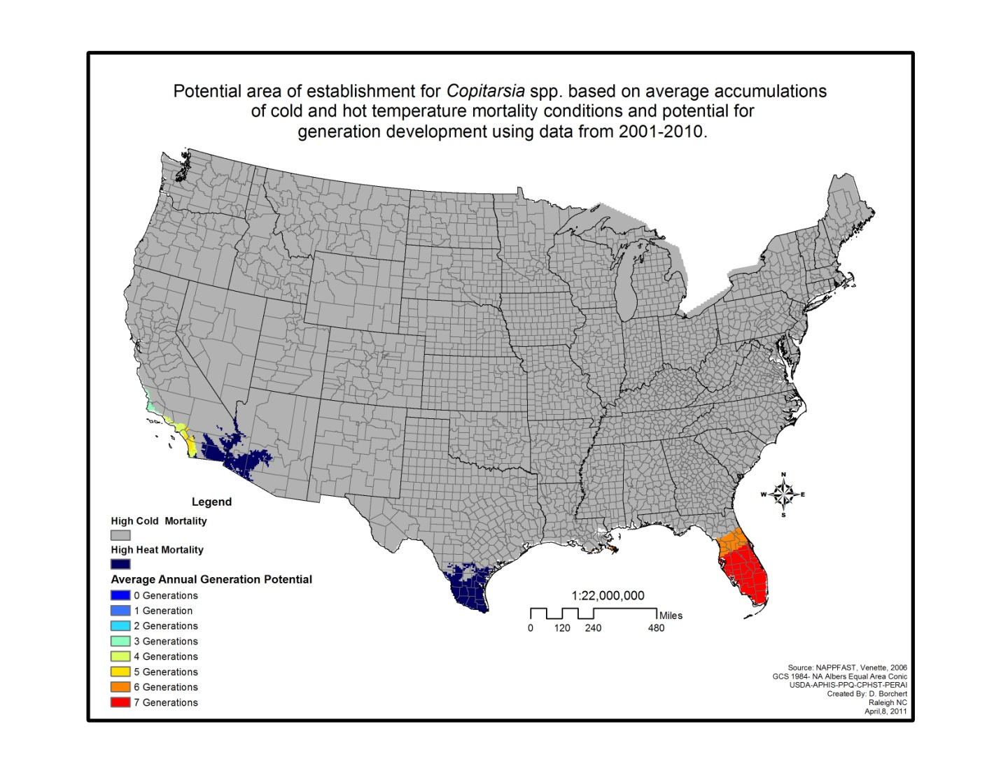

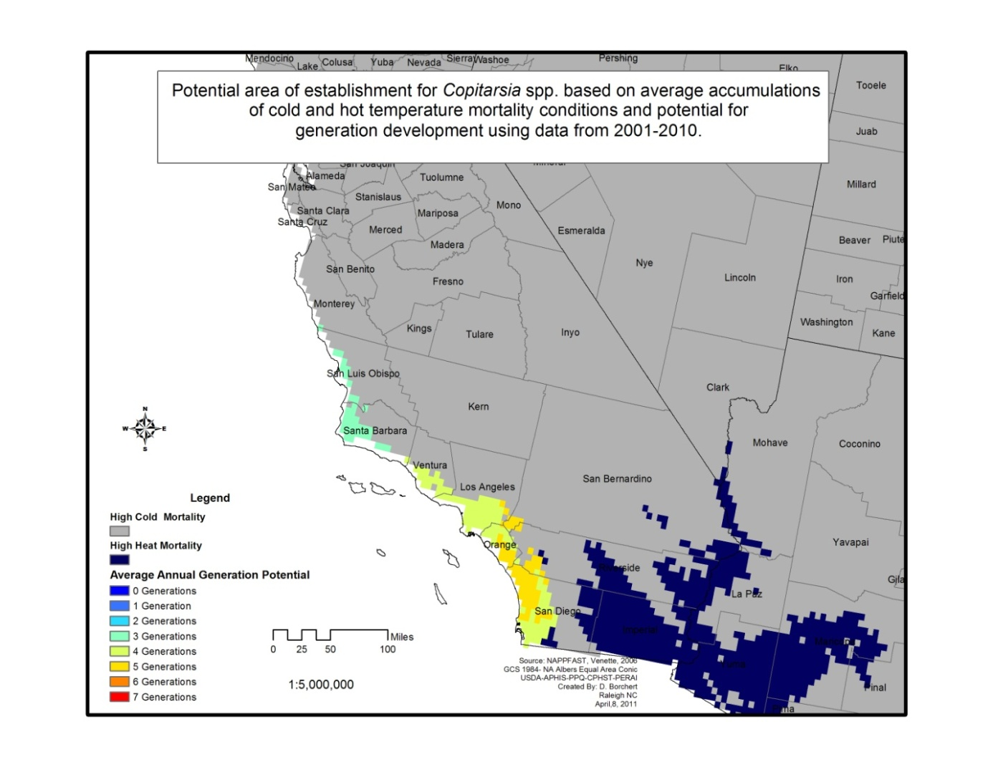

**Proposal:**

Remove from Grape and Small Grains Survey Manuals. Pest will only be available for survey through Discretionary funding.

**5. *Planoccocus minor* (Passionvine mealybug)**

Hemiptera: Pseudococcidae

AHP, Grape

**Issues:**

* Pest is established in two states (usually would result in removal from AHP).
* Pest status is unclear (not causing damage in FL).

**Background:**

* Distributed in FL and HI.
* Up for review by Whitefly/Mealybug Taskforce directed by Lance Osborne (Univ. of FL). The group is made up of industry, government, and science representatives. The group is tasked with developing management tools for the pest. Deb McPartlan (EDP) is the PPQ contact for this pest.
* Amy Roda says is not causing damage in FL and Trinidad; under control by natural enemies.
* CA is intercepting the pest in cut flowers from HI.
* The pest is currently listed as Actionable as of Jan. 2011.
* CAPS surveys: In 2011, FL, SC, and St. Croix. In 2012, CO, FL, SC, and St. Croix.
* Joel Floyd: The species is very similar to *P. citri*. In FL, males were caught in a pheromone trap, but it took 1.5 yr to find a female in the environment for ID confirmation.

**Proposal:**

Wait for NPAG’s revised report. The report has been completed and is waiting for NPB’s approval. The report should be finalized by April, in time to make a decision for the 2013 Guidelines.

**6. *Hylurgops palliatus* (Lesser Spruce Shoot Beetle)**

Coleoptera: Curculionidae

EWB/BB

**Issues:**

* Increased distribution in U.S.
* Pest status is unclear (not causing damage in established states).

**Background:**

* We had discussed this pest in previous years. We said that we would re-evaluate this pest if its distribution increased. It was already present in OH, PA, and NY. In 2011, it was found in Sheffield, Berkshire County, Massachusetts.
* CAPS surveys: In 2011, 12 states. In 2012, 13 states. This is likely due to the trap and lure combo. The recommended lures are alpha-pinene and ethanol, which are also used for two other CAPS targets.
* Bob: This pest is still on the EDRR list. The literature made it out to be a potentially bad pest for the U.S., but we have not seen this yet. It has been found in OH, PA, and NY for 10 years. The pest has only been found in traps and has not been shown causing damage.

**Proposal:**

Remove from the EWB/BB manual. Add to Additional Pests of Concern List. Pest will remain on the CAPS Approved Methods page. Pest datasheet will be removed from EWB/BB manual and posted on the CAPS Approved Methods page. States will likely still survey for the pest, as they can use the same trap and lure combo for two other EWB/BB targets. *Hylurgops palliatus* will remain in IPHIS as having an approved method.

**7. *Curculio elephas* (Chestnut weevil)**

Coleoptera: Curculionidae

Oak

**Issues:**

* Is it really a pest of Oak?
* Is there a high risk of establishment?

**Background:**

* The pest was added to the Oak Reference by the author.
* Jens Prana, (SEL, Curculiionidae expert): During a review of the identification section during a revision of the datasheet (10/25/11), Jens questioned why this pest was on our list. Lisa called him and here are highlights from the discussion:
* First of all, the pest is listed in the Oak manual, but it is a very host-specific pest of chestnut. Jens doubts whether oak is a true host.
* The larvae are intercepted very frequently (From September 1984 to November 2010, this species has been intercepted 2,592 times. Over 98% (2,552) of material was intercepted in baggage, most of which was on the seed or fruit of *Castanea* sp.)
* The insect is a serious pest of chestnut in Europe, but the pathway does not seem complete in the U.S.
* Jens thinks the pathway is disrupted by the biology of the insect. Dispersal and overall mobility are limited and the weevil remains in or near the fruit (i.e., nuts) of its host plant or the host plant itself throughout its life. The larvae leave the chestnut and pupate in the soil. The pupae need a cold winter. When the adults emerge, they need to find chestnuts. They then mate and females then oviposit inside the nuts of the tree under which they emerged. This usually occurs under the same host tree. Jens thinks the chances of the larvae completing their lifecycle and finding a host tree are very unlikely.
* Parul: It will likely remain on OPIS pest list, although I don’t have the final list from the misc. pest SME group yet; also, the U.S. still grows and exports relevant amount of chestnuts for consumption… so, there is still an economic component to keeping the pest it out of U.S.
* Joel Floyd: Charlie O’Brian is another weevil expert
* CAPS surveys: In 2011, OK and TX. In 2012, SC and TX.

**Updates, 1/25/12:**

* Parul: *Curculio elephas* will remain on the OPIS pest list
* Keith Colpetzer (member of OPIS review panel): “I believe we considered oak as a host, as there were a few interceptions (5) from “*Quercus* sp. seed” and literature sources.”

**Original Proposal:** Wait for the OPIS group to complete their review process.  They will look into whether the pest is also a pest of oak.

**Updated Proposal:**

1. Lisa will investigate the oak host aspect.

2. Refer back to the PLWG for further discussion. If oak is a minor/ rare host, we could leave the pest in the Oak Reference, but remove it from the Oak Guidelines. Or we could remove it altogether. The Oak Guidelines is the only place that the pest is listed at this time.

**8. *Sirex noctilio* (Sirex woodwasp)**

Hymenoptera: Siricidae

EWB/BB

**Issue:**

* If it is no longer a PPQ program, is it appropriate for CAPS funds to be used for Sirex surveys?

**Background:**

* PPQ did not perform surveys in 2011 as part of the Sirex program and will not be surveying in 2012.
* PPQ is transitioning the program to the Forest Service.
* CAPS surveys: In 2011, 16 states are surveying for it. In 2012, 15 states.
* Brian: States are concerned about it. We would need to coordinate getting rid of all of the lures at the Mission warehouse.
* John C.: We have 4200 lures in stock.
* Bob: We haven’t had this discussion yet at the FS. The trap and lure combination is not that great. We could work to improve the lure. No one in the South has requested surveys. We don’t anticipate doing surveys next year.

**Proposal:** Keep in the EWB/BB manual for 2012. For 2013, remove from the manual. Pest will only be available through Discretionary funding.

**9. Grape manual potential additions (reference only at this time) - Suggested by**

**CAPS community**

**Issue:**

These are past suggestions for addition to the Grape manual. Should we run these through the new Pre-assessment questionnaire along with the pests submitted for addition this year?

**Background:**

Melinda received the suggestions and Talitha evaluated the pests for inclusion. All three pests are exotic to the U.S.

From Talitha:

I’ve looked over the four potential grape pests, and I think all of them except maybe for *C. punctiferalis* are good candidates for the Grape Survey Reference document.  Most of the info I found for this species states that it’s a pest of grapes but doesn’t give any more info or the original source.  I think this information may have been taken from Gour and Sriramulu (1992) and possibly Ram et al. (1997).  The Gour and Sriramulu (1992) paper states that it attacked grapes in Andhra Pradesh, India most likely because the primary host, castor, was not available at the time.  I requested the Gour and Sriramulu (1992) paper from NAL over a month ago and am still waiting to receive that one. From the sources I’ve seen, I don’t really think that this is anything more than a minor pest of grapes.

*Conogethes punctiferalis* - Insect

* Pest of grapes (Biosecurity NZ, 2007 [based off of CABI]; Púcat, 1995)
* Minor pest of grapes (Biosecurity NZ, 2009)
* “Other” pest of grapes (CABI, 2011)
* Pest of grapes in India (Devasahayan et al., 2005)
* Can attack grape when primary host, castor, is unavailable (Gour and Sriramulu, 1992)
* On Additional Pests of Concern List

*Cryptoblabes gnidiella-*Insect

* Pest of grapes- secondary, damages fruit previously damaged by grape-berry moth (Avidov and Harpaz, 1969)
* Important pest of grapes in Brazil (Bisotto-de-Oliveira et al., 2007), Uruguay (Sellanes, 2010), and Israel (Harari et al., 2007)
* Grapes are main host (CABI, 2011)
* Grapes are host (Carter, 1984; Zhang, 1994)

*Pseudopezicula tracheiphila –* Fungal plant pathogen

* Disease of grapes (Balasubramaniam, n.d.; Holz, 2000; König et al., 2009)
* Grapes are the main host (CABI, 2011; EPPO, 2009)
* Principle pest of grapes (EPPO, 2002)

*Xylophilus ampelinus–* Bacterial plant pathogen

* Grapes are the only known host; can lead to serious harvest loss (CABI, 2011; EPPO, n.d.)

**Proposal:** Run the three verified pests of grape (*Cryptoblabes gnidiella, Pseudopezicula tracheiphila, and Xylophilus ampelinus* through the Pre-assessment.

**10. *Monilia polystroma* -** fungal pathogen

**Phylum:** Ascomycota, **Class:** Leotiomycetes, **Order:** Helotiales, **Family:** Sclerotiniaceae

**AHP**

**Issue:**

* *Monilia polystroma* is an AHP listed pest and causes Asiatic brown rot. Add to stone fruit guideline/survey? Only included in stone fruit reference at this time.
* *Monilinia fructigena* is also exotic to the United States and would need to be distinguished from *Monilia polystroma* and two endemic brown rot fungi (*Monilinia fructicola* and *Monilinia laxa*), because it would be a visual survey and all are similar morphologically. Should *Monilinia fructigena* be added/run through pre-assessment?

**Background:**

* Melinda: this pest should be added to both the stone fruit reference and guideline (currently only in the reference document). *Monilinia fructigena* is also exotic to the United States but is very widespread in Europe. It occurred briefly in the United States for a time but was eradicated. This new *Monilia* species was once called *M. fructigena*, because the symptoms and morphology are quite similar to *M. fructigena*. There are only slight differences. In 2002, the Japanese *M. fructigena* isolates were the ones designated as *Monilia polystroma*. There was a recent interception of *M. fructigena* from Mexico.
* Since this will be a visual survey and we are essentially looking for symptoms that could fit both of these exotic species, should we also include *M. fructigena* to the stone fruit documents? They both produce cream to buff colored mycelia. Diagnostically whether using morphology or PCR, you will have to distinguish both of these species and the two endemic species. I don't know if this species has ever been evaluated for the AHP, but it makes sense to me to include it as well (even if just in the reference document).
* There is a multiplex-PCR that will distinguish *Monilia polystroma* and the three *Monilinia* species that cause brown rot (*M. fructicola*, *M. fructigena*, and *M. laxa*).
* Parul: *Monilia polystroma* is being reviewed by an OPIS review group. It will likely be on the list.
* CAPS surveys: In 2012, OR is signed up for *Monilia polystroma.*

**Updates, 1/25/12:**

Parul: *Monilia polystroma* will tentatively remain on the OPIS pest list. It didn’t rate out

quite as high, however, as *Monilinia fructigena*.

**Proposal:** Wait to add to stone fruit guideline/survey and ask CPHST Beltsville to validate the multiplex-PCR. Evaluate *Monilinia fructigena* for inclusion on the AHP as it seems to be an important exotic pest.

**11. *Geosmithia morbida* -**Thousand Cankers disease – fungal pathogen

**Phylum:** Ascomycota, **Class:** Sordariomycetes, **Order:** Hypocreales, **Family:** Incertae sedis

Additional Pests of Concern List.

**Issue:**

* Is the distribution too large to be considered a CAPS priority pest?

**Background:**

* This pest is on the Additional Pests of Concern List.
* There are positive records in NAPIS for California, Colorado, Idaho, Tennessee, and recently found in Pennsylvania.
* FS Pest Alert lists: In the West: Arizona, California, Colorado, Idaho, Nevada, New Mexico, Oregon, Washington, and Utah. In the East: Virginia, Tennessee, and Pennsylvania.
* Should we have a maximum # of states for Add’l pests or just leave that as a catch-all list?
* The vector, Walnut Twig Beetle, is present in 9 states.
* The Forest Service has identified a lure and it is now available commercially ($3.75/ lure).
* In 2011, the survey was supported through the Farm Bill but we don’t know if it will be supported in 2012.
* CAPS surveys: In 2012, 6 states for *Geosmithia morbida;*4 forwalnut twig beetle.
* States can use discretionary funding and use the trap and lure.

**Proposal:** Remove both *Geosmithia morbida* and Walnut Twig Beetle from the Additional Pests of Concern List. States can use discretionary funding and use the trap and lure.

**12. Citrus disease support**

**A. Phoma tracheiphila**- Mal Secco

This pest is on the Additional Pests of Concern List. This is strictly a fungal disease of citrus. Should this be removed? CAPS is no longer funding citrus surveys.

**Proposal:** Take off the Additional Pests of Concern List.

**B.** When there is a new validated molecular diagnostic for a citrus pest that is currently being surveyed for, should we link somewhere on CAPS Approved Methods site? Laurene Levy’s lab just validated a molecular diagnostic for citrus leprosies virus and will be ready soon. The virus was being surveyed for by Puerto Rico (2011).

**Proposal:** Yes.

**13.** **Torradoviruses**

Additional Pests of Concern List

**Issues:**

* List out virus species on the Additional Pests of Concern List?

**Background:**

* Melinda: This is a fairly new virus family. We have it listed at the family level on the Additional Pests of Concern List. I think we should list out the actual viruses (at least in parenthesis). I have found at least five of them: tomato torradovirus (ToTV), tomato apex necrosis torradovirus (ToANV), tomato marchitez torradovirus (ToMarV), tomato chocolate spot torradovirus (ToChSV), and tomato chlorosis virus (ToCV). We will be preparing a datasheet on these viruses and based on the amount of information available may have 1 large datasheet or 5 separate datasheets.
* What about the Solanaceous commodity manual that is under development?
* John B.: What is the economic value?
* Melinda: They are very economically important where they have been found. It is a new family and every one is a new species.
* John B.: What about ID? CPHST? They don’t do viruses. Do we have method development capability?
* Joel Floyd: We usually work with universities and ARS for viruses.
* Parul: There is a Federal Order against torradoviruses. These are also being reviewed by an OPIS team.
* John B.: We could do visual surveys for virus-like symptoms.
* CAPS surveys: In 2012, Guam is signed up for tomato torradovirus (ToTV).

**Proposal:** Don’t do anything until we can screen for them. Take off of the Additional Pests of Concern List. Add to CPHST methods development list.