The Pest Detection Program supports APHIS’ goal of safeguarding U.S. agricultural and environmental resources by ensuring that new introductions of harmful plant pests and diseases are detected as soon as possible, before they have a chance to cause significant damage. The Agency and its State cooperators carry out surveys for high-risk pests through the Cooperative Agricultural Pest Survey (CAPS) Program. The mission of the Pest Detection/CAPS program is to provide a survey profile of plant pests in the United States deemed to be of regulatory significance to USDA-APHIS-PPQ, State Departments of Agriculture, tribal governments, and cooperators by confirming the presence or absence of plant pests impacting the domestic and international movement of plants and plant products; and establishing and maintaining a comprehensive network of cooperators and stakeholders to facilitate our mission and to safeguard our American plant resources. The Pest Detection Program also leverages funding through the Farm Bill Plant Pest and Disease Management and Disaster Prevention Program, Goal1 Survey, to accomplish its goals.

The National Cooperative Agricultural Pest Survey (CAPS) Committee (NCC) meets annually to discuss the performance of the Pest Detection/CAPS program, and to discuss and update the CAPS National Survey Guidelines. The NCC also will discuss the implementation of any changes that may be needed to the Program and Guidelines based on issues raised during the previous survey year as a result of discussions with the various representatives’ constituency. A major portion of the meeting will focus on the initiation of a strategic plan and the discussion of what will the Program look like in 2020. This focus also is scattered throughout the agenda. The NCC also will need to address a wide variety of other Program-related issues, including further development of program management tools, such as the Survey Summary Form and CAPS Accountability Report, to be compatible with new data entry fields and pest naming conventions in NAPIS, tracking surveys and projects funded by Pest Detection, and the use of volunteers in surveys and outreach activities, among others. The agenda is attached.

The annual meeting provides a forum to obtain input on the direction of the CAPS Program from those in the field, is an avenue to inform the States of new initiatives and survey and data guidelines, and is a means to alert our state cooperators of any plant pest threats and PPQ policy direction that may be on the horizon. The annual meeting also provides a forum for discussions among PPQ and State personnel and the Farm Bill Program that may well lead to major changes in the CAPS and Farm Bill Program’s business models.

The meeting will be held at the offices of the Florida Department of Agriculture and Consumer Services, Division of Plant Industry, 1911 SW 34th Street, Gainesville, Florida 32608,  
(352) 395-4700. <http://www.freshfromflorida.com/Divisions-Offices/Plant-Industry>

The meeting will start at 8:00 am and go until 5:00 pm each day, Tuesday and Wednesday, January 28 and 29, 2014. Suggested travel days are Monday, January 27 and Thursday, January 30, 2014. The local airport is Gainesville Regional Airport (GNV). <http://www.gra-gnv.com>

Jacksonville and Orlando airports are approximately a 1.5 and 2.0 hour drive from Gainesville, respectively.

A block of rooms has been reserved at the Homewood Suites in Gainesville for January 27-30 at the federal per diem rate of $91. Rooms can be reserved by calling the Homewood Suites at (352) 335-3133 and referencing the group name “USDA.” The block will be held until January 6, 2014. As usual, folks will need to call in and make the reservation with their own credit card.

[Homewood Suites by Hilton Gainesville](http://homewoodsuites3.hilton.com/en/hotels/florida/homewood-suites-by-hilton-gainesville-GNVHWHW/index.html), 3333 SW 42nd Street, Gainesville, Florida, 32608, (352) 335-3133. The hotel (A on the map below) is approximately 1.5 miles from the DPI offices (B on the map).

PPQ Florida has offered the use of vehicles for transportation from the hotel to the meeting location.

Travel expenses for state employees will be reimbursed through the National Plant Board. Contact Aurelio Posadas for information at (916) 709-3484, or via email at [aureliop@elkgrove.net](mailto:aureliop@elkgrove.net).

There are numerous restaurants and eating establishments along Archer Rd. in the area, so we likely will go out for lunch.

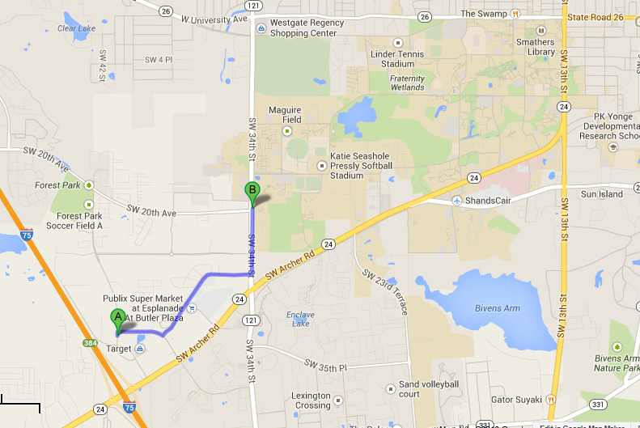

Univ of FL