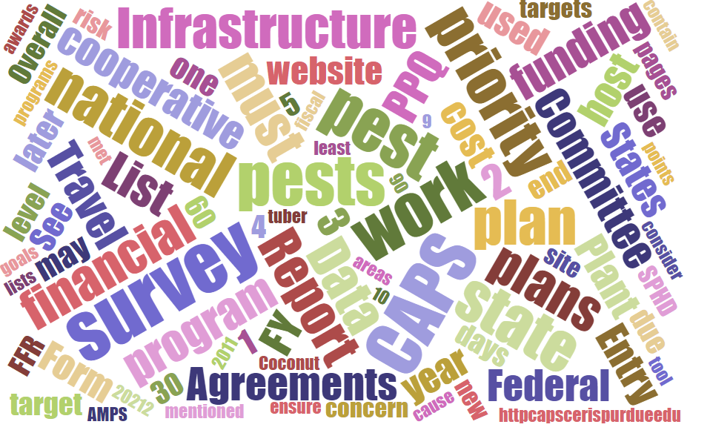



# Participants

**National CAPS Committee (NCC) Conference Call**

March 3, 2022

|  |  |  |  |  |  |  |  |
| --- | --- | --- | --- | --- | --- | --- | --- |
|  | Megan Abraham |  | Brad Danner |  | Helmuth Rogg |  | Feridoon Mehdizadegan |
|  | Cynthia Kwolek |  | Eric Ewing |  | Michael Hill |  | Sarah Phipps |
|  | Gregory Aydelotte |  | Lisa Ferguson |  | Avraham Eitam |  | Darcy Oishi |
|  | Darrell Bays |  | Tina Peltier |  | Lisa Jackson |  | Alana Wild |
|  | Stephen Bullington |  | Michelle Gray |  | Kim Rice |  | James Kruse |
|  | John Crowe |  | Jesse Hardin |  | Daniel Mackesy |  | Christopher Pierce |
|  | Bonnie Dietrich |  |  |  |  |  |  |

# CAPSIS Page update to new platform.

Bonnie Dietrich is the new CAPSIS Coordinator.

* Previously worked for HDOA under Darcy Oishi
* Entomologist and worked under a CAPS grant for Solenopsis invicta (red imported fire ant). Completed surveys statewide and filed reports semi-annually.
* Used NAPIS to report new county, state, and US pests
* Worked for well-known arborist in Hawaii over the last several years doing plant/soil diagnostics and insect/pathogen detection and writing reports
* Originally from California and Nevada where she worked on projects with Melissa blue butterfly, western toads, and mule dear
* Has been training with James and it is going well

Drupal 9

* The CAPS R&C website was migrated from Drupal 8 to Drupal 9 in March.  The migration enabled new features to addition modules and enhanced performance of the website. The migration also removed deprecations, enhanced security capabilities and optimized content processing to the site. This will allow for easier testing and maintenance of the website.
* Please note that the migration caused minimal impact to the user community at large and most will not notice any change to the appearance of the CAPS R&C website.

For CAPSIS questions please continue to use: [CAPSIS@purdue.edu](mailto:CAPSIS@purdue.edu)

# 

# 

# PPA - due dates

All work and financial plans (for all Goals) are due to the Field Operations Cooperative Agreements SharePoint site no later than **Monday, April 11, 2022**. Cooperator agreements must be obligated by July 31.

# 

# PPA Work Plans Interface

As in FY2021, we will be using the online work plan interface on the CAPS Resource and Collaboration website. This will be mandatory for all Goal 1 Survey work plans, **except for *P. ramorum* and Honeybee Surveys.** For *P. ramorum* and Honeybee Surveys, continue to use the program-specific work and financial plan templates. Do not use the online work plan interface for these surveys.

Please refer to the [Work Plan Process for Goal 1 Surveys](https://download.ceris.purdue.edu/file/4060). It provides guidance and steps to use the online work plan interface and the larger work plan process. If you have questions, please reach out to your Pest Detection NOM and ADODR. If you have any issues using the interface, please alert your NOM and the CAPSIS Team at CAPSIS@purdue.edu. They can usually resolve your issue quickly. And if it is a larger issue that affects other end users, it is good to know as soon as possible.

Resources

* General FY2022 PPA Webpage on the CAPS Resource and Collaboration website: <http://caps.ceris.purdue.edu/ppa7721/2022>
* The Survey Summary Form: <https://pest.ceris.purdue.edu/services/surveyplanning/?source=1>
* [Work Plan Process for Goal 1 Surveys](https://download.ceris.purdue.edu/file/4060): Provides guidance and steps to use the online work plan interface and the larger work plan process.
* [Survey Summary Form and Data Requirements for Funded Surveys](https://download.ceris.purdue.edu/file/4130): Excel spreadsheet of what information needs to go where (by funded survey).

# Pest Specific Manuals

The Commodity Manuals have been archived because they have not been updated in many years. The Approved Methods pages now contain all biological information previously available in the manuals.

Now found here:

[Archive | CAPS (purdue.edu)](https://caps.ceris.purdue.edu/archive)

The datasheets are all on the AMPS pages. You can also sort by "List" to get a dropdown of pests by Survey Manual here: [Approved Methods | Cooperative Agricultural Pest Survey (purdue.edu)](http://pest.ceris.purdue.edu/services/napisquery/query.php?code=approvedmethods2022).

# Survey Supply Winter Ordering Period

Survey Supply ordering closed on March 8 and all orders have been approved. Since IPHIS was having some issues recently, please ensure that you received a confirmation email from IPHIS for **each order**. In the subject line it will say “Your order number XXXX has been approved.” Please review the email and make sure that the products, quantities requested, and all contact information is correct. (Zip code does not show up in the email.). It is a good standard practice after every open period to make sure that you receive these.

### 

### **IPHIS Display Screens**

IPHIS ([https://iphis.aphis.usda.gov/](https://gcc02.safelinks.protection.outlook.com/?url=https%3A%2F%2Fiphis.aphis.usda.gov%2F&data=04%7C01%7C%7C92eebb5f8c684a801cdf08d9fe0917b5%7Ced5b36e701ee4ebc867ee03cfa0d4697%7C0%7C0%7C637820137422537311%7CUnknown%7CTWFpbGZsb3d8eyJWIjoiMC4wLjAwMDAiLCJQIjoiV2luMzIiLCJBTiI6Ik1haWwiLCJXVCI6Mn0%3D%7C1000&sdata=3JrNEsbE4ngPO%2ByJ%2BkkLNtHvrUr6ezv1o1m8YLOhv2M%3D&reserved=0)) has recently changed how it will display screens.  If you’re not getting the expected results in IPHIS please click the “Search” button. This should display information in your Browse Catalog, My Orders and possibly other IPHIS Screens. Attached are a few screen captures to help you.

Please feel to reach out if you have any additional questions. This message was sent to all Pest Survey Specialists and State Survey Coordinators feel free to pass along to any other interested group.

If you’re having problems seeing pages displayed in IPHIS try clicking search to see the expected results. For the “Browse Catalog” Screen:

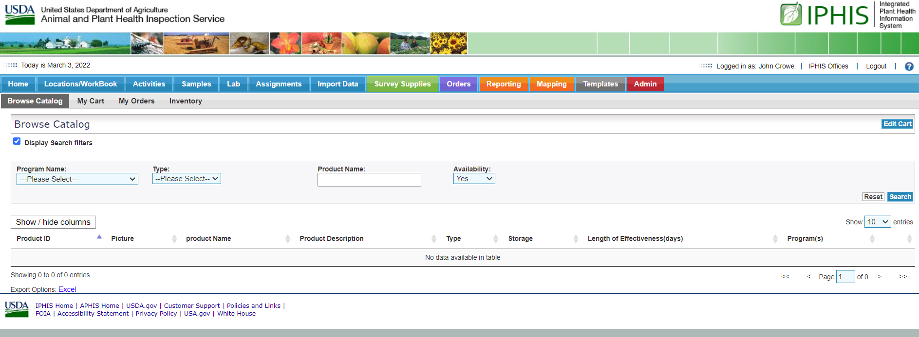

Catalog Displays after clicking search:

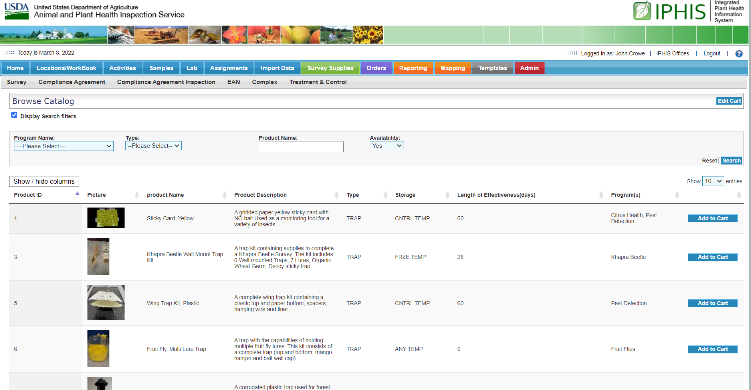

# Anthonomus rubi

Products are now available to order for this pest in the IPHIS survey supply catalog. The approved methods page is still being developed. It’s possible that this pest will have active and passive trapping available. We are confirming these approaches with experts and will work to get the page posted as soon as possible for 2023.

|  |  |  |
| --- | --- | --- |
| 1741 | Vaned Plastic Bucket Trap - Green | A plastic bucket trap (Unitrap / universal moth trap) used to collect various insects utilizing a DRY method. This trap has vanes and is green in color. |
| 1761 | Anthonomus rubi Lure | Anthonomus rubi - Strawberry Blossom Weevil: set of lures (plant volatile and insect attractant pheromone) for trapping the Strawberry blossom weevil |

# Regional Plant Boards

Agenda Topics should be sent forward to the NOMs as soon as possible.