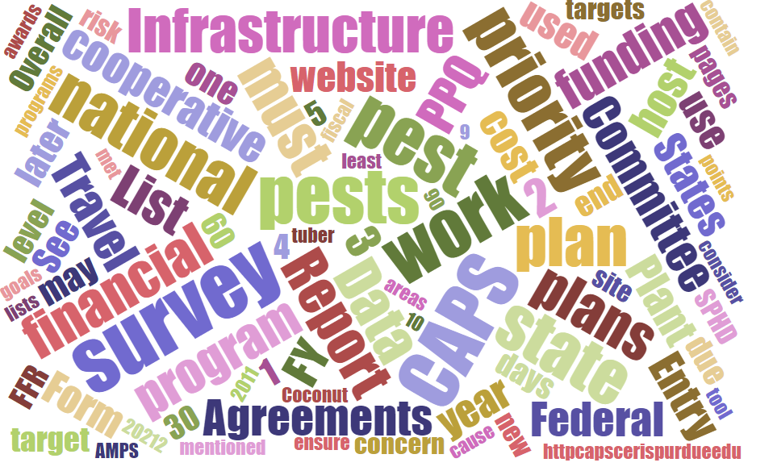



# Participants

**National CAPS Committee (NCC) Conference Call**

April 7, 2022

|  |  |  |  |  |  |  |  |
| --- | --- | --- | --- | --- | --- | --- | --- |
|  | Megan Abraham |  | Brad Danner |  | Helmuth Rogg |  | Feridoon Mehdizadegan |
|  | Cynthia Kwolek |  | Eric Ewing |  | Michael Hill |  | Sarah Phipps |
|  | Gregory Aydelotte |  | Lisa Ferguson |  | Avraham Eitam |  | Darcy Oishi |
|  | Darrell Bays |  | Tina Peltier |  | Lisa Jackson |  | Alana Wild |
|  | Stephen Bullington |  | Michelle Gray |  | Kim Rice |  | James Kruse |
|  | John Crowe |  | Jesse Hardin |  | Daniel Mackesy |  | Christopher Pierce |
|  | Bonnie Dietrich |  |  |  |  |  |  |

# PPA - due dates

# All work and financial plans (for all Goals) are due to the Field Operations Cooperative Agreements SharePoint site no later than Monday, April 11, 2022. Agreements must be obligated by July 31.

# CAPS Guidelines Update

Currently being reviewed. Each survey will need to have 60% of the target pests be Priority Pests. There will be additional leeway for pests that do not incur additional costs for either survey or diagnostics.

Example: A state is conducting a Cyst Nematode Survey that includes several Priority Pests. Additional cyst nematode targets may be surveyed for and identified from a soil sample that was taken for the Priority Pests. These pests can be denoted “No Cost Pests” since they do not incur additional funding to 1) collect the sample or 2) process the sample to perform the identification.

 If a state includes "No Cost Pests" in the Survey Summary Form, the additional "No Cost Pests" will not count against the 60% calculation.

## 

## Expect to see the new guidelines sometime between Earth Day and the May NCC Meeting.

# Online Interface for FY2023 CAPS Cycle

For FY2023 and onward, for both CAPS and PPA, we are envisioning using the online interface for only the Financial Portion of the work plan. There will be three separate components needed for CAPS and PPA Goal 1 Survey:

1. Survey Summary Form

2. Work Plan Template (Word form). These are the potential different types of unique templates that would be needed:

* CAPS:
  + Infrastructure
  + Individual Survey
  + Combined Survey
* PPA:
  + National Priority Surveys
  + Honeybee
  + *P. ramorum*
  + Other "Program-like pests" that may need a separate template - especially if they have unique DDII requirements (Core Data, Data Addendum, etc.) (PCN/GN, Fruit Fly, etc.).

3. Financial Plan (online interface)

* It's important to keep collecting the Financial Plan information electronically so that reports can be run and information can be analyzed across years.
* We will offer a Word template that can be shared while developing the financial plan.
* Final dollar amounts will need to be entered into the Interface.
* We are considering removing the calculations from the online portion, as most people first calculate this in Excel and then just paste the amounts into the online interface. We will accept feedback through May on what most of the community’s preference is regarding keeping the calculations in the interface.

Creating the final work plan

* The final work plan will need to be a pdf of the Work Plan Template + the Financial Plan.
* We will accept feedback on whether it is preferred to export the Financial Page out of the interface, or to just use the Word template.
* Since the Survey Summary Form will no longer feed into the Work Plan in the interface, the ADODR will need to ensure that the pest list is the same in the Survey Summary Form and final work plan.

If you have suggestions on the new workflow or questions, please send them through your NCC representative. There will also be time to discuss this at the regional plant board meetings.

# ESA

Pest Surveillance ESA guidance for states is posted at: [https://caps.ceris.purdue.edu/pest-surveillance-guidelines/esa](https://gcc02.safelinks.protection.outlook.com/?url=https%3A%2F%2Fcaps.ceris.purdue.edu%2Fpest-surveillance-guidelines%2Fesa&data=04%7C01%7C%7C0d4b1a91a1d343bf2a2008da10e8125b%7Ced5b36e701ee4ebc867ee03cfa0d4697%7C0%7C0%7C637840886168641924%7CUnknown%7CTWFpbGZsb3d8eyJWIjoiMC4wLjAwMDAiLCJQIjoiV2luMzIiLCJBTiI6Ik1haWwiLCJXVCI6Mn0%3D%7C3000&sdata=gAiL8druIJ4p4Mhw7DbLKbLjf1XXJ62wO7dGrPvUqwc%3D&reserved=0).

The following states have restrictions in place for ESA:

* Eastern PB: CT, MD, ME, MA, NH, NY, RI and WV
* Southern PB: AR, FL, OK, TX, VA
* Central PB: IL, IN, IA MN, MT, NE, OH, and WI
* Western PB: CA, MT, NV, and WY

(Entire List:  AR, CA, CT, FL, IL, IN, IA, ME, MD, MA, MN, MT, NE, NV, NH, NY, OH, OK, RI, TX, VA, WV, WI and WY)

The ESA guidance for your state has been updated at: [https://caps.ceris.purdue.edu/pest-surveillance-guidelines/esa](https://gcc02.safelinks.protection.outlook.com/?url=https%3A%2F%2Fcaps.ceris.purdue.edu%2Fpest-surveillance-guidelines%2Fesa&data=04%7C01%7C%7Cae0e8d52442546fcc14908da10f34cfa%7Ced5b36e701ee4ebc867ee03cfa0d4697%7C0%7C0%7C637840934396308322%7CUnknown%7CTWFpbGZsb3d8eyJWIjoiMC4wLjAwMDAiLCJQIjoiV2luMzIiLCJBTiI6Ik1haWwiLCJXVCI6Mn0%3D%7C3000&sdata=ZW%2B5iGd2WaHBpXxnJqBc9PUaW0DnO%2FLD%2ByDKk%2Fk4Kas%3D&reserved=0).  Please follow the guidance and if you’re unable to comply send me a written message as to why you’re unable to comply.  This multi-year project is moving along and we are making some progress because of your support. I’m looking forward to working with any SPHD on the remaining insects in their state and keeping this information as up to date as possible.  Remember, this guidance only applies to Pest Surveillance to include: CAPS, PPA Goal 1 Survey, and PPQ Pest Detection Survey work at this time; please remember to also remind cooperators that may do these types of surveys.

# NCC Meeting Notes Posted

# 

# The Annual NCC Meeting Notes have been posted at: <https://caps.ceris.purdue.edu/ncc>.