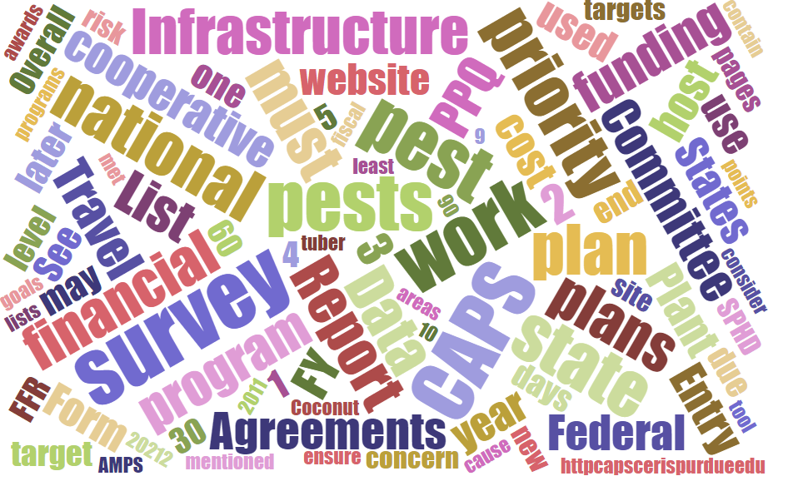



# Participants

**National CAPS Committee (NCC) Conference Call**

July 7, 2022

|  |  |  |  |  |  |  |  |
| --- | --- | --- | --- | --- | --- | --- | --- |
|  | Megan Abraham |  | Brad Danner |  | Helmuth Rogg |  | Feridoon Mehdizadegan |
|  | Cynthia Kwolek |  | Eric Ewing |  | Michael Hill |  | Erin Biggs |
|  | Gregory Aydelotte |  | Lisa Ferguson |  | Avraham Eitam |  | Darcy Oishi |
|  | Darrell Bays |  | Tina Peltier |  | Lisa Jackson |  | Alana Wild |
|  | Stephen Bullington |  | Michelle Gray |  | Kim Rice |  | James Kruse |
|  | John Crowe |  | Jesse Hardin |  | Daniel Mackesy |  |  |
|  | Bonnie Dietrich |  |  |  |  |  |  |

 CAPS 2021 Data – Accountability Report Emails

Emails went out on July 6 regarding outstanding data from 2021 CAPS surveys. The Accountability Report is linked to your state's Survey Summary Form and also to your NAPIS data. If you received one of these emails, please upload your missing data. If the survey was not performed or the pest was not surveyed for, please revise your Survey Summary Form.

All records are to be entered into the NAPIS database no later than the date that the final Accomplishment Report is due - 120 days after the end of the agreement. If data is pending for some reason (no cost extension to agreement, etc.), contact your SPHD and National Operations Manager for Pest Detection. There is a way to add a comment that will display in the Accountability Report and will turn off the emails.

## 

# 2023 PPA 7721 Open Period

The PPA 7721 FY2023 Suggestion Open Period began on June 13 and will run for 7 weeks, through **August 1**. The final PPA training webinar will be held on July 20.

Here are a few resources:

* [USDA APHIS | Plant Pest and Disease Management and Disaster Prevention Program](https://www.aphis.usda.gov/aphis/ourfocus/planthealth/ppa-ppdmdpp/ppdmdpp/plant-pest-disease-managemet-disaster-prevention-program)
* Frequently Asked Questions (FAQs): [Plant Protection Act Section 7721 Program FAQs (usda.gov)](https://www.aphis.usda.gov/plant_health/ppa-7721/fy22/ppa-7721-faqs.pdf)
* Webinars: July 20. See PPA 7721 homepage: [USDA APHIS | Plant Pest and Disease Management and Disaster Prevention Program](https://www.aphis.usda.gov/aphis/ourfocus/planthealth/ppa-ppdmdpp/ppdmdpp/plant-pest-disease-managemet-disaster-prevention-program)
* Survey Suggestion Template: [2023 PPA 7721 Goal 1 Survey](https://www.aphis.usda.gov/plant_health/ppa-7721/2023/fy2023-goal-1-survey.xlsx)

For any questions, please email the PPA Team at [PPA-Projects@usda.gov](mailto:PPA-Projects@usda.gov).

# PPA 7721 Goal 1 Survey Review Team

We lost five review team members this year. Most importantly, we are down 1 SPRO and 2 SPHDs. Our number of SSCs stayed consistent. We lost one PSS, but gained another. Representatives from any of our core 4 groups would make good reviewers. Anyone who is interested can reach out to John Crowe and Lisa Jackson for more information.

# Prelim ID Fields - SSF (Darrell)

The proposed changes to the Diagnostic Details section of the SSF were communicated to the NCC using a PowerPoint presentation. The goal of the change is to help the preliminary ID coordinators manage nationwide capacity and to coordinate timely screening and preliminary identification of domestic pest finds.

The change is proposed for the 2023 CAPS cycle, but it was noted that clear guidance and training need to be in place before implementation.

# Survey Summary Form Changes (Sites, Locations, etc.)

The NCC agreed upon the proposed changes: removal of Locations and addition of Counties for the 2023 cycle. The revision to Sites, with the new Site Description fields, will need more discussion and revision before rolling out. This is planned for the FY 2023 PPA Survey Summary Form.

NCC members are encouraged to share the draft Site Descriptions with their constituents. Please send any pests and Site Descriptions that need further discussion to John Crowe, with details for a revised or different Site Description for that pest.

In addition, there were questions about how this will impact NAPIS data entry. Additional information will be provided soon on any impacts to data entry.

# Webinar -

The CAPSIS Team and Pest Detection Cross Functional Working Group will host a webinar on **Tuesday July 19, 2022 at 3:00 pm Eastern Time** (2pm CT, 1pm MT, 12 PT, 11AM AK, 9AM HT).

The purpose of this webinar is to explain the changes to the:

1. CAPS Work Plan Process
   * Work Plans will use a Word Template
   * Financial Plan will be online
2. Survey Summary Form
   * No Cost Pests
   * Changes to Site, Location, and County
   * Diagnostic Details

 The Survey Summary Form for the FY2023 CAPS cycle opens August 1, and the FY2023 CAPS Work Plans are due September 9.

# iNaturalist – Helmuth Rogg

# Helmuth shared the Western Plant Board’s concerns with erroneous reports of quarantine pests in iNaturalist. The NCC shared other strategies that have worked with similar platforms. The Western Plant Board (WPB) intends to share this concern with the NPB and the PPQ Management Team to see if a national solution can be reached. The WPB would like to see support for iNaturalist in its effort to receive some PPA funding to work more closely with regulatory agencies avoiding misidentification or posting of regulatory pests that have not been vetted by agencies.