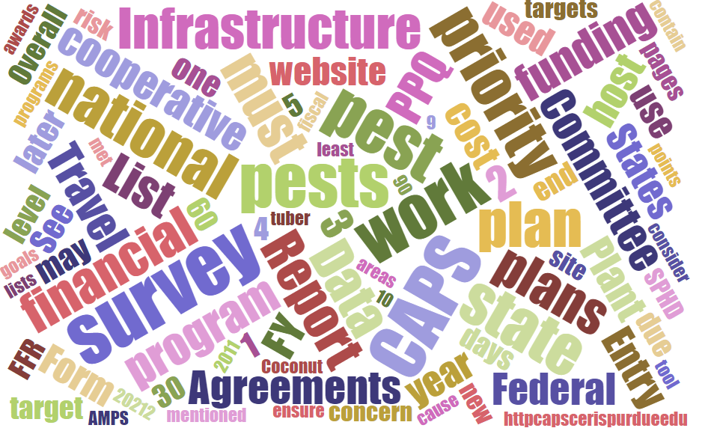



# Participants

**National CAPS Committee (NCC) Conference Call**

May 5, 2022

|  |  |  |  |  |  |  |  |
| --- | --- | --- | --- | --- | --- | --- | --- |
|  | Megan Abraham |  | Brad Danner |  | Helmuth Rogg |  | Feridoon Mehdizadegan |
|  | Cynthia Kwolek |  | Eric Ewing |  | Michael Hill |  | Sarah Phipps |
|  | Gregory Aydelotte |  | Lisa Ferguson |  | Avraham Eitam |  | Darcy Oishi |
|  | Darrell Bays |  | Tina Peltier |  | Lisa Jackson |  | Alana Wild |
|  | Stephen Bullington |  | Michelle Gray |  | Kim Rice |  | James Kruse |
|  | John Crowe |  | Jesse Hardin |  | Daniel Mackesy |  | Christopher Pierce |
|  | Bonnie Dietrich |  |  |  |  |  |  |

# Guidelines

To be shared May 11.

# FY2023 CAPS - Financial Page (Lisa) - (Jackson)

Next week Lisa will send an email to NCC to distribute to community to ask for feedback on what the financial page should look like in FY2023. We need to make a couple of decisions:

* Should we keep the calculations in the interface?
* Workflow:

1. Create your financial plan in Excel (on your own)

2. Copy into Word template (submit with work plan in one pdf)

3. Copy into online interface for reporting needs

*Or could export out of interface.

# PPA Implementation Plan - Crowe

* Survey Names will be distilled down to few options moving forward
  + Example, Root Crop will be removed and Vegetable Crops Pest Survey moving forward

Draft List:

|  |  |
| --- | --- |
| National Priority Surveys - Survey Names |  |
| Asian Defoliator Survey | Oak Commodity Survey |
| Berry Pest Survey |  |
| Citrus Commodity Survey | Orchard Commodity Survey |
| Corn Commodity Survey | Other Specialty Crop |
| Cotton Commodity Survey | Palm Survey |
| Cyst Nematode Survey | Pathway Survey for Pests of Multiple Agricultural Systems |
| Exotic Buprestid (Cerceris) Survey | Pine Commodity Survey |
| Exotic Wood Borer/Bark Beetle Survey | Rice Pest Survey |
| Field Crops Pest Survey | Small Fruit Pest Survey |
| Forest Pest Survey | Small Grains Commodity Survey |
| Fruit Crops Pest Survey | Solanaceous Commodity Survey |
| Grape Commodity Survey | Soybean Commodity Survey |
| Greenhouse Crops Pest Survey | Stone Fruit Commodity Survey |
| Legume Pest Survey | Tree Nursery Pest Survey |
| Mollusk Survey | Tropical Crops |
| Nursery and Ornamental Survey | Tropical Hosts Pests Survey |
| Nut Pest Survey | Vegetable Crops Pest Survey |

|  |
| --- |
| **Program Pest Surveys** |
| **Program Pest - Box Tree Moth Survey** |
| **Program Pest - Cucumber Green Mottle Mosaic Virus Survey** |
| **Program Pest – Exotic Fruit Fly Survey** |
| **Program Pest – Khapra Beetle Survey** |
| **Program Pest - National Honeybee Pests and Diseases Survey** |
| **Program Pest - Program: Pale Cyst Nematode / Golden Nematode Survey** |
| **Program Pest - Phytophthora ramorum Nursery Survey** |
| **Program Pest - Spotted Lanternfly Survey** |

# 

# Potatoes to Mexico

This message is being sent to the SPHD and SPRO in: CA, CO, ID, NE, NM, NV, OR, TX, WA, and WI

## Message 1:

**Background:**

This information seeks to clarify how the Cooperative Agriculture Pest Survey (CAPS) Program will be managing the requirements in the recently signed U.S. potatoes to Mexico (beyond the 26 km border zone) 2021 Operational Work Plan (OWP) for pests noted in the OWP with CAPS-specific language and how 2022 surveys will be conducted.

On December 6, 2021, PPQ signed an OWP with Mexico’s SENASICA to allow the exportation of potatoes from the United States beyond the 26 km border zone. Mexico identifies six total quarantine pests in the OWP (Annex 1- high risk pests) for U.S. potatoes including: *Epitrix tuberis*, *Clavibacter michiganensis* subsp. *sepedonicus*, *Ditylenchus destructor*, and *Meloidogyne chitwoodi*.*,* as well as *Globodera pallida* and *G. rostochiensis*.

The OWP also states the following CAPS specific language for four of the six pests listed above:

* “In addition to the general requirements and risk mitigation measures listed in the OWP, APHIS agrees to include -*Epitrix tuberis*, *Clavibacter michiganensis* subsp. *sepedonicus*, *Ditylenchus destructor*, and *Meloidogyne chitwoodi*- to the Cooperative Agricultural Pest Survey (CAPS). The survey data will be used by APHIS as a targeting tool and to intensify inspections and testing to ensure that shipments are free from this particular pest.”

The other pests listed in the OWP either do not have CAPS requirements or fall outside the scope of this guidance (e.g., *Globodera pallida* and *G. rostochiensis)* and should continue to follow standard data and program requirements.

Emergency and Domestic Programs has updated the Pest Tracker ([http://pest.ceris.purdue.edu/](https://gcc02.safelinks.protection.outlook.com/?url=http%3A%2F%2Fpest.ceris.purdue.edu%2F&data=05%7C01%7C%7C664efee5f1704314266308da2e145dde%7Ced5b36e701ee4ebc867ee03cfa0d4697%7C0%7C0%7C637872962253191309%7CUnknown%7CTWFpbGZsb3d8eyJWIjoiMC4wLjAwMDAiLCJQIjoiV2luMzIiLCJBTiI6Ik1haWwiLCJXVCI6Mn0%3D%7C3000%7C%7C%7C&sdata=1LGrqTdHA0DXEQ58MzBYbUBIaCAeUWs2oYn%2FC2AC7QU%3D&reserved=0)) website to include the four pests referenced in the OWP including: *E. tuberis*, *C. michiganensis* subsp. sepedonicus, *D. destructor*, and *M. chitwoodi.* The Pest Tracker provides the public with survey maps based on NAPIS data entries and provides a mechanism for tracking news articles for each pest. The addition of these four pests to the Pest Tracker website will allow anyone to view the survey information provided in NAPIS.

*E. tuberis*, *C. michiganensis* subsp. sepedonicus, *D. destructor*, and *M. chitwoodi* will not be added to the National Priority Pest List because they do not meet the criteria and requirements for that list. For 2022’s field season, extension surveys or other state-funded surveys that are already occurring for these pests should be entered into NAPIS if potatoes will be shipped to Mexico.

**Methodologies:**

* *Globodera pallida* and *G. rostochiensis* - Approved Method or Program survey methods are required.
* *E. tuberis*, *C. michiganensis* subsp. sepedonicus, *D. destructor*, and *M. chitwoodi –* are considered pests of state concern and do not require the use of an approved method. Though an approved method for [*Meloidogyne* spp](https://gcc02.safelinks.protection.outlook.com/?url=http%3A%2F%2Fpest.ceris.purdue.edu%2Fservices%2Fapprovedmethods%2Fsheet.php%3Fv%3D130&data=05%7C01%7C%7C664efee5f1704314266308da2e145dde%7Ced5b36e701ee4ebc867ee03cfa0d4697%7C0%7C0%7C637872962253191309%7CUnknown%7CTWFpbGZsb3d8eyJWIjoiMC4wLjAwMDAiLCJQIjoiV2luMzIiLCJBTiI6Ik1haWwiLCJXVCI6Mn0%3D%7C3000%7C%7C%7C&sdata=k1BhF8hlgUoYsadFPFNI6i1bQzOHerqpxOMOJk5%2B9R8%3D&reserved=0). is available from 2013. Surveys can occur in packing houses or fields.  If surveys happen in packing houses the lots of potatoes should be tied to specific fields and noted in NAPIS data.  Size scope and details of surveys can be determined locally based on available resources.

**Immediate Needs -**

There is a planned site visit by Mexico on April 20.  The goal is to have these changes in motion by this date.  I understand that it may not be possible to have all the changes completed by this date.  In hopes having a successful meeting, I am requesting that the SPRO email me prior to April 20 confirming the following information:

1. **Which survey work plans will be modified to include these targets (PPA or CAPS), including the name of the work plan. Or, if the surveys will be conducted through state-funded surveys.**
2. **Survey information for *E. tuberis*, *C. michiganensis* subsp. sepedonicus, *D. destructor*, and *M. chitwoodi* will be entered into NAPIS in 2022.**
3. **The institution(s) who will be conducting the surveys (State Department of Agriculture, university, extension, etc.).**

**Next steps -**

Over the next two weeks, work with the appropriate National Operations Manager (listed below), the ADODR, and PPQ Agreements Specialist to get these changes implemented.

The Survey Summary Form and work plans should be updated to include: *E. tuberis*, *C. michiganensis* subsp. sepedonicus, *D. destructor*, and *M. chitwoodi.* States may include these targets into a planned Cyst Nematode Solanaceous, Vegetable Crop, or other survey that takes place in potatoes. Please work with the appropriate National Operations Manager (listed below) to determine which modifications are needed in your work plan:

* Cyst Nematode Surveys – Sylvia Shadman-Adolpho ([sylvia.a.shadman-adolpho@usda.gov](mailto:sylvia.a.shadman-adolpho@usda.gov))
* CAPS or other PPA goal 1 surveys - Lisa Jackson ([lisa.d.jackson@usda.gov](mailto:lisa.d.jackson@usda.gov)) or Darrell Bays ([darrell.a.bays@usda.gov](mailto:darrell.a.bays@usda.gov))

For assistance modifying your Survey Summary Form, contact Lisa or Darrell. Depending on the status of the cooperative agreement in the approval process, additional steps may be needed. Work with the ADODR, and appropriate National Operations Manager, and PPQ Agreements Specialist on how to address your state’s work plans. Data for *E. tuberis*, *C. michiganensis* subsp. sepedonicus, *D. destructor*, and *M. chitwoodi* pests must be uploaded to NAPIS for 2022 field surveys.

If a county is planning on shipping potatoes to Mexico, that county will need to complete surveys *E. tuberis*, *C. michiganensis* subsp. sepedonicus, *D. destructor*, and *M. chitwoodi* in 2022. The scope of survey can be determined locally.

If you have questions, please reach out, I’m happy to assist.

## Message 2

Is following up with further details on the previous message regarding CAPS surveys required for supporting Potatoes to Mexico. The operational work plan (OPW) for the importation of U.S. potato into Mexico identified six (6) high risk pests:

* *Epitrix tuberis*
* *Clavibacter michiganensis subsp. Sepedonicus*
* *Ditylenchus destructor*
* *Meloidogyne chitwoodi*
* *Globodera pallida*
* *G. rostochiensis*

 CAPS Surveys are only required for four of these pests:

* *Epitrix tuberis*
* *Clavibacter michiganensis subsp. sepedonicus*
* *Ditylenchus destructor*
* *Meloidogyne chitwoodi*

The 4 pests requiring CAPS surveys are considered Pests of State Concern, and thus, APHIS will not provide sampling procedures. Each state can develop their own sampling procedures. A visual inspection of the tubers for, *E. tuberis, C. michiganensis* subsp*. sepedonicus, D. destructor, M. chitwoodi* is acceptable*. P*hytosanitary inspections done for export purposes meet CAPS survey data standards.

APHIS anticipates that Mexico’s National Plant Protection Organization will request information related to CAPS surveys involving these pests. In an effort to provide consistent data APHIS is requesting the following measures:

* For tubers grown in 2021:
  + After a Phytosanitary Certificate is issued, upload the negative data into the National Agriculture Pest Information System (NAPIS) as CAPS survey data.
  + Each county with shipments of tubers to Mexico should have representative survey data entered into NAPIS.
* For 2022 produced potatoes:
  + Continue to upload all survey data into NAPIS.
  + Field inspections of plants and soil may be used to meet survey requirements.
  + Packing house inspections remain acceptable.
* In the event of positive samples from visual inspections, a laboratory confirmation from a state accredited laboratory is required before the data is entered into NAPIS. Potential positives of *Clavibacter michiganensis* subsp*. sepedonicus* must be confirmed by an accredited laboratory.
* The state is responsible for the sampling and reporting of Pests of State Concern. States may develop local surveys to meet their needs; however, PPQ may seek clarification regarding data entered in NAPIS.
* Survey data will be required to meet annual audits described in the OWP and compliance agreements. A state must make final NAPIS entry in advance of the annual audit and consider more frequent uploads to assist with data reporting.
* PPQ has developed the attached guidance for entering NAPIS data from field and packing house inspections. PPQ is requesting the state’s collaboration in following the guidance.
* Existing work plans that do not require NAPIS data entry may be adjusted to include, *E. tuberis, C. michiganensis* subsp*. sepedonicus, D. destructor, M. chitwoodi.* However, data for *E. tuberis, C. michiganensis* subsp*. sepedonicus, D. destructor, M. chitwoodi* must be entered into NAPIS.

# Q&A from regional plant boards

## What is the data in NAPIS used for, besides the agreements? (JC to prepare response)

The primary purpose of the NAPIS data entry system remains to recorded completed surveys and to support accomplishment reporting. This is evidenced by the accountability report. Further, the new criteria for Report Generating has shown that Data Entry Confirmation remains one of the top two reasons users run reports. In CY 2022 283 reports have been run and 78 of those reports were identified as Data Entry Confirmation this was only exceeded by Understanding General Pest Populations at 84.

Trade support uses NAPIS data in two ways, Preparing Pest Risk Assessments and Supporting Trade Directors. Though Understanding General Pest Populations could also support trade in some ways.

The federal government's primary purpose for accessing NAPIS entry is related to accountability to completion of cooperative agreements. Though reports may be run to support Trade in the ways already described or to support general scientific research. Further, Survey Maps are generated on an annual basis on Pest Tracker to convey to the public work completed.

NAPIS maintains a log for each report run by NAPIS each user. This information is not available

Other than this they were also interested in knowing:

- How does the federal government use the NAPIS data?

- How is NAPIS data used for export purposes?

On the bottom of the NAPIS login page it also says:

*“Pest detection survey observations recorded in NAPIS emphasize exotic pests that may impact exports of U.S. agricultural products or damage agricultural production and natural resources.”*

# 

|  |  |
| --- | --- |
| **NAPIS Usage from January 1, 2022 to May 4, 2022** | **Count** |
| Completing a Pest Risk Assessment | 8 |
| Data Entry Confirmation | 78 |
| Other | 34 |
| Research | 57 |
| Support Trade Director or Bilateral | 22 |
| Understanding General Pest Population | 84 |
| **Grand Total** | **283** |