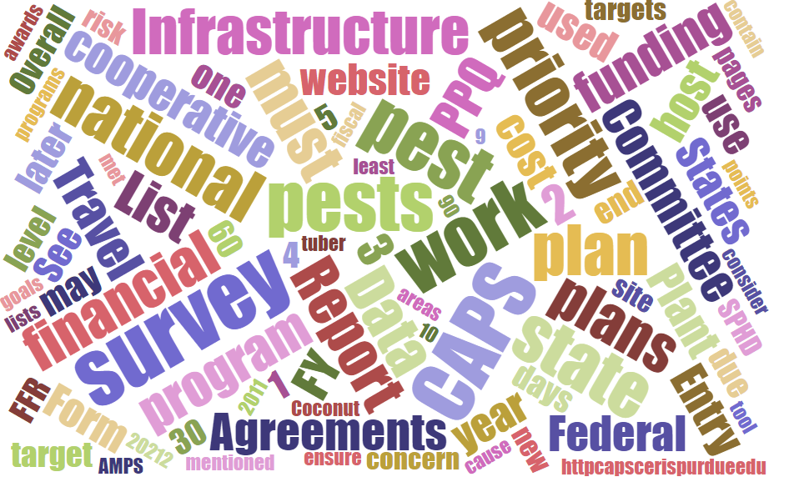



# Participants

**National CAPS Committee (NCC) Conference Call**

June 2, 2022

|  |  |  |  |  |  |  |  |
| --- | --- | --- | --- | --- | --- | --- | --- |
|  | Megan Abraham |  | Brad Danner |  | Helmuth Rogg |  | Feridoon Mehdizadegan |
|  | Cynthia Kwolek |  | Eric Ewing |  | Michael Hill |  | Erin Biggs |
|  | Gregory Aydelotte |  | Colin Funaro |  | Avraham Eitam |  | Darcy Oishi |
|  | Darrell Bays |  | Tina Peltier |  | Lisa Jackson |  | Alana Wild |
|  | Stephen Bullington |  | Michelle Gray |  | Kim Rice |  | James Kruse |
|  | John Crowe |  | Jesse Hardin |  | Daniel Mackesy |  | Christopher Pierce |
|  | Bonnie Dietrich |  |  |  |  |  |  |

# Central Plant Board Replacement

Erin Biggs from Nebraska has replaced Sarah Phipps as the State Survey Coordinator Representative from the Central Plant Board.

# 

# FY2023 PPA Open Period - Feridoon Mehdizadegan

We are working on the FY 23 cycle and plan to have the open period on June 13, pending final agency’s approval. We will use the Metastorm platform again for project submission and the platform will have some improvements. Please remind your cooperators to update their eAUth credentials for submitting suggestions.

Based on the Goal Team leads’ feedback there will be some revisions in the FY23 Implementation plan, so please review it thoroughly to ensure alignment with PPA goal objectives and other requirements. One key change you will see is a distinction between a cooperator and a collaborator when submitting a suggestion’s budget. A collaborator doesn’t require a separate budget but if you have two or more cooperators, the system will ask for a separate budget. We plan to provide three webinars on the FY 23 PPA submission process.

Finally, if you are not able to use the funding for any of your FY 22 projects, please let your ADODR know, so that we can redirect the funds.

Stay tuned for the FY23 PPA open period which we will broadcast through the stakeholder’s announcement and the APHIS PPA website.

# Financial Plan for FY2023 CAPS

From the feedback that we received, we will remove the calculations from the Financial Plan in the online interface and go with this option:

Option A.

1. Create the Financial Plan in Excel on your own.

2. Copy information into the online interface.

3. Copy information into the Financial Plan Word Template, to include in your final pdf. (Or export out of the online interface - just the Financial Plan.)

4. Create one pdf of the Work Plan and Financial Plan.

# No Cost Pests

Starting with FY2023 CAPS agreements, cooperators can add “No Cost Pests” to their surveys. A No Cost Pest is a pest that is not on the National Priority Pest List but that can be surveyed and identified without requiring additional funding or adding costs to the agreement. No Cost Pests will not count towards the 40% pests of state concern. These pests will be indicated on the Survey Summary Form as “No Cost Pests.” This is a change from FY 2022 when adding non-priority pests counted towards the pests of state concern 40% limit.

Example: A state is conducting a cyst nematode survey that includes several priority pests. Additional cyst nematode species of state concern may be surveyed and identified from the same soil sample that was taken for the priority pests. These other cyst nematode species can be included in the Survey Summary Form and denoted “No Cost Pests” since they do not require additional funding to 1) collect the sample, or 2) process the sample to perform the identification.

More information will be shared soon on how to document No Cost Pests in your Survey Summary Form.

# Webinar about the Survey Summary Form and Work and Financial Plan

CAPSIS and the Pest Detection Cross Functional Working Group will host a webinar in early July to ensure cooperators understand the changes to the Survey Summary Form and the Online Work plan interface described above.