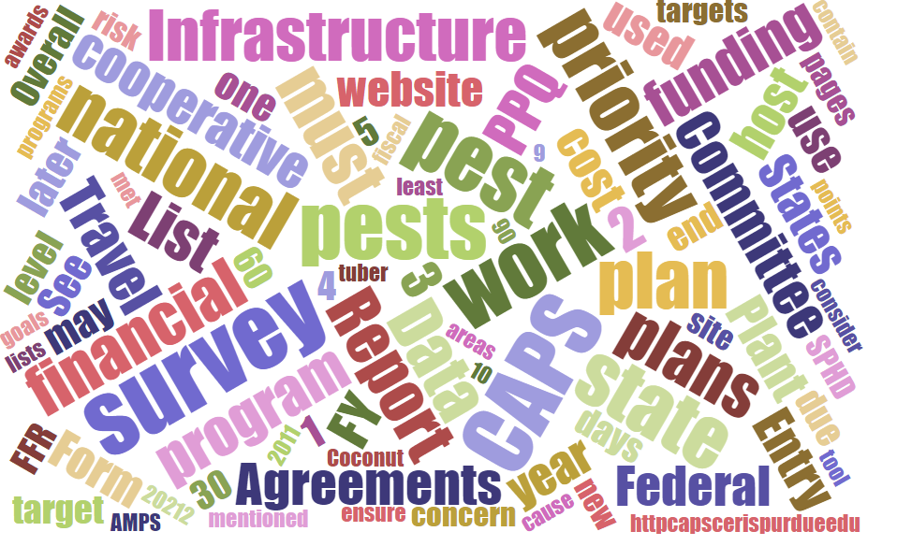



# Participants

**National CAPS Committee (NCC) Conference Call**

September 1, 2022

|  |  |  |  |  |  |  |  |
| --- | --- | --- | --- | --- | --- | --- | --- |
|  | Megan Abraham |  | Brad Danner |  | Helmuth Rogg |  | Feridoon Mehdizadegan |
|  | Cynthia Kwolek |  | Eric Ewing |  | Michael Hill |  | Erin Biggs |
|  | Gregory Aydelotte |  | Lisa Ferguson |  | Avraham Eitam |  | Darcy Oishi |
|  | Darrell Bays |  | Tina Peltier |  | Lisa Jackson |  | Alana Wild |
|  | Stephen Bullington |  | Michelle Gray |  | Kim Rice |  | James Kruse |
|  | John Crowe |  | Jesse Hardin |  | Daniel Mackesy |  |  |
|  | Bonnie Dietrich |  | Kathryn Bronsky |  |  |  |  |

# FY2023 CAPS Work Plans - Lisa

Work plans are coming in; however, the Survey Summary Forms are lagging behind. Darrell and Lisa need both to be complete before they will review the work plans. Several states have their SSFs at the SPHD level awaiting approval. SPHDs, please review and approve SSFs when you receive the work plans.

You will need to create one combined pdf of your Work and Financial Plans. To do this, you may either:

* Export the Financial Plan out of the online interface, add it to your Work Plan Word document, and create one pdf.
* Or you may fill out the [Financial Plan Template](https://caps.ceris.purdue.edu/pest-surveillance-guidelines/financial-plan-template/2023) and combine this into one pdf with your Work Plan Word document.

To summarize, here are the actions needed:

* Survey Summary Form completed and approved by SPHD/PSS.
* Financial Plan completed in the online interface.
* Work and Financial Plan combined into one pdf and uploaded to the PPQ Agreements SharePoint site.
* At a minimum, there should be one pdf of the Work and Financial Plan for Infrastructure and one for Survey.

# 

# Data Entry Roles and Responsibilities Document - revised

There were minor revisions and updates to the document. We will post it in the FY2023 Guidelines.

# 

# Port Environs Survey Pilot Discussion - Crowe

AQI User Fee Port Environs funding supports PPQ early detection survey work in many states. Currently, PPQ is unable to report on this work and how it is prioritized. Heather Moylett and I are developing a more comprehensive approach for Port Environs survey as part of the PPQ Pest Surveillance initiative.

**In FY23, we are conducting a pilot to capture Port Environs survey plans and data.** The goals of the pilot are to 1) capture the survey work that is done with Port Environs funding, 2) explore how and where to capture Port Environs data (PPQ Pest Detection data management guidance or another process). For example, Port Environs survey plan information will be entered into a Survey Summary Form (SSF), modeled after the PPQ Pest Detection SSF and survey data will go into NAPIS or other appropriate data repository.

**Texas, North Carolina, Pennsylvania, Illinois, and Washington have agreed to join the pilot.** This is an important step towards understanding and reporting the work accomplished using AQI UF Port Environs funds. Based on the results of the pilot, we may expand to include more states in FY24.

------------------------------------

***What to expect (in brief)***

In the coming months, we will meet with each state participating in the pilot to discuss the PPQ Port Environs SSF and data entry requirements. In the fall, we will provide a guide for the pilot and open the PPQ Port Environs SSF for submissions.

Survey Summary Form

When planning your surveys, the guidance from Pest Detection is, “If you do a survey, for instance EWB/BB, and it is paid for by two funding sources (Port Environs and Pest Detection), do your best to estimate the percent of work that is supported by Pest Detection. For instance, the survey is supported by 30% Port Environs and 70% Pest Detection. Include 70% of your traps in the SSF.”

For the pilot, in this scenario you would enter the 30% of traps funded by Port Environs into the PPQ Port Environs SSF.

The review and approval process will follow the same workflow used for the PPQ Pest Detection SSF. I will be the NOM who approves the PPQ Port Environs SSF. In the pilot, we want to see what you are currently surveying for using AQI UF PE funds. This information will help to develop future policy guidance.

Data Management

Port Environs survey data may already be included as part of the datasets shared with the State Survey Coordinators for upload into NAPIS. We would like to be able tell these data apart in NAPIS. We are still working on how to do this, but data entry requirements for the pilot will likely align with the Pest Detection “Data Entry – Roles and Responsibilities” document, specifically numbers 2 and 6 (found [here](https://gcc02.safelinks.protection.outlook.com/?url=https%3A%2F%2Fdownload.ceris.purdue.edu%2Ffile%2F3967&data=05%7C01%7C%7Cec5508cd6251406da66008da74017bf3%7Ced5b36e701ee4ebc867ee03cfa0d4697%7C0%7C0%7C637949846963671176%7CUnknown%7CTWFpbGZsb3d8eyJWIjoiMC4wLjAwMDAiLCJQIjoiV2luMzIiLCJBTiI6Ik1haWwiLCJXVCI6Mn0%3D%7C3000%7C%7C%7C&sdata=t8dTLuJQC5bZ76l97rT19Dpon1NYL8xlwoubohDvwI8%3D&reserved=0)), depending on the target pests.

# CAPSIS Pest Tracker Updates - Bonnie

 The attached presentation reviews the request to change the Pest Tracker Website. The NCC determined that when CAPSIS receives requests for pest identification help, the message should be sent to the SSC, SPRO, SPHD and PSS or the respective state. This change will be made moving forward.

# Webinars page - Now Training

Webinars are now titled “Trainings” on the Resource and Collaboration site. Small changes will be made moving forward to help users differentiate between videos and slide decks.

**Survey Planning**

* [CAPS Survey Summary Form & Online Financial Plan](https://gcc02.safelinks.protection.outlook.com/?url=https%3A%2F%2Fdownload.ceris.purdue.edu%2Ffile%2F4280&data=05%7C01%7C%7Ca0a910325c5a4366d97d08da868bf74f%7Ced5b36e701ee4ebc867ee03cfa0d4697%7C0%7C0%7C637970232948200045%7CUnknown%7CTWFpbGZsb3d8eyJWIjoiMC4wLjAwMDAiLCJQIjoiV2luMzIiLCJBTiI6Ik1haWwiLCJXVCI6Mn0%3D%7C3000%7C%7C%7C&sdata=2X3U9V2i9hjulYmMEOZuD0zj%2BxXiAJSMPsTz%2FSCZvHc%3D&reserved=0)
  + [Recent Changes](https://gcc02.safelinks.protection.outlook.com/?url=https%3A%2F%2Fdownload.ceris.purdue.edu%2Ffile%2F4266&data=05%7C01%7C%7Ca0a910325c5a4366d97d08da868bf74f%7Ced5b36e701ee4ebc867ee03cfa0d4697%7C0%7C0%7C637970232948200045%7CUnknown%7CTWFpbGZsb3d8eyJWIjoiMC4wLjAwMDAiLCJQIjoiV2luMzIiLCJBTiI6Ik1haWwiLCJXVCI6Mn0%3D%7C3000%7C%7C%7C&sdata=HCKMiTeSZ5L2T9t3AHHVWliPT%2B2TicrMhN3OljTSTik%3D&reserved=0) | [Diagnostic Support](https://gcc02.safelinks.protection.outlook.com/?url=https%3A%2F%2Fdownload.ceris.purdue.edu%2Ffile%2F4265&data=05%7C01%7C%7Ca0a910325c5a4366d97d08da868bf74f%7Ced5b36e701ee4ebc867ee03cfa0d4697%7C0%7C0%7C637970232948200045%7CUnknown%7CTWFpbGZsb3d8eyJWIjoiMC4wLjAwMDAiLCJQIjoiV2luMzIiLCJBTiI6Ik1haWwiLCJXVCI6Mn0%3D%7C3000%7C%7C%7C&sdata=PEoIXEo4%2BHOYFAuzDJP0UtCoIElH2Mbg8yjdxoXO%2FAE%3D&reserved=0) | [Work Plan](https://gcc02.safelinks.protection.outlook.com/?url=https%3A%2F%2Fdownload.ceris.purdue.edu%2Ffile%2F4267&data=05%7C01%7C%7Ca0a910325c5a4366d97d08da868bf74f%7Ced5b36e701ee4ebc867ee03cfa0d4697%7C0%7C0%7C637970232948200045%7CUnknown%7CTWFpbGZsb3d8eyJWIjoiMC4wLjAwMDAiLCJQIjoiV2luMzIiLCJBTiI6Ik1haWwiLCJXVCI6Mn0%3D%7C3000%7C%7C%7C&sdata=4qrk0Nmax6ecSgWBGiU8YOGYHkVXoM6imbgTc3eAbqk%3D&reserved=0)

# 

# ESA's common name change for *Lymantria dispar* and related *Lymantria* species, and APHIS's implementation process

In March 2022, the Entomological Society of America (ESA) announced a change in their common names database for *Lymantria dispar*, changing the common name to "spongy moth" to remove the term "gyspy." APHIS supports this change and has been working to implement the new spongy moth name, but the process involves a few challenges. Prior to implementation, APHIS needs to address the regulatory term used to define the complex of five Lymantria species and subspecies from Asian countries - currently called AGM. APHIS works closely with other countries that regulate AGM, and together these international partners have been working to identify a new term for the AGM complex to keep consistent messaging to industry. The new complex term would remove "Asian" and "gypsy" to align with ESA's Better Common Name Initiative. APHIS is finalizing an implementation plan for spongy moth and the new Lymantria complex name and plans to formally announce the changes later this year.

In July, ESA re-convened a working group of federal, state, and industry representatives including APHIS to discuss designating common names for the three *L. dispar* subspeciesand related Lymantria species. Future working group discussions will determine if new common names will be selected for these Lymantria species of concern to North America. The proposed common names would then need to be approved by the ESA governing board before being entered into ESA's common names database.

These changes will have impacts to the NAPIS dictionary moving forward. If users perform searches using common names and the expected results are not received, please use the scientific name, which will remain consistent.

# Survey Supply Open Period

September 12 - November 18 – please keep an eye out for the message.

# Term Rotations

It’s that time of year for new members to be considered for the NCC. Each is expected to notify John Crowe of changes so this can be updated in NCC documentation. Current, rotations can be found at (copied below):

<https://download.ceris.purdue.edu/file/4175>

## The 2023 rotating members are as follows:

Central Plant Board SSC – Erin Biggs

Central Plan Board SPRO - Megan Abram

State Plant Health Director: Alana Wilds

PPQ Pest Survey Specialist: Greg Aydelotte

Western Plant Board SSC: Darci Oishi

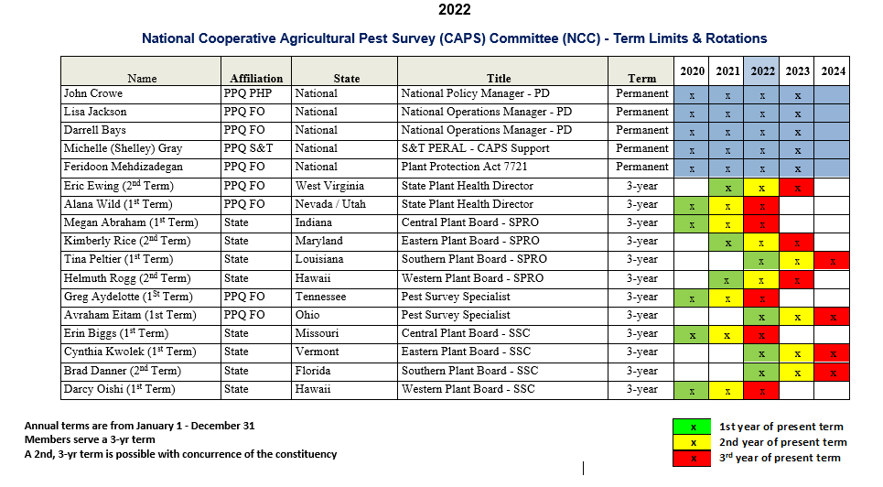

# Annual Meeting

Tentative Dates - Week of January 30 - February 3

The S&T Forest Pest Methods Laboratory will be hosting the NCC.

Crowe will be sending:

Invitation letters

Agenda

# OPEP Summary Report

S&T will make OPEP summary reports available to individuals working for State Departments of Agriculture, Universities, and other similar entities. However, many PestLens users have left their profile information blank, which makes it difficult to identify everyone who should be granted access. Please update your profile in PestLens so that this access can be made available to you. NPRGs will also become accessible to these same users.

NCC members should reach out to their respective constituency to see that they update their PestLens account details. PestLens can be accessed at: <https://pestlens.info/index.cfm>?