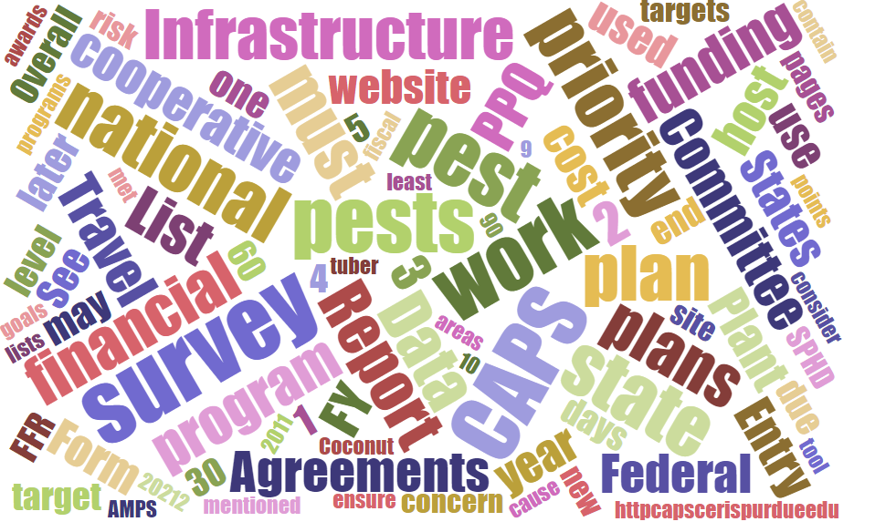



# Participants

**National CAPS Committee (NCC) Conference Call**

October 6, 2022

|  |  |  |  |  |  |  |  |
| --- | --- | --- | --- | --- | --- | --- | --- |
|  | Megan Abraham |  | Brad Danner |  | Helmuth Rogg |  | Feridoon Mehdizadegan |
|  | Cynthia Kwolek |  | Eric Ewing |  | Michael Hill |  | Erin Biggs |
|  | Gregory Aydelotte |  | Lisa Ferguson |  | Avraham Eitam |  | Darcy Oishi |
|  | Darrell Bays |  | Tina Peltier |  | Lisa Jackson |  | Alana Wild |
|  | Stephen Bullington |  | Michelle Gray |  | Kim Rice |  | James Kruse |
|  | John Crowe |  | Jesse Hardin |  | Daniel Mackesy |  | Bonnie Dietrich |
|  |  |  |  |  |  |  |  |

# Review of the Draft Agenda

We are seeking topics for the 2023 annual NCC Meeting. Current identified topics include:

* + New Member Introductions
  + National Priority Pest List FY 2024
    - Program Pests
    - General Surveys – Bark Beetle Pilot

Survey Summary Form

* + Site Descriptors
  + No Cost Pests
  + Number of Samples Generated
  + Condition of Sample
  + Financials
  + Difficulties

Survey and Diagnostic Assessments Updates

FY 2023 Quarterly Webinar Topics

NCC - Documentation Update:

NCC Bylaws <https://download.ceris.purdue.edu/file/3768>

Roles and Responsibilities <https://download.ceris.purdue.edu/file/3770>

Outreach Guidance <https://download.ceris.purdue.edu/file/3773>

Preliminary ID Update

PPA 7721 Update

* + Outreach Discussion
  + CAPS Metrics
  + Otis Laboratory Site Visit
    - Containment Facility
    - Rearing Overview
    - Lure Production

# Site Descriptor

Bonnie demoed the draft changes to the Survey Summary Form for PPA 2023 to make sure that Cooperators are ok with the changes in both defining the sites and entering them in the form. Please see the file “Supporting Details” for more details. There was consensus among the NCC that the format for entering the details will work. However, additional information will be needed about when to select details for available site descriptors.

Currently, there are about 13 unique sites identified including:

|  |
| --- |
| 10 objects inspected from each of 25 meter x 25 meter square |
| 10 Sweep Net Sweeps |
| 15 meter Transects in 3 directions |
| 5 Pound Sample Bags |
| Composite Samples |
| Dual (Trap) + (Visual) |
| Dual (water Bait) + ( Symptomatic Plants Sampled) |
| Leaves Sampled |
| Single Plant Inspected |
| Single Tree Inspected |
| Symptomatic Plants Sampled |
| Trap |
| Water Bait |

When thinking only about National Priority Pests, we are looking for feedback on the site descriptions listed above.

For example, snail surveys will have a site defined as 10 objects inspected from each 25 meter x 25 meter square. This will mean that a single survey point would be required for a defined 25 m x 25 m square and 10 objects looked at it in this area. This could be 10 plants, 10 rocks, or any combination of items. Some concern is that 10 objects may not be present to complete the survey. Should this number be reduced?

# NCC Term Rotations

The 2023 rotating members are as follows:

|  |  |
| --- | --- |
| Current Member | New Member Starting 2023 |
| Central Plant Board SSC – Erin Biggs |  |
| Central Plan Board SPRO - Megan Abram |  |
| State Plant Health Director - Alana Wilds | Alana Wilds |
| PPQ Pest Survey Specialist - Greg Aydelotte |  |
| Western Plant Board SSC - Darci Oishi | Darci Oishi |

# New Climate Suitability Maps

<https://safaris.cipm.info/safarispestmodel/StartupServlet?cindex>