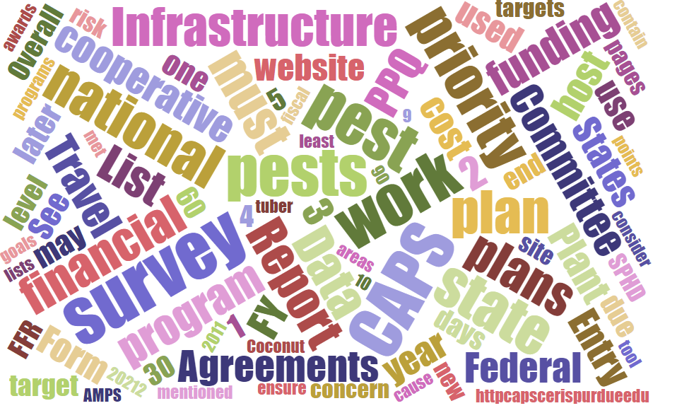



# Participants

**National CAPS Committee (NCC) Conference Call**

November 3, 2022

|  |  |  |  |  |  |  |  |
| --- | --- | --- | --- | --- | --- | --- | --- |
|  | Megan Abraham |  | Brad Danner |  | Helmuth Rogg |  | Feridoon Mehdizadegan |
|  | Cynthia Kwolek |  | Eric Ewing |  | Michael Hill |  | Erin Biggs |
|  | Gregory Aydelotte |  | Lisa Ferguson |  | Avraham Eitam |  | Darcy Oishi |
|  | Darrell Bays |  | Tina Peltier |  | Lisa Jackson |  | Alana Wild |
|  | Stephen Bullington |  | Michelle Gray |  | Kim Rice |  | James Kruse |
|  | John Crowe |  | Jesse Hardin |  | Daniel Mackesy |  | Bonnie Dietrich |
|  |  |  |  |  |  |  |  |

# NCC Draft Agenda - Review

# The annual NCC meeting has been approved. John sent the draft agenda out today. Are there any additional topics?

# Survey Supply Ordering Period

The Survey Supply Ordering System in IPHIS is open now through **November 18, 2022**, for orders supporting the fiscal year (FY) 2023 CAPS and PPQ program surveys (including Emerald Ash Borer).

The Survey Supply Ordering System will open again to support FY 2023 approved Plant Protection Act (PPA) 7721 – Goal 1 surveys after the FY 2023 PPA-7721 spending plan is released via the APHIS Stakeholder Registry. Please do not submit orders for FY 2023 PPA Goal 1 surveys until the spending plan is released.

*Please place orders for Emerald Ash Borer products as a separate order.

**Effective August 1, 2022, the following products are no longer offered through the IPHIS Survey Supply Ordering System:

1) *Trichoferus campestris* lure: The target pest was removed from the Priority Pest List.

2) Black light trap products: These products are not an approved survey method for any 2023 Priority Pests or PPQ Program Pests.

Please take this into consideration when planning your 2023 PPA-7721 suggestions, 2023 CAPS surveys, and surveys for PPQ Program Pests.

We have a limited supply of these items in stock that will be offered on a first-come, first-served basis. **Do not place orders for these items through IPHIS** as the items will not display as available. Please reach out directly to Lisa Jackson at [lisa.d.jackson@usda.gov](mailto:lisa.d.jackson@usda.gov) to request these items. She will place an order for you if stock is available.

The [Survey Supplies page](https://gcc02.safelinks.protection.outlook.com/?url=http%3A%2F%2Fcaps.ceris.purdue.edu%2Fsurvey-supplies&data=05%7C01%7C%7Ca16dc87610fc4bee943108da8cda7af4%7Ced5b36e701ee4ebc867ee03cfa0d4697%7C0%7C0%7C637977167234370070%7CUnknown%7CTWFpbGZsb3d8eyJWIjoiMC4wLjAwMDAiLCJQIjoiV2luMzIiLCJBTiI6Ik1haWwiLCJXVCI6Mn0%3D%7C3000%7C%7C%7C&sdata=YeT3tjEhvXEZTQ9WTrQA8r2y5QhOWB%2FoXKhk%2FJFAPvs%3D&reserved=0) on the [CAPS](https://gcc02.safelinks.protection.outlook.com/?url=http%3A%2F%2Fcaps.ceris.purdue.edu%2F&data=05%7C01%7C%7Ca16dc87610fc4bee943108da8cda7af4%7Ced5b36e701ee4ebc867ee03cfa0d4697%7C0%7C0%7C637977167234214700%7CUnknown%7CTWFpbGZsb3d8eyJWIjoiMC4wLjAwMDAiLCJQIjoiV2luMzIiLCJBTiI6Ik1haWwiLCJXVCI6Mn0%3D%7C3000%7C%7C%7C&sdata=lNJw4L166mKJJKThnog6xNTohQ%2FP01QOxBdO9%2F%2BxYj4%3D&reserved=0) website contains several resources and important information. Please review the documents listed below as we have recently revised these:

* [Video - Placing Survey Supply Orders in IPHIS](https://gcc02.safelinks.protection.outlook.com/?url=https%3A%2F%2Fdownload.ceris.purdue.edu%2Ffile%2F4286&data=05%7C01%7C%7C7960daae06d448df82b008da95c5051c%7Ced5b36e701ee4ebc867ee03cfa0d4697%7C0%7C0%7C637986970664325543%7CUnknown%7CTWFpbGZsb3d8eyJWIjoiMC4wLjAwMDAiLCJQIjoiV2luMzIiLCJBTiI6Ik1haWwiLCJXVCI6Mn0%3D%7C3000%7C%7C%7C&sdata=BtuTTpXN1SyFq1yydzJdEOMGrGiGmr2DEu3%2BSuYybc8%3D&reserved=0)
* [Slides - Placing Survey Supply Orders in IPHIS](https://gcc02.safelinks.protection.outlook.com/?url=https%3A%2F%2Fdownload.ceris.purdue.edu%2Ffile%2F4118&data=05%7C01%7C%7C7960daae06d448df82b008da95c5051c%7Ced5b36e701ee4ebc867ee03cfa0d4697%7C0%7C0%7C637986970664325543%7CUnknown%7CTWFpbGZsb3d8eyJWIjoiMC4wLjAwMDAiLCJQIjoiV2luMzIiLCJBTiI6Ik1haWwiLCJXVCI6Mn0%3D%7C3000%7C%7C%7C&sdata=9kR6D1hQfHbDEUHmN9P7asxDaqsZg4GkBcJ%2F%2FXHwBjQ%3D&reserved=0)
* [Survey Supplies Best Practices Guidance Document](https://download.ceris.purdue.edu/file/4292)

# Change of Site Descriptors to Survey Units and Survey Unit Descriptors

Last month on the NCC Call we showed examples of the Survey Summary Form with the new fields for Sites and Site Descriptors. Upon consideration, we changed the names to: Survey Unit Descriptors and Survey Units. The overall details will still remain the same. Survey Unit Descriptors define the specific survey activity and Survey Units will have the count of that activity. Example:

Survey Unit Descriptor = 5 Pound Sample Bags

Survey Unit = 10

There will be 10 (5 pound sample bags) taken.

Currently, survey unit descriptors will be available for National Priority Pests only.

We are currently working through the definitions for Survey Units. There is some complication for dual surveys and combined survey methods.

|  |  |  |  |  |  |  |  |  |  |  |  |  |  |  |  |
| --- | --- | --- | --- | --- | --- | --- | --- | --- | --- | --- | --- | --- | --- | --- | --- |
| Survey Unit Descriptor | Survey Unit Descriptors define the specific survey activity. Currently, survey unit descriptors will be available for National Priority Pests only.     |  | | --- | | 10 objects inspected from each of 25 meter x 25 meter square | | 10 Sweep Net Sweeps | | 15 meter Transects in 3 directions | | 5 Pound Sample Bags | | Composite Samples | | Dual (Trap) + (Visual) | | Dual (water Bait) + ( Symptomatic Plants Sampled) | | Leaves Sampled | | Nest | | Single Plant Inspected | | Single Tree Inspected | | Symptomatic Plants Sampled | | Trap | | Water Bait | |

# No Cost Pests

While reviewing the FY2023 CAPS Survey Summary Forms, Darrell and Lisa have been noticing that people may not be taking full advantage of the No Cost Pests option. We wanted to reiterate that there are benefits to including these pests. For instance, for trade purposes it can be valuable to have this data in NAPIS. If you are unsure if a pest would qualify as a No Cost Pest, please reach out to Darrell and Lisa.

"A No Cost Pest is a pest that is not on the National Priority Pest List but can be surveyed for and identified without requiring additional funding or adding costs to the agreement. This pest will not count towards the 40% pests of state concern."

This PowerPoint goes into more detail: [Slides - Recent Changes](https://download.ceris.purdue.edu/file/4266).

# Mexico Potato Pests Data Entry

Guidance will be coming out for NAPIS data entry using PCIT reports for the four non-priority pests required in the Operational Work Plan of Potatoes to Mexico outside the 26 km zone. John Crowe is the point of contact if you have any questions.

# *Lymantria* Update (Avi Eitam)

The ESA Committee on Common Names recently proposed new common names for several CAPS targets in the *Lymantria* genus. The proposed names are being submitted to the ESA membership for comment. The comment period is open until December 2, 2022. The proposed names can be found here: [Proposed Common Names | Entomological Society of America (entsoc.org)](https://entsoc.org/publications/common-names/proposed).