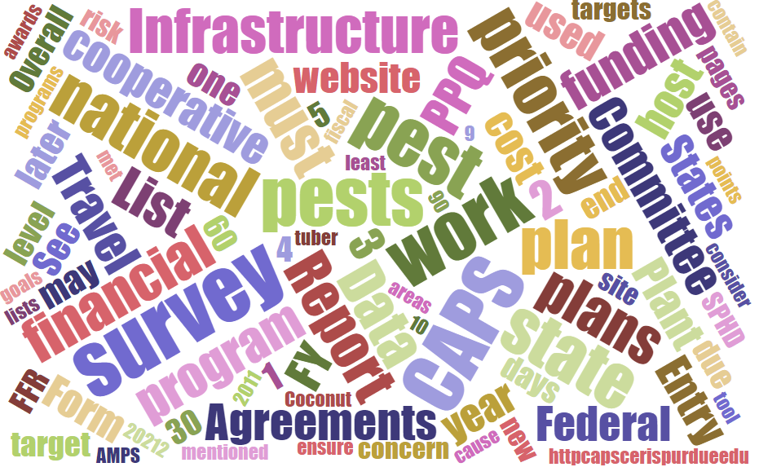



# Participants

**National CAPS Committee (NCC) Conference Call**

December 1, 2022

|  |  |  |  |  |  |  |  |
| --- | --- | --- | --- | --- | --- | --- | --- |
|  | Megan Abraham |  | Brad Danner |  | Helmuth Rogg |  | Feridoon Mehdizadegan |
|  | Cynthia Kwolek |  | Eric Ewing |  | Michael Hill |  | Erin Biggs |
|  | Gregory Aydelotte |  | Lisa Ferguson |  | Avraham Eitam |  | Darcy Oishi |
|  | Darrell Bays |  | Tina Peltier |  | Lisa Jackson |  | Alana Wild |
|  | Stephen Bullington |  | Michelle Gray |  | Kim Rice |  | James Kruse |
|  | John Crowe |  | Jesse Hardin |  | Daniel Mackesy |  | Bonnie Dietrich |
|  | Chelsey Penuel |  | Colin Funaro |  | Isaac Powell |  | Kathryn Bronsky |

# NCC Draft Agenda - Review

# The annual NCC meeting has been approved. Draft Agenda is available at CAPS Collaboration Site: <https://download.ceris.purdue.edu/file/4327>

# Spongy Moth Update - Bronsky

APHIS’ plan to implement the new common names spongy moth and flighted spongy moth complex

APHIS is replacing the common name for *Lymantria dispar,* formerly known as gypsy moth, to “spongy moth,” which aligns with the Entomological Society of America’s (ESA) Better Common Names Initiative. Spongy moth is under federal quarantine in the northeastern United States and the female moths do not have flight capability. It’s important to note that the name spongy moth refers to the insect’s egg masses, which is the life stage most likely to be moved inadvertently on outdoor items and lead to new infestations.

APHIS also worked with our international partners that regulate Asian gypsy moth, or AGM, to designate the new name “flighted spongy moth complex” to replace AGM. The five regulated *Lymantria* moths in the complex (*L. dispar asiatica*, *L. dispar japonica*, *L. albescens*, *L. umbrosa*, and *L. postalba*) have flighted females, occur in Asia, and are not established in the United States.

APHIS is finalizing the implementation plan of these new common names and is timing a stakeholder registry notice to announce the name changes in December. While some changes within APHIS may occur quickly (website updates), other changes will take time (regulation, program manuals, forms and checklists, outreach materials, etc.). We appreciate the understanding of our cooperators and partners while we implement both of these new names together.

ESA re-convened a working group of federal, state, and industry representatives including APHIS in July to discuss designating common names for related-*Lymantria* species. In November, the committee provided common name proposals for six species, three of which are in the flighted spongy moth complex (*L. albescens*, *L. postalba*, and L. umbrosa) and three related species (*L. mathura, L. monacha, L. xylina).* The proposals are currently in ESA member comment until December 2, after which they will need to be approved by the ESA governing board before being entered into ESA's common names database. These new common name designations will not impact APHIS which plans to use spongy moth or flighted spongy moth complex when referring to the moths, or when needed, default to using the scientific names.

# NCC Call

## Prework review:

CFWG links to the following documents can be found at: <https://usdagcc.sharepoint.com/sites/aphis-ppq-policy/php/PD/CAPS/G4%20Drafts/Forms/AllItems.aspx?viewpath=%2Fsites%2Faphis%2Dppq%2Dpolicy%2Fphp%2FPD%2FCAPS%2FG4%20Drafts%2FForms%2FAllItems%2Easpx&id=%2Fsites%2Faphis%2Dppq%2Dpolicy%2Fphp%2FPD%2FCAPS%2FG4%20Drafts%2FNational%20CAPS%20Committee%20Meetings%2FNCC%20Mtg%202023%20Otis&viewid=8a92e1f7%2D945f%2D4eba%2Dbd3f%2D3ecdafc5f102>

* NCC Bylaws <https://download.ceris.purdue.edu/file/3768>
* Roles and Responsibilities <https://download.ceris.purdue.edu/file/3770>
* Outreach Guidance <https://download.ceris.purdue.edu/file/3773>
* CAPS Mission statement
* Capture current perspectives

## Seek feedback from your constituency about items on the Survey Summary Form:

* Work Plans in general how did this go?
* Financials
* No Cost Pests
* Taxonomic Support