Animal and Plant
Health Inspection
Service

Plant Protection and
Quarantine

4700 River Road,
Riverdale, MD 20737

Voice: 202-851-2108
Fax: 202-690-0472

Trap Placement in Rusty Patched Bumble Bee Areas

Plant Protection and Quarantine (PPQ) and its cooperators will limit the use of traps that may affect the rusty-patched bumble bee (Bombus affinis) as a bycatch in Low Potential Zones (yellow) or High Potential Zones (red) identified on the U.S. Fish and Wildlife Service’s (FWS) Rusty Patched Bumble Bee Map. Because these zones change over time, FWS will post updated maps by April of each year, which PPQ and cooperators must check each season.

Each trap and zone will have unique requirements. Follow the directions below when using the traps in areas identified by FWS as rusty patched bumble bee habitat. Following are the traps as named in the Integrated Plant Heath Information System’s (IPHIS) catalog and the requirements:

Plastic Bucket Trap – Multi-Colored (White, Yellow, and Green)
- Low Potential Zones (yellow zones on the map) - do not require additional notice or approval from FWS to trap in these areas; however, all bumble bees (Bombus spp.) collected from traps must be submitted using Annex 1.
- High Potential Zones (red zones on the map) in Illinois, Minnesota, and Wisconsin require annual approval from the FWS before plastic bucket traps can be used in these areas and all bumble bees (Bombus spp.) collected in high potential zones in these three States must be submitted using Annex 1.
        - To obtain the annual clearance, each State Plant Health Director’s (SPHD) office must prepare and send a single list of all potential trap locations as GPS coordinates to PPQ’s Pest Detection cross functional working group (PD CFWG) before April 1 of each year. Once received, the PD CFWG will review the three lists received – one list per state - and will forward the lists to APHIS’ Environmental and Risk Analysis Services (ERAS) staff. ERAS will consult with FWS about the traps that are proposed for placement in high-potential (red) zones. Traps may only be placed once approval is provided by the PD CFWG.
        - With FWS’ clearance, only a maximum of five (5) traps per state will be approved; however, trapping in these areas is not guaranteed and may require relocating traps or making further adjustments.
- High Potential Zones (red zones on the map) in other states besides Illinois, Minnesota, and Wisconsin will have no traps deployed; this is prohibited.
- Historical Areas (blue/gray zones on the map) do not require additional steps for bumble bee identifications.

Prism Traps (Purple)
- High Potential Zones (red zones on the map) – May not be used.
- Low Potential Zones (yellow zones on the map) – Limit use as much as possible.
- Historical Areas (blue/gray zones on the map) – No restrictions.

Large Plastic Delta Traps (White)
- High Potential Zones (red zones on the map) – May not be used. (Alternative colors are acceptable.)
- Low Potential Zones (yellow zones on the map) – Limit use as much as possible.
- Historical Areas (blue/gray zones on the map) – No restrictions.

Large Plastic Delta Traps (Red and Orange)
- High Potential Zones (red zones on the map) – Limit use as much as possible.
- Low Potential Zones (yellow zones on the map) – Limit use as much as possible.
- Historical Areas (blue/gray zones on the map) – No restrictions.

White Wing Traps (White)
- High Potential Zones (red zones on the map) – May not be used.
- Low Potential Zones (yellow zones on the map) – Limit use as much as possible.
- Historical Areas (blue/gray zones on the map) – No restrictions.

Jackson Traps (White)
- High Potential Zones (red zones on the map) – May not be used until after fruit tree bloom.
  - Bumble Bee bycatch must be identified using Annex 1.
- Low Potential Zones (yellow zones on the map) – Limit use as much as possible.
  - Bumble Bee bycatch must be identified using Annex 1.
- Historical Areas (blue/gray zones on the map) – No restrictions.

Annex 1

Bumble Bee Bycatch Submission Procedures
The purpose of this document is to outline proper procedures for sorting, packaging, and shipping bumble bee (Bombus spp.) specimens captured as bycatch in plastic bucket traps used in PPQ’s pest surveillance activities including, the Cooperative Agricultural Pest Survey (CAPS) program, PPQ Pest Detection Survey activities, and Plant Protection Act Section 7721 (PPA 7721) Goal 1 early detection surveys.

Servicing the traps
When servicing the trap, remove debris and bring the complete sample back to the laboratory or office for sorting. Do not pre-sort samples from Plastic Bucket Trap in the field.

Sorting the samples
Keep samples in the freezer until you are ready to process them.
Use Appendix A: Job aid for sorting out bees from bucket traps to sort bumble bees from the sample. If you are uncertain about a specimen, then include it with the bycatch sample.
Prepare bumble bee specimens as outlined below and complete the PPQ Form 391 Specimens for Determination. See Appendix B: How to assemble an ethyl acetate jar/vial for sending bycatch bee specimens for detailed instructions with images.

If sample is dry (preferred):
- Place bumble bee specimens in a glass container with a cotton ball dampened with ethyl acetate. As a rule, use 4-5 drops of ethyl acetate per specimen. Do not oversoak the cotton ball or have liquid ethyl acetate in the container. Depending on the number of samples, either add more cotton balls to absorb the ethyl acetate or split your sample into multiple containers.

Note: Ethyl acetate prevents fungal growth during transport and relaxes specimens, making them easier to handle during identification (i.e., keeps them from becoming brittle and fragile). Do not use plastic containers as they may melt when exposed to ethyl acetate.

- Place a piece of plane white paper between the cotton ball and the specimens so that the specimens do not come in direct contact with the ethyl acetate.

- Label the container(s), making sure to include the collection number matching the associated entry in the PPQ Form 391 data form or IBP record if possible (details on using IBP numbers can be found at: https://arm.aphis.usda.gov/documents/domestic/ARM_User_Guide_-_Domestic_Programs.pdf)
If sample is wet (for example, if the trap flooded):
Bees that are wet, or have been wet, are difficult to identify because their hair becomes matted and dries to the sides of the body.
- Clean the bumble bees with ethanol:
  - Put on gloves resistant to ethanol.
  - Place the bumble bee specimens from one sample into a sieve (i.e., fine-mesh strainer) placed over a sorting pan or container.
  - Rinse the bumble bee specimens thoroughly with at least 70% ethanol. Make sure to do this over a sorting pan or other container to collect the run-off ethanol. You can reuse the run-off ethanol to clean additional samples. *
  - Tap or shake off the excess ethanol and then spread the specimens on a layer of clean paper towels. Cover the specimens with additional paper towel sheets and gently rub the bees with the towel to absorb any excess. Be careful of not crushing the bees while rubbing them with the paper towel.
  - Transfer the almost dried specimens to a new paper towel sheet and let them sit until they are completely dried. To expedite the process, you can also use a hair dryer set on low. For more information on drying bees and how to use a hair dryer, see Sam Droege’s slide presentation “Drying Wet Bees.”
- Once completely dried, follow the steps for dry samples above.

* Note: When the ethanol becomes discolored or dirty, do not reuse but collect it in appropriate container and dispose of if following agency protocols.

Local Screenings
Screening of bumble bees may be completed by a screener able to successfully identify a bumble bee. Generally, these are individuals with education or training in entomology.

If after processing a trap collection and no bumble bee specimens are present, then create and keep a local record containing the following information.
  - Date of when the sample was collected
  - Date of when the sample was screened for bumble bees
  - Who processed the samples
  - Note of negative determination for bumble bees, i.e., no bumble bees were found

These records will be collected locally and at the end of the season each state will forward consolidated negative records to: allan.h.smith-pardo@usda.gov. Any local record keeping procedures should also be followed.

Shipping Bumble Bee Samples
Pack the glass container(s) in a box or mailing tube large enough to allow space for packing material on all sides to prevent breakage. If sending multiple containers (e.g., glass vials) in one shipment, wrap each container in a paper towel to firmly restrain the sample and avoid breakage. If using small containers such as glass vials, these can be sent in padded envelopes sealed with tape, but not staples.

Important: Do not send bumble bee specimens to state or university insect taxonomists in your state for identification. APHIS must receive and confirm the identity of the specimens to effectively communicate with FWS regarding trap findings.

Ship bumble bee samples to:
Allan H. Smith-Pardo, Ph.D.
Biological Scientist- Entomologist
Identification Technology Program (ITP)
USDA-APHIS-PPQ-Science & Technology (S&T)
801 I Street, Suite 406, Sacramento, California 95814
Office: 916-403-4505; Cell: 650-533-5428
Email: allan.h.smith-pardo@usda.gov

Before shipping samples, send an email to Dr. Smith-Pardo with the subject line “bee bycatch samples.” Include in your message a description of the sample(s) you are sending, package tracking number, and the filled-out PPQ Form 391 or IBP number.
Include the following when completing the PPQ Form 391:
- Date of collection
- Date of submission
- Location (coordinates and description, closest cross streets, other)
- Type of property (farm, residence, nursery, greenhouse, other)
- Crop/habitat/ecosystem type (soybean, tomato, edge with native vegetation, meadow, other)
- Trap and lure type
- Trap placement (e.g., within or adjacent to crop/natural habitat, height, other)
Details on using IBP numbers can be found at: https://arm.aphis.usda.gov/documents/domestic/ARM_User_Guide_-_Domestic_Programs.pdf

Identification
Dr. Smith-Pardo will screen for Bombus affinis and B. bohemicus using a representative number of submitted bumble bee samples. If Dr. Smith-Pardo identifies either species, he will forward the specimen(s), along with the record number, to USDA-ARS Systematic Entomology Laboratory (SEL) for final confirmation of the identification.

SEL will send confirmed b. affinis samples to, USDA Agricultural Research Service, Bee Research Laboratory, 1410 E. 900 N. Logan, UT 84341 (attn: Dr. Jonathan Koch), where they will be retained.

Sharing of Identification Results
Positively confirmed identifications by SEL of either species will be shared with FWS by APHIS. SPHD and SPRO communication will follow the established simulation communication processes.

Contacts
If you have questions about submitting bumble bee samples, please contact Allan Smith-Pardo at allan.h.smith-pardo@usda.gov.
If you have questions about this policy, the pollinator bycatch identification pilot project, or the Section 7 Consultation, please contact the National Policy Manager, John Crowe at john.f.crowe@usda.gov.

Appendix: Job aid for sorting out bees (specially bumblebees) from bucket traps

Bees (Apoidea: Anthophila) belong to the order of insects known as Hymenoptera; this order also includes wasps and ants. Hymenopterans can be separated from other groups of insects by a combination of external traits or characters. In this aid we provide the description and images of some of these characters to assist in sorting out bees from other insects inside the bucket traps used for the surveys.

Use the following external characters to separate bees and relatives from other insects:

Bees from Flies (Diptera):
Bees and relatives have two pairs of membranous wings that are maybe brownish or smoky in appearance. These characters are useful to separate bees and relatives from flies (order Diptera) that can mimic bees. Flies only have two membranous wings while bees and relatives have four membranous wings.

The wings of bees and relatives also lack scales and have multiple veins.

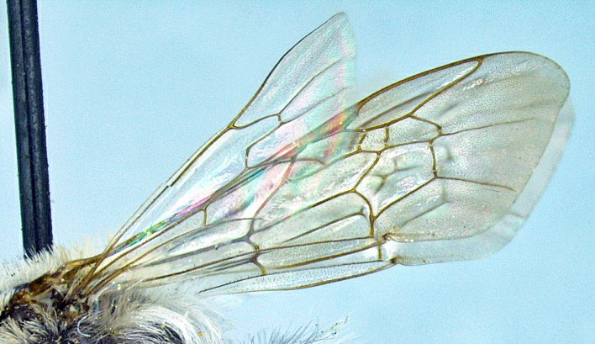

Membranous wings

Wing veins

Bees from winged ants and wasps (Hymenoptera):

Most bees have their bodies covered with hairs or setae. Although some bees may not have as many hairs, bees are unique in that some of their hairs are plumose or branched. To confirm this may require the use of a hand lenses or a scope. Not all hairs covering the body of a bee are plumose.

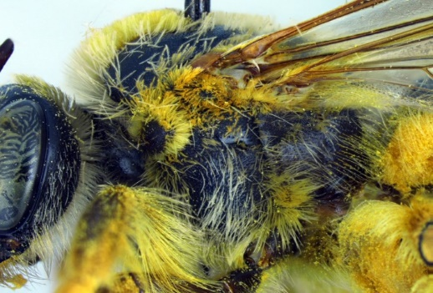
Body of bee with setae (hairs)

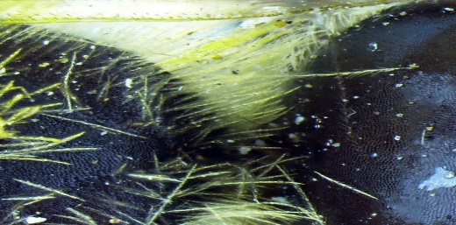
Branched hair
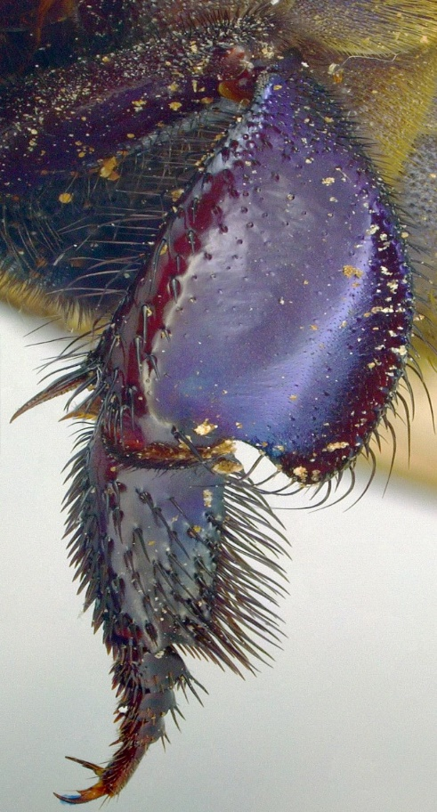
Basitarsus

Other
tarsomeres

All bees have the hind legs modified and can be distinguished from other insects by having the basitarsus (third segment counting from the body out) longer and wider than the following segments (also call tarsomers).

Some bees (nonparasitic bumble- bees and honeybees) have the tibia of the hind legs (the tibia is the second segment of leg from the body out) modified into a pollen basket or corbiculae which is basically a concave tibia surrounded by setae.
Hind leg of a corbiculate bee

Pollen basket (Corbicula)

