John Crowe

USDA APHIS PPQ  4700 River Road Riverdale, MD

2023 National caps Committee Meeting Notes

Contents

Purpose 3

Participants 3

January 31, 2023 – Day 1 – Morning 3

New NCC Member Rotations 3

Annual CAPS Award 4

Decision 1: 4

Decision 2: 4

NCC Member Term Transitions 5

NCC Annual Meeting Attendance 5

Decision 3: 5

NCC Monthly Meeting Attendance 5

Decision 4: 5

National Priority Pest List 5

Decision 5: 6

Question 1: 6

State Survey Coordinator – role in other non-CAPS tasks 6

Ideas for Training Opportunities 6

Training – NCC Members 6

Training – CAPS Community 7

January 31st, 2023 – Day 1 - Afternoon 8

No Cost Pests 8

Decision 5 8

Decision 6 8

On-line Financial Workplan 8

Review of Survey and Diagnostic Assessments Updates 8

AMPS Page Update 8

Decision 7 8

SAFARIS Climate Suitability Maps 9

February 1, 2023 - Day 2 – Morning 9

PPA721 updates 9

Preliminary ID 10

NCC - Documentation Update: 10

NCC Bylaws 10

Decision 8 10

Roles and Responsibilities 10

Decision 9 10

Accomplishment Report Update - Outreach Guidance 11

Decision 10 11

Day 2 Afternoon: Tour of the FPML facilities 11

# Purpose

The purpose of this 2-day meeting was to bring together National CAPS Committee (NCC) members to share key pieces of information and make program decisions, including revisiting what makes a priority pest and strategies to maintain the priority pest list.

# Participants

|  |  |
| --- | --- |
| Attendee | Organization |
| John Crowe | PPQ National Policy Manager – Pest Detection |
| Darrell Bays | PPQ National Operations Manager – Pest Detection |
| Lisa Jackson | PPQ National Operations Manager – Pest Detection |
| Soo-Hoon (Sam) Kim | PPQ S&T CAPS Science Support |
| Feridoon Mehdizadegan (Day 2) | PPQ PPA 7721 Representative |
| Patrick Haslem (Day 2) | PPQ National Policy Manager – Preliminary ID |
| Alana Wild | PPQ SPHD Representative – NV&UT |
| Kimberly Rice | Eastern Plant Board SPRO Representative - MD |
| Megan Abraham | Central Plant Board SPRO Representative - IN |
| Avi Eitam | PPQ PSS Representative – OH |
| Isaac Powell | PPQ PSS Representative – NC/SC |
| Cindy Kwolek | Eastern Plant Board SSC Representative - RI |
| Brad Danner | Southern Plant Board SSC Representative - FL |
| Erin Biggs | Central Plant Board SSC Representative - MO |
| Bonnie Deitrick | CAPSIS Team – Project Coordinator – Purdue |
| Colin Funaro | PPQ S&T – CAPS Science Support Lead |
| Amber Tripodi | PPQ S&T – Risk Analyst |

# January 31, 2023 – Day 1 – Morning

# New NCC Member Rotations

John Crowe reviewed document regarding National CAPS Committee rotations. Detailed list is available at: <https://caps.ceris.purdue.edu/ncc>. Table of NCC members as of January 2023 is below.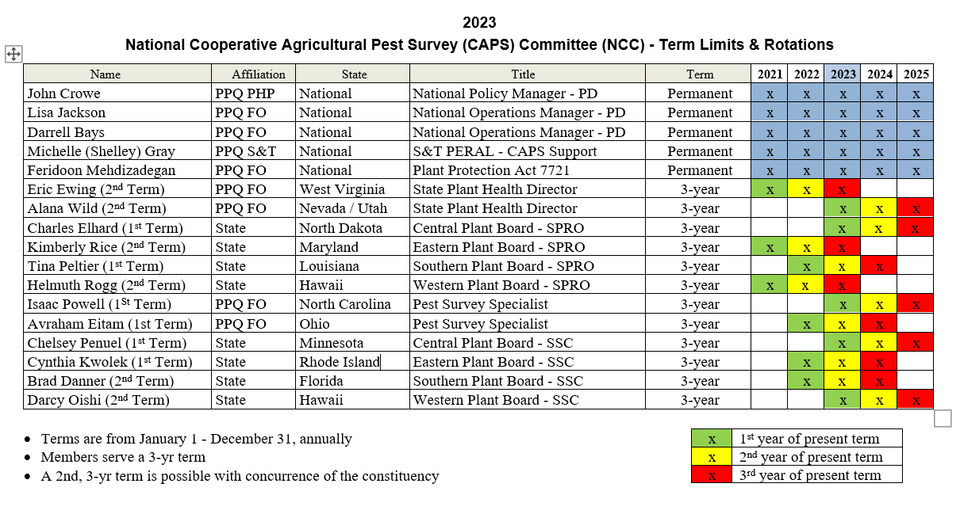

Individuals coming off the committee at the end of FY 2023 include:

* Eric Ewing – completing 2nd term
* Kimberly Rice - Completing 2nd term
* Helmuth Rogg – completing 2nd term

This means there will be vacancies to be filled for FY 2024 in:

* State Plant Health Director
* Eastern Plant Board – State Plant Regulatory Official
* Western Plant Board – State Plant Regulatory Official

# Annual CAPS Award

The NCC met to discuss the annual CAPS Recognition Award that had been previously presented. In previous years, nominations were solicited; however, the National CAPS Committee did not have a clear set of criteria for what activities qualified for the award. This made it difficult to select award recipients fairly.

## Decision 1:

The NCC reached consensus on discontinuing the annual nomination period for the CAPS Recognition Award. Moving forward, the NCC may continue to issue awards for major accomplishments on a case-by-case basis.

The NCC decided to provide tokens of appreciation to members who complete two full terms (6 years total). The group would also like to give a certificate to the individual.

## Decision 2:

Each member who completes 6 years on the NCC will receive a token of appreciation from the NCC. Each token will include a certificate of appreciation.

# NCC Member Term Transitions

## NCC Annual Meeting Attendance

The Central Plant Board SPRO Representative (Meghan Abraham) brought a concern about SPROs not having enough background to successfully represent the interests of their groups. There was a discussion centering around the idea that SPROs are a bit more removed in general from CAPS and may not live and breathe it like the SSCs.

## Decision 3:

The NCC resolved this concern by allowing the SPROs to utilize existing flexibilities in the NCC bylaws. Currently, the bylaws allow designated representatives to attend the NCC annual meeting. In this instance, the new and old SPRO will meet and determine the optimal attendance at the NCC annual meeting. The person determined to be the optimal attendee will attend the meeting.

## NCC Monthly Meeting Attendance

Attendance at the monthly meeting during a transition was brought up as a concern. Current bylaws only allow the month of December for overlap of transition. There was a discussion about the appropriateness of having more overlap and when that could happen and the impacts.

The NCC was able to reach consensus on new transitioning members with attending monthly NCC meetings as early as October. This would provide up to three meetings to transition.

In concert with this meeting attendance, previous bylaws mentioned formal voting within the NCC. During this discussion the NCC agreed that should voting continue in any bylaw updates there would be a one vote per position if they occurred during these transition months. With the current official member being the voting member (see note below).

## Decision 4:

The NCC agreed to remove formal voting from the bylaws. New bylaws will address the issue of multiple members attending monthly meetings.

# National Priority Pest List

The NCC discussed which pests need to be a part of the National Priority Pest List. Crowe brought up inconsistencies between certain pests’ inclusion or not on the list. For example, why is Asian longhorned beetle (ALB) on but fruit flies are not? There is no clear explanation or criteria for PPQ Program pests or what constitutes a program pest.

Several NCC members pointed out that they didn’t understand what the criteria was for program pest either. That the group may need to have a clear definition of what contributes to a program pest.

The Crowe agreed to putting a list of program pest together and running it through the PD CFWG. Once the pests are identified the PD CFWG will present a list of potential program pests to the NCC for consideration.  The purpose of this will be to determine what a definition for a “program pest” is, in relation to the National Priority Pest list.  After the definition is determined the NCC may establish criteria for inclusion of program pests on the National Priority Pest list.

At this point, I don’t think that we are ready to fully share at the state CAPS level for this topic because of the amount of unknowns.

## Decision 5:

The NCC agreed to examen what the PD CFWG determined are the current program pests. Though no decision was made about removal or criteria during the meeting.

## Question 1:

Is the response to a new pest different if the pest is on the National Priority Pest List vs. a pest that is not on the list? This question was forwarded on to the Pest Evaluation and Response director.

# State Survey Coordinator – Role in non-CAPS tasks

The NCC brought up how much time SSCs should spend on CAPS tasks vs. responding to emergencies/new pests in their state. Here are some thoughts from that discussion:

* Should SSCs be spending a lot of their time responding to new pests?
* Is this part of their role as “first responders” in the state?
* Should there be maximum percentages of time associated with their time spent on CAPS vs. other issues?
* Does it depend how much of their salary is paid for by the Infrastructure agreement?

The NCC will continue these discussions. One option could be for the percent time to at least be captured in the Infrastructure Accomplishment Report to better inform these discussions. For example, their time could be recorded in more detail. Also, PPA work should be listed specifically.

# Ideas for Training Opportunities

The NCC had a brainstorming session related to the ideas for training. Each member was asked to provide technical and non-technical training needs for the general CAPS community and the NCC Committee. Two general categories of training were identified, technical and non-technical. Below is a listing of the general ideas. Individual NCC members suggestions were not recorded in the notes. Overarching themes bubbled up from the discussion. The ideas are summarized below.

## Training – NCC Members

Below are suggestions specific to the NCC, while they may be useful to the overall CAPS community, the NCC meeting participants identified these ideas may be more ideal for NCC members.

* NCC Welcome Kit – which looks to examine the roles and responsibilities, acronyms, organizational structure, and general onboarding to the NCC. The ideal delivery method would be through video.
* There was discussion about regional meetings and how to better plan for the CAPS breakout sessions. There was discussion about a national SSC call being helpful for regional CAPS break out session agenda development.
* Courses from APHIS’s Center for Training and Organization Development:
  + Crucial Conversations
  + Project Management Essentials
  + Leadership is Everyone’s Business
* DISC/Meyers Briggs training – Explore opportunities for training on interpersonal communication styles.

## Training – CAPS Community

* Dealing with misinformation – the NCC saw a learning gap on how to manage misinformation (from the media, etc).
* How to email effectively
* ServiceNow Training – The NCC identified some gaps in utilizing the ServiceNow platform. This is important because PPA 7721 goal 1 survey will be transitioning to this platform for FY 2024.
* A series of general information about using the CAPS Collaboration Website was identified, specific topics include:
  + NAPIS
  + Priority Pests – how pests get on the list
  + Survey Planning Portal/Survey Summary Form (short 5 minute videos)
    - All Planned Surveys
    - No Cost Pests
    - How to fill out Taxonomic section
    - Sites, Counties, Visits
    - Site Descriptors
    - SSF approval process, different steps
    - SSF change request process
  + Regularly available NAPIS training
  + Structure of CAPS/Roles and Responsibilities of SPHDs, SPROs, PSSs, and SSCs
  + Infrastructure vs Survey Agreements
  + Accountability Report
* Agreements training – for SPHDs and PSSs ideally in person. Led by PPQ Agreements staff.
  + Could also have webinars on common problems (ezFedGrants, etc.)
* National Plant Diagnostic Network Basics – How does NPDN integrate into new pest notifications?
* CAPS Maps
* How to choose pests for your survey
  + Priority Pests
  + Bundling
  + No Cost Pests
  + Climate maps
* Information Sharing - When is it appropriate to share data?
* How to run a state CAPS meeting (presented by an SSC)
  + Required attendees
  + How to get your optional attendees to want to attend
* iNaturalist and EDDMapS – How to leverage them for CAPS style surveys. Are there best practices?
* CAPS Calendar – The NCC discussed developing an interactive calendar to help communicate critical dates. Relative to training, these dates and information can be used during training to help orientate members to key dates.
* New Approved Methods for Pest Surveillance pages
* New Pests
  + How PPQ responds to new pests
  + The relationship between the National Priority Pest List and how PPQ responds to new pests.

# January 31st, 2023 – Day 1 - Afternoon

# No Cost Pests

Group Feedback – SSC’s stated there was confusion in the field regarding the difference between a bundled pest and no cost pest. They recommended a short refresher video discussing the difference may help survey coordinators.

Sample Condition of Sample/ Preliminary Diagnostician

* Group feedback – SPRO’s and SSC’s requested guidance in the form of definitions of each data field and specifically what information is expected.

## Decision 5

Develop a short video describing the difference between no-cost and bundled pest.

## Decision 6

Develop a video to walk through how to fill out the taxonomic section of the SSF.

# On-line Financial Workplan

Group feedback – SSC’s received positive feedback that the data entry template process improved significantly between CAPS 2022 and 2023.

# Review of Survey and Diagnostic Assessments Updates

Group Feedback – the update produced positive feedback from the NCC group members. It was suggested to add a response deadline for section respondents. The addition would ensure document completion timeliness standards.

# AMPS Page Update

Group Feedback – the PSS representative requested that a link to the screening aids remain in the Key Diagnostic or Identification section of the AMPS page. The link to taxonomic services where the screening aids are archived was given as an alternative.

## Decision 7

The NCC agreed that the AMPS website updates are acceptable and CAPSIS can implement the changes.

# SAFARIS Climate Suitability Maps

Amber Tripodi demonstrated interactive maps, which are primarily based on climate data and NOT host presence. She also highly recommended that users become familiar with the methodology document for each map. We don’t want users to unintentionally misuse the maps. Users should read the methodology document for each pest map.

Summary of demonstration is available at: <https://download.ceris.purdue.edu/file/4352>

Key Questions from Discussion

Historically host information was included. Can we add a disclaimer that clearly says maps DO NOT indicate where hosts are present?

* Yes, this information can be added.

Has the model been validated?

* Models are heavily reviewed. Difficult to validate for pests not known to be present in the US.

How should we be using the maps?

* Currently the maps are just a tool to assist in decision making, and are not intended to inform where to place traps

# February 1, 2023 - Day 2 – Morning

# PPA721 updates

Feridoon Mehdizadegan provided an update on PPA. He covered:

* Budget breakdown based on goal category
* Overall, there was a slight decrease in the total budget, but an increase in total suggestion submissions.
* Told to be on the lookout for the new submission website rollout once Metastorm is taken offline
* Question about if the overall funded/nonfunded included partials – included only fully funded
* Question regarding rapid response funds and what is it used for – money set aside to use for pest detections that require a response

# Preliminary ID

Darrell Bays shared updates on preliminary ID and CFWG plans for FY23. He introduced Patrick Haslem to the group. Patrick gave an introduction and relayed his tasks and duties within the prelim ID group. Darrell gave a brief presentation on the Prelim ID group and CFWG:

* Presented to the NCC the working members of the Preliminary ID CFWG
* Key tasks the Prelim CFWG does and future planning
* Listed Domestic PPQ identifiers and areas of specialty for each – samples sent to PPQ identifiers need to be screened first, no raw samples
* Cooperating identifiers and limits of sampling and areas of specialty for each
* Went over roles and responsibilities of Darrell and Patrick within the Prelim ID team
* Presented CAPSIS role in Prelim ID and what areas they aided in
* Presented the role ARM has in Prelim ID

# NCC - Documentation Update:

## NCC Bylaws

Previous NCC Bylaws are available at: <https://download.ceris.purdue.edu/file/3768>. The NCC drafted updated of bylaws and substantial changes were made to the document during this process.

## Decision 8

The PD CFWG will finalize updates to the bylaws and present a final draft prior to the March 2, 2023 NCC Monthly Call. Once the NCC Bylaws are approved, they will be posted to, <https://caps.ceris.purdue.edu/ncc>

## Roles and Responsibilities

Pervious roles and responsibility document is available at: <https://download.ceris.purdue.edu/file/3770>

## Decision 9

The NCC agreed to establish a working group focused on revising the “Roles and Responsibilities of Federal and State Employees Engaged in the Cooperative Agricultural Pest Survey (CAPS) Program” document. Since 2006, the National CAPS Committee (NCC) has updated this document several times, with the last revision occurring in 2019.

The NCC agreed to have the following members as part of the working group:

* Alana Wilds – State Plant Health Director – Chair
* Isaac Powell – Pest Survey Specialist
* Charles Elhard – State Plant Regulatory Official
* Cindy Kwolek – State Survey Coordinator
* Chelsey Penuel – State Survey Coordinator

The working group expects to have a drafted document ready by the end of March. We will discuss this draft during the NCC’s meeting in April and hopefully have a final version for NCC approval shortly thereafter.

Once the NCC approves the updated document, the Pest Detection cross functional working group will follow up with the PPQ Management Team and the National Plant Board as appropriate, finalize the document, and post it on the CAPS Collaboration Website ([https://caps.ceris.purdue.edu/](https://gcc02.safelinks.protection.outlook.com/?url=https%3A%2F%2Fcaps.ceris.purdue.edu%2F&data=05%7C01%7C%7Cbb3b77e4b94946b26c4408db0aced250%7Ced5b36e701ee4ebc867ee03cfa0d4697%7C0%7C0%7C638115655624128426%7CUnknown%7CTWFpbGZsb3d8eyJWIjoiMC4wLjAwMDAiLCJQIjoiV2luMzIiLCJBTiI6Ik1haWwiLCJXVCI6Mn0%3D%7C3000%7C%7C%7C&sdata=usmaIoB4V60VbOLCseLC5BKj184wAClyYx9QrRJ4AAk%3D&reserved=0)).

## Accomplishment Report Update - Outreach Guidance

Current outreach guidance is available at: <https://download.ceris.purdue.edu/file/3773>

## Decision 10

Because of time constraints the NCC will cover this review in the next monthly NCC.

# Day 2 Afternoon: Tour of the FPML facilities

* Quarantine facility area
  + Insect rearing facilities
  + Biocontrol testing
  + Quarantine insect EAG and other behavioral studies
* Tour of different scientist in the lab and their projects
* Tour of lure production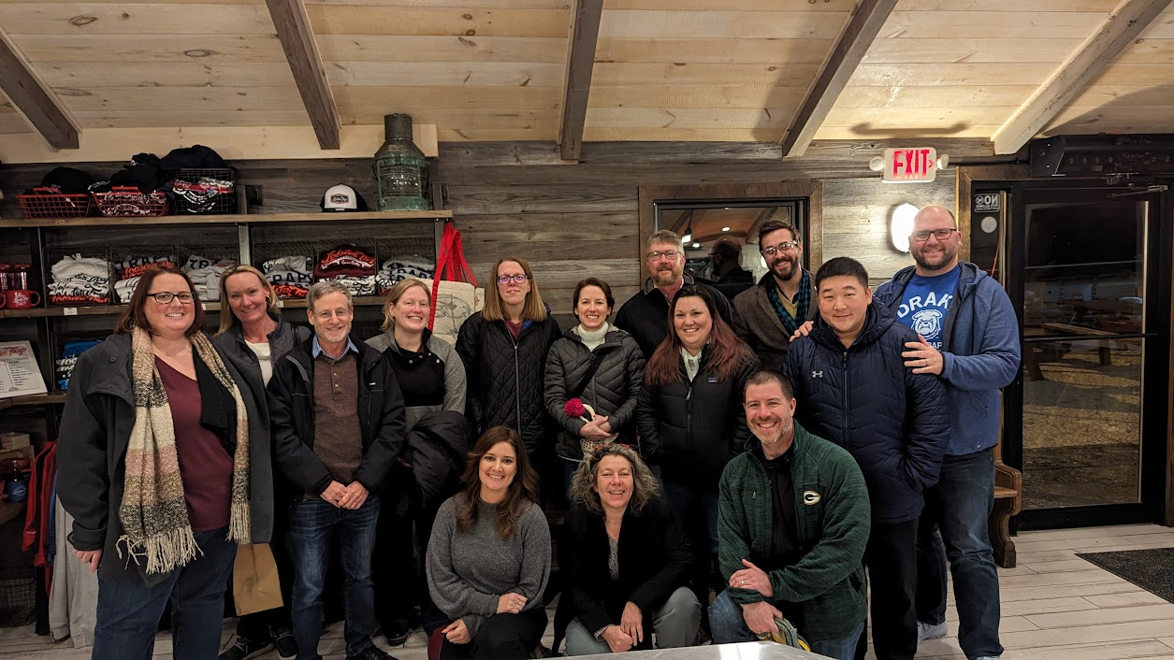

NCC Group Dinner on February 1, 2023

Back Row (From Left to Right): Megan Abrams, Alana Wild, Avraham Eitam, Chelsey Penuel, Kimberly Rice, Lisa Jackson, Darrell Bays, Isaac Powell, John Crowe.

Middle Row: Cindy Kwolek, Soo-Hoon (Sam) Kim

Front Row: Bonnie Dietrich, Amber Tripodi, Brad Danner