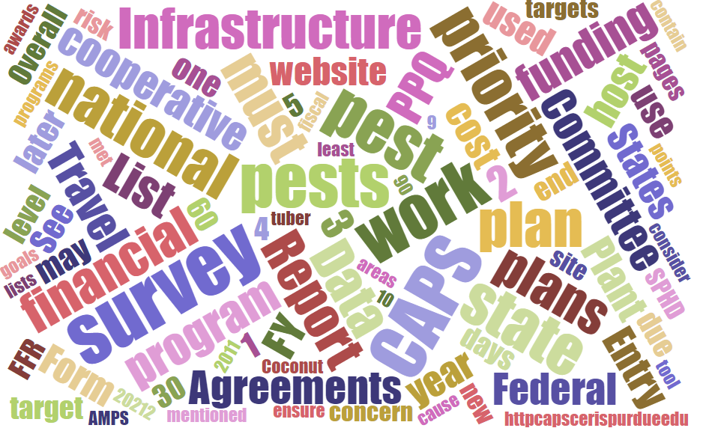



Participants**National CAPS Committee (NCC) Conference Call**

March 2, 2023

|  |  |  |  |  |  |  |  |
| --- | --- | --- | --- | --- | --- | --- | --- |
|  | Darrell Bays |  | Jake Bodart |  | John Crowe |  | Brad Danner |
|  | Avraham Eitam |  | Charles Elhard |  | Eric Ewing |  | Michelle Gray |
|  | Lisa Jackson |  | Cynthia Kwolek |  | Darcy Oishi |  | Tina Peltier |
|  | Chelsey Penuel |  | Isaac Powell |  | Kimberly Rice |  | Helmuth Rogg |
|  | Alana Wilds |  | Soo-Hoon Kim |  |  |  |  |
|  |  |  |  |  |  |  |  |
|  | Feridoon Mehdizadegan |  | Bonnie Dietrich |  | Colin Funaro |  | Mike Hill |

# January and February Notes

January’s NCC meeting was focused on logistics for the NCC meeting later in the month.

February’s NCC was cancelled because of the in person NCC meeting happening. Please see the notes available.

# CAPS 5% Update

We've been given the rare opportunity to allow a 5% increase to the total CAPS agreement amount for each state that participates in the CAPS Program. This increase will be available in FY2023 and will also be the new total amount for each state moving forward.

Please contact your ADODR for your additional 5% amount. You may apply this amount to your Infrastructure agreement, Survey agreement, or between the two agreements.

**These amounts will be your new amounts for FY2023. If you need to make changes in FY2024, we will honor revisions. You need to work with your ADODR and Pest Detection NOM on any changes for FY2024 in advance of when work plans are due. The FY2024 amounts will be your final amounts for the coming years and will not be able to be revised.**

Once the ADODR and NOM approve of the revised amounts, you may begin revising your work plans. You will need to also revise the financial plans in the online interface on the CAPS website. Revised work plans are due to your ADODR **by March 9.** Work plans will be reviewed by your NOM and Agreements Specialist and opportunities will start being published at the full amount.

For any questions, please reach out to your ADODR and Pest Detection NOM. Here are some additional important points:

 1. Any revisions that you make to your CAPS Infrastructure or Survey financial plans will also need to be made in the online financial interface. The CAPSIS Team has re-opened all financial plans for CAPS 2023. Darrell and I will approve them once we receive the revised work plans.

 To access your online financial plan, go to the lower left-hand corner of the Survey Planning page, and click on “Manage Plans”:

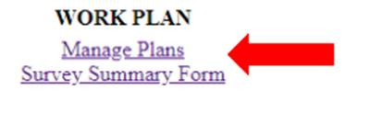

2. We **are not** asking cooperators or CAPSIS to update the 2023 financial totals reflected each year in the SSF (see screenshot below). You will see the updated totals reflected in the 2024 SSF in advance of the FY2024 CAPS cycle. For FY2023, your financial details will be updated in the online financial interface only.

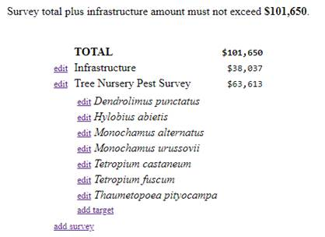

3. If part or all of the 5% increase will be applied to the Survey work plan **and** this will impact the scope of the survey (Counties, sites, visits) or target pests then, the 2023 SSF **should be updated** to reflect the change. Please use the request a modification function to request that the SSF be re-opened.

# SSC CAPS Collaboration Site Email Lists

Some SSC's have identified issues using the lists from the [CAPS collaboration site](https://caps.ceris.purdue.edu/caps-directories). The CAPSIS is looking into these details and potential solutions. For now, it's recommended to send messages via the individual emails and not use the provided lists.

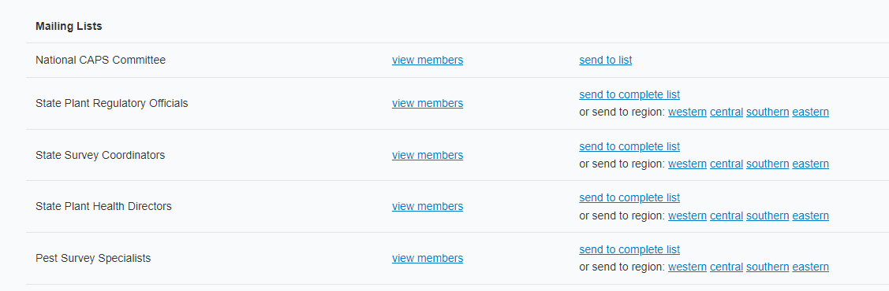

# NCC Updates - Changes of membership

Some changes to the NCC have happened since our last meeting.

Alana Wild has taken a new position within PPQ and will no longer be the SPHD of Nevada and Utah. She will be moving off the NCC and Jake Bodart, the SPHD of Oregon, will be replacing her.

As mentioned at the NCC Meeting Megan Abraham has stepped down and Charles Elhard will be replacing her. Charles attended his first meeting on March 2, 2023.

# NCC Annual Meeting Document Approval

## Meeting Notes

The meeting notes from the annual NCC meeting at the Forest Pest Laboratory were accepted with no edits.

## Updated - Bylaws Adoptions

The bylaws had a few minor edits during the Monthly Call to clarify some language.

The NCC membership will have until March 8th to send [mailto:John.F.Crowe@usda.gov ?subject=NCC Bylaws Edits](mailto:John.F.Crowe@usda.gov?subject=NCC%20Bylaws%20Edits%20) any objections to the bylaws acceptance. If none are received then the updated NCC Bylaws will be posted on March 9th.

## Roles and Responsibility Update

Roles and Responsibility working group comprised of:

* Alana Wilds – State Plant Health Director – Chair
* Isaac Powell – Pest Survey Specialist
* Charles Elhard – State Plant Regulatory Official
* Cindy Kwolek – State Survey Coordinator
* Chelsey Penuel – State Survey Coordinator

Alana has confirmed that she will continue to be the chair of this working group until the document is completed, even after her departure from the NCC.

The group had their initial meeting and have tentatively scheduled a second in March. A draft document will be made available for the next NCC. Depending on the timing the NCC may work to approve the document during the April meeting or delay approval until May's meeting.

# RPBB Meetings updated

There are two meetings scheduled for states with populations of rusty patched bumble bee (RPBB) on March 8, 2023. These meetings will review the requirements for trapping in RPBB areas. Illinois, Minnesota, and Wisconsin my trap, with restrictions, in high potential zones. While the remaining states with RPBB population may not trap in these areas. The calls will go over specific requirements from traps and locations.

# Palm weevil cone trap update - S&T

 The AMPS pages for the South American palm weevil (Rhynchophorus palmarum) and Red palm weevil (R. ferrugineus) were updated to include palm weevil cone traps (aka Picusan traps) as an approved survey method.

Bucket traps are still listed as an approved method, but the cone traps are currently the most effective trap available for detecting these weevils. Both traps will be available for the 2023 season. We will gradually transition to just the cone traps. We recently purchased the Palm Weevil Cone Traps. If you would like to order these traps for the 2023 survey season, please reach out to your National Operations Manager for Pest Detection (Darrell Bays or Lisa Jackson).

# Small brown planthopper trap glue update – S&T

The AMPS page for the small brown planthopper (*Laodelphax striatellus*) will be updated soon to include a new approved trap: the yellow sticky card trap **with hard glue**. Compared to the soft glue sticky cards currently in use, hard glue makes it easier to extract undamaged specimens and identify the pests.

Yellow sticky traps with soft glue are still approved for 2023. Starting in 2024, only sticky card traps with hard glue will be on the approved method list for this pest. The two other approved methods for *L. striatellus*, sweep netting and the stationary suction trap, will remain in place. Note: The suction trap is only approved for use in Florida.