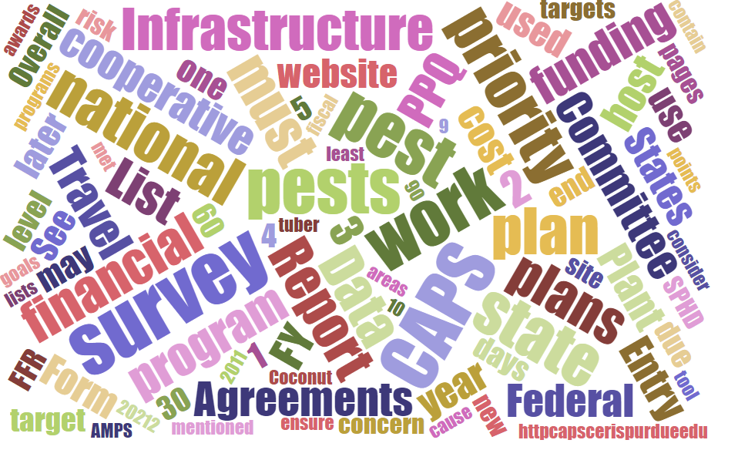



Participants**National CAPS Committee (NCC) Conference Call**

June 1, 2023

|  |  |  |  |  |  |  |  |
| --- | --- | --- | --- | --- | --- | --- | --- |
|  | Darrell Bays |  | Jake Bodart |  | John Crowe |  | Brad Danner |
|  | Avraham Eitam |  | Charles Elhard |  | Eric Ewing |  | Michelle Gray |
|  | Lisa Jackson |  | Cynthia Kwolek |  | Darcy Oishi |  | Tina Peltier |
|  | Chelsey Penuel |  | Isaac Powell |  | Kimberly Rice |  | Helmuth Rogg |
|  | Alana Wilds |  | Soo-Hoon Kim |  | Laurie Morales |  | Joanna Fisher |
|  | Heather Hartzog |  | Kai Caraher |  |  |  |  |
|  | Feridoon Mehdizadegan |  | Bonnie Dietrich |  | Colin Funaro |  | Mike Hill |

# April and May Notes

The meeting notes for the April and May meetings need to be compiled and posted on the CAPS website.

# Pest Health Page update

# The Plant Protection Act 7721 (PPA 7721) CFWG had announced the tentative dates for the PPA 7721 Open Period for FY 24 as June 7 through July 26; however, that announcement has been delayed. Stay tuned for the Open Period announcement through the stakeholder registry. We encourage suggesters visit the PPA 7721 web site (USDA APHIS | Plant Protection Act Section 7721 Funding), review the FY 24 Implementation Plan, and access ServiceNow. The previously announced trainings will continue as scheduled, and those dates and log in information are also available on the PPA web site.

# Thank you for your patience.

# NCC personnel changes

Congratulations to our PSS Rep. Avi Eitam who will be moving on the Policy as an Assistant National Policy Manager, starting June 18.

**NCC Roles and Responsibilities**

Darrell emailed the NCC with a copy of the NCC R&R on May 30. While the document describes current practices, everyone agreed more time was needed to review the content. Kai suggested a summary of differences between the various responsibilities for each role might be useful. The group thought a table might be a good way to show the common responsibilities and highlight differences (e.g. “in addition to the above the SSC must …”).

Once the NCC approves, we need to understand how best to proceed with the NPB and PPQ management approval and if they are even necessary. Jo-Ann may also have to clear the document, possibly through PPQ-MT. Kai sent her a copy on May 31. The NCC agreed on a July 26 deadline for finalizing the R&R document.

**NCC Composition**

There was some discussion concerning the number of SPRO members on the NCC. Not many have intimate knowledge of CAPS surveys and administrative procedures. Maybe two SPRO representatives rather than four would be more appropriate.

# NCC Updates - Changes of membership

Some changes to the NCC have happened since our last meeting.

Shelly Gray has taken a new position within PPQ and will no longer be an Assistant Director in PPQ S&T. Heather Hartzog is assuming her role for the next few months in the PD-CFWG and on the NCC.

Kai Caraher lateralled into the PD-NPM position (vice-John Crowe) until July 1 when JC is scheduled to return.