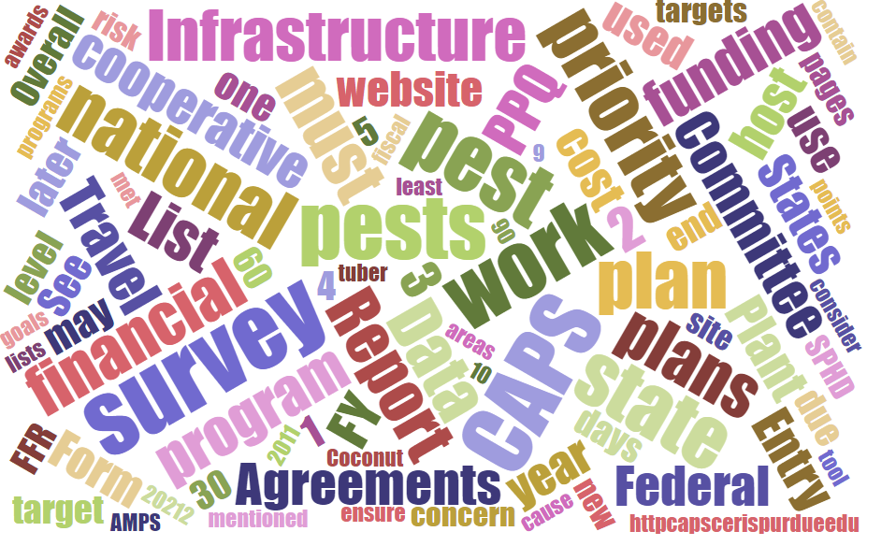



Participants**National CAPS Committee (NCC) Conference Call**

July 6, 2023

|  |  |  |  |  |  |  |  |
| --- | --- | --- | --- | --- | --- | --- | --- |
|  | Darrell Bays |  | Jake Bodart |  | John Crowe |  | Brad Danner |
|  | Avraham Eitam |  | Charles Elhard |  | Eric Ewing |  | Tina Peltier |
|  | Chelsey Penuel |  | Cynthia Kwolek |  | Kimberly Rice |  | Helmuth Rogg |
|  | Heather Hartzog |  | Isaac Powell |  | Laurie Morales |  | Joanna Fisher |
|  | Feridoon Mehdizadegan |  | Kai Caraher |  | Kim Rice |  | Mike Hill |
|  | Bonnie Dietrich |  | Colin Funaro |  |  |  |  |

# CAPSIS Update

# Bonnie Dietrich (Perdue Univ.) shared a presentation on CAPSIS (attached). The topics covered were: New Users, New Online Training Material, Troubleshooting email List-servs, Scheduled Email Reminders and Site Updates.

# 2024 CAPS Rollout Timeline

|  |  |  |
| --- | --- | --- |
| **CAPS** |  | **FY 2024** |
| ACCOUNTABILITY - data entry, two years prior | 4 weeks before SSF is opened | July 5, 2023, Wednesday |
| ACCOUNTABILITY - data entry, two years prior | 2 weeks before SSF is opened | July 17, 2023 |
| Open SSF | 6 weeks before CAPS Work Plans are due | July 31, 2023 |
| No email, just FYI: Work Plans due | Usually first Friday in Sept. after Labor Day | Sept. 8, 2023 |
| SSF - Status emails | 1 week after workplans are due | Sept. 18, 2023 |
| SSF - Status emails | 2 weeks after workplans are due | Sept. 25, 2023 |

**NCC Roles and Responsibilities**

The NCC Roles and Responsibilities was shared with the group in late May and some comments and edits have been returned. Kai will share the draft with Jo-Ann to clear the document, possibly through PPQ-MT. The NCC agreed on a July 26 deadline for finalizing the R&R document.

**PSS Nomination Process**

Isaac Powell has initiated the nomination process. Actively seeking volunteers.

**Screening aid for *G. aurantianum* and *T. leucotreta***

Identifier Julieta Brambila has proposed identification aids for those processing CAPS survey samples for *Gymnandrosoma aurantianum*, the citrus fruit borer and *Thaumatotibia leucotreta*, the false coddling moth.

Action item: CFWG approves the screening aids, Colin will email Bonnie to add them to the CAPS site and email Julieta to notify her of their approval. No login is needed for accessing the screening aids.