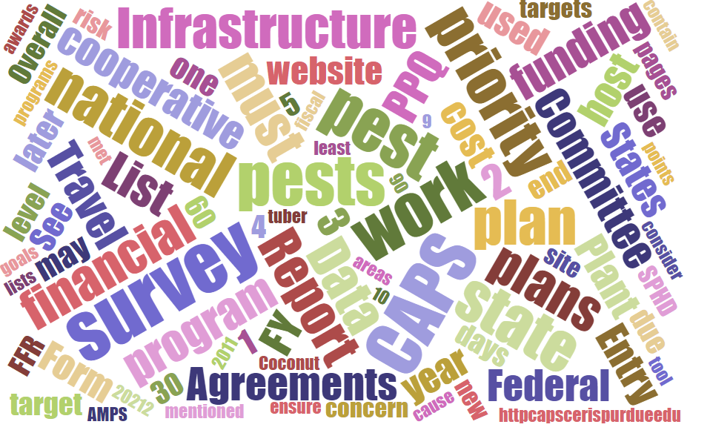



Participants**National CAPS Committee (NCC) Conference Call**

October 5, 2023

|  |  |  |  |  |  |  |  |
| --- | --- | --- | --- | --- | --- | --- | --- |
|  | Darrell Bays |  | Jake Bodart |  | John Crowe |  | Brad Danner |
|  | Emily Hagan |  | Charles Elhard |  | Eric Ewing |  | Damon Crook |
|  | Laurie Morales |  | Cynthia Kwolek |  | Joanna Fisher |  | Tina Peltier |
|  | Chelsey Penuel |  | Isaac Powell |  | Kimberly Rice |  | Judy Rosovsky |
|  | Amy Mesman |  | Sven Spichiger |  | Amber Tripodi |  |  |
|  |  |  |  |  |  |  |  |
|  | Feridoon Mehdizadegan |  | Bonnie Dietrich |  | Colin Funaro |  | Mike Hill |

# Staffing Updates

## S&T Rotation Update

Heather - Thank you for your time and energy to CAPS. Welcome to Damon for the new acting Science and Technology Member.

## SPHD

Eric Ewing will be stepping down at the end of this year.

Amy Mesman will be filling Eric's spot on the NCC.

## EPB SPRO

Kim will be stepping down.

Judy Rosovsky will be entering as the EPB SPRO.

## 2024 NCC Draft Rotations Chart Review

 The NCC reviewed a draft of the NCC Rotations Chart. The updated 2024 membership chart is available [here](https://download.ceris.purdue.edu/file/4439).

# Survey Summary form, CAPS Work Plans and Financial plans

These are currently being reviewed.

Pre-Award Letters can be requested at up to 13.11% of the expected agreement amount.

# One Agreement - Request

One agreement will not happen for FY 2024 and we continue to look at the details needed for the FY 2025 cycle based on this request. The Jake will be working with Amy and Eric (SPHDs on NCC) to determine a best path forward to ensure, workplans, financial plans, and accomplishments reports are available for a “One Agreement Approach”. The NCC plans on reviewing these details at the NCC meeting in January 2024 and determining if this approach can be added as an option for CAPS cooperators.

# Potential Distribution Maps

Amber Tripodi led a discussion about volunteering to help PPRA improve our potential distribution maps. She are looking to meet with folks a few times throughout this fiscal year to:

* solicit feedback on the current maps
* discuss non-standard map options for complex pests
* develop a list of topics to cover in a user guide

Meeting are likely on Teams once a quarter to discuss the maps, how you use them, and ways we can improve the maps and how we communicate our findings. Potential volunteers must get in touch with Amber if they are interested. [amber.tripodi@usda.gov](mailto:amber.tripodi@usda.gov)

# Survey Supply Ordering is Open

About November 17 - watch your email for details on dates.

If a furlough happens orders will not be filled. Urgent needs should be elevated.

Survey Supply Inventory will be taking place the week of Nov. 13 - no shipping during this time. Best to have urgent order needs submitted by end of October or 1st week of November.

We expect shipping for CAPS survey supplies to start in January.

Fall 2023 Survey Supplies Traps and Lures Ordering Period – Open Now!

The IPHIS Survey Supply Ordering System is open now through November 17, 2023 for trap and lure orders supporting the fiscal year (FY) 2024 Cooperative Agricultural Pest Surveys (CAPS) and PPQ program surveys.

 Please note the following updates to the survey supply product catalog:

* **Fruit fly multi-lure traps:** Product ID-6 (full multi-lure trap kit) is no longer available in the IPHIS catalog. If you need to order a complete trap kit, please order product ID-481 (clear trap top with hardware included: swivel ring, mango-style hanger, s-hook, and bait well cap), AND product ID-147 (yellow trap bottom).
* **Japanese beetle traps:** We have added a new product to the catalog, ID-1861, which is a bag-style Japanese beetle trap kit that includes two bag traps, two extra bags, and two dual lures. The older style green and yellow plastic Japanese beetle traps and collection cups are still available while supplies last. Once they are depleted from inventory, we will only be offering the new bag-style kit.
* **Diprion pini lure:** We are offering a plastic vial-style lure from a new vendor this year. Note the vial appears empty but the plastic is impregnated with pheromone. The vial should be removed from its outer packaging and deployed with the vial lid closed to allow slow release of the pheromone.
* **Vaned plastic bucket trap**: The green vaned plastic bucket trap, product ID-1741, is only approved for surveys targeting *Anthonomus rubi* (Strawberry blossom weevil). This trap should not be ordered for surveys for any other pests.
* **Ethanol lures**: We have reverted back to offering the pouch style lures and will no longer offer the tube style lures due to a manufacturing defect with the tube seals.
* **Palm weevil cone traps:** We have added a new product to the catalog, the palm weevil cone trap (also known as Picusan traps), ID-1801, which is approved for the South American palm weevil (Rhynchophorus palmarum) and Red palm weevil (R. ferrugineus). The palm weevil bucket trap, ID-23, is still available while supplies last. Once they are depleted from inventory, we will only be offering the palm weevil cone trap.

The warehouse will begin delivering orders for FY 2024 CAPS and PPQ program surveys the first week of January 2024.

Please do not place orders for FY 2024 PPA 7721 Goal 1 surveys at this time. We will announce a new ordering period in early 2024 after the spending plan for FY 2024 PPA 7721 surveys has been published.

The Survey Supplies page on the [CAPS website](https://gcc02.safelinks.protection.outlook.com/?url=https%3A%2F%2Fcaps.ceris.purdue.edu%2F&data=05%7C01%7Cdarrell.a.bays%40usda.gov%7C9f565cd437ef46ed2aab08dbb55fb792%7Ced5b36e701ee4ebc867ee03cfa0d4697%7C1%7C0%7C638303194978382461%7CUnknown%7CTWFpbGZsb3d8eyJWIjoiMC4wLjAwMDAiLCJQIjoiV2luMzIiLCJBTiI6Ik1haWwiLCJXVCI6Mn0%3D%7C3000%7C%7C%7C&sdata=%2FGteUAivsNQADfi1oP1CdEvGMsVqbiawyBVtM5WslmM%3D&reserved=0) contains several helpful resources:

* [Survey supplies best practices](https://gcc02.safelinks.protection.outlook.com/?url=https%3A%2F%2Fdownload.ceris.purdue.edu%2Ffile%2F4438&data=05%7C01%7Cdarrell.a.bays%40usda.gov%7C9f565cd437ef46ed2aab08dbb55fb792%7Ced5b36e701ee4ebc867ee03cfa0d4697%7C1%7C0%7C638303194978382461%7CUnknown%7CTWFpbGZsb3d8eyJWIjoiMC4wLjAwMDAiLCJQIjoiV2luMzIiLCJBTiI6Ik1haWwiLCJXVCI6Mn0%3D%7C3000%7C%7C%7C&sdata=34Y8nsyyz86eN9tTo9zwejc2tfpkYkktWaHvJezrJyo%3D&reserved=0)
* [Placing an order in IPHIS (video)](https://gcc02.safelinks.protection.outlook.com/?url=https%3A%2F%2Fdownload.ceris.purdue.edu%2Ffile%2F4286&data=05%7C01%7Cdarrell.a.bays%40usda.gov%7C9f565cd437ef46ed2aab08dbb55fb792%7Ced5b36e701ee4ebc867ee03cfa0d4697%7C1%7C0%7C638303194978382461%7CUnknown%7CTWFpbGZsb3d8eyJWIjoiMC4wLjAwMDAiLCJQIjoiV2luMzIiLCJBTiI6Ik1haWwiLCJXVCI6Mn0%3D%7C3000%7C%7C%7C&sdata=ayXwrBTlRlUq6W3GGtv4vURgl9WoYLJ8oMceNlTcP8U%3D&reserved=0)
* [Placing an order in IPHIS (slides)](https://gcc02.safelinks.protection.outlook.com/?url=https%3A%2F%2Fview.officeapps.live.com%2Fop%2Fview.aspx%3Fsrc%3Dhttps%253A%252F%252Fdownload.ceris.purdue.edu%252Ffile%252F4118%26wdOrigin%3DBROWSELINK&data=05%7C01%7Cdarrell.a.bays%40usda.gov%7C9f565cd437ef46ed2aab08dbb55fb792%7Ced5b36e701ee4ebc867ee03cfa0d4697%7C1%7C0%7C638303194978382461%7CUnknown%7CTWFpbGZsb3d8eyJWIjoiMC4wLjAwMDAiLCJQIjoiV2luMzIiLCJBTiI6Ik1haWwiLCJXVCI6Mn0%3D%7C3000%7C%7C%7C&sdata=wAOej4DS3NDQfuOofYcVLWySG%2Fh376LbyvLjnV2MTr8%3D&reserved=0)
* [Safety Data Sheets](https://gcc02.safelinks.protection.outlook.com/?url=https%3A%2F%2Fcaps.ceris.purdue.edu%2Fsurvey-supplies&data=05%7C01%7Cdarrell.a.bays%40usda.gov%7C9f565cd437ef46ed2aab08dbb55fb792%7Ced5b36e701ee4ebc867ee03cfa0d4697%7C1%7C0%7C638303194978382461%7CUnknown%7CTWFpbGZsb3d8eyJWIjoiMC4wLjAwMDAiLCJQIjoiV2luMzIiLCJBTiI6Ik1haWwiLCJXVCI6Mn0%3D%7C3000%7C%7C%7C&sdata=uSSvraxk6JqHk4sgFc56qhUB2JsyKhFAcx%2FrTw5pRoE%3D&reserved=0)

If you cannot find what you are looking for, please email the survey supply team at [SSPP@usda.gov](mailto:SSPP@usda.gov) for assistance.

# Identification Support

Sample submissions are managed locally and it's important that there is a local communication about how to submit samples in the event of a lapse in government funding.

Confirmatory identification may depend on the pest group and funding source of the specialist. ARS/SEL will likely be furlough and these confirmation identifications will not likely happen. PPQ area specialist may be able to complete confirmatory identifications depending on salary funding source. We are unable to provide an exact list, requests can be made to National Identification Services for these details.

# NCC Annual Meeting

Annual meeting is being planned for Baton Rouge, Louisiana, January 29 – February 1. Please be on the look out for details as they become available.