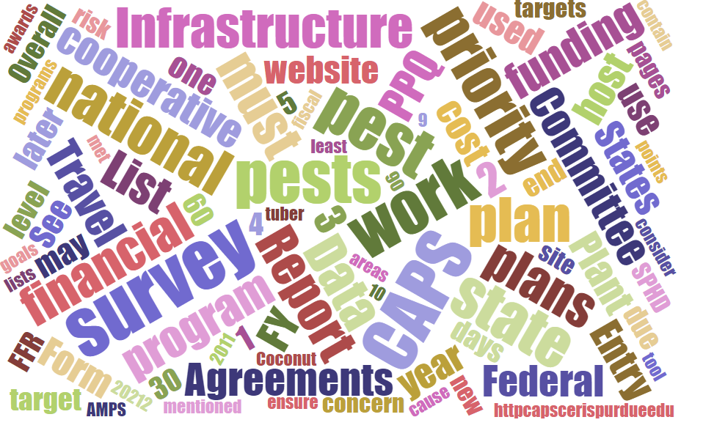



Participants**National CAPS Committee (NCC) Conference Call**

November 2, 2023

|  |  |  |  |  |  |  |  |
| --- | --- | --- | --- | --- | --- | --- | --- |
|  | Darrell Bays |  | Jake Bodart |  | John Crowe |  | Brad Danner |
|  | Emily Hagan |  | Charles Elhard |  | Eric Ewing |  | Damon Crook |
|  | Laurie Morales |  | Cynthia Kwolek |  | Joanna Fisher |  | Tina Peltier |
|  | Chelsey Penuel |  | Isaac Powell |  | Kimberly Rice |  | Judy Rosovsky |
|  | Amy Mesman |  | Sven Spichiger |  |  |  |  |
|  |  |  |  |  |  |  |  |
|  | Feridoon Mehdizadegan |  | Bonnie Dietrich |  | Colin Funaro |  | Mike Hill |

# PPA 7721

FY 2024 Suggestion period number:

* 504 Suggestions - a 30 number increase from FY 2023
* Goal 1S 170 suggestion $126 million - $14.3 Million reserved
* Goal to submitt the draft Spending Plan to PPQ leadership in November
* Final spending plan is expected in February.
* Feedback period for future planning is ongoing.

# Federal Funding Situation

Current federal funding is available until November 17. It's not clear if there will be another Continuing Resolution, a new agriculture funding bill or a lapse in funding. Please know that lapse in funding guidance starts about 2 days before. In the situation of November 17, it's unclear how the weekend/Friday will impact these procedures, in the past furlough letters were provided on Monday.

Please know workers are provided only 4 hours to complete the orderly shutdown, it's possible that communication will be unclear during this time. Now is the time to ask about key functions that you want to know how they will be impacted:

* Identifications
* Sample submissions
* Cooperative agreements

# NCC Annual Meeting

Details on the upcoming meeting are available at: <https://caps.ceris.purdue.edu/ncc>

Make your room reservations:

A block of rooms has been made available for committee members at Hilton Hotel – Baton Rouge Capitol Center, 201 Lafayette Street, Baton Rouge, LA, (225-344-5866). Reservations must be made by January 12, 2024. You may use the booking website: [https://book.passkey.com/e/50718910](https://gcc02.safelinks.protection.outlook.com/?url=https%3A%2F%2Fbook.passkey.com%2Fe%2F50718910&data=05%7C01%7Cjohn.f.crowe%40usda.gov%7C875228a0967f407dfc7908dbe6b995a5%7Ced5b36e701ee4ebc867ee03cfa0d4697%7C1%7C0%7C638357456970444700%7CUnknown%7CTWFpbGZsb3d8eyJWIjoiMC4wLjAwMDAiLCJQIjoiV2luMzIiLCJBTiI6Ik1haWwiLCJXVCI6Mn0%3D%7C3000%7C%7C%7C&sdata=GLUuvHmI5u7yJdkYqEtc%2FAGgJfZfU3QTl2XOc%2B1996o%3D&reserved=0) or by call the hotel directly at 225.344.5866. Room block is under National CAPS Committee, 3 nights of lodging at $107/night plus applicable taxes (15.95%).

# CAPS Workplan update

The 2024 CAPS Workplan NOM review process continues with a completion goal of January 2024. The NOM's will notify the SPHD when the review is complete. The agreements will be entered into EzFed Grants once PPQ receives the allocation. Please contact your SPHD for questions about requesting a pre-award.

# Survey Supply Ordering Period

No shipping from warehouse week of inventory - November 13th to 17th.

If there is a shutdown the warehouse will not ship survey supplies.

Fall 2023 Survey Supplies Traps and Lures Ordering Period – Open Now!

The IPHIS Survey Supply Ordering System is open now through November 17, 2023 for trap and lure orders supporting the fiscal year (FY) 2024 Cooperative Agricultural Pest Surveys (CAPS) and PPQ program surveys.

 Please note the following updates to the survey supply product catalog:

* **Fruit fly multi-lure traps:** Product ID-6 (full multi-lure trap kit) is no longer available in the IPHIS catalog. If you need to order a complete trap kit, please order product ID-481 (clear trap top with hardware included: swivel ring, mango-style hanger, s-hook, and bait well cap), AND product ID-147 (yellow trap bottom).
* **Japanese beetle traps:** We have added a new product to the catalog, ID-1861, which is a bag-style Japanese beetle trap kit that includes two bag traps, two extra bags, and two dual lures. The older style green and yellow plastic Japanese beetle traps and collection cups are still available while supplies last. Once they are depleted from inventory, we will only be offering the new bag-style kit.
* **Diprion pini lure:** We are offering a plastic vial-style lure from a new vendor this year. Note the vial appears empty but the plastic is impregnated with pheromone. The vial should be removed from its outer packaging and deployed with the vial lid closed to allow slow release of the pheromone.
* **Vaned plastic bucket trap**: The green vaned plastic bucket trap, product ID-1741, is only approved for surveys targeting *Anthonomus rubi* (Strawberry blossom weevil). This trap should not be ordered for surveys for any other pests.
* **Ethanol lures**: We have reverted back to offering the pouch style lures and will no longer offer the tube style lures due to a manufacturing defect with the tube seals.
* **Palm weevil cone traps:** We have added a new product to the catalog, the palm weevil cone trap (also known as Picusan traps), ID-1801, which is approved for the South American palm weevil (Rhynchophorus palmarum) and Red palm weevil (R. ferrugineus). The palm weevil bucket trap, ID-23, is still available while supplies last. Once they are depleted from inventory, we will only be offering the palm weevil cone trap.

The warehouse will begin delivering orders for FY 2024 CAPS and PPQ program surveys the first week of January 2024.

Please do not place orders for FY 2024 PPA 7721 Goal 1 surveys at this time. We will announce a new ordering period in early 2024 after the spending plan for FY 2024 PPA 7721 surveys has been published.

The Survey Supplies page on the [CAPS website](https://gcc02.safelinks.protection.outlook.com/?url=https%3A%2F%2Fcaps.ceris.purdue.edu%2F&data=05%7C01%7Cdarrell.a.bays%40usda.gov%7C9f565cd437ef46ed2aab08dbb55fb792%7Ced5b36e701ee4ebc867ee03cfa0d4697%7C1%7C0%7C638303194978382461%7CUnknown%7CTWFpbGZsb3d8eyJWIjoiMC4wLjAwMDAiLCJQIjoiV2luMzIiLCJBTiI6Ik1haWwiLCJXVCI6Mn0%3D%7C3000%7C%7C%7C&sdata=%2FGteUAivsNQADfi1oP1CdEvGMsVqbiawyBVtM5WslmM%3D&reserved=0) contains several helpful resources:

* [Survey supplies best practices](https://gcc02.safelinks.protection.outlook.com/?url=https%3A%2F%2Fdownload.ceris.purdue.edu%2Ffile%2F4438&data=05%7C01%7Cdarrell.a.bays%40usda.gov%7C9f565cd437ef46ed2aab08dbb55fb792%7Ced5b36e701ee4ebc867ee03cfa0d4697%7C1%7C0%7C638303194978382461%7CUnknown%7CTWFpbGZsb3d8eyJWIjoiMC4wLjAwMDAiLCJQIjoiV2luMzIiLCJBTiI6Ik1haWwiLCJXVCI6Mn0%3D%7C3000%7C%7C%7C&sdata=34Y8nsyyz86eN9tTo9zwejc2tfpkYkktWaHvJezrJyo%3D&reserved=0)
* [Placing an order in IPHIS (video)](https://gcc02.safelinks.protection.outlook.com/?url=https%3A%2F%2Fdownload.ceris.purdue.edu%2Ffile%2F4286&data=05%7C01%7Cdarrell.a.bays%40usda.gov%7C9f565cd437ef46ed2aab08dbb55fb792%7Ced5b36e701ee4ebc867ee03cfa0d4697%7C1%7C0%7C638303194978382461%7CUnknown%7CTWFpbGZsb3d8eyJWIjoiMC4wLjAwMDAiLCJQIjoiV2luMzIiLCJBTiI6Ik1haWwiLCJXVCI6Mn0%3D%7C3000%7C%7C%7C&sdata=ayXwrBTlRlUq6W3GGtv4vURgl9WoYLJ8oMceNlTcP8U%3D&reserved=0)
* [Placing an order in IPHIS (slides)](https://gcc02.safelinks.protection.outlook.com/?url=https%3A%2F%2Fview.officeapps.live.com%2Fop%2Fview.aspx%3Fsrc%3Dhttps%253A%252F%252Fdownload.ceris.purdue.edu%252Ffile%252F4118%26wdOrigin%3DBROWSELINK&data=05%7C01%7Cdarrell.a.bays%40usda.gov%7C9f565cd437ef46ed2aab08dbb55fb792%7Ced5b36e701ee4ebc867ee03cfa0d4697%7C1%7C0%7C638303194978382461%7CUnknown%7CTWFpbGZsb3d8eyJWIjoiMC4wLjAwMDAiLCJQIjoiV2luMzIiLCJBTiI6Ik1haWwiLCJXVCI6Mn0%3D%7C3000%7C%7C%7C&sdata=wAOej4DS3NDQfuOofYcVLWySG%2Fh376LbyvLjnV2MTr8%3D&reserved=0)
* [Safety Data Sheets](https://gcc02.safelinks.protection.outlook.com/?url=https%3A%2F%2Fcaps.ceris.purdue.edu%2Fsurvey-supplies&data=05%7C01%7Cdarrell.a.bays%40usda.gov%7C9f565cd437ef46ed2aab08dbb55fb792%7Ced5b36e701ee4ebc867ee03cfa0d4697%7C1%7C0%7C638303194978382461%7CUnknown%7CTWFpbGZsb3d8eyJWIjoiMC4wLjAwMDAiLCJQIjoiV2luMzIiLCJBTiI6Ik1haWwiLCJXVCI6Mn0%3D%7C3000%7C%7C%7C&sdata=uSSvraxk6JqHk4sgFc56qhUB2JsyKhFAcx%2FrTw5pRoE%3D&reserved=0)

If you cannot find what you are looking for, please email the survey supply team at [SSPP@usda.gov](mailto:SSPP@usda.gov) for assistance.

**VERY IMPORTANT –** Inactive IPHIS Accounts – IPHIS accounts without activity over the past 60 days were deactivated on September 8th. Many of our cooperators who place orders in IPHIS once or twice a year may have been affected. PLEASE reach out to them now to ensure they have an active accounts. If they do not please email Laurie and/or Darrell so that their accounts can be re-activated.

PSS’s are responsible for reviewing and approving assigned state cooperator’s orders for accuracy.

I am going to record this portion of the call as I demo how to perform this task in IPHIS. The recording can be accessed here - [HERE](https://usdagcc-my.sharepoint.com/:v:/g/personal/darrell_a_bays_usda_gov/EcTzeljZQuJDoUQJU2X-4BEBN1EYMaQKMZFQKIp-3ocgbw)

# Box Tree Moth Trap Alternatives – From Central Plant Board

“Bucket Traps, multi colored” are not required for box tree moth; An exception can be granted for all green plastic bucket traps. These all green traps do not require Endangered Species Act clearance from Fish and Wildlife Service for detection surveys (CAPS) performed in any potential rusty patch bumble bee zones. Only when using the multi colored plastic bucket trap are you required to follow the extra steps.

 To receive the exception when placing trap orders please work with your NOM.

# One Agreement Committee

Opening for one SSC and PSS. Message Jake if there is interest. (Jake.Bodart@usda.gov)