The Priority Pest List represents the national priorities for the Cooperative Agricultural Pest Survey (CAPS) program and Plant Protection Act 7721 (PPA 7721) Goal 1 early detection surveys. Plant Protection and Quarantine (PPQ) evaluates the list each year to make sure it reflects national priorities. Pests are removed if they have been federally deregulated or have become established in multiple states. Pests are added if they are predicted to have a high impact in the United States and effective methods and resources are available to support detection surveys. PPQ evaluates candidate pests using the pest prioritization process (Figure 1).

Pest Prioritization Process for Adding a New Pest
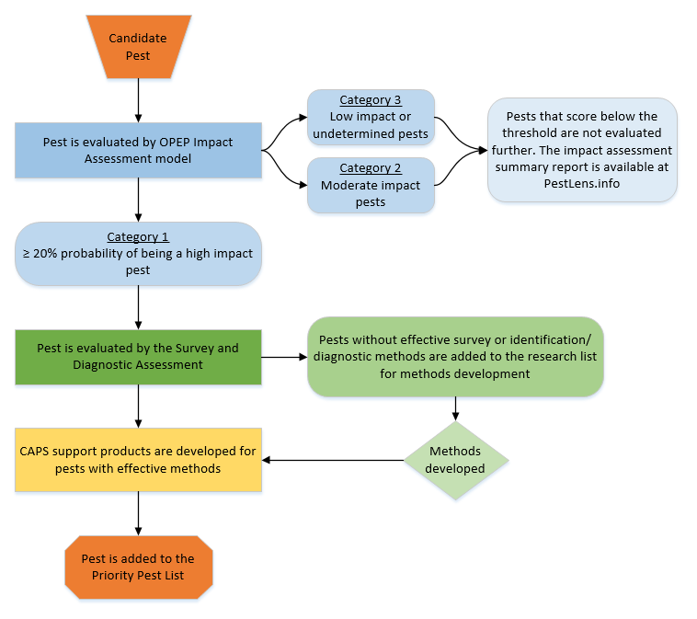
Figure 1. Evaluation of candidate pests using the pest prioritization process

All pests on the priority pest list, with the exception of mollusks and weeds, have been evaluated using the Objective Prioritization of Exotic Pests (OPEP) process. Weeds are prioritized using a Weeds Risk Assessment.

Candidates for the Priority Pest List
Any stakeholder can submit a pest to be evaluated for potential inclusion in the Priority Pest List.
Email candidates to STCAPS@usda.gov. Please provide the pest’s scientific name. Supporting information is helpful, but not required. Candidates must not be present in the United States.

OPEP Impact Assessment
PPQ developed the OPEP impact assessment model to prioritize exotic pests according to the impacts they are likely to have if introduced into the United States. There are separate assessments for arthropods and plant pathogens (including nematodes). Each assessment includes questions that are predictive of potential impacts. These questions are based on the biology and behavior of the pest, control measures used against the pest, and production practices used in the United States.

A summary report is developed for each assessment, which is available through the PestLens website. The summary report includes:
- A brief introduction to the region(s) and host(s) at risk in the United States.
- The potential impacts or symptoms that may be observed.
- A summary of the assessment results.
- A list of pest-specific biological features or production practices that likely affected the final rating.
- Any other information relevant for stakeholders.
- A copy of all the questions, answers, and associated evidence used in each assessment.

The OPEP assessment best evaluates pests that have spread outside of their native range, and/or have caused significant impacts within their native range. Species that have not spread outside of their native range or caused significant impacts within their native range are not assessed and are given an “undetermined” rating. A summary of the known information is archived and available at the PestLens website.

To enable PPQ to focus resources on pests that are most likely to cause significant impacts, assessment results are grouped into three categories (Appendix). Category 1 includes organisms with a greater than 20% probability of being a high impact pest. PPQ evaluates the availability of survey and diagnostic methods for pests in Category 1.

Survey and Diagnostic Assessment
The Survey and Diagnostic (S&D) Assessment evaluates whether an early detection survey is possible and practical by answering the following questions:
- Are effective detection methods available for survey?
- Are effective diagnostic methods available?
- Is there capacity and available expertise to identify the species if a large-scale survey is conducted?

The assessment is completed by reviewing literature and consulting S&T methods development labs, PPQ National Identification Service, and other subject matter experts. There are separate assessment templates for plant pathogens and arthropods. The outcome of the assessment is archived internally.

If acceptable methods or necessary expertise/capacity does not exist, the species is added to the CAPS research needs and methods development list. Each year, research needs are presented to S&T methods development labs and included in the guidance for Goal 3: “Increase Identification Capacity and Strengthen Pest Detection Technology” in the annual PPA 7721 Implementation Plan. Cooperators use the implementation plan to develop research proposals.

Stakeholder review and approval of Priority Pest List changes
The Pest Detection Cross-Functional Working Group (PD CFWG) and the National CAPS Committee (NCC) review and approve the proposed changes before they are incorporated into the Priority Pest List.

The process is outlined using the 2022 Priority Pest List as an example:
Fall 2020 – PD CFWG review.
The PD CFWG includes the National Policy Manager, National Operations Managers, and S&T representative for Pest Detection.

The S&T CAPS Support Lead presents the proposed Priority Pest List changes to the PD CFWG. The group discusses and the PD CFWG approves the proposed changes to present at the annual NCC meeting.

Winter 2021 – NCC review and approval.
The NCC represents CAPS cooperators at the national and state level. Two State Plant Health Directors and Pest Survey Specialists represent the national perspective. Four State Survey Coordinators and State Plant Regulatory Officials representing the regional plant boards provide the state perspective.

S&T presents the proposed changes at the annual NCC meeting. The NCC reviews the proposed changes and asks questions. Once S&T addresses all questions, the NCC approves the pest list changes. NCC review is documented in the annual NCC meeting minutes available on the NCC page on the CAPS Resource and Collaboration website: http://caps.ceris.purdue.edu/ncc.

April 2021 – Finalized Priority Pest List.
The final Priority Pest List and a Summary of Pest List Changes for 2022 survey season are made publicly
available.

The PPQ Pest Detection Program publishes the annual National Pest Surveillance Guidelines on the CAPS website. PPQ and state cooperators use the Guidelines to plan and prepare for CAPS and PPA 7721 early detection surveys.

State surveyors use the updated Priority Pest List and Summary of Pest List Changes to select new targets and to modify state survey plans. S&T develops and maintains support products for the species on the Priority Pest List, including CAPS Datasheets and the Approved Methods for Pest Surveillance for survey and identification/diagnostics. These products provide information that helps state surveyors select appropriate targets for their state based on pest biology, risk, and capacity.

Appendix: OPEP Impact Assessment Categories
Category 1 (high and some moderate pests)
- Pests have a significant likelihood to have a high impact in the United States. Pests have a greater than 20% probability of being a high impact pest.
- If the pests pass the S&D Assessment, they will be listed on the Priority Pest List.
- If pests fail the S&D Assessment, they are placed on the CAPS research list for methods development.
Category 2 (other moderate pests)
- Pests are most likely to have a moderate impact in the United States. Pests have a 10–20% probability of being a high impact pest.
- Pests on the Priority Pest List will be removed. These pests will still be available for bundling into other surveys.
- These pests will not be part of the Priority Pest List unless there is a significant reason (political/ trade implications, human or animal health impacts, etc.) for it to be offered for survey.
- Pests that are recommended for survey and pass the S&D Assessment will be added to the Priority Pest List.
- If pests are recommended for survey but fail the S&D Assessment, they may or may not be listed as priorities for research.
Category 3 (low impact or undetermined pests)
- Pests have a less than 10% probability of being a high impact pest.
- Pests are most likely to have a low impact in the United States.
- Undetermined pests:
  - There is not enough information available to evaluate likely impacts. Species may be reevaluated if new information becomes available.
  - The species has not spread outside of its native range. Species may be reevaluated if geographic distribution expands.
  - The species is already present in the United States and not under official control. Species are not eligible for reevaluation.
- These pests will not be included on the Priority Pest List.

