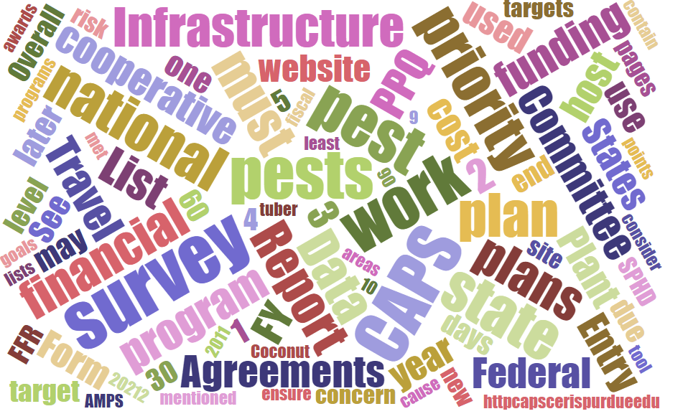



Participants**National CAPS Committee (NCC) Conference Call**

March 7, 2024

|  |  |  |  |  |  |  |  |
| --- | --- | --- | --- | --- | --- | --- | --- |
|  | Darrell Bays |  | Jake Bodart |  | John Crowe |  | Brad Danner |
|  | Emily Hagan |  | Charles Elhard |  | Tina Gresham |  | Sven Spichiger |
|  | Amy Mesman |  | Cynthia Kwolek |  | Joanna Fisher |  | Tina Peltier |
|  | Chelsey Penuel |  | Isaac Powell |  | Judy Rosovsky |  | Judy Rosovsky |
|  |  |  |  |  |  |  |  |
|  |  |  |  |  |  |  |  |
|  | Mike Hill |  | Bonnie Dietrich |  | Colin Funaro |  |  |

# 60% Visualization

Performance measures were added or will be shortly added to the NCC members roles by CAPSIS. [CAPS Performance Measures (purdue.edu)](https://caps.ceris.purdue.edu/performance-measures) I you're an NCC member, please confirm access to this website.

Maps option is available on the right side:

# 

# 

# 

Maps for since 2015 are available; though we focused on 2023 maps and 2024 maps are not yet available.

# Pest Lens Access – NCC has been provided access to OPEP & NPRG

* Federal - Existing Access is available. If you are not signed up, sign up here: [PestLens: Registration](https://pestlens.info/public/register.cfm)
* NCC – Kimberly, Sven, & Brad were already registered and their access level was changed to allow access to OPEP & NPRG.
  + Others - registration has been completed for you and you have been granted access to OPEP & NPRG. You will need to reset your password to login. Here are the steps :
  + Use this link ([https://pestlens.info/public/index.cfm](https://gcc02.safelinks.protection.outlook.com/?url=https%3A%2F%2Fpestlens.info%2Fpublic%2Findex.cfm&data=05%7C02%7CLeah.Granke%40usda.gov%7C43545b7a8bc54bc0698808dc3df99ce6%7Ced5b36e701ee4ebc867ee03cfa0d4697%7C1%7C0%7C638453389485228950%7CUnknown%7CTWFpbGZsb3d8eyJWIjoiMC4wLjAwMDAiLCJQIjoiV2luMzIiLCJBTiI6Ik1haWwiLCJXVCI6Mn0%3D%7C0%7C%7C%7C&sdata=mK%2FHbH9dYELGFD3VdXU1vKUEM0qJEEngQ8Y7T4UX3BA%3D&reserved=0)) to reset the password. The link will ask you to enter your email and then you will receive a temporary login password in your inbox. The email has to be the same one used on the CAPS website.

|  |  |  |
| --- | --- | --- |
| **Name** | **User Email** | **user ID** |
| Tina Peltier | [tpeltier@ldaf.state.la.us](mailto:tpeltier@ldaf.state.la.us) | tpeltie |
| Charles Elhard | [celhard@nd.gov](mailto:celhard@nd.gov) | celhard |
| Cynthia Kwolek | [cynthia.kwolek@dem.ri.gov](mailto:cynthia.kwolek@dem.ri.gov) | ckwolek |
| Chelsey Penuel | [chelsey.penuel@state.mn.us](mailto:chelsey.penuel@state.mn.us) | cpenuel |
| Joanna Fisher | [joanna.fisher@cdfa.ca.gov](mailto:joanna.fisher@cdfa.ca.gov) | jfisher2 |
| Judy Rosovsky | judy.rosovsky@vermont.gov | jrosovs |

* + Use the username listed above and login here [https://pestlens.info/](https://gcc02.safelinks.protection.outlook.com/?url=https%3A%2F%2Fpestlens.info%2F&data=05%7C02%7CLeah.Granke%40usda.gov%7C43545b7a8bc54bc0698808dc3df99ce6%7Ced5b36e701ee4ebc867ee03cfa0d4697%7C1%7C0%7C638453389485237984%7CUnknown%7CTWFpbGZsb3d8eyJWIjoiMC4wLjAwMDAiLCJQIjoiV2luMzIiLCJBTiI6Ik1haWwiLCJXVCI6Mn0%3D%7C0%7C%7C%7C&sdata=HbKg80mWet7MLAccOUei5XROPEdat0mkfsE3wDsUQWY%3D&reserved=0). Reset the password

Core 4 - waiting on decision to determine if this is the best path forward.

# FY 2024 - AMPS Page

# Bud borer - Crocidosema aporema

Updated to include notes related to the hot melt glue - similar to Tuta absoluta.

# FY 2025 AMPS page will reflect these changes for

Crocidosema and Tuta.

Diabrotica - new survey methods added (visual & sweep netting)

General Mollusk Survey - Can be pushed to April

# PPQ Pest Detection Data Coming Forward - Laurie

SSC's should be looking for these details coming from

# Accountability Report Messages

# Review NCC Meeting Notes and Commitments.

<https://usdagcc.sharepoint.com/sites/aphis-ppq-policy/php/PD/CAPS/G4%20Drafts/National%20CAPS%20Committee%20Meetings/NCC%20Mtg%202024%20Baton%20Rouge/NCC%20Meeting%20Notes%202024%20-%20Baton%20Rouge.docx?web=1>