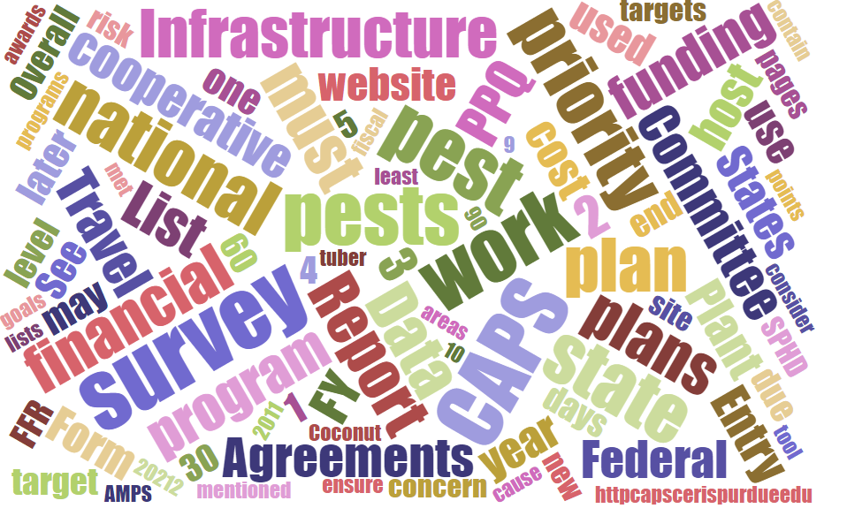



Participants**National CAPS Committee (NCC) Conference Call**

April 4, 2024

|  |  |  |  |  |  |  |  |
| --- | --- | --- | --- | --- | --- | --- | --- |
|  | Darrell Bays |  | Jake Bodart |  | John Crowe |  | Brad Danner |
|  | Emily Hagan |  | Charles Elhard |  | Tina Gresham |  | Sven Spichiger |
|  | Amy Mesman |  | Cynthia Kwolek |  | Joanna Fisher |  | Tina Peltier |
|  | Chelsey Penuel |  | Isaac Powell |  | Judy Rosovsky |  | Judy Rosovsky |
|  |  |  |  |  |  |  |  |
|  |  |  |  |  |  |  |  |
|  | Mike Hill |  | Bonnie Dietrich |  | Colin Funaro |  |  |

No NCC Meeting happened in April 2024