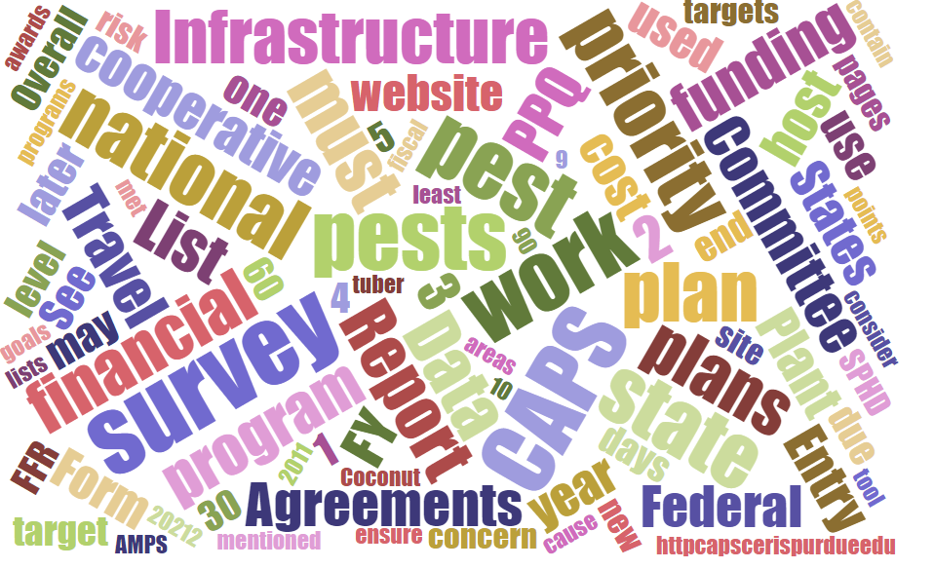



Participants**National CAPS Committee (NCC) Conference Call**

May 3, 2024

|  |  |  |  |  |  |  |  |
| --- | --- | --- | --- | --- | --- | --- | --- |
|  | Darrell Bays |  | Jake Bodart |  | John Crowe |  | Brad Danner |
|  | Emily Hagan |  | Charles Elhard |  | Tina Gresham |  | Sven Spichiger |
|  | Amy Mesman |  | Cynthia Kwolek |  | Joanna Fisher |  | Tina Peltier |
|  | Chelsey Penuel |  | Isaac Powell |  | Judy Rosovsky |  | Judy Rosovsky |
|  |  |  |  |  |  |  |  |
|  |  |  |  |  |  |  |  |
|  | Mike Hill |  | Bonnie Dietrich |  | Colin Funaro |  |  |

# Welcome and Program Updates (5 minutes) - Crowe

Crowe kicked off the meeting by welcoming all committee members and guests. He then provided a quick rundown of program updates:

* **Staffing Changes:** He announced that Tina Gresham will be assuming leadership of the Pest Surveillance portfolio which include CAPS.
  + **Survey Supplies:** Tina is vacating survey supplies portfolio and a highly experienced PPQ individual will be filling the Survey Supplies role, starting about May 20th. A broader announcement for this change will be circulated once finalized.
* **JC's Departure:** JC took a moment to express sincere appreciation to the NCC for their support since taking over CAPS. NCC expressed thanks to JC for his contributions to the CAPS program and Pest Surveillance throughout his years of service.

## Outreach Subcommittee Update (10 minutes)

### **I. Confirmation and Membership**

1. **NCC Subcommittee Participation (NCC-CAPS Metrics):** We're happy to confirm Jason Allen and Karen Williams as our representatives on the NCC Subcommittee tasked with developing outreach metrics for CAPS workplans. Their participation ensures our subcommittee has a voice in this important initiative.
2. **Membership Verification:** Let's take a moment to verify Charles Elhard and Joanna Fisher's current membership in the Outreach Subcommittee. Having their expertise is crucial for our success.

### **II. Call for Additional Volunteers**

The Outreach Subcommittee was officially formed today by the NCC with unanimous support.

The initial membership is now finalized and includes:

Tina Gresham (Lead), Jason Allen, Karen Williams, Charles Elhard, and Joanna Fisher.

We encourage everyone to reach out if they'd like to contribute to the subcommittee's work. The committee will be provided time on future NCC calls to provide updates as they are warranted.

**4. 2025 Revised National Priority Pest List (NPP List) Update (10 minutes)**

## National Plant Pest (NPP) List Update and Mollusk Consolidation Discussion (15 minutes)

### **Update on the 2025 NPP List**

The NCC reviewed and approved the addition of two new pests to the 2025 National Plant Pest List:

* **Diabrotica speciosa (Cucurbit beetle):** This addition ensures we have a national strategy to address this potential threat to cucurbit crops.
* **Amrasca biguttula (Indian cotton jassid):** Adding this pest to the NPP List allows for coordinated efforts to prevent its establishment in the US.

### **II. Mollusk Consolidation Update**

The Mollusk Cross Functional Working Group is finalizing the approved methods page for a single standardized survey targeting gastropods (snails and slugs). This consolidation aims to streamline monitoring efforts.

### **III. Potential Impact on National Priority Pest Threshold**

The NCC acknowledged a potential impact of mollusk consolidation on the number of National Priority Pests. Combining multiple mollusk species into a single category on the NPP List could affect the 60% threshold used for prioritization. This is because several current priority pests would be combined under one umbrella.

## 2025 CAPS Guidelines Update ( 5 minutes)

The 2025 CAPS Guidelines (potentially mid-May) for release.

## 2024 PPA Goal 1S Update (5 minutes)

**Important Deadlines:**

* A reminder that the deadline for Notice of Intent (NOM) review was **May 1st**.

**Workplan & Reporting Requirements:**

We encourage all cooperators to submit their workplans, Survey Summary Forms, online financials, and any updates to NAPIS data by the established deadlines. Timely submissions ensure a smooth process and allow for efficient use of resources towards achieving our shared goals under PPA Goal 1S.

**For any questions or assistance with the submission process, please don't hesitate to reach out to the PPA 7721 Goal 1 Survey Team.**

## Pest Detection Budget Update (10 minutes)

Unfortunately, the Pest Detection program continues to face budgetary constraints in 2024. There's a significant concern that these limitations might impact cooperative agreements in 2025.

**Strategic Prioritization:**

Given the current financial climate, it's crucial to strategically prioritize program activities. We need to ensure we're maximizing the impact of available resources.

## Map Visualization & Performance Measures Update (15 minutes)

**NCC Review and Feedback:**

NCC members have reviewed the map details with their constituencies. We're happy to report that there haven't been any concerns raised to date. This positive feedback from our members makes the NCC comfortable with moving forward.

**Sharing with CAPS Community:**

Based on the NCC's review, we plan to share the performance measures and map visualization with the broader CAPS Community, including SPHD, SPRO, PSS, and SSC. NCC members currently have access to the maps for reference.

**Next Steps:**

* We'll continue soliciting feedback on the visual design of the map page to ensure optimal user experience.
* A final decision regarding full accessibility of the map visualization and performance measures to the CAPS Community will be made at the June NCC meeting.

## CAPSIS Update: (5 minutes)

A draft Survey Summary Form report called “Download Plan Data PDF” was presented and NCC members asked to view and provide feedback on an emailed version prior to it going on the Survey Planning site. This document is a visualization of the previous report in Excel.