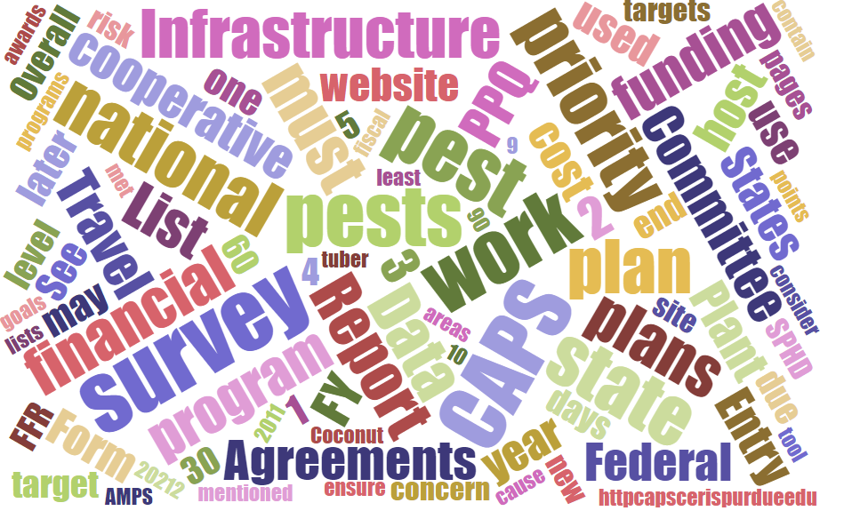



Participants

**National CAPS Committee (NCC) Conference Call**

June 13, 2024

|  |  |  |  |  |  |  |  |
| --- | --- | --- | --- | --- | --- | --- | --- |
|  | Darrell Bays |  | Jake Bodart |  | Brad Danner |  | Judy Rosovsky |
|  | Emily Hagan |  | Charles Elhard |  | Tina Gresham |  | Sven Spichiger |
|  | Amy Mesman |  | Cynthia Kwolek |  | Joanna Fisher |  | Tina Peltier |
|  | Chelsey Penuel |  | Isaac Powell |  |  |  |  |
|  |  |  |  |  |  |  |  |
|  |  |  |  |  |  |  |  |
|  | Mike Hill |  | Bonnie Dietrich |  | Colin Funaro |  |  |

## Welcome and Program Updates

Gresham kicked off the meeting by welcoming all committee members and guests. She provided a quick rundown of program updates:

## FY 2025 CAPS Guidelines rollout

* No significant administrative changes to the process for FY 2025
* Additions to National Priority Pest List (NPPL) are:
  + Diabrotica speciosa (Cucurbit beetle)
  + Amrasca biguttula (Indian cotton jassid)
* No pests removed from the list
* We considered combining all snails/slugs on the FY 2024 NPPL into a new combined mollusk survey for FY 2025 but moved that to consideration for FY 2026 to allow more time to refine our approach.
* Email announcement to SPHDs, SPROs, SSCs, and PSSs went out on June 13th
* FY 2025 CAPS agreement amounts will be, at most, the same amounts as in FY 2024

## S&T Updates:

* Datasheet and Approved Methods PS are in progress for Amrasca biguttula, new to the FY 2025 NPPL
* CAPS Datasheets have been revised and updated for:

Adoxophyes orana (Summer fruit tortrix moth)

Grapholita funebrana (Plum fruit moth)

Globodera rostochiensis (Golden nematode)

## PPA 7721: Plant Pest and Disease Management and Disaster Prevention Program Funding Opportunity FY 2025

* Suggestion period is open through July 31st
* Webinars, resources on the website at:

[PPA 7721: Plant Pest and Disease Management and Disaster Prevention Program | Animal and Plant Health Inspection Service (usda.gov)](https://www.aphis.usda.gov/funding/ppdmdpp)

# 

## NCC Member Rotations Reminder:

* If coming to end of term, let Tina know if you plan to re-up for second term, or if we need to begin recruiting.
  + Matt Howell will be replacing Brad Danner

## CAPSIS Update:

* The “Download Plan Data PDF” was emailed to you following the May NCC Meeting. This document is a visualization of the Survey Summary Form and report in Excel named Download Plan Data. Please provide feedback on the PDF design, so we can incorporate changes before 2025 CAPS Survey Planning opens. Either email Bonnie or bring comments to the July NCC meeting.