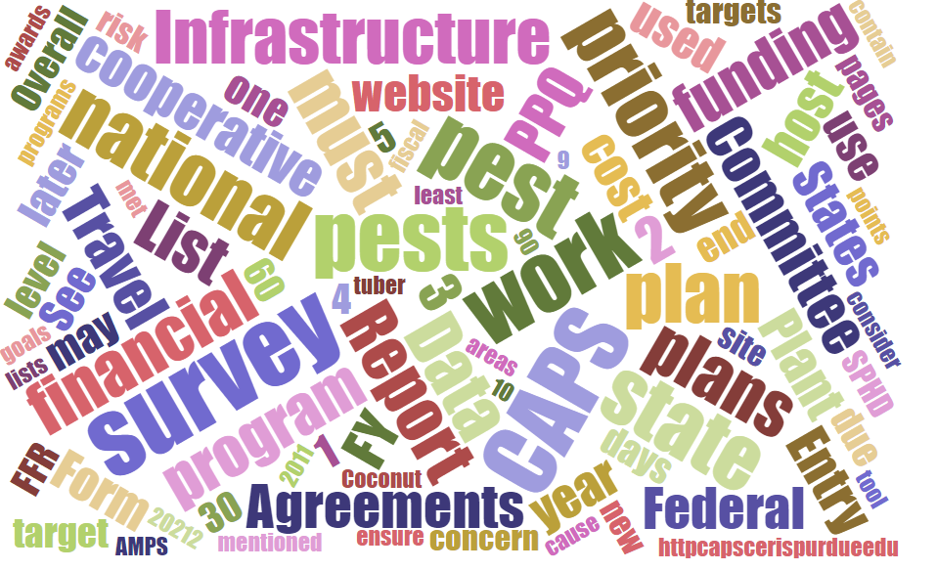



Participants

**National CAPS Committee (NCC) Conference Call**

July 11, 2024

|  |  |  |  |  |  |  |  |
| --- | --- | --- | --- | --- | --- | --- | --- |
|  | Darrell Bays |  | Joanna Fisher |  | Amy Mesman |  | Judy Rosovsky |
|  | Jake Bodart |  | Tina Gresham |  | Tina Peltier |  | Sven Spichiger |
|  | Brad Danner |  | Emily Hagan |  | Chelsey Penuel |  |  |
|  | Charles Elhard |  | Cynthia Kwolek |  | Isaac Powell |  |  |
|  |  |  |  |  |  |  |  |
|  | Mike Hill |  | Bonnie Dietrich |  | Colin Funaro |  |  |

## NCC FY 2025 Annual Meeting Planning:

* Location suggestion – McAllen, TX (visit Moore Airbase, trap and lure warehouse and PPQ Science and Technology fruit fly rearing facility)
* Possible dates: January 28-29, February 4-5, February 11-12
* We discussed meeting in early November, but this will conflict with the Lymantria annual meeting. We also considered meeting later in February, but we run into challenges with the President’s Day holiday and others’ travel schedules.
* Watch for an email poll to vote on dates and to suggest other meeting locations for consideration

## S&T Updates:

* There were no updates to report in today’s meeting

## NCC FY 2024 Commitments:

We discussed the status of these commitments made at the FY 2024 NCC meeting:

* Commitment 1: Science and Technology (S&T) will determine cooperator access to PestLens, specifically to review and access Objective Prioritization of Exotic Pests (OPEP).
  + Status: Complete
* Commitment 2: The Pest Detection Cross Functional Working group will determine if an open comment period should exist for Objective Prioritization of Exotic Pests (OPEP) for the broader CAPS Community.
  + Status: We discussed this previously and determined we do not need an open comment period, especially since access to these documents through PestLens has been granted.
* Commitment 3: National Identification Service will be invited to the monthly NCC meeting to discuss their approach to the survey and diagnostic assessment review.
  + Status: Not completed. Tina will look for a time we can invite Andy Brower or Jesse Hardin from National Identification Services (NIS) to an NCC monthly call. We will also consider inviting a series of presentations to include representatives from the Forest Pest Methods Laboratory (FPML), Preliminary Identification, and/or the Plant Pest Confirmation and Diagnostic Laboratory (PPCDL).
* Commitment 4: Science and Technology will draft a single mollusk approved methods page which includes the following 12 pests and once developed the PD CFWG will work to ensure the NCC can review the drafted Mollusk Page.
  + Status: In progress for FY 2026 Guidelines
* Commitment 5: CAPSIS will work to provide NCC members access to the draft visualization for the 60% threshold.
  + Status: Complete
* Commitment 6: NCC members will lead discussions with their constituents to obtain feedback regarding the following 60% threshold proposal presented by the PPQ Pest Detection cross-functional working group (CFWG):
  + - The proposed approach considers a cooperator's **total pest list** across all surveys, instead of individual surveys. This provides more flexibility while ensuring the 60% target is still met. See NCC FY24 annual meeting notes for more details.
  + Status: Although conversations have happened with some NCC members’ constituents, some asked for more time to gather feedback.
* Commitment 7: the PD CFWG will work with CAPSIS to explore the use of an address book in the Survey Summary Form.
  + Status: Complete
* Commitment 8: The National Policy Manager will continue discussions with agriculture communication teams regarding CAPS outreach efforts and reporting
  + Status: Needs additional discussion/follow-up (Tina)

## Reminder: PPA 7721 Plant Pest and Disease Management and Disaster Prevention Program FY 25 suggestion period closing soon

* Open through July 31st
* Webinars, resources on the website at:

[PPA 7721: Plant Pest and Disease Management and Disaster Prevention Program | Animal and Plant Health Inspection Service (usda.gov)](https://www.aphis.usda.gov/funding/ppdmdpp)

## NCC Member Rotations Reminder:

* If coming to end of term, let Tina know if you plan to re-up for second term, or if we need to begin recruiting.
* Matt Howle will be replacing Brad Danner

## CAPSIS Update:

At the Annual NCC Meeting in Baton Rouge, LA in 2024, the NCC came up with several action items for the CAPS Information Services team. Those items have been completed. CAPSIS previewed the last of the enhancements during the July call including:

1. The **links for Survey Planning Maps and Tables** were placed on the new Survey Planning landing page here: [Survey Planning | CAPS (purdue.edu)](https://gcc02.safelinks.protection.outlook.com/?url=https%3A%2F%2Fcaps.ceris.purdue.edu%2Fsurveyplanning&data=05%7C02%7Ctina.gresham%40usda.gov%7C6c3f11c2e4994977b5ba08dcb19daeb4%7Ced5b36e701ee4ebc867ee03cfa0d4697%7C1%7C0%7C638580538016504534%7CUnknown%7CTWFpbGZsb3d8eyJWIjoiMC4wLjAwMDAiLCJQIjoiV2luMzIiLCJBTiI6Ik1haWwiLCJXVCI6Mn0%3D%7C0%7C%7C%7C&sdata=L95PEj3K1ViJuUAKYptcudoRrxGeDIDOV09TzVP4kS4%3D&reserved=0)
2. The **Download Plan Data PDF** is now on the Survey Planning site in the Links menu. Please inform your states and let CAPS Information Services know if you would like to request any formatting changes or additions to the document. [Survey Planning (purdue.edu)](https://gcc02.safelinks.protection.outlook.com/?url=https%3A%2F%2Fpest.ceris.purdue.edu%2Fservices%2Fsurveyplanning%2F&data=05%7C02%7Ctina.gresham%40usda.gov%7C6c3f11c2e4994977b5ba08dcb19daeb4%7Ced5b36e701ee4ebc867ee03cfa0d4697%7C1%7C0%7C638580538016516541%7CUnknown%7CTWFpbGZsb3d8eyJWIjoiMC4wLjAwMDAiLCJQIjoiV2luMzIiLCJBTiI6Ik1haWwiLCJXVCI6Mn0%3D%7C0%7C%7C%7C&sdata=2B52uftMgZ8NMs7F791MBx03AyI8Nolzw0t7GKWan6k%3D&reserved=0)
3. Survey Summary Form enhancements:

**For Identifier / Diagnostician** → Browser autofill was disabled and replaced by a **saved directory now exists**.

* The user enters Name, Title, and Affiliation once, and the information is saved for use on the Survey Summary Form. To access saved entries, just start typing.

**For Diagnostic Details** → Browser autofill was disabled and replaced by a **saved directory now exists.**

* The user enters Contact Name and Contact Email once, and the information is saved for use on the Survey Summary Form. To access saved entries, just start typing (like for add target).

1. Accountability Report enhancement:

* If data is pending, click on the link titled **Edit survey comment** to add description for the delay and date to indicate when the data is expected. [Accountability Report I CAPS (purdue.edu)](https://gcc02.safelinks.protection.outlook.com/?url=https%3A%2F%2Fcaps.ceris.purdue.edu%2Faccountability-report&data=05%7C02%7Ctina.gresham%40usda.gov%7C6c3f11c2e4994977b5ba08dcb19daeb4%7Ced5b36e701ee4ebc867ee03cfa0d4697%7C1%7C0%7C638580538016524080%7CUnknown%7CTWFpbGZsb3d8eyJWIjoiMC4wLjAwMDAiLCJQIjoiV2luMzIiLCJBTiI6Ik1haWwiLCJXVCI6Mn0%3D%7C0%7C%7C%7C&sdata=x8Pw0gNuBG8%2FtSo2ELgrdx9AVegaa%2FbXc82lat6KV4c%3D&reserved=0)
* *This page refreshes every 4 hours. The timestamp of the last refresh is displayed at the bottom of the page. If data is entered into NAPIS or a comment is added/deleted, view the page after the next refresh to verify the results. Refresh times are: 4am, 8am, noon, 4pm, 8pm, and midnight Eastern time.*