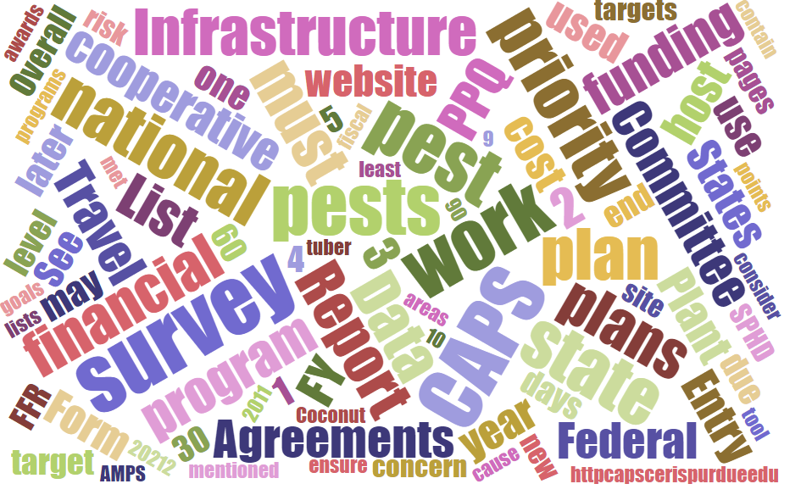



Participants

**National CAPS Committee (NCC) Conference Call**

August 1, 2024

|  |  |  |  |  |  |  |  |
| --- | --- | --- | --- | --- | --- | --- | --- |
|  | Darrell Bays |  | Joanna Fisher |  | Cynthia Kwolek |  | Isaac Powell |
|  | Jake Bodart |  | Leah Granke |  | Amy Mesman |  | Judy Rosovsky |
|  | Brad Danner |  | Tina Gresham |  | Tina Peltier |  | Sven Spichiger |
|  | Charles Elhard |  | Emily Hagan |  | Chelsey Penuel |  |  |
|  |  |  |  |  |  |  |  |
|  | Bonnie Dietrich |  | Mike Hill |  | Colin Funaro |  |  |

## Recap of Changes and Enhancements to CAPS Resource and Collaboration Site

Darrell and Bonnie presented updates and demonstrations showing all the changes and updates to the CAPS site in preparation for the 2025 CAPS survey year. Links to the updated sections are provided below:

Survey Guidelines - [CAPS Survey Guidelines | CAPS (purdue.edu)](https://gcc02.safelinks.protection.outlook.com/?url=https%3A%2F%2Fcaps.ceris.purdue.edu%2Fguidelines%2F2025&data=05%7C02%7Ctina.gresham%40usda.gov%7C887efdbaa8244d079c6d08dca7817d76%7Ced5b36e701ee4ebc867ee03cfa0d4697%7C1%7C0%7C638569421870984920%7CUnknown%7CTWFpbGZsb3d8eyJWIjoiMC4wLjAwMDAiLCJQIjoiV2luMzIiLCJBTiI6Ik1haWwiLCJXVCI6Mn0%3D%7C0%7C%7C%7C&sdata=uj8vi3RS0o4ELnEkZ7RGggM4fckD3Lph1dL4xiYYoak%3D&reserved=0)

Survey Planning - [Survey Planning | CAPS (purdue.edu)](https://gcc02.safelinks.protection.outlook.com/?url=https%3A%2F%2Fcaps.ceris.purdue.edu%2Fsurveyplanning&data=05%7C02%7Ctina.gresham%40usda.gov%7C887efdbaa8244d079c6d08dca7817d76%7Ced5b36e701ee4ebc867ee03cfa0d4697%7C1%7C0%7C638569421870996570%7CUnknown%7CTWFpbGZsb3d8eyJWIjoiMC4wLjAwMDAiLCJQIjoiV2luMzIiLCJBTiI6Ik1haWwiLCJXVCI6Mn0%3D%7C0%7C%7C%7C&sdata=1rkCJ%2BRETEIduEw21gygYT%2FMiccJ5wxmLGa8eGtgdNc%3D&reserved=0)

* From the Survey menu, a Survey Planning **landing page** was created with **Resources** including the Maps and Tables that display the approved survey plan information from previous years in a new visual format. The same information is available in the All-Planned Surveys web report and an excel download file, linked on the landing page.
* Survey Summary Form enhancements:

**For Identifier / Diagnostician** → Browser autofill was disabled and replaced by a saved directory now exists.

* + The user enters Name, Title, and Affiliation once, and the information is saved for use on the Survey Summary Form. To access saved entries, just start typing.

**For Diagnostic Details** → Browser autofill was disabled and replaced by a saved directory now exists.

* + The user enters Contact Name and Contact Email once, and the information is saved for use on the Survey Summary Form. To access saved entries, just start typing (like for add target).
* Financial Plan enhancements:

The designated APHIS Funds amount for an Infrastructure, Combined Surveys, or Individual Surveys Financial Plan is brought in from the Survey Summary Form and used on the Financial Plan page to ensure the Plan does not exceed the Agreement Amount. This is for the APHIS Funds column and Total only. Any amounts entered on the Survey Summary Form or in the Financial Plan for Cooperator Funds are not included in the validation process.

If the APHIS Funds total exceeds the Agreement Amount, a warning will display in red and the Approve button at the top of the page will be disabled.

Approved Methods - [2025 Approved Methods for National Priority Pests (purdue.edu)](https://gcc02.safelinks.protection.outlook.com/?url=https%3A%2F%2Fapprovedmethods.ceris.purdue.edu%2F&data=05%7C02%7Ctina.gresham%40usda.gov%7C887efdbaa8244d079c6d08dca7817d76%7Ced5b36e701ee4ebc867ee03cfa0d4697%7C1%7C0%7C638569421871005191%7CUnknown%7CTWFpbGZsb3d8eyJWIjoiMC4wLjAwMDAiLCJQIjoiV2luMzIiLCJBTiI6Ik1haWwiLCJXVCI6Mn0%3D%7C0%7C%7C%7C&sdata=eKuekH3OMaf0y4RfgKKPy0KbrZHyOi8OxxGEKPD2w3g%3D&reserved=0)

* The 2025 National Priority Pest List has 105 pests because two pests were added to the 2024 list.

|  |  |  |
| --- | --- | --- |
| **Scientific Name** | **Common Name** | **Status** |
| *Diabrotica speciosa* | Cucurbit beetle | Added |
| *Amrasca biguttula* | Indian cotton jassid | Added |

Accountability Report - [Accountability Report | CAPS (purdue.edu)](https://gcc02.safelinks.protection.outlook.com/?url=https%3A%2F%2Fcaps.ceris.purdue.edu%2Faccountability-report&data=05%7C02%7Ctina.gresham%40usda.gov%7C887efdbaa8244d079c6d08dca7817d76%7Ced5b36e701ee4ebc867ee03cfa0d4697%7C1%7C0%7C638569421871010736%7CUnknown%7CTWFpbGZsb3d8eyJWIjoiMC4wLjAwMDAiLCJQIjoiV2luMzIiLCJBTiI6Ik1haWwiLCJXVCI6Mn0%3D%7C0%7C%7C%7C&sdata=OkujcHLHVG4Sy%2FAR6wFDVA%2FW%2BTuBjG9F1AKBJJxCxXE%3D&reserved=0)

* If data is pending, click on the link titled **Edit survey comment** to add description for the delay and date to indicate when the data is expected. [Accountability Report I CAPS (purdue.edu)](https://gcc02.safelinks.protection.outlook.com/?url=https%3A%2F%2Fcaps.ceris.purdue.edu%2Faccountability-report&data=05%7C02%7Ctina.gresham%40usda.gov%7C6c3f11c2e4994977b5ba08dcb19daeb4%7Ced5b36e701ee4ebc867ee03cfa0d4697%7C1%7C0%7C638580538016524080%7CUnknown%7CTWFpbGZsb3d8eyJWIjoiMC4wLjAwMDAiLCJQIjoiV2luMzIiLCJBTiI6Ik1haWwiLCJXVCI6Mn0%3D%7C0%7C%7C%7C&sdata=x8Pw0gNuBG8%2FtSo2ELgrdx9AVegaa%2FbXc82lat6KV4c%3D&reserved=0)
* *This page refreshes every 4 hours. The timestamp of the last refresh is displayed at the bottom of the page. If data is entered into NAPIS or a comment is added/deleted, view the page after the next refresh to verify the results. Refresh times are: 4am, 8am, noon, 4pm, 8pm, and midnight Eastern time.*

Survey Supplies - [Survey Supplies | CAPS (purdue.edu)](https://gcc02.safelinks.protection.outlook.com/?url=https%3A%2F%2Fcaps.ceris.purdue.edu%2Fsurvey-supplies&data=05%7C02%7Ctina.gresham%40usda.gov%7C887efdbaa8244d079c6d08dca7817d76%7Ced5b36e701ee4ebc867ee03cfa0d4697%7C1%7C0%7C638569421871016104%7CUnknown%7CTWFpbGZsb3d8eyJWIjoiMC4wLjAwMDAiLCJQIjoiV2luMzIiLCJBTiI6Ik1haWwiLCJXVCI6Mn0%3D%7C0%7C%7C%7C&sdata=axyP%2BsD%2F9ElD%2BTIyjivXjSckLoK3fQaVj56uAf2QEeo%3D&reserved=0)

* New [Order Form](https://gcc02.safelinks.protection.outlook.com/?url=https%3A%2F%2Fdownload.ceris.purdue.edu%2Ffile%2F4505&data=05%7C02%7Ctina.gresham%40usda.gov%7C887efdbaa8244d079c6d08dca7817d76%7Ced5b36e701ee4ebc867ee03cfa0d4697%7C1%7C0%7C638569421871021284%7CUnknown%7CTWFpbGZsb3d8eyJWIjoiMC4wLjAwMDAiLCJQIjoiV2luMzIiLCJBTiI6Ik1haWwiLCJXVCI6Mn0%3D%7C0%7C%7C%7C&sdata=lLok6qWgqE2jzfX%2FBAM4oiQBv6na1yVz%2FZlL7kM77w4%3D&reserved=0) for new orders placed outside of the ordering open period added to the page states
* "Please us the following form to request additional survey supplies outside of the Survey Supply Ordering System in IPHIS. Send an email to your National Operations Managers for Pest Detection Darrell Bays ([darrell.a.bays@usda.gov](mailto:darrell.a.bays@usda.gov)) cc. National Policy Manager Waleska Ramírez ([waleska.v.ramirez@usda.gov](mailto:waleska.v.ramirez@usda.gov))."
* New [Survey Supplies Best Practices](https://gcc02.safelinks.protection.outlook.com/?url=https%3A%2F%2Fdownload.ceris.purdue.edu%2Ffile%2F4484&data=05%7C02%7Ctina.gresham%40usda.gov%7C887efdbaa8244d079c6d08dca7817d76%7Ced5b36e701ee4ebc867ee03cfa0d4697%7C1%7C0%7C638569421871026444%7CUnknown%7CTWFpbGZsb3d8eyJWIjoiMC4wLjAwMDAiLCJQIjoiV2luMzIiLCJBTiI6Ik1haWwiLCJXVCI6Mn0%3D%7C0%7C%7C%7C&sdata=N%2B4QWL5GSsNpJTMb6AwnStKO7ojeoIrE1bwDaMPV3wA%3D&reserved=0) document added.

The **Download Plan Data PDF** is now on the Survey Planning site in the Links menu.

* Please inform your states and let CAPS Information Services know if you would like to request any formatting changes or additions to the document. [Survey Planning (purdue.edu)](https://gcc02.safelinks.protection.outlook.com/?url=https%3A%2F%2Fpest.ceris.purdue.edu%2Fservices%2Fsurveyplanning%2F&data=05%7C02%7Ctina.gresham%40usda.gov%7C6c3f11c2e4994977b5ba08dcb19daeb4%7Ced5b36e701ee4ebc867ee03cfa0d4697%7C1%7C0%7C638580538016516541%7CUnknown%7CTWFpbGZsb3d8eyJWIjoiMC4wLjAwMDAiLCJQIjoiV2luMzIiLCJBTiI6Ik1haWwiLCJXVCI6Mn0%3D%7C0%7C%7C%7C&sdata=2B52uftMgZ8NMs7F791MBx03AyI8Nolzw0t7GKWan6k%3D&reserved=0)

## CAPS Agreement Updates:

* We have temporarily suspended access to the FY 2025 CAPS survey summary form, as we do not have confirmation on CAPS agreement funding levels yet. The funding situation is complicated this year and PPQ is looking at all FY 2025 agreements (including CAPS). Our APHIS Administrator and PPQ Deputy Administrator spoke at NPB and explained the possible funding scenarios that could play out and possible reductions. We don’t have firm answers yet, so we took down the FY25 CAPS survey summary form to avoid anyone completing their planning, and then having to do it all over again if the agreement amounts change. As soon as we know more, we will keep you informed.

## NCC FY 2025 Annual Meeting Planning:

* Thanks for everyone’s quick response to the poll for possible meeting dates. February 11-12 (with travel days on February 10 and 13) had the most votes. Pencil this in on your calendars. We received many suggestions for next year’s meeting location, including several that might be easier and/or less expensive for air travel. Tina will follow up with a poll for location voting.

## Discussion - 60% Priority Pest Threshold Calculation:

* Continuation of discussion from July NCC meeting – Tina asked the NCC about Commitment 6 from the 2024 NCC meeting notes, if a decision had been made regarding how the 60% threshold would be calculated. Since then, Bonnie has helped clarify that the current calculation adopted uses the total national priority pests (surveys combined), rather than the total from each individual survey. Bonnie provided the graphic below to further illustrate.
* Chelsey pointed out that this calculation method can be problematic if a state has the same pest in more than one survey. When the same pest is listed in more than one survey, the pest is only counted once in the new calculation, thus artificially reducing the overall % priority pest value. We are open to suggestions for how to deal with this unique situation and ensure the final % priority pest value better represents the actual survey effort in that state.

