|  |  |
| --- | --- |
| A picture of a winding road and trees  National Caps committee | **FY 2024 Annual Meeting - Notes**  **January 30 – 31, 2024**  **Hosted by the Louisiana Department of Agriculture** |

Purpose: 3

Expected Outcomes: 3

Program Decisions to be Discussed: 3

Participants 3

Meeting Introduction 4

Ice Breaker 4

Group Introductions 5

Meeting Agenda Review and Outcomes 5

National Priority Pest List 5

Updates to National Priority Pest List 6

Commitment 1: Science and Technology (S&T) will determine cooperator access to PestLens, specifically to review and access Objective Prioritization of Exotic Pests (OPEP). 7

Commitment 2: the Pest Detection Cross Functional Working group will determine if an open comment period should exist of OPEPs for the broader CAPS Community. 7

Commitment 3: National Identification Service will be invited to the monthly NCC meeting to discuss their approach to the survey and diagnostic assessment review. 7

NCC Discusses Streamlining Mollusk Priority Pest Procedures 7

Commitment four: Science and Technology will draft a single mollusk approved methods page which includes the following 12 pests and once developed the PD CFWG will work to ensure the NCC can review the drafted Mollusk Page. 8

Performance Measures 9

Commitment 5: CAPSIS will work to provide NCC members access to the draft visualization for the 60% threshold. 11

Commitment 6: NCC members will lead discussions with their constituents to obtain feedback regarding the 60% threshold. 11

Survey Summary Form 12

Commitment 7: the PD CFWG will work with CAPSIS to explore the use of an address book in the Survey Summary Form. 12

FY2025 – Optional One-Agreement for CAPS Work 12

Ice Breaker 12

NCC – Document Review 13

CAPS Outreach Discussion 13

Commitment 8 – Crowe to continue discussion with Agriculture Communications teams. 15

Preliminary ID Update and Conversation 15

ARM 15

IPHIS and Survey Supply 16

# Purpose:

The purpose of this 2-day meeting is to bring together National CAPS Committee (NCC) members, share program information and updates, revisiting what makes a priority pest and strategies to maintain the priority pest list, and to make program decisions accordingly.

# Expected Outcomes:

Share Relevant Information:

* New NCC Member Rotations
* CAPS Program Updates
* CAPS Information System Update
* PPA 7721 Updates
* Preliminary Identification Plans
* FY24 Pest Detection CFWG Plans
* Distribution Maps
* Performance Measures
* Survey and Diagnostic Assessment
* Site Descriptors
* Science & Technology Updates

# Program Decisions to be Discussed:

* How can we better manage the National Priority Pest List?
  + Discussion of historical information on the issue.
  + Review how pests go on and off the National Priority Pest List.

# Participants

|  |  |  |
| --- | --- | --- |
| **Attendee** | **Organization and Title** | **Present** |
| John Crowe | PPQ EDP - National Policy Manager | Yes |
| Darrell Bays | PPQ FO - National Operations Manager | Yes |
| Laurie Morales | PPQ FO - National Operations Manager | Yes |
| Leah Granke | PPQ S&T – Assistant Director | Yes |
| Jake Bodart | PPQ FO - SPHD Representative – OR | Yes |
| Amy Mesman | PPQ FO SPHD Representative – ND and SD | Yes |
| Judy Rosovsky | Eastern Plant Board SPRO Representative - VT | Yes |
| Tina Peltier | Southern Plant Board SPRO Representative - LA | Yes |
| Charles Elhard | Central Plant Board SPRO Representative - ND | Yes |
| Sven Spichiger | Western Plant Board SPRO Representative - WA | Yes |
| Emily Hagen | PPQ FO PSS Representative – AZ and NM | Yes |
| Isaac Powell | PPQ FO PSS Representative – NC | Yes |
| Cindy Kwolek | Eastern Plant Board SSC Representative - RI | No |
| Brad Danner | Southern Plant Board SSC Representative - FL | Yes |
| Chelsey Penuel | Central Plant Board SSC Representative - MN | Yes |
| Joanna Fisher | Western Plant Board SSC Representative - CA | Yes |
| Tina Gresham | National Policy Manager | Yes |
| Bonnie Dietrich | CAPSIS Team – Project Coordinator – Purdue | Yes |
| Jeff Hash | PPQ FO - Director of Operations | No |
| Colin Funaro | PPQ S&T CAPS Support – Risk Analyst | Yes |
| Patrick Haslem | National Policy Manger | Yes |
| Jo-Ann Bentz-Blanco | PPQ EDP Director of the Pest Surveillance and Emergency Management unit | Yes |
| Kevin Bigsby | PPQ S&T –Assistant Director | Yes |

**Tuesday, January 30, 2024 – Day #1 of the meeting**

**Location:**

Louisiana Department of Agriculture and Forestry

Training Room

5825 Florida Blvd

Baton Rouge, LA 70806

Meeting started at 8:00 am Central Time.

# Meeting Introduction

This meeting convened members of the NCC on January 30 and 31, 2024 to discuss critical topics related to the Plant Protection and Quarantine (PPQ) cooperative programs and ensure effective pest detection and management strategies. The agenda covered a wide range of updates and collaborative efforts, including welcoming new NCC members, reviewing CAPS program developments, exploring the upgraded CAPS Information System, and receiving insights on PPA 7721 updates. Additionally, discussions focused on preliminary identification plans for pest threats, FY24 plans for the Cooperative Federal-State Working Group for Pest Detection, and the utilization of distribution maps and performance measures. Participants also delved into survey and diagnostic assessments, site descriptors, and the latest advancements in science and technology relevant to pest management. This comprehensive meeting aimed to foster collaboration, share crucial information, and drive progress towards safeguarding agricultural resources and mitigating pest risks.

## Ice Breaker

To break the ice and foster connections among NCC members, we kicked off the meeting with a fun and engaging activity. This year's icebreaker focused on getting to know each other on a deeper level, beyond professional titles and roles. We paired off and encouraged participants to share unique experiences, hidden talents, or other life events that they have in common. The lighthearted atmosphere sparked laughter, facilitated conversation, and helped us build rapport, establishing a foundation for stronger collaboration throughout the meeting.

## Group Introductions

The meeting commenced with warm welcomes extended to our newest National Cooperating Committee (NCC) members. We're delighted to have their diverse expertise and perspectives enrich our collaborative efforts. They briefly introduced themselves, sharing their backgrounds and roles within the organization. This exchange initiated a friendly atmosphere of open communication and laid the foundation for productive discussions throughout the meeting.

## Meeting Agenda Review and Outcomes

Crowe led a facilitated conversation about outcomes. The NCC agreed to the following expected outcomes:

* 1. Agreement on the National Priority Pest List
  2. Improved understanding of National Priority Pests
  3. Bylaw changes would be completed
  4. Improved NCC Connections
  5. Provide creative solutions
  6. Open discussion about a One-Agreement approach

The meeting agenda was reviewed and additional topics were sought, there were a few additional topics added to the agenda including:

* Pest Detection Guidelines overview
* Review of CAPS Collaboration site and changing of the menu related to survey.
* A general discussion about 5 lures to a package was brought up vs the 1 lure per package. This was not addressed at the meeting; though SSPP will follow up directly with NCC member of concern.

# National Priority Pest List

Funaro led a discussion focused on proposed updates to the National Priority Pest List. Funaro reviewed the process and requirements for PPQ adding or removing National Priority Pests. Funaro presented the following information:



## Updates to National Priority Pest List

* 1. No removals
  2. Discussion for the re-addition of *Diabrotica speciosa*

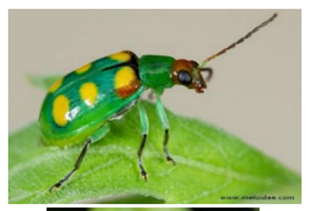

* + 1. Revised OPEP moves the impact rating from 1D (moderate) to 1C (High)
       1. It’s been causing fairly serious damage in South America
    2. CAPS Surveys have continued for this pest even after its removal in 2023

The NCC had a robust discussion about the review of the OPEP assessments and making them available to a broader community. PPQ asserted that the OPEP assessments can be shared when requested and the NCC didn’t feel this was always enough or in the nature of cooperator.  This conversation led to commitment one and two below.

Similarly, the survey and diagnostic assessment process and availability of the review process brought a great deal of discussion from NCC members. There is a general concern that the process may not be robust enough to ensure identification institutions which perform substantial identification are given an opportunity to provide input. The conversation led to commitment 3 to further discuss the NIS process on completing these assessments.

### Commitment 1: Science and Technology (S&T) will determine cooperator access to PestLens, specifically to review and access Objective Prioritization of Exotic Pests (OPEP).

### Commitment 2: the Pest Detection Cross Functional Working group will determine if an open comment period should exist of Survey and Diagnostic Assessments for the broader CAPS Community.

### Commitment 3: National Identification Service will be invited to the monthly NCC meeting to discuss their approach to the survey and diagnostic assessment review.

# NCC Discusses Streamlining Mollusk Priority Pest Procedures

**Inconsistencies in National Priority Pest List:**

* Crowe highlighted inconsistencies in applying pests to the National Priority Pest List, particularly for mollusks.
* The current process involves OPEP assessments, survey & diagnostic approvals, NCC review, and PD CFWG approval.

**Mollusks as a Case Study:**

* No OPEP exists for mollusks, and current survey methods are identical (visual observation).
* The Mollusk CFWG is revising New Pest Response guidelines, including a more detailed survey methodology section.

**Proposed Change:**

* Develop a single, approved methods page for mollusks referencing the updated New Pest Response Guides.
* These guides, managed by the Mollusk CFWG, provide more current biological information, survey methods, and optimal timing recommendations.

**NCC Feedback:**

* NCC agreed to consider the change, shifting the existing 12 mollusk methods pages to a single one.
* They requested a draft for review with their constituents to ensure clarity and alignment.

**Next Steps:**

* Develop a draft single-page document summarizing approved methods for mollusk pests.
* Share the draft with NCC for review and feedback.
* Finalize the document based on NCC input and consider implementation for FY 2025.

**Additional Notes:**

* You may want to include the rationale behind the proposed change, such as efficiency, clarity, or consistency.
* Briefly mention the potential benefits of this approach, like reducing redundancy and simplifying procedures.
* Consider including a timeline for developing and finalizing the single-page document.

### Commitment four: Science and Technology will draft a single mollusk approved methods page which includes the following 12 pests and once developed the PD CFWG will work to ensure the NCC can review the drafted Mollusk Page.

|  |  |  |  |
| --- | --- | --- | --- |
| Approved Methods Link | *Scientific Name* | Common Name | Survey Method |
| [Approved Methods](https://approvedmethods.ceris.purdue.edu/sheet/2060) | *Cernuella virgata* | Maritime garden snail | Visual |
| [Approved Methods](https://approvedmethods.ceris.purdue.edu/sheet/1688) | *Cochlicella* spp. | Cochlicellid snails | Visual |
| [Approved Methods](https://approvedmethods.ceris.purdue.edu/sheet/1884) | *Belocaulus* spp. | Leatherleaf slugs | Visual |
| [Approved Methods](https://approvedmethods.ceris.purdue.edu/sheet/2059) | *Cernuella* spp. | Hygromiid snails | Visual |
| [Approved Methods](https://approvedmethods.ceris.purdue.edu/sheet/1886) | *Colosius* spp. | Leatherleaf slugs | Visual |
| [Approved Methods](https://approvedmethods.ceris.purdue.edu/sheet/1888) | *Laevicaulis* spp. | Leatherleaf slugs | Visual |
| [Approved Methods](https://approvedmethods.ceris.purdue.edu/sheet/1702) | *Lissachatina fulica* | Giant African snail | Visual |
| [Approved Methods](https://approvedmethods.ceris.purdue.edu/sheet/1703) | *Meghimatium pictum* | Chinese slug | Visual |
| [Approved Methods](https://approvedmethods.ceris.purdue.edu/sheet/2057) | *Monacha* spp. | Hygromiid snails | Visual |
| [Approved Methods](https://approvedmethods.ceris.purdue.edu/sheet/1891) | *Sarasinula* spp. | Leatherleaf slugs | Visual |
| [Approved Methods](https://approvedmethods.ceris.purdue.edu/sheet/1892) | *Semperula* spp. | Leatherleaf slugs | Visual |
| [Approved Methods](https://approvedmethods.ceris.purdue.edu/sheet/31) | *Veronicella* spp. | Leatherleaf slugs | Visual |

# Performance Measures

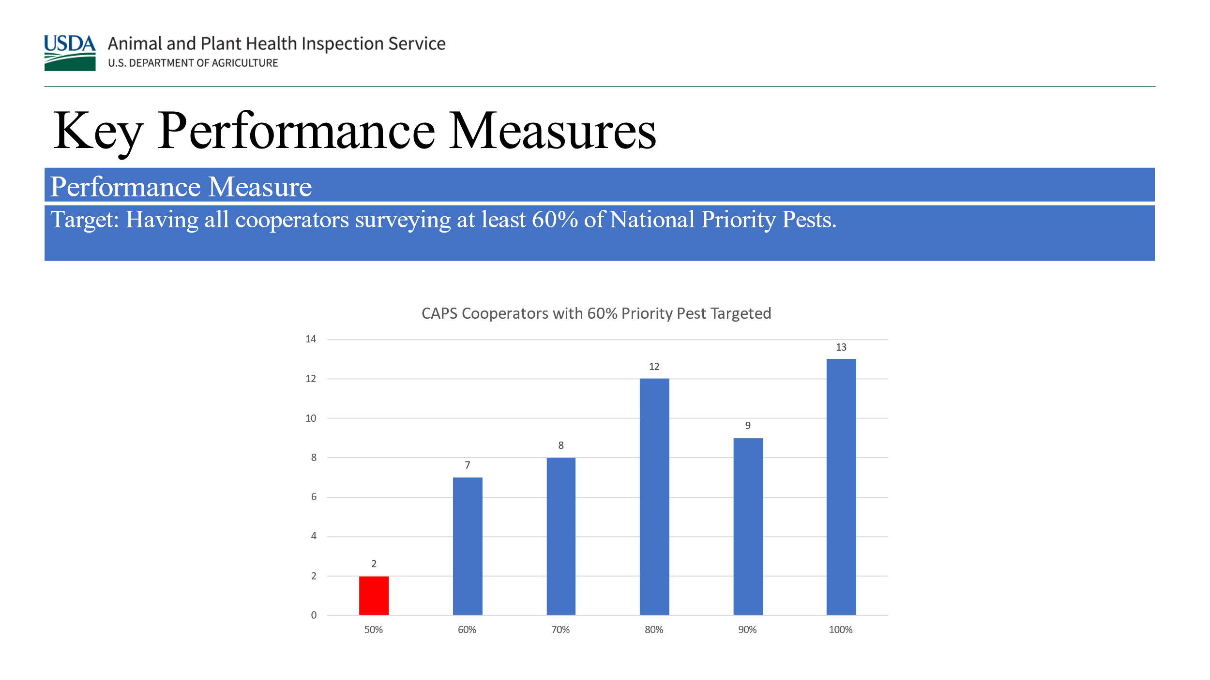

 Dietrich led a discussion seeking feedback on a new performance measure visualization based on the 60% threshold per survey. This aims to assess compliance with the FY 2024 CAPS Guidelines, which require 60% of pests surveyed to be National Priority Pests.

Current Challenge:

The existing visualization relies on data from the Survey Summary form, which can be restrictive. **Each survey** must have 60% National Priority Pests, limiting flexibility for cooperators.

$$\frac{Survey 1 National Prioity Pests }{\left(National Prioirty Pests+Pests of State Concern\right)-\left(No Costs Pests\right)}>60\%$$

$$\frac{Survey 2 National Prioity Pests }{\left(National Prioirty Pests+Pests of State Concern\right)-\left(No Costs Pests\right)}>60\%$$

Proposed Change:

The PD CFWG proposes a new approach that considers a cooperator's **total pest list** across all surveys, instead of individual surveys. This provides more flexibility while ensuring the 60% target is still met.

$$\frac{Total National Prioirty Pests}{\left(National Prioirty Pests+Pests of State Concern\right)-(No Costs Pests)}$$

Benefits:

* Increased flexibility for cooperators in designing and implementing surveys.
* Improved accuracy in reflecting overall compliance with the 60% threshold.
* Enhanced collaboration and transparency by making the visualization available to relevant stakeholders.

Next Steps:

* NCC members will gather feedback from their constituents on the proposed change.
* FY 2025 CAPS Guidelines will be amended if the change is accepted.
* It is crucial to emphasize that the visualization and calculations are based on planned surveys, excluding detection information.

### Commitment 5: CAPSIS will work to provide NCC members access to the draft visualization for the 60% threshold.

### Commitment 6: NCC members will lead discussions with their constituents to obtain feedback regarding the 60% threshold.

**1.** Flexibility vs. Specificity:

* **Current Requirement:** Each named survey must have 60% National Priority Pests (NPPs).
* **Proposed Change:** Consider a cooperator's total pest list across all surveys, allowing flexibility in survey design while ensuring 60% NPPs overall.
* **Focus Points for Discussion:**
  + Will this change offer sufficient flexibility without compromising the focus on NPP detection?
  + Are there concerns about potential inconsistencies in application across different states/regions?

2. Transparency and Collaboration:

* **Proposed Action:** Share the 60% threshold performance measure visualization with SPHD, SPRO, PSS, and SSCs.
* **Benefits:** Increased transparency, collaboration, and data-driven decision-making.
* **Focus Points for Discussion:**
  + Are there any concerns about data privacy or misuse of the information?
  + How can this information be used effectively for collaborative efforts and improvement?

Additional Notes:

* Clearly communicate that the change represents a deviation from the current "60% per survey" requirement.
* Emphasize that the visualization uses planned survey data, not detection information.
* Consider including a timeline for potential implementation and any further feedback mechanisms.

Remember, the goal is to gather constructive feedback from your constituents to inform a decision that balances flexibility, accuracy, transparency, and collaboration.

# Survey Summary Form

The National Cooperating Committee (NCC) engaged in a discussion regarding the revised survey summary form and the challenges encountered in its implementation. Specifically, concerns were raised around the identification section, where adding names proved difficult and led to confusion and user frustration.

Further details regarding the specific difficulties encountered and any proposed solutions or suggestions for improvement would be valuable additions to the meeting notes for future reference and action.

### Commitment 7: the PD CFWG will work with CAPSIS to explore the use of an address book in the Survey Summary Form.

# FY2025 – Optional One-Agreement for CAPS Work

* Bodart presented ongoing efforts to develop an **optional** one-agreement for combining CAPS survey and infrastructure work and financial plans.
* State feedback indicated potential for reduced administrative burden through this approach.
* A **subcommittee of NCC members** has been formed to draft a template for review.
* **Important points:**
  + **No mandatory use:** States can choose this option if it aligns with their needs.
  + **Audit compliance:** Standard record keeping for claims remains essential.
  + **Target implementation:** 2025 CAPS cycle.

**Next Steps:**

* Subcommittee continues developing the template.
* Template will be presented for NCC review and feedback.
* Finalized template will be made available for states to choose if desired.

**Wednesday, January 31, 2024 – Day #2 of the meeting**

**Location:**

Louisiana Department of Agriculture and Forestry

Training Room

5825 Florida Blvd

Baton Rouge, LA 70806

# Ice Breaker

In a lighthearted departure from tradition, day 2 of the NCC meeting kicked off with a unique icebreaker: the spaghetti and marshmallow challenge! We divided into teams, participants were tasked with constructing the tallest freestanding structure using only spaghetti and marshmallows. The room buzzed with laughter and collaborative energy as teams strategized, built, and supported each other's creations. While structures varied in height and stability, the exercise served a more profound purpose: fostering teamwork, communication, and problem-solving in a fun and unexpected way. Beyond the playful competition, the shared experience built camaraderie and set a positive tone for the day's discussions, reminding us that even the most serious endeavors can benefit from a touch of creativity and collaboration.

# NCC – Document Review

NCC members reviewed current by-laws and roles and responsibilities document. No substantive changes were suggested, though several edits to improve readability will be made and posted. The document titled “Comparison of Duties and Tasks of State and Federal CAPS Personnel” was also discussed. The NCC came to consensus that the table titled "Comparison of Duties and Tasks of State and Federal CAPS Personnel” will no longer be used and removed from the CAPS Collaboration site.

# CAPS Outreach Discussion

Crowe lead a discussion on current messaging on outreach conducted and expectations from the FY 2024 CAPS Guidelines

Outreach

The CAPS program encourages cooperators to be creative with outreach to the public. Outreach funded by CAPS should focus on conveying information about National Priority Pests. Cooperators should consider metrics to measure the effectiveness of outreach including, but not limited to, increased access to property for the purpose of survey, proportion of industry visited, and new pest reporting. Currently, the accomplishment report includes the number of interviews conducted, publications developed, and outreach materials and publications distributed.

Current Accomplishment Report CAPS infrastructure FY 2024:

Compare actual accomplishments to objectives established as indicated in the work plan. When the output can be quantified, a computation of cost per unit is required when useful.*(Use a narrative or insert tables to document completed work. Document work accomplished by the cooperator, as determined by the objectives in the work plan).

Activities:

* Pest Detection / CAPS Survey Work:
* Other APHIS or State Survey Work:
* Committee Service

Outreach and Education:

* Interviews (TV/Radio/Newspaper/Magazines):
* Outreach materials (Pamphlets/ brochures/ posters):
* Publications:
* Public Service Announcements (PSA):

Meetings:

* Conference calls:
* Conferences:
* Webinars

Crowe asked if there is a way to report these efforts or to support existing outreach campaigns.

|  |  |  |  |
| --- | --- | --- | --- |
|  | Low Pest Reports | High Pest Reports | Higher Hours |
| Hours Worked Developing replies | 10 | 10 | 100 |
| Hours Worked Developing messaging | 20 | 20 | 20 |
| Hours work Delivering messaging | 100 | 100 | 100 |
| Number of unique Individual reporting pests | 1000 | 10000 | 1000 |
| Number of unique pests reported | 20 | 200 | 20 |
|  | Sum Hours / Sum Number | Sum Hours / Sum Number | Sum Hours / Sum Number |
| Efficiency | 0.12745098 | 0.012745098 | 0.215686 |
|  |  |  |  |

Summary:

* Discussion focused on supporting outreach activities within the CAPS program and exploring options for more comprehensive measurement.
* No consensus was reached on advocating for a single national outreach campaign.
* Concerns raised:
  + Potential for the SSC position to shift focus towards outreach specialization.
  + Cyclical nature of pest reports impacting outreach effectiveness.
* Next Steps:
  + Crowe will continue communication with state departments of agriculture.
  + Washington State's existing approach will serve as a starting point for further discussion.
  + A committee will be established to explore:
    - Supporting outreach efforts within CAPS.
    - Developing more meaningful ways to measure and report outreach activities.

### Commitment 8 – Crowe to continue discussion with Agriculture Communications teams.

## Preliminary ID Update and Conversation

Discussion Leader: Haslem

Summary:

* The importance of accurate sample volume estimates for diagnostic lab preparation was highlighted, impacting readiness and resource allocation.
* A key issue identified was infrequent sample submission from some surveys, leading to delayed data and confirmation.
* Ideas for improvement:
  + Develop a communication framework to encourage more frequent sample submissions.
  + Establish best practices and guidelines at the beginning of each survey season.
  + Include specific wording in the work plan emphasizing timely sample submission.

# ARM

Gresham led a discussion on ARM, which is an IT system used to document and communicate domestic pest detections of regulatory concern. It is also used to document and communicate regulatory actions that may stem from those pest detections. There are several modules to the ARM system but the focus of the discussion was on the domestic module that directly supports domestic program activities.

Tina leads a working group comprised of individuals from all core functional areas within PPQ who have expertise and/or an interest in improving the domestic ARM module. It was the last module to be developed for PPQ, and it was sort of created in the image of the modules that came before it. It’s workflow and attributes haven’t really been a good fit for domestic programs, and it wasn’t initially well received.

The ARM domestic working group is tasked with identifying system improvements and working with the developer to make the necessary system updates. We are working on a 3-year timeline for these system enhancements, with more than 50% of the identified system improvements happening in FY 2024.

The domestic working group is also leading the effort to test the system enhancements to ensure they meet user needs and expectations. We expect to be working in the development and testing mode through June. Once completed, this group will turn it’s efforts to outreach and providing education and guidance resources to domestic programs.

Given the nature of the ARM system, its span across multiple functions within PPQ, and the vast amount of sensitive information it houses, extending access to non-PPQ cooperators is not possible.

We are working to incorporate system enhancements that will facilitate information sharing with non-PPQ cooperators. These are a few examples of improvements completed in FY 2023:

* Enabled ability to upload data directly from a fillable PPQ Form 391 (Specimens for Determination) form into ARM when creating a new diagnostic request; this may facilitate faster and more accurate diagnostic requests being created by SPHD offices.
* Added data fields to capture sample submitter’s name, contact information, and affiliation on the diagnostic request; this may facilitate communication about who completed the preliminary ID and requested that the sample be submitted to PPQ for confirmatory ID.

Improvements coming in FY 2024:

* The ARM system will automatically generate a PPQ Form 391-like output after confirmatory ID has been completed. This will contain all salient information about the sample (such as collection, collector, interception site, submitter, preliminary ID, and confirmatory ID). This .pdf will be attached to all confirmatory notifications. This will be particularly helpful for non-PPQ cooperators so they can have this information at their fingertips without access to ARM.
* Create the ability to bulk upload data for up to 300 diagnostic requests at a time. This will be particularly useful for situations where you have multiple samples from the same interception site, same date, etcetera. Ultimately this option will speed up the process of submitting bulk diagnostic requests.

Improvements proposed for FY 2025:

* Contingent upon garnering internal PPQ approvals and funding, we propose to create an ARM portal for non-PPQ cooperators to submit a PPQ 391 Form into ARM, which will initiate the process for creating a diagnostic request. Submitting the form into the portal would auto-generate an email to the appropriate SPHD office, alerting them there is a request pending their attention. Likewise, the system would send an email to the submitter letting them know it was completed and would provide them the DR # for reference.

## IPHIS and Survey Supply

The SSPP manages an IT portal for PPQ employees and non-PPQ cooperators to place orders for survey supplies. This system is also used for inventory management and order fulfillment. It is part of the IPHIS system (Integrated Plant Health Information System), which has been around for 12ish years, and is coming to the end of its lifecycle. We will be transitioning the IPHIS survey supply module to a new platform in the next 2 to 5 years. We are evaluating Service Now as a suitable replacement system. One major benefit would be that many users would have a single access point and a single login for both PPQ 7721 suggestions, and or ordering survey supplies. We are in the very early stages of this process and will keep you updated as new information becomes available.

**Thursday, February 1, 2024 - Travel Day Home**

Photos

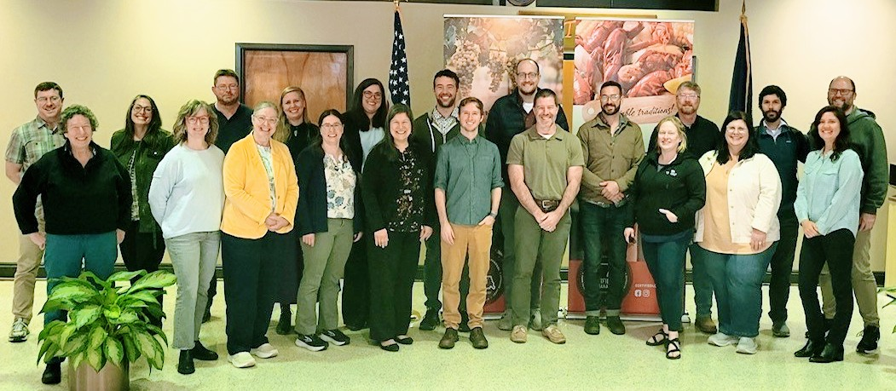

Figure 1 - National Cooperative Agriculture Pest Survey Committee – Front row from left to right, Judy Rosovsky, Amy Mesman, Jo-Ann Bentz-Blanco, Joanna Fisher, Laurie Morales, Jake Bodart, Brad Danner, (space), Chelsey Penuel, Tina Peltier, and Bonnie Dietrich. Second Row from Left to Right Patrick Haslem, Tina Peltier, Sven Spichiger, Emily Hagen, Leah Granke, Charles Elhart, Colin Funaro, Isaac Powell, Darrell Bays, Kevin Bigsby, and John Crowe

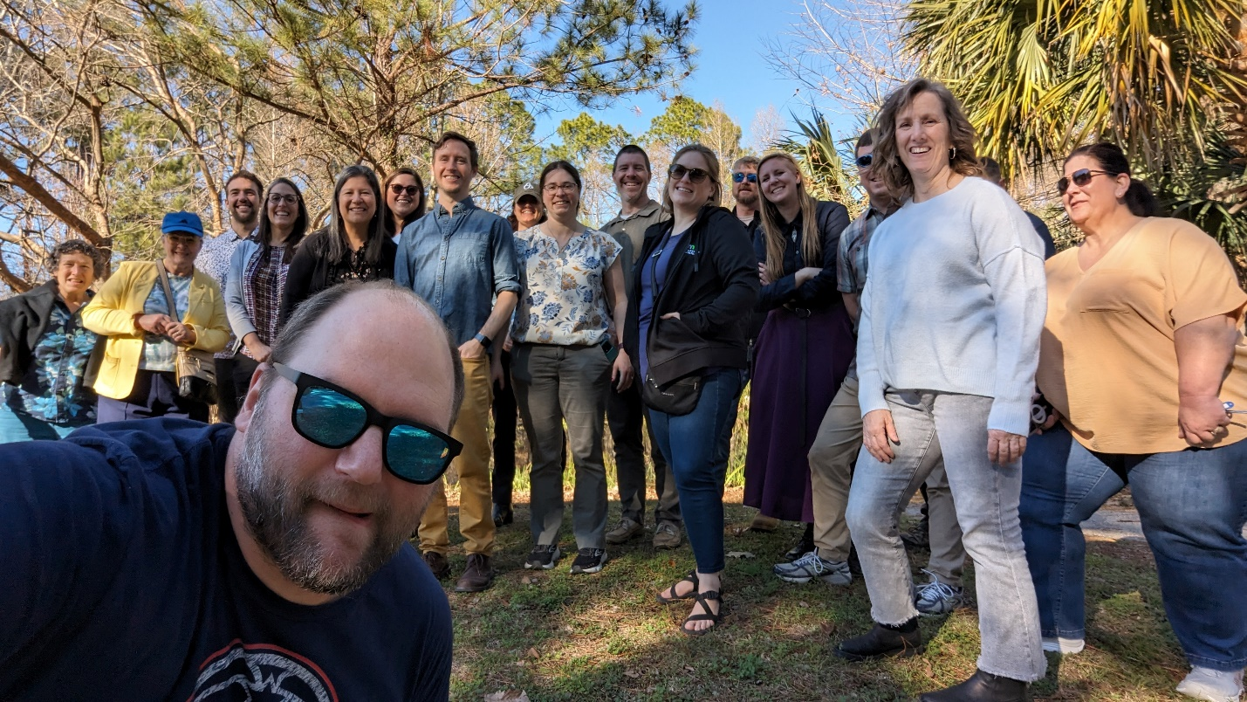

Figure 2 - NCC Field Trip Fore Ground John Crowe; First row from right to left, Amy Mesman, Chelsey Penuel, Joanna Fisher, Jake Bodart, Laurie Morales, Tina Gresham, Jo-Ann Bentz-Blanco. Second row from right to left Tina Peltier, Patrick Haslem (partially obstructed) Sven Spichiger (obstructed), Darrell Bays, Brad Danner, Bonnie Dietrich, Leah Granke, Charles Elhart, and Judy Rosovsky