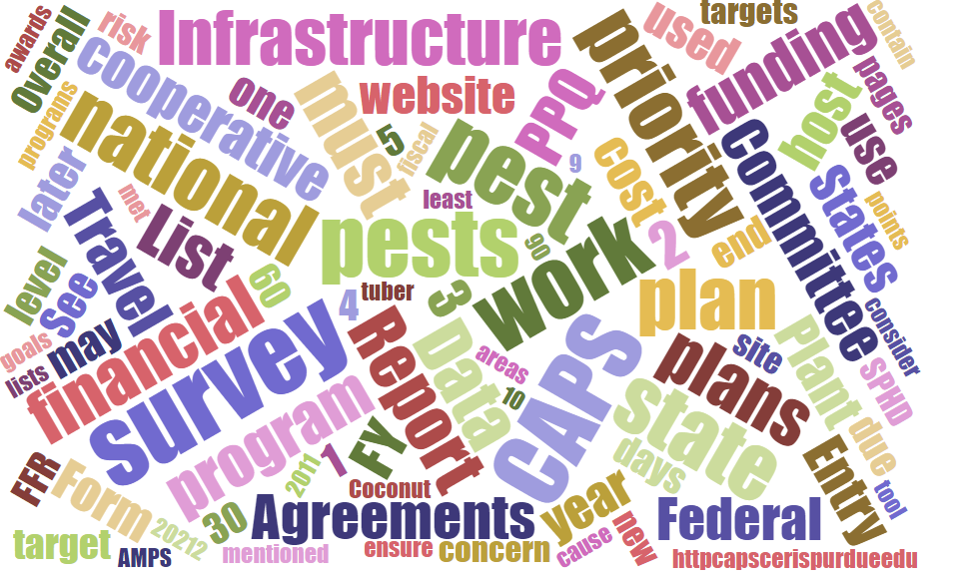



Participants

**National CAPS Committee (NCC) Conference Call**

October 3, 2024

|  |  |  |  |  |  |  |  |
| --- | --- | --- | --- | --- | --- | --- | --- |
|  | Darrell Bays |  | Joanna Fisher |  | Cynthia Kwolek |  | Isaac Powell |
|  | Jake Bodart |  | Leah Granke |  | Amy Mesman |  | Judy Rosovsky |
|  | Brad Danner |  | Tina Gresham |  | Tina Peltier |  | Sven Spichiger |
|  | Charles Elhard |  | Emily Hagan |  | Chelsey Penuel |  |  |
|  |  |  |  |  |  |  |  |
|  | Bonnie Dietrich |  | Mike Hill |  | Colin Funaro |  | Matthew Howle |

## Introductions and Welcome

We welcomed Matthew Howle, a State Survey Coordinator located at Clemson University in South Carolina. Matt will be replacing Brad Danner as the NCC Southern Plant Board Representative. Welcome, Matt! Thank you for volunteering to support the NCC and we look forward to working with you.

## 2025 CAPS Survey Summary Form

Darrell Bays reminded everyone that the 2025 CAPS survey summary form will close October 5, 2024. He asked if anyone had problems or questions about completing the form since we revised the agreement amounts and there were none reported.

## NCC FY 2025 Annual Meeting Planning:

Plans for the 2025 annual NCC meeting are coming along. The meeting will be held in Phoenix, AZ February 11-12. We have a great field trip lined up for the afternoon of February 12. Stay tuned for more information regarding meeting logistics.

## Bat Bycatch

Tina Gresham shared a recent report of a northern long eared bat (an endangered species) being caught and killed in a plastic bucket trap. She polled the attendees if they’ve encountered any bat bycatch in their states, but none were reported. She will follow up all state plant health directors to determine whether the bat bycatch was a fluke or a wider issue.

Tina reminded the NCC and their constituents to please alert PPQ as soon as possible if an endangered species is caught during trapping or survey activities.

## Calculating the 60% Priority Pest Threshold

Judy Rosovsky asked if there was any further discussion around how we are calculating the 60% threshold for priority pests. The last discussion happened in the August meeting where we confirmed the calculation uses the total national priority pests (surveys combined), rather than the total from each individual survey. Bonnie provided the graphic below to further illustrate.

We acknowledge the calculation can be problematic if a state has the same pest in more than one survey. When the same pest is listed in more than one survey, the pest is only counted once in the new calculation, thus artificially reducing the overall % priority pest value. We are open to suggestions for how to deal with this unique situation, and regarding the treatment of no cost pests in the formula, to ensure the final % priority pest value better represents the actual survey effort in a state.

We also made note to update the 2026 CAPS Guidelines to clarify the calculation is done by pest, not by survey.

