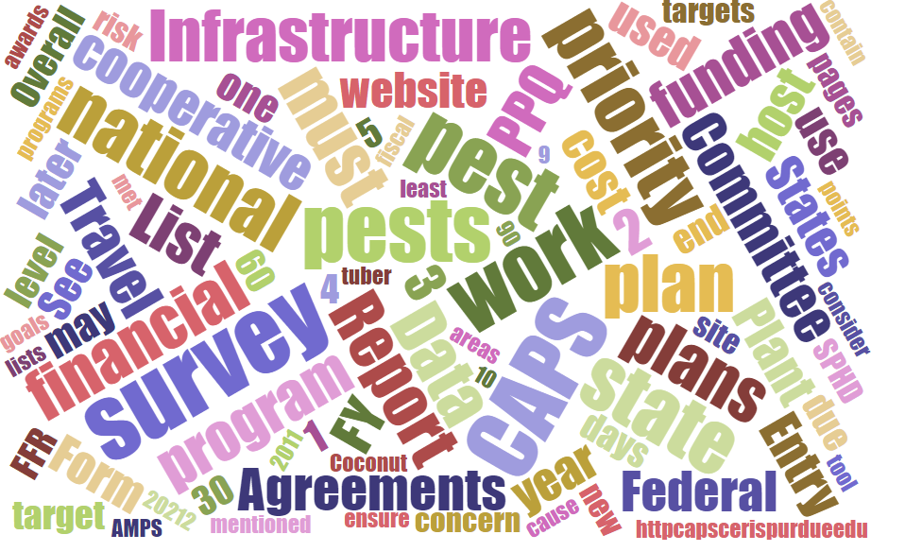



Participants

**National CAPS Committee (NCC) Conference Call**

November 7, 2024

|  |  |  |  |  |  |  |  |
| --- | --- | --- | --- | --- | --- | --- | --- |
|  | Darrell Bays |  | Joanna Fisher |  | Cynthia Kwolek |  | Isaac Powell |
|  | Jake Bodart |  | Leah Granke |  | Amy Mesman |  | Judy Rosovsky |
|  | Brad Danner |  | Tina Gresham |  | Tina Peltier |  | Sven Spichiger |
|  | Charles Elhard |  | Emily Hagan |  | Chelsey Penuel |  |  |
|  |  |  |  |  |  |  |  |
|  | Bonnie Dietrich |  | Mike Hill |  | Colin Funaro |  | Matthew Howle |

## The following CAPS Datasheets have been revised and updated:

* + [Globodera pallida](https://approvedmethods.ceris.purdue.edu/sheet/122) (Pale cyst nematode) finalized 06/24/2024
  + [Ralstonia solanacearum race 3 biovar 2](https://approvedmethods.ceris.purdue.edu/sheet/1919) (Bacterial wilt; Southern bacterial wilt) finalized 7/24/2024
  + [Ca. Phytoplasma phoenicium](https://approvedmethods.ceris.purdue.edu/sheet/1939) (Almond witches' broom) finalized 09/24/2024
  + Reach out to Colin Funaro if you have any questions.

## NCC members confirmed for a second 3-year term:

* Emily Hagen, Cynthia Kwolek, and Tina Peltier
* Watch for an updated 2025 NCC membership chart – please let Tina Gresham know if any corrections are needed

## Supply ordering period extended to November 15th:

* It appears the email only went out to PSSs, please help spread the word!

## Bucket trap mesh modification experiment underway:

* We are looking at the type of screening that can be used in a bucket trap to keep samples from getting waterlogged. PPQ is working with Joe Francese at the Forest Pest Methods Laboratory (FPML) to do an experiment with different mesh and screening types after a surveyor in Pennsylvania found that using a finer mesh seemed to reduce bee bycatch. Not sure why the mesh would have this effect, but it was intriguing enough to pursue further.
* CA and MN might be interested in participating in the experiment. Colin will put Joanna Fisher and Chelsey Penuel in touch with Joe Francese to receive firsthand guidance.

## CAPSIS updates:

* Fall is a busy time for data entry. Reach out to Bonnie Dietrich if you are having any issues.
* The CAPSIS team has moved offices. Some servers have moved to the Purdue campus. The move shouldn’t impact CAPSIS but reach out if you run into any issues or oddities.

## Round Robin with SCCs and SPROs:

* We used the rest of our meeting time to do a round robin for updates from regional representatives (SCCs and SPROs), and to hear their thoughts on the question: What is most important for you to get from these monthly NCC meetings?
* These were some of the major takeaways:
  + CAPS funding updates are always appreciated
  + CAPSIS updates
  + Can PPQ provide an update on filling the vacant PSS positions? (We have this penciled in for the December NCC call)
  + CAPS program and survey guidelines updates, national priority pest list updates, updates
  + Opportunity to interface with other NCC members and learn about CAPS-related processes from each other.
  + It would be helpful if/when there is a new first in nation detection, the state where it was found would share that information with the NCC.

## Reminders:

* The annual in-person NCC meeting is scheduled for February 11-12 in Phoenix, AZ. Tina Gresham is working through the PPQ meeting approval process and will share details and travel logistics as soon as possible once the event is approved.
* Next call is December 5th at 2PM EST