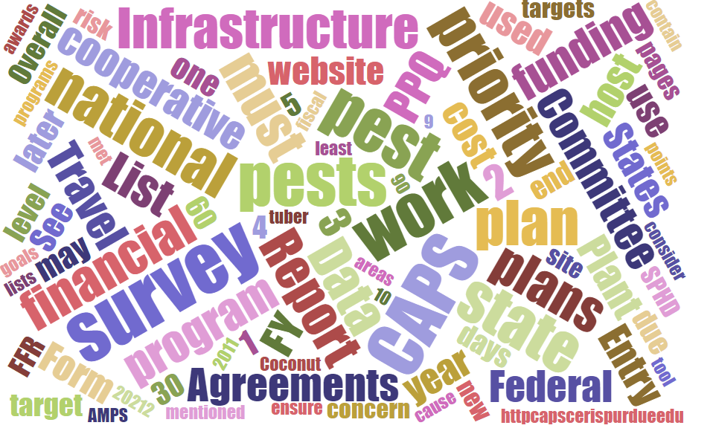



Participants

**National CAPS Committee (NCC) Conference Call**

December 5, 2024

|  |  |  |  |  |  |  |  |
| --- | --- | --- | --- | --- | --- | --- | --- |
|  | Darrell Bays |  | Joanna Fisher |  | Cynthia Kwolek |  | Isaac Powell |
|  | Jake Bodart |  | Leah Granke |  | Amy Mesman |  | Judy Rosovsky |
|  | Brad Danner |  | Tina Gresham |  | Tina Peltier |  | Sven Spichiger |
|  | Charles Elhard |  | Emily Hagan |  | Chelsey Penuel |  |  |
|  |  |  |  |  |  |  |  |
|  | Bonnie Dietrich |  | Mike Hill |  | Colin Funaro |  | Matthew Howle |

## November call minutes review:

No edits or questions

## PPQ Science and Technology update:

The CAPS Datasheet for [Neoleucinodes elegantalis](https://download.ceris.purdue.edu/file/4538) has been revised and updated.

## CAPS agreement funding updates:

PPQ is working through budget planning exercises and exploring ways to increase agreements above the FY 2022 minus 2% level (this level is currently reflected in 2025 survey summary forms). We are looking at scenarios that would allow us to increase funding above this level. No decisions will be made until PPQ receives its FY 2025 budget allocation. PPQ is still funded under a continuing resolution (CR) that expires December 20th.

## Annual NCC in-person meeting:

Stand by for official meeting information and logistics information coming soon (final approval just received on December 5th). The meeting is scheduled for February 11-12, 2025 in Chandler, Arizona; the field trip will be a tour of the [ARS Arid Lands Agricultural Research Center](https://www.ars.usda.gov/pacific-west-area/maricopa-arizona/us-arid-land-agricultural-research-center/).

## Updates to CAPS Guidebook:

The CAPS Guidebook posted on the CAPS Research and Collaboration website is due for updates. We’d appreciate NCC members reviewing and providing feedback before we publish the updated version to the website. Watch for a draft of the revised document in your email inbox before the end of December.

## Round Robin with PSSs and SPHDs:

We continued our round robin discussion from last month, asking PSSs and SPHDs: What is most important for you to get from these monthly NCC meetings?

* SPHDs appreciate getting updates from the CAPS community that they can share on their monthly all-SPHD call.
* Discussions regarding how national priority pests are added/removed from the national priority pest list, and how states go about building their survey plans and selecting pests for survey are very helpful.
* The NCC is a valuable resource for helping address questions and issues from constituents.
* Everyone benefits from updates about CAPS agreement and PPA 7721 funding.

## Questions/Discussion:

* There are broken links in the CAPS approved methods page for cotton jassid (*Amrasca biguttula*), when will these be fixed? This data sheet is under development and should be completed by the end of January 2025.
* Are there any plans for creating a climate suitability map for the cotton jassid? Yes, we plan to evaluate and create maps for all national priority pests (provided there is sufficient data to support a map) at a rate of 8 to 10 pests per year. Due to the complex life cycle of the cotton jassid, this one may take longer than others. It is not in the queue for release in 2025.

## Reminders:

* The next NCC call will be January 9, 2025, at 2PM EST.