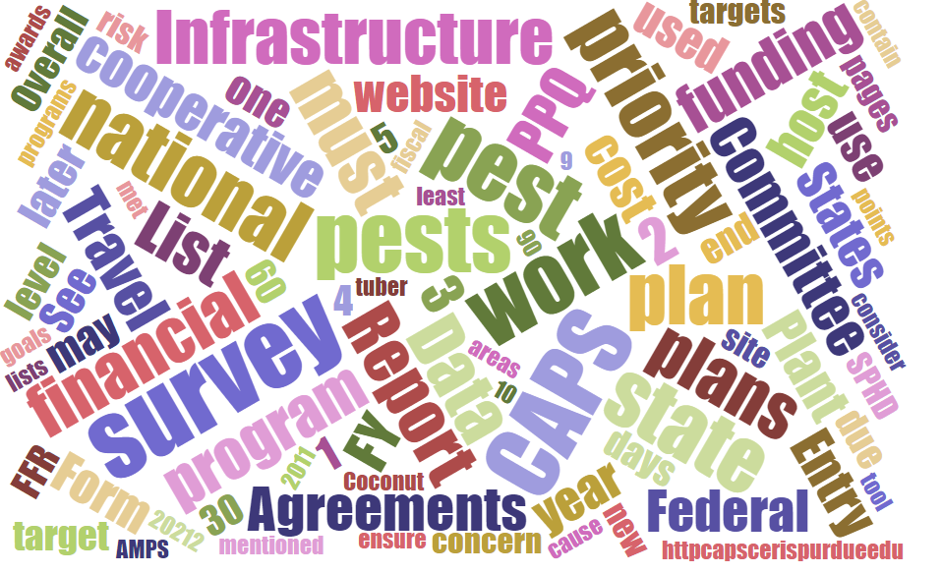



Participants

**National CAPS Committee (NCC) Conference Call**

January 16, 2025

|  |  |  |  |  |  |  |  |
| --- | --- | --- | --- | --- | --- | --- | --- |
|  | Darrell Bays |  | Leah Granke |  | Cynthia Kwolek |  | Isaac Powell |
|  | Jake Bodart |  | Tina Gresham |  | Amy Mesman |  | Judy Rosovsky |
|  | Charles Elhard |  | Emily Hagan |  | Tina Peltier |  | Sven Spichiger |
|  | Joanna Fisher |  | Matthew Howle |  | Chelsey Penuel |  |  |
|  |  |  |  |  |  |  |  |
|  | Bonnie Dietrich |  | Mike Hill |  | Colin Funaro |  |  |

## December call minutes review:

* No edits or questions

## Carry over topics from December call:

## CAPS agreement funding updates - PPQ is operating under continuing resolution until March 14, unless a full budget or another continuing resolution (CR) is passed sooner; no new information about CAPS agreements until PPQ has a final budget allocation.

## Annual NCC in-person meeting:

* We discussed the [updated draft agenda](https://download.ceris.purdue.edu/file/4545) that was sent out to NCC members on January 15th. We went though section by section describing presentation topics and discussions we would like to have. We clarified that regional report-outs could be informal/conversational or PowerPoint; it’s up to the presenter what they feel is most appropriate. No new topics, nor any changes to the draft agenda, were suggested.
* Tina G will compile flight arrival/departure times if you’d like to share with the group to facilitate ride sharing to/from the airport.

## Updates to CAPS Guidebook:

* The [CAPS Introductory Guidebook](https://caps.ceris.purdue.edu/introductory-guidebook) has been revised to update contact information, correct broken links, and to make the document Section 508 compliant. We welcome feedback or any suggested edits from the NCC or their constituents.

## Updates to the NCC Bylaws:

* [Version 1.2](https://download.ceris.purdue.edu/file/4570) was posted to the CAPS site this week (replaces Version 1.1 updated in January 2024). We updated contact information for the PPQ National Operations Manager and PPQ National Policy Manager. The NCC discussed the non-member standing invitation section which, in Version 1.1, outlined a list of individuals who would be invited to the monthly meeting. This list did not align with the actual meeting invitation over the past few years. We decided, due to the infrequency of information exchange with certain individuals, that we would move the following from the standing meeting invitation to the ad-hoc invitation list: national policy managers representing the PPQ Survey Supply and Procurement program, Preliminary Identification, PPA 7721, and PPQ management. Any NCC member may suggest adding these individuals to the meeting invitation on an as-needed basis.

## CAPSIS updates:

* Recent changes to the CAPS Resource and Collaboration website might slightly change how the page looks but should not impact how it functions. If you notice anything odd or have issues, please contact Bonie Dietrich.

## Regional Updates:

Western:

* New US Pest Record for Washington State:

The Washington state Department of Agriculture (WSDA) collected a single specimen of *Protaetia brevitarsis suelensis* (KOLBE), the White-spotted flower chafer, on July 29, 2024, in a CAPS wood destroying insect survey trap. The detection was in a cross-vein panel trap baited with Spruce Blend ethanol-geranyl-acetol lure and set in the Port of Tacoma, Pierce County, Washington. The specimen was tentatively identified as SCARABAEIDAE: *Protaetia brevitarsis* Lewis. The specimen identification was additionally refined to the subspecies *seulensis* by DNA analysis at the WSDA Plant Pest and Molecular Diagnostic Laboratory and was confirmed by the USDA as a new US record for this species on August 26th. DNA analysis was a close match for known records from the country of South Korea. In South Korea, this species is mass reared for use in traditional medicine and as a food source.

On November 13th, after completion of a Domestic Detected Pest Assessment, APHIS designated this species as a quarantine pest for the entire United States. Key factors for quarantine status include literature indicating outbreaks on important agricultural commodities. The white-spotted flower chafer is a serious pest of many fruit and vegetable crops, such as grape, peach, and tomato in Mongolia, Japan, Russia, Korea, Northeast China, and North China. A second contributing factor was the existence of a plausible pathway for introduction. The detection site is adjacent to a major off-loading facility for automobile imports from South Korea.

WSDA responded with an immediate deployment of 50 traps and lures demonstrated to be effective for this species around the detection site in early August.  Staff also completed visual inspections of flowering vegetation in the immediate area.  No additional specimens were detected through trapping or visual survey in 2024.  In its native range, one study indicates that adults of this species are known to be active from early June through early September.  Peak activity occurs from mid-July through mid-August.  As a precaution, WSDA will deploy additional delimiting traps in the area starting in June of 2025.

Southern:

* No new detections to report
* The yellow-legged hornet response in South Carolina and Georgia continues through winter.  No eradication declarations in order yet. South Carolina is expanding trapping in the 15 to 20-mile range, out from the nests found in 2024 in hopes to be ahead of pest population build up and to catch dispersed queens early in their lifecycle.

Eastern:

* Planning for the Eastern Plant Board meeting is underway. Darrell will give updates on box tree moth detections.

## Other Updates:

* The Plant Protection Act PPA 7721 [2025 spending plan](https://www.aphis.usda.gov/sites/default/files/fy2025-ppa-ppdmdpp-spending-plan-508-final.pdf) was announced 1/14/2025.
  + Survey supply ordering will be open From January 28 – March 7, 2025.
* Two new Spatial Analytic Framework for Advanced Risk Information Systems (SAFARIS) maps were recently added:
  + Spotted lanternfly - <https://safaris.cipm.info/safarispestmodel/StartupServlet?caps&pid=SLF>
  + Small brown planthopper (Laodelphax striatellus) - <https://safaris.cipm.info/safarispestmodel/StartupServlet?caps&pid=SBP>

## Next NCC Call:

* The next NCC monthly call is scheduled for February 6, 2025, at 2 PM EST. We are keeping this on the agenda in case anyone has last minute questions or needs for the NCC annual in-person meeting in Phoenix/Chandler, AZ, February 11-12.