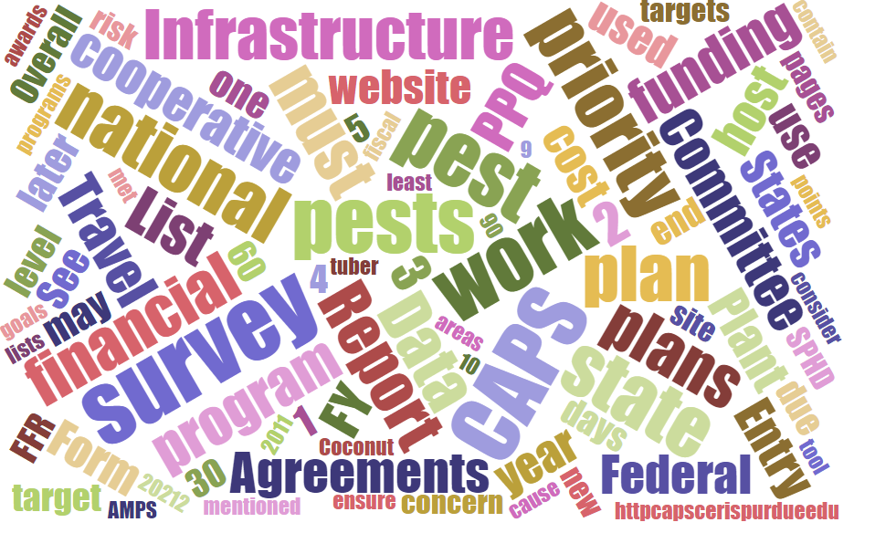



Participants

**National CAPS Committee (NCC) Conference Call**

February 6, 2025

|  |  |  |  |  |  |  |  |
| --- | --- | --- | --- | --- | --- | --- | --- |
|  | Darrell Bays |  | Leah Granke |  | Cynthia Kwolek |  | Isaac Powell |
|  | Jake Bodart |  | Tina Gresham |  | Amy Mesman |  | Judy Rosovsky |
|  | Charles Elhard |  | Emily Hagan |  | Tina Peltier |  | Sven Spichiger |
|  | Joanna Fisher |  | Matthew Howle |  | Chelsey Penuel |  |  |
|  |  |  |  |  |  |  |  |
|  | Bonnie Dietrich |  | Mike Hill |  | Colin Funaro |  |  |

Today’s call was very brief. We met to discuss any last minute logistics or questions for the in-person NCC meeting next week (February 11-12) in Phoenix, AZ.

Everyone reported having their travel plans are in place and expressed excitement for our time together in Phoenix next week.