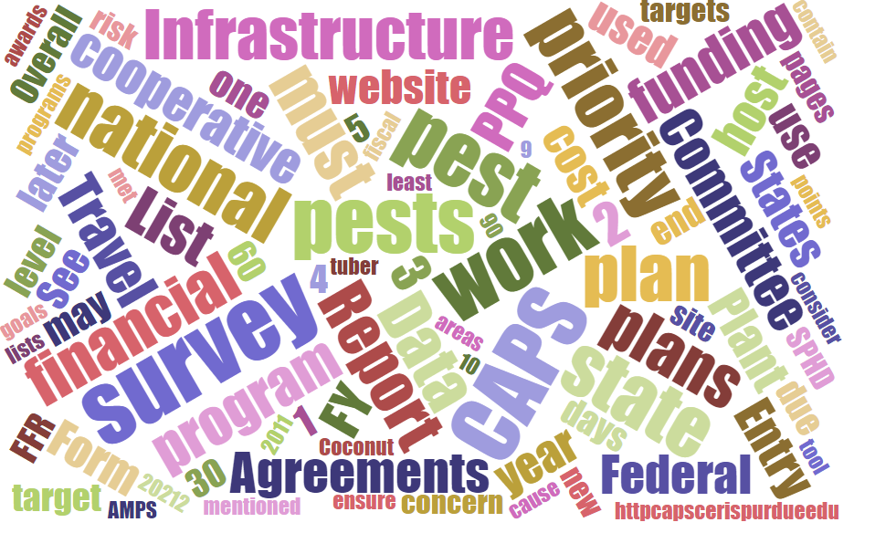



Participants

**National CAPS Committee (NCC) Conference Call**

March 6, 2025

|  |  |  |  |  |  |  |  |
| --- | --- | --- | --- | --- | --- | --- | --- |
|  | Darrell Bays |  | Leah Granke |  | Cynthia Kwolek |  | Isaac Powell |
|  | Jake Bodart |  | Tina Gresham |  | Amy Mesman |  | Judy Rosovsky |
|  | Charles Elhard |  | Emily Hagan |  | Tina Peltier |  | Sven Spichiger |
|  | Joanna Fisher |  | Matthew Howle |  | Chelsey Penuel |  |  |
|  |  |  |  |  |  |  |  |
|  | Bonnie Dietrich |  | Mike Hill |  | Colin Funaro |  |  |

## Cooperative Agricultural Pest Survey Information System (CAPSIS) updates

#### Temporary changes to CAPSIS services:

* While we work out issues related to funding cooperative agreements, the CAPSIS team at Purdue has been reassigned to other projects. Bonnie and Mike will not attend calls until further notice.
* The CAPS Resource and Collaboration (CAPS R&C) site is functioning; NAPIS data can be entered, survey summary forms (SSF) can be revised, reporting tools will automatically update data.
* Monthly NAPIS data notifications are paused; this may impact cooperators because they won’t receive a heads up about detections in other states.
* Core four (SPHD, SPRO, PSS, and SCC) email list serves will not be updated, and any messages sent to these list serves will not be cleared/released until Bonnie returns. Regional plant boards have these email distribution lists, and we recommend you use these in the interim.
* PPQ sent out this message to SPHDs and PSSs; please forward to your constituents:

*The Cooperative Agricultural Pest Survey (CAPS) Resource & Collaboration webpage remains available; however, support from the CAPS Information Services (CAPSIS) team is currently limited. For critical questions or support requests, please contact* [*Darrell.A.Bays@usda.gov*](mailto:Darrell.A.Bays@usda.gov) *and* [*Tina.Gresham@usda.gov*](mailto:Tina.Gresham@usda.gov)*. We will assist in resolving critical issues as much as possible, but routine inquiries or requests may need to wait until CAPSIS services are fully restored. Thank you for your patience and understanding.*

#### NAPIS data notifications:

* Bonnie asked us to pass on the following updates and information:
* NAPIS data notifications are for PPQ-confirmed detections only. Any new detection not confirmed by PPQ is not distributed to the CAPS community.
* NAPIS data notifications for “new-in” detections are those that have been reported to NAPIS for the first time. A “new-in” notification may not represent the first time a pest has been detected in the U.S, state, or county; it simply represents the first time it has been confirmed by PPQ and reported in NAPIS.
* The CAPSIS team may notify states to revise codes accordingly to maintain data accuracy.
* Question: When data is being used for exports, does it show new-in information? That could be problematic for phytosanitary certificate (“phyto”) issuance. Disputes about positive data might be problematic. We don’t believe new-in data appears on phytos, only information regarding presence/absence of pest within an area.

#### New CAPS R&C website:

* The new CAPS R&C website went live on Friday, February 28th. It looks and functions similarly to the old site. We have received reports of a few things that are not working as expected and have compiled a list for the CAPSIS team to address when they return. Please forward any issues or questions about the new website to Tina and Darrell; they will pass on to the CAPSIS team.

## Survey supplies (from Waleksa Ramirez)

* Please note the geranyl acetol lures cost $22 each and we ask our cooperators to order them judiciously. They also ship from Canada and cannot be sourced quickly. We are doing our best to ensure everyone has enough for the upcoming survey season.
* The current supply ordering period closes March 14th. We ask that you do not place any orders after this date. Doing so messes up inventory projections and purchasing. We cannot guarantee we will fill orders received after this date.
* Even though we do not have final approval for CAPS agreements this year, the supply warehouse will continue to fill ship supply orders as planned.
* Question: If survey plans change, and the supplies received are no longer needed, what should cooperators do? Keep the supplies or send them back? We will pass this question on to Waleska and get back to you.

## Pest datasheets and approved methods pages (AMPS)

* *Amrasca biguttula* is new - <https://approvedmethods.ceris.purdue.edu/sheet/2112>
* Data sheets for *Conogethes punctiferalis*, *Ips sexdentatus*, and *Candidatus Phytoplasma* *australiense* were recently updated.

## Objective Prioritization of Exotic Pests (OPEP) updates

* NCC members and anyone with a USDA.gov email can access PestLens and monitor the OPEP process (<https://pestlens.info/pagsReports.cfm>)
* Four OPEPs were completed in January and are moving on to the next part of the process, which is the survey and diagnostic assessment (S/D). These are: *Carpomya incompleta*, *Pecluvirus arachis, Sternochetus mangiferae,* and *Tobamovirus kyuri*.
* Two S/D assessments are currently in review by the PPQ pest detection cross-functional working group (CFWG).
* Two S/D assessments were recently completed, pests not added to national priority pest list: *Plenodomus tracheiphilus* and *Xylophilus ampelinus*
* Any pest assessment can be reevaluated as new information comes in.

## Use of screening aids

* Question for the CAPS community: Do you use screening aids regularly? Which screening aids from the [CAPS Screening Aids](https://gcc02.safelinks.protection.outlook.com/?url=https%3A%2F%2Fcaps.ceris.purdue.edu%2Fscreening-aids%2F&data=05%7C02%7Ctina.gresham%40usda.gov%7C0681e1f7e4a34449769a08dd60160fe2%7Ced5b36e701ee4ebc867ee03cfa0d4697%7C1%7C0%7C638772370054526140%7CUnknown%7CTWFpbGZsb3d8eyJFbXB0eU1hcGkiOnRydWUsIlYiOiIwLjAuMDAwMCIsIlAiOiJXaW4zMiIsIkFOIjoiTWFpbCIsIldUIjoyfQ%3D%3D%7C0%7C%7C%7C&sdata=PfW9yQT08B026pIvef6OGhKJ%2BXp9W0legQdpWHj1Gv0%3D&reserved=0) site do you or your constituents use the most?
* A Plant Protection Act (PPA) 7721 project is underway to update the available screening aids and migrate them to a new location that is hosted by PPQ Science and Technology taxonomic experts rather than the CAPS R&C website. See <https://idtools.org/identify.cfm?sort=dateDesc>.
* Colin is helping the cooperator start with identifying a small batch of high impact screening aids to migrate.
* **Note:** this agreement was not funded to make NEW screening aids, though this is a good topic for a future conversation. Contact the Pest Detection CFWG if you need identification support for any surveys.
* Feedback received:
  + Even just a set of pest photos and their lookalikes would be really helpful.
  + Most useful screening aids are for Cerambycids, Scolytinae, stink bugs, sawflies, Tortricid moths; Exotic moth species Helicoverpa and Spodoptera.
  + Some reported not using screening aids for exotic woodborers (too difficult); they send these to domestic identifiers.
* Joanna offered use of some screening aids if helpful. She will send to Colin to connect with the agreement cooperator.
* Please send any additional feedback from your constituents to Colin Funaro.

## Pest detection CFWG updates:

* Notes from the NCC Phoenix meeting will be sent to the NCC as soon as cleared by PPQ management. (Update: the notes were sent to NCC members on 3/14/2025)
* With so many uncertainties and competing priorities within PPQ, we may not proceed with the proposed national priority pest list (NPPL) removals for the 2026 survey season. We still welcome feedback from your constituents about trade impacts of removing the pests we discussed. This information will be useful for when we review the list for 2027. We plan to proceed with creating the three combined mollusk categories and two new NPPLs additions we discussed.

## Upcoming PPA 7721 deadlines:

* Work and Financial plans due to ADODR by 3/7/2025; ADODRs are supposed to have workplans uploaded by March 14
* Work and Financial plans due date in PowerApps by 3/14/2025
* Work and Financial plans NOM approved by 4/11/2025
* Applications in ‘Agreement Draft’ Status by 7/17/2025
* All agreements obligated by 7/31/2025 (if cooperative agreements are allowed to proceed this fiscal year)

## Regional updates:

* Isaac will be presenting general information on pests and diseases, and CAPS resources the week of March 10th with APHIS Tribal Extension. We currently have one CAPS cooperator representing tribal nations.

## Next NCC call:

* The next NCC monthly call is scheduled for April 3, 2025, at 2 PM EDT. Send discussion topics or agenda requests to Leah or Darrell by April 1st.