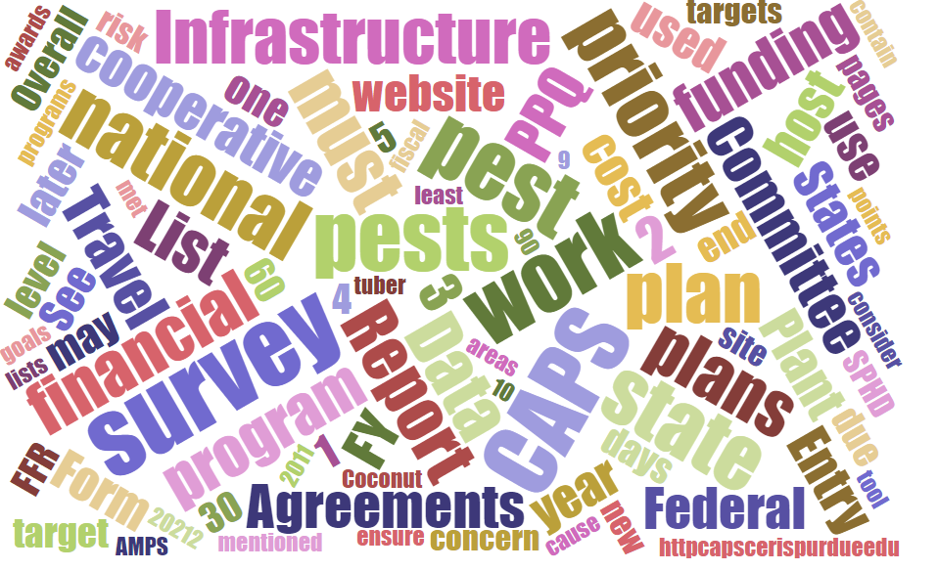



Participants

**National CAPS Committee (NCC) Conference Call**

April 2, 2025

|  |  |  |  |  |  |  |  |
| --- | --- | --- | --- | --- | --- | --- | --- |
|  | Darrell Bays |  | Leah Granke |  | Cynthia Kwolek |  | Isaac Powell |
|  | Jake Bodart |  | Tina Gresham |  | Kim Dean |  | Judy Rosovsky |
|  | Charles Elhard |  | Emily Hagan |  | Tina Peltier |  | Sven Spichiger |
|  | Joanna Fisher |  | Matthew Howle |  | Chelsey Penuel |  |  |
|  |  |  |  |  |  |  |  |
|  | Bonnie Dietrich |  | Mike Hill |  | Colin Funaro |  |  |

## National CAPS Committee member update

* Thank you to Amy Mesman, State Plant Health Director (SPHD) for North Dakota and South Dakota, for serving on the National CAPS Committee (NCC). Welcome to Kimberly (Kim) Dean who is the SPHD for New York and will be replacing Amy on the committee as one of two SPHD representatives.

## Cooperative Agricultural Pest Survey Information System (CAPSIS) updates

#### Return to fully restored CAPSIS services:

* Funding for the cooperative agreement that funds the CAPSIS team at Purdue has been fully restored and the excellent service provided by Bonnie, Mike, and their team will resume.
* The CAPS Resource and Collaboration (CAPS R&C) site remains fully functional, NAPIS data and survey summary forms (SSF) can be entered and revised.
* Monthly NAPIS data notifications will resume.
* The ‘core four’ email list serves will be updated. These are the lists for SPHDs, State Plant Regulatory Officials (SPROs), Pest Survey Specialists (PSSs), and State Survey Coordinators (SSCs). Bonnie will be attending all four regional plant board meetings this year to provide CAPSIS updates.

## Survey supplies

* We discussed returning excess survey supplies to the Moore Airbase warehouse facility in Texas if cooperators find their survey plans have changed. There is no one-size-fits-all answer. The decision will be made on a case by case basis regarding the products involved and how cost prohibitive it will be to return the supplies.
* Recent increases in shipping costs may result in the survey supply program asking cooperators to re-purpose any excess perishable items such as lures.
* New shipment reconciliation requirements were discussed. Please let your constituents know that a digital SIGNATURE is required when receiving survey supply orders so shipping costs can be reconciled in PPQ’s procurement system. A UPS digital signature on the UPS handheld device is acceptable but **the signature must be LEGIBLE.** If the signature is not legible the Moore Airbase warehouse staff must contact the receiving office to obtain proof of receipt.We want to avoid this time-consuming step for Moore Airbase staff. Also, PPQ is paying extra for access to download and reconcile UPS signatures with orders.
* Special note from Jake: Signature requirements and other administrative practices like this are being enforced more actively now in PPQ than they were before. The people reaching out for signatures are adjusting to new rules, may be stressed, and need some grace as they deal with a difficult job.
* Chelsey noted the IPHIS shipping notification now indicates the need for shipment signatures and expressed sincere gratitude to the warehouse staff and management.
* Questions and comments from the NCC:
  + Jake is waiting for supplies to come in from the warehouse, wondering if there are delays to which Darrell informed the group that survey supply has suffered from staffing changes and that he is aware of some backorders.
  + Isaac Powell stated some shipments with April 1st request by dates did NOT arrive to which Darrell replied give it until Monday, as survey supply shipping by UPS can be affected by weather delays.
  + Darrell reminded the group that, if a survey start date is approaching and the needed supplies have not arrived, to please let him know and he and Waleska will help expedite the shipment.
  + Joanna Fisher wished to convey the group's thanks and appreciation to the survey supply warehouse staff for the work they are doing despite challenging circumstances.

## S&T updates

## Survey and Diagnostic Assessment update

* *Aclees taiwanensis* (fig weevil) – The survey and diagnostic (S&D) assessment will be advanced into the pipeline for possible addition to the 2027 national priority pest list.

Screening aids

* Colin expressed appreciation for those who provided feedback on screening aids as it will help Colin and his Pest Identification Technology Laboratory (PITL) colleagues prioritize revisions. Joanna Fisher is also collected screening aid information and will share it with Colin.

S&T speakers invited to upcoming NCC meetings

* May - Allard Cosse from Forest Pest Methods Lab (FPML)
* June - Joe Francese from FPML
* July –pending

## Pest detection CFWG updates:

* The proposed 2026 National Priority Pest List was discussed. The recap is below;

|  |  |  |
| --- | --- | --- |
| **Scientific Name** | **Common Name** | **Status** |
| *Cacopsylla pyri* | European pear sucker | Added |
| *Coniothyrium glycines* | Red leaf blotch of soy | Added |
| *Ca*. Phytoplasma aurantifolia | Witches’ broom of lime | Added |

The twelve terrestrial gastropods in the current list are being considered for consolidation into three new pathways approved methods for pest surveys (AMPS).

Other proposed removals discussed at the Phoenix meeting have been tabled for the moment, awaiting more stable environment. Joanna Fisher has feedback for suggested removals discussed at Phoenix meeting.

2025 CAPS workplan updates

* On April 2nd PPQ leadership approved a change to the funding amounts available to CAPS cooperators for 2025. The funding amounts approved are FY 2022 level plus 3%. Darrell Bays emailed each SPHD their state’s revised CAPS agreement amounts.
* SPHDs should work with their individual state cooperators to revise the infrastructure and survey work and financial plans to align with the new funding levels (FY 2022 levels plus 3%).
* Signed CAPS workplans should be uploaded into the [Agreements PowerApps](https://gcc02.safelinks.protection.outlook.com/?url=https%3A%2F%2Forgf8ad277e.crm9.dynamics.com%2Fmain.aspx%3Fappid%3Defdd6de5-f3cf-ee11-9079-001dd804e341%26pagetype%3Dentitylist%26etn%3Dmjb_ppqagreementsdocument%26viewid%3D4302e4d3-26c2-4916-a4fa-0343a2194ae6%26viewType%3D1039&data=05%7C02%7Cdarrell.a.bays%40usda.gov%7Cf81e4cf36ed34902798808dd721cf1fc%7Ced5b36e701ee4ebc867ee03cfa0d4697%7C1%7C0%7C638792191476238976%7CUnknown%7CTWFpbGZsb3d8eyJFbXB0eU1hcGkiOnRydWUsIlYiOiIwLjAuMDAwMCIsIlAiOiJXaW4zMiIsIkFOIjoiTWFpbCIsIldUIjoyfQ%3D%3D%7C0%7C%7C%7C&sdata=Sk1hew%2B5CnY%2B82vbimO5IhMTXhLBaGZgncqRIH%2Fmf2o%3D&reserved=0) site no later than April 25, 2025. The agreements specialist will delete all previously uploaded 2025 CAPS workplans in PowerApps. If you already have a partially executed agreement, please upload your revised workplan to include “version 2” as part of the workplan name.
* If the change in funding will be applied to survey, the cooperator will need to revise the 2025 CAPS Survey Summary Form. Please email [Darrell.a.bays@usda.gov](mailto:Darrell.a.bays@usda.gov) to have it returned to the SPHD level where the cooperator can access it to make changes. Please email [Darrell.a.bays@usda.gov](mailto:Darrell.a.bays@usda.gov) with changes to preliminary identification capacity needs from taxonomic institutions or PPQ Domestic Identifiers to ensure capacity for the plant pest submissions.
* If the CAPS agreement funding increase will increase survey supply needs, the cooperator will need to submit this [order form](https://download.ceris.purdue.edu/file/4593) to [Darrell.a.bays@usda.gov](mailto:Darrell.a.bays@usda.gov) to create the new order in IPHIS.
* Please pay close attention to the limits on the types of supply products and/or travel amounts, and their purposes, in the CAPS agreement.

## Regional updates:

* Matt Howle
  + Question regarding work plans:
    - Goal 6 project in WV proposing drone camera footage machine learning project to find yellow legged hornet nests in the treetops
    - Work plans by academic researchers is unfamiliar -- possibly drafted for S&T? Any advice?
      * Darrell is unaware of anything other than the standard Goal 6 template.
      * University researchers may be using a different work plan as a rough draft based on other types of grants they apply for.
* Charles Elhard
  + The Central Plant Board (CPB) meeting is in two weeks. He confirmed that three PPQ employees and eight or nine CPB members are attending.
  + The meeting is being held in St. Louis and also offered virtually. The Missouri SPRO is setting up virtual details.
* Emily Hagen - Nothing to report.
* Isaac Powell
  + Nothing to report from the PSS group, they are out there getting things done.
* Sven Spichiger
  + Invasive moth coordinator is back (Susan Brush), runs spongy moth (SM) and most Goal 1 surveys
  + Eradication coordinator is now Nathan Chambers, who was in pathology lab for 16 years prior.
    - Also a representative to the drone policy committee - good for the future of drone use.
  + Nothing else to report from the SPROs.
* Joanna Fisher
  + No updates from the west.
  + Getting ready for surveys and treatments to start.
  + CA started treating Japanese beetle in Sacramento.
  + CA starting treatments for SM this year for the first time (mass trapping).
    - Pheromone disruption not yet registered in CA (hopefully next year).
  + Joanna is organizing SSC breakout for the western plant board (WPB) meeting, needs speakers.
    - Joanna may need to consult with Colin for speakers or ask Colin to give a talk.
* Chelsey Penuel
  + No updates
  + Survey planning as usual
  + Plant board meeting
* Tina Peltier
  + Starting surveys, sending out emails.
  + Prepping for the southern plant board (SPB) meeting, the second week in May
  + Quite a few vacancies and there is a hiring freeze coming.
* Jake Bodart
  + No updates, question about survey supply

## Next NCC call:

* The next NCC monthly call is scheduled for May 1, 2025, at 2 PM EDT.