Cooperative Agricultural Pest Survey (CAPS) - Survey Work Plan Process

- Create work plans using the CAPS Resource and Collaboration Survey Planning webpage using the following fiscal year (FY) 2026 templates:
  - Infrastructure Work Plan Template
  - Survey Work Plan Template
  - Financial Plan Template
- For the Financial Plan, the calculation feature has been removed from the Indirect Rate row in the online interface, as this was causing errors in past years. The calculation feature is active in the Subtotals and Total Direct Costs sections.
- You must combine your Work and Financial Plans into one combined .pdf file. There are two ways to do this:
- Export the Financial Plan out of the online interface, add it to your Work Plan Word document, and then create one .pdf, or
- Fill out the Word version of the Financial Plan and combine it into one .pdf with the Work Plan Word document
- States may combine their CAPS surveys into one combined work and financial plan or to submit separate work plans for each survey. A combined work and financial plan is preferred, as it reduces administrative burdens on both the state and federal sides. See Example of a combined survey work plan.
- Regardless of whether a state pursues a combined survey work plan or an individual work plan, the State Survey Coordinator (SSC) must fill out each survey plan with accompanying target pests separately in the SSF. This will aid in reporting program performance measures.
- Infrastructure work plans must be submitted as separate work plans from survey.
- SSCs will enter the details in the SSF using these survey planning instructions. Once this is complete, cooperators can access the Survey Planning Tool.
- The SSC is the only person in a state who can enter the SSF for CAPS.
- Cooperators other than the SSC will have access to enter their own financial information into the Financial Plan in the online interface. They will not have access to the SSF.
- See the CAPS Resource and Collaboration website for a powerpoint presentation with screenshots and more details on using the interface.

Important Dates:
- Submit work plans signed by the Authorized Departmental Officer’s Designated Representative (ADODR) and ROAR to the PPQ Agreements PowerApps site by September 5, 2025.
- The FY 2026 CAPS Survey Summary Form (SSF) and Online Work Plan Interface on the CAPS Resource and Collaboration website open on July 28, 2025.

Actions Before Initiating the Online Work Plan
- For CAPS surveys conducted by non-traditional cooperators (institutions other than the typical State/SSC), the Authorized Departmental Officer’s Designated Representative (ADODR) should work with the cooperator and the SSC to enter data into the SSF.
- By August 4, 2025, the ADODR must:
  - Provide the contact information (name and email address) for the non-traditional cooperator to the Cooperative Agricultural Pest Survey Information Services (CAPSIS) Support Team at capsis@purdue.edu. The CAPSIS Support Team will grant the cooperator access to the online work plan interface.
  - Introduce the non-traditional cooperator to the SSC and identify their individual responsibilities.
- The SSC should work closely with the non-traditional cooperator to complete the SSF.
- The SSC and ADODR should ensure data from previous years’ surveys have been entered into the National Agricultural Pest Information System (NAPIS). The National Operations Managers (NOM) will not approve FY 2026 work plans until data has been entered for 2024 surveys conducted by the same cooperator.
- The State Plant Health Director (SPHD), State Plant Regulatory Official (SPRO), Pest Survey Specialist (PSS), SSC, and NOM will receive email reminders from CAPSIS on June 30 and July 14, 2025, if 2024 CAPS data has not been entered into NAPIS.
- If there is a legitimate reason why the data has not yet been entered (no-cost extension, etc.), reach out to your ADODR and Pest Detection NOM.
- The Accountability Report can be accessed after logging in to the CAPS Resource and Collaboration website.
- Refer to Data Entry Roles and Responsibilities for data entry responsibilities for CAPS Surveys throughout the timeframe of the survey agreement.

Work Plan Process
*Steps in red occur outside of the online work plan interface.
- Complete the Infrastructure Work Plan using the Infrastructure Work Plan Template.
- Complete the Financial Plan in the online interface.
- There will be an Infrastructure link available for each state.
- If your state does not receive an Infrastructure agreement, there should not be an Infrastructure link in the online workplan.
- Click on the link to begin filling out the Financial Plan for Infrastructure.
- The SSF does not need to be started to work on the Infrastructure financial plan.
- The Infrastructure Financial Plan in the online interface can be completed before, after, or at the same time as the Survey work plan.
- The Financial Plan Template provides instructions on how to fill out a Financial Plan. It may also be used as a template to be included in your final Work Plan .pdf (see step (9.a.).
- For the Financial Plan, the calculation feature has been removed from the Indirect Rate row in the online interface. This was the section that was causing the most errors. The calculations have been left in the other sections (Subtotals and Total Direct Costs).
- For the Indirect Costs:
  - Type in your percentage rate.
  - Choose what the Indirect Cost Rate is applied to from the dropdown menu (Direct, Personnel, etc.).
  - Enter the dollar amount of the Indirect Cost Rate (the amount will not be auto calculated).
  - The Total agreement amount will auto calculate.

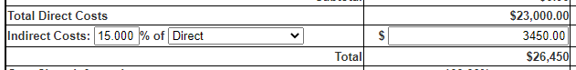

- Complete the SSF
- Access the SSF from the Survey Planning page.
- The SSC will coordinate all survey entries into the SSF, including for non-traditional cooperators.
- The default in the SSF’s “Add Survey” section is the Combined Survey Work Plan.
- Most states now use the Combined Survey Work Plan.
- Fill out the SSF individually by each survey, regardless of whether you pursue a Combined Survey work plan or Individual Work Plans.
- Here is the default view for a Combined Survey Work Plan:

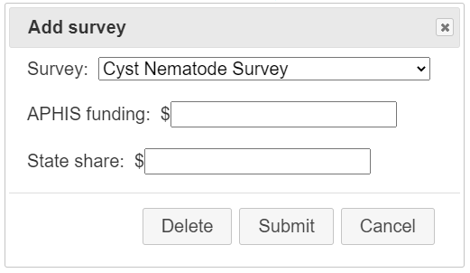

- Individual Work Plans:
- Some states may still need to submit more than one survey work plan because there are multiple cooperators needing separate work plans/agreements.
- For states that have previously needed individual work plans, your interface is set up with Individual Work Plan as an option.
- You will see this box that you need to check:

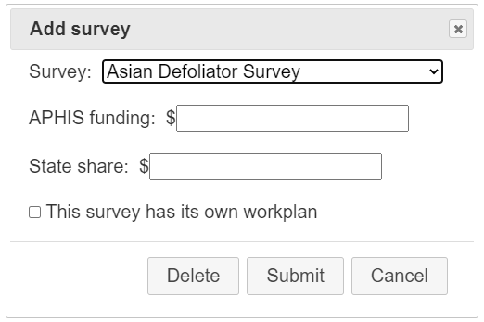

- For any states needing to go from Combined to Individual, contact your ADODR and NOM.

- Complete the Survey Work Plan in the Survey Work Plan Template.
- Complete the Financial Plan for the Survey work plan in the online interface.
- As a survey is entered into the SSF, it unlocks the Financial Plan in the online work plan interface. At a minimum, the SSF needs a Survey Name for the survey to be created in the online work plan interface.
- To access the online work plan interface, after the SSF has been started, go to the lower left-hand corner of the Survey Planning page, and click on “Manage Plans”:
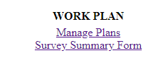

- Combined Survey Work Plan
- The Financial Plan for a Combined Survey does not need to be broken down by survey. See Example of a Combined Survey Work Plan

- Individual Survey Work Plan
- Each work plan needs its own financial plan.
- Each work plan will result in a separate agreement.

6. Cooperator: send work plan out for review before finalizing.

7. Cooperator and SSC: finalize work plan and SSF.
a. The SSC revises the SSF if needed.
b. The final SSF is populated into the table in the work plan.
c. The cooperator makes any revisions to the work plan in the Word template.

8. SPHD/PSS reviews and approves SSF on the Survey Planning page.

9. Cooperator: create .pdf.
You will need to create one combined .pdf of your Work and Financial Plans. To do this, you may either:
- Export the Financial Plan out of the interface, add to your Work Plan Word document, and create one .pdf.
- Or, you may fill out the Financial Plan Template and combine this into one .pdf with your Work Plan.

10. ADODR and the Recipient Organization’s Authorized Representative (ROAR) sign the .pdf.
11. ADODR: upload .pdf of work plans to PPQ Agreements PowerApps site.

12. Pest Detection NOM: reviews .pdfs of work plans on PPQ Agreements SharePoint site.
- The NOM reviews the work plan and SSF.

13. If revisions are requested by the NOM:
- There may be a back and forth with revisions to the SSF and/or work plan.
- The cooperator performs revisions in the SSF (go back to step 1). This would follow the current process for revisions to the SSF:
1) NOM rejects the SSF.
2) The SSC revises the SSF.
3) The SPHD/PSS approves the SSF, sending it back to the NOM.
- ADODR follows step 8-9 again. ADODR uploads revised work/financial plan to PPQ Agreements SharePoint site.
- The NOM deletes older version from PPQ Agreements SharePoint site.

14. NOM approves work plan.
- The NOM approves the work plan on the PPQ Agreements SharePoint site.
- The NOM locks the financial plan in the online interface (approves).
- The financial plan is now locked from change.
- The SPHD is notified that the work plan has been approved.

15. The Financial Plan in the online interface for that year is now locked.

16. PPQ Agreements Specialist reviews work plan.
- If revisions are needed, the PPQ Agreements Specialist reaches out to the ADODR.
- Edits are made and a revised version is sent via email to the PPQ Agreements Specialist.
- No edits are made in the online interface.
- A new version does not need to be posted to the PPQ Agreements SharePoint site.

17. PPQ Agreements Specialist: creates the opportunity in ezFedGrants.

Appendix 1.
Example for a state that has Individual Work Plans and multiple cooperators. A Grape Survey will be done by Non-traditional Cooperator X:
- Cooperator X sends the SSC their information for the SSF.
- SSC enters Grape survey information into the SSF.
- SSC checks the “This survey has its own workplan” box.
- A Grape survey opens in the online work plan interface for that state.
- Cooperator X completes the Financial Plan in the online interface and the Work Plan in the Word template.
- The Pest Detection NOM reviews each SSF entry (per survey) and work plan separately.
- The Grape survey may move forward, even if the state has other surveys in various stages of review.
- If the state had an incomplete accountability report, it would only affect the surveys under that cooperator (i.e., if State Y Dept. of Ag. had missing data, it would only affect their work plans, not work plans for the Univ. of State Y).
- The NOM will not approve (and lock) the SSF until all survey entries are accurate.

