 | National Cooperative Agricultural Pest Survey Committee  Annual Meeting Notes  February 11-12, 2025  Phoenix, Arizona

Table of Contents
Participants 3
Opening remarks 3
Purpose 3
Expected Outcomes 4
Meeting Agenda Review 4
2024 Highlights and 2025 Survey Plans 4
CAPS by the Numbers 4
Regional Updates 6
Western 6
Eastern 6
Central 7
Southern 7
Fiscal Year 2026 Planning and Discussion 8
How to Submit a Priority Pest Candidate 8
Pest Prioritization Process for Adding a New Pest 9
National Priority Pest List 9
Proposed additions 9
Changes to mollusks on the NPPL 11
Proposed removals 12
Other proposed changes to the NPPL 14
CAPS Performance Measures 14
Review of current measures and priority pest survey percentage 14
Support Services Updates 16
CAPSIS 16
Preliminary Identification 17
Survey Supply and Procurement Program 18
SSPP best practices reminders 18
Pest Detection Cross-Functional Working Group Updates 19
S&T Updates 19
Cotton jassid – Amrasca biguttula update 20
2026 Meeting Planning 20
Group photo - Meeting attendees 21
Appendix 1 – Meeting Agenda 22
Appendix 2 – Notable detections in 2024 23

Participants
Darrell Bays, PPQ Field Operations - National Operations Manager
Jo-Ann Bentz-Blanco, PPQ Emergency and Domestic Programs - Director
Jake Bodart, PPQ Field Operations – State Plant Health Director Representative (OR)
Bonnie Dietrich, Cooperative Agricultural Pest Survey Information Services – Project Coordinator
Charles Elhard, Central Plant Board - State Plant Regulatory Official Representative (ND)
Joanna Fisher, Western Plant Board - State Survey Coordinator Representative (CA)
Colin Funaro, PPQ S&T CAPS Support – Risk Analyst
Leah Granke, PPQ Science and Technology - Assistant Director
Tina Gresham, PPQ Emergency and Domestic Programs - National Policy Manager
Emily Hagen, PPQ Field Operations - Pest Survey Specialist Representative (AZ, NM)
Jeff Hash, PPQ Field Operations – National Operations Director
Patrick Haslem, PPQ Emergency and Domestic Programs - National Policy Manager
Matt Howle, Southern Plant Board - State Survey Coordinator Representative (SC)
Cindy Kwolek, Eastern Plant Board - State Survey Coordinator Representative (RI)
Tina Peltier, Southern Plant Board - State Plant Regulatory Official Representative (LA)
Chelsey Penuel, Central Plant Board - State Survey Coordinator Representative (MN)
Isaac Powell, PPQ Field Operations - Pest Survey Specialist Representative (NC)
Waleska Ramirez, PPQ Emergency and Domestic Programs - National Policy Manager
Judy Rosovsky, Eastern Plant Board - State Plant Regulatory Official Representative (VT)
Sven Spichiger, Western Plant Board - State Plant Regulatory Official Representative (WA)

Opening remarks
Tina Gresham started the meeting with a greeting from the Arizona State Plant Health Director, Mike Wallace, who was unable to attend in person but wanted to extend the National Cooperative Agricultural Pest Survey Committee (NCC) meeting attendees his welcome to Arizona.
Meeting participants introduced themselves in a round-robin manner, stating their name, affiliation, and their role in the NCC and/or their role in the meeting as a guest. Gresham highlighted two meeting invitees who were unable to attend, Amy Mesman, State Plant Health Director Representative from North Dakota and South Dakota, and Nicole Russo, Associate Deputy Administrator for Emergency and Domestic Programs.

Purpose
The purpose of this two-day meeting was to exchange updates and information regarding survey years 2024 and 2025, to hold focused, open conversations about the strengths and challenges of the National Cooperative Pest Survey (CAPS) program, and identify innovations to support the program into the future.

Expected Outcomes
Gresham reviewed the meeting outcomes and asked the group if anything should be added. No additional outcomes were suggested. The group agreed the expected meeting outcomes were to:
- Evaluate CAPS program performance
- Review the National Priority Pest List (NPPL) and discuss its relevance and proposed changes for 2026
- Share Plant Protection and Quarantine (PPQ) updates from the Pest Detection cross-functional working group (CFWG), Science and Technology (S&T), preliminary identification, and the survey supply and procurement program (SSPP)
- Share National Plant Board regional CAPS updates from the 2024 survey season, and plans for the 2025 survey season
- Share Cooperative Agricultural Pest Survey Information Services (CAPSIS) updates from Purdue University
- Identify updates to 2026 CAPS survey guidance and resources that will improve communication and program delivery
- Document focus areas and to-do list for the NCC’s monthly virtual meetings in 2025
- Plan for the 2026 NCC meeting – identify tentative dates and location

Meeting Agenda Review
Gresham reviewed the meeting agenda (Appendix 1) and asked the group if any changes were needed. The following new topics were raised and the group agreed to add them to the agenda:
- Discuss how changes to pest survey protocols are documented and communicated
- Discuss survey permission issues that CAPS survey cooperators are experiencing, and identify ways to address difficulties with accessing locations for surveys
The group identified the following agenda topics that could be postponed to a future NCC virtual call to make room in the meeting for the new topics added:
- Discuss any new CAPS survey guidance needs for 2026
- Review program administration/cooperator support resources and discuss any gaps or needs that should be addressed prior to the 2026 survey season

2024 Highlights and 2025 Survey Plans

CAPS by the Numbers
Gresham presented the following graphic summarizing CAPS survey program statistics for the 2024 survey season, demonstrating that 2024 statistics were similar to 2023 regarding the number of cooperators participating (49 states and 3 territories). There were 103 pests on the NPPL in 2024; 92 of them were survey targets in CAPS surveys. Cooperator surveys targeted 178 pest species, of which 86 were non-priority pests. Of the 86 non-priority pests, 30 were no cost pests. See Appendix 2 for a summary of notable detections in 2024.
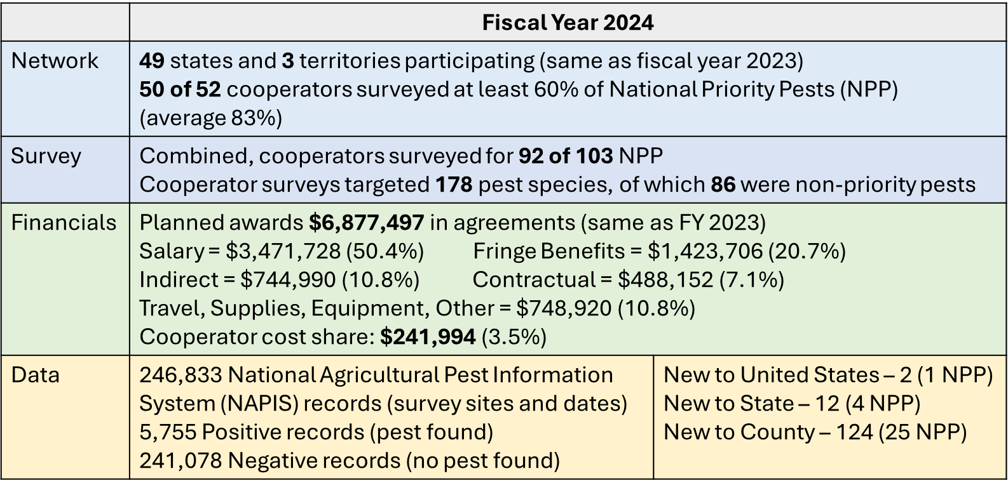
Fifty of 52 CAPS cooperators met or exceeded the target for having 60% of the pests in their survey plans drawn from the PPQ NPPL. She pointed out it would have been 52 out of 52 if you factor in that Diabrotica speciosa was not a priority pest in 2024 but was added for 2025. Considering 2025 planned CAPS surveys, we are currently at 51 of 52 cooperators at or above the 60% threshold with only Alaska at 47%. The group commented on limitations for reaching the 60% threshold in areas where priority pest surveys are impractical due to unsuitability for pest establishment.
In 2024, the overall average for priority pest surveys across CAPS cooperators was 83%, demonstrating that CAPS surveys are predominantly focused on priority pests, and well above the performance metric for 60% priority pests. This is similar to 2023 which was 86% priority pests. While 2024 CAPS surveys targeted only 92 of the 103 priority pests, surveys for all 103 priority pests were conducted under one or more of PPQ’s pest surveillance funding sources (CAPS, Plant Protection Act (PPA) 7721, PPQ pest detection, and PPQ port environs).
CAPS cooperative agreements in fiscal year 2024 totaled $6,877,497 (same as 2023). Gresham highlighted the documented 3.5% cooperator cost share of $241,994. The group discussed that cooperator cost shares are not being recorded accurately in workplans and agreements, and that cost shares are actually quite a bit higher. We discussed the need for documenting cost shares more accurately to demonstrate and defend the true cooperative effort between PPQ and its CAPS cooperator community.
- Question: Can PPQ message to Authorized Departmental Officer's Designated Representatives (ADODRs) the need to include cost shares? Cooperator representatives commented that some states don’t want to calculate these on the front end of their agreement. The NCC will consider creating a subcommittee to work on improving documenting cooperator cost shares.
- Suggestion for the online financial plan: Update with averages of state match after work is completed.

Regional Updates

Western
Sven Spichiger:
- Clear panel traps supplied by PPQ are disintegrating after one season in the field. The SSPP will investigate
- Japanese cedar longhorn beetle distribution data request
- Mexico potato trade delegation will visit in July and our data collection procedure may be scrutinized
- Thirty-two spongy moths detected in Washington (WA); not going to do treatments. Will do delimitation/precision survey
  - Question: Where is spongy moth data recorded? Answer from the Spongy Moth CFWG: For CAPS and PPA 7721 funded surveys, data should be reported in NAPIS. For spongy moth survey outside of the quarantine area, funded through spongy moth program allocations, data should be reported in PPQ’s IPHIS system or PPQ’s Data Mart.
- Strawberry blossom weevil important for trade with Canada
- Japanese beetle response surveys are well supported by WA State funding
Joanna Fisher:
- Hawaii (HI): No new detections of coconut rhinoceros beetle in Maui County for over a year and Hawaii County for the last 8 months. Fisher working on confirming if there have been no detections at all in HI for the past 8 months
- Oregon (OR): Three dead SLF adults were intercepted on materials coming from out-of-state into OR (a pallet, contractor equipment, and other materials). This shows there are pathways for these pests to enter Oregon. There are no suspect SLF infestations in OR
- California (CA): Mediterranean fruit fly – 71 adults detected in Alameda County, CA. Doing sterile release, folia bait sprays, larval survey, and fruit removal to combat outbreak.
- CA: One male flighted spongy moth (Lymantria dispar asiatica) was detected in 2024. Delimitation trapping was started in 2024 and will continue in 2025
- Japanese beetle surveys ongoing

Eastern
Cindy Kwolek:
- Cindy represents 12 states in her region. Across the board their biggest question/concern for the NCC is what the 2025 CAPS funding level will be. Early detection surveys in 7 of these 12 states are funded entirely by CAPS. Without CAPS funding they have no survey program
- More box tree moth (BTM) detections, states have enacted quarantines
- Spotted lanternfly (SLF) is now in 9 of the 12 eastern region states
- They responded to many Phytophthora ramorum trace-forwards in 2024
- Many states experiencing pushback from industry about allowing European cherry fruit fly (ECFF) surveys. They do not see the benefits of early detection, only the drawbacks
- PPA 7721 Goal 1 Survey suggestions in the region didn’t fare well for 2025. Many suggestions for PPQ program pests were not funded or were funded at reduced levels
- What changed for 2025? Submitters want to understand so they can plan better for 2026
  - Follow-up comment - State Plant Health Directors (SPHDs) can request PPA 7721 reviewer comments and provide feedback to submitters
- There are still several vacant pest survey specialist (PSS) positions in the region
Judy Rosovsky:
- Trace forward for zebra mussels found in Marimo moss balls, mostly to western states. There are jurisdictional questions on this, as aquatic pests are usually regulated by the Department of Interior, but USDA regulates pet stores as nurseries in regard to aquatic plants
- The golden clam was discovered in Lake Champlain in VT though it had been found in NY and another VT lake years ago. Lake Champlain lies between NY and VT
- Longtime Eastern Plant Board (EPB) members Dana Rhodes (PA) and Vicki Smith (CT) have retired. Dana was a leader in SLF control and regulation, and Vicki was known for her fierce battle against Xylella and her dry sense of humor
- EAB continues to spread in EPB states, all of which are infested. See https://www.aphis.usda.gov/plant-pests-diseases/eab/eab-infestation-map for map
- SLF is present and spreading in all EPB states except ME, NH and VT. SLF in WV is confined to its northeastern counties. See https://cornell.app.box.com/v/slf-distribution-map-detail for a distribution map
- BTM is present in DE and PA (Erie County) as of 2024. It was already present in MA and NY. MA and DE have quarantined their entire states. A map of quarantined areas available at https://www.aphis.usda.gov/plant-pests-diseases/box-tree-moth/box-tree-moth-federal-quarantine-boundary-viewer

Central
Chelsey Penuel and Charles Elhard:
- States in their region would prefer greater opportunity to use the green bucket trap due to rusty-patched bumble bee (RPBB) and other pollinator bycatch concerns
- There were a number of new pest detections across the central region states
- Funding is a concern across the central region

Southern
Matt Howle:
- Notable detections:
  - 25 detections of citrus greening disease in AL. All diseased trees destroyed
  - Vascular streak dieback in several states
  - Cotton jassid (Amrasca biguttula) - Detected in 16 FL counties. Most detections in okra, post-harvest. None found in nurseries yet. Current cotton production practices seem to be keeping it in check
  - Spodoptera litura detected in FL at Miami International Airport
  - Thrips parvispinus found in NC, asks NCC to investigate this as a priority pest
- SLF area in NC has not spread from initial two counties
- SLF spreading to 7 additional northern Kentucky counties
- SC is launching an outreach campaign for yellow legged hornet in hopes public help is successful at removing queens and nests from the landscape early in the season
- SC Asian longhorned beetle (ALB) dashboard updated, spans area of about 76 square miles
- TX dealing with citrus canker, Mexfly, emerald ash borer (EAB), and imported fire ant (IFA)
- VA removing SLF quarantine

Fiscal Year 2026 Planning and Discussion

How to Submit a Priority Pest Candidate
Anyone can propose a candidate pest for the priority pest list. Ideally, NCC members can check the objective prioritization for exotic pests (OPEP) list to see if the pest has already been given a risk rating prior to proposing a new target. Pests are evaluated by S&T for potential impact relative to other exotic pests. The survey and diagnostic (S/D) evaluation suggests whether effective survey and diagnostic methods exist for potentially high impact pests. If a pest fails the S/D assessment and we are interested in adding it to the NPPL, PPQ may investigate developing new methods and reconsider the pest for the NPPL at a later time. This is an iterative process – things change over time and are updated as new information becomes available.
OPEP process – Likelihood of introduction is considered to some degree before an OPEP is conducted when the pest candidate is proposed. Although considered, likelihood of introduction is difficult to quantify objectively and previous attempts to add this to the OPEP process have been unsuccessful. For this reason, the current OPEP focuses on pest impacts.
Question: How is review related to imports/exports? Spichiger commented that he submits many candidates, but they are thrown out because no survey or diagnostic method exists. Spichiger suggested putting non-selected candidates on the CAPS site as a thing “to watch out for” with supporting information such as photos and host damage.
Someone suggested S&T provide a “top 10” list of the information points that should be submitted with a new candidate NPP nomination. Granke commented it will suffice to simply submit a pest name and why you are concerned about it. S&T will follow up on the pest suggestion from there.
Question: is it possible for NCC to see what is in the OPEP pipeline? Answer: The pest detection CFWG has added this as a recurring topic on the monthly NCC calls.
Question: What if changes to a survey protocol are needed? Answer: Email stcaps@usda.gov to suggest changes.
Suggestion: Spichiger asked S&T to reevaluate the yellow spotted longhorned beetle (Psacothea hilaris) as national priority pest – This is already in the OPEP pipeline.

Pest Prioritization Process for Adding a New Pest

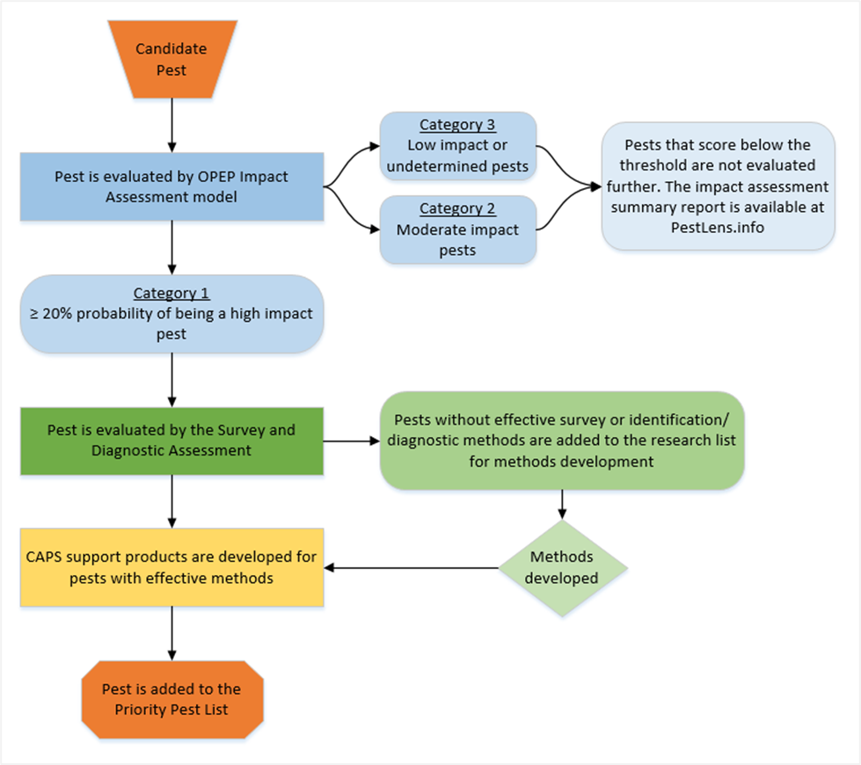

National Priority Pest List
PPQ provides support for National Priority Pests:
- Detailed information about the pests
- Survey supplies where appropriate (traps, lures)
- Approved methods pages via the CAPS Resource & Collaboration website

Proposed additions
We are proposing adding three new pests to the NPPL for 2026:
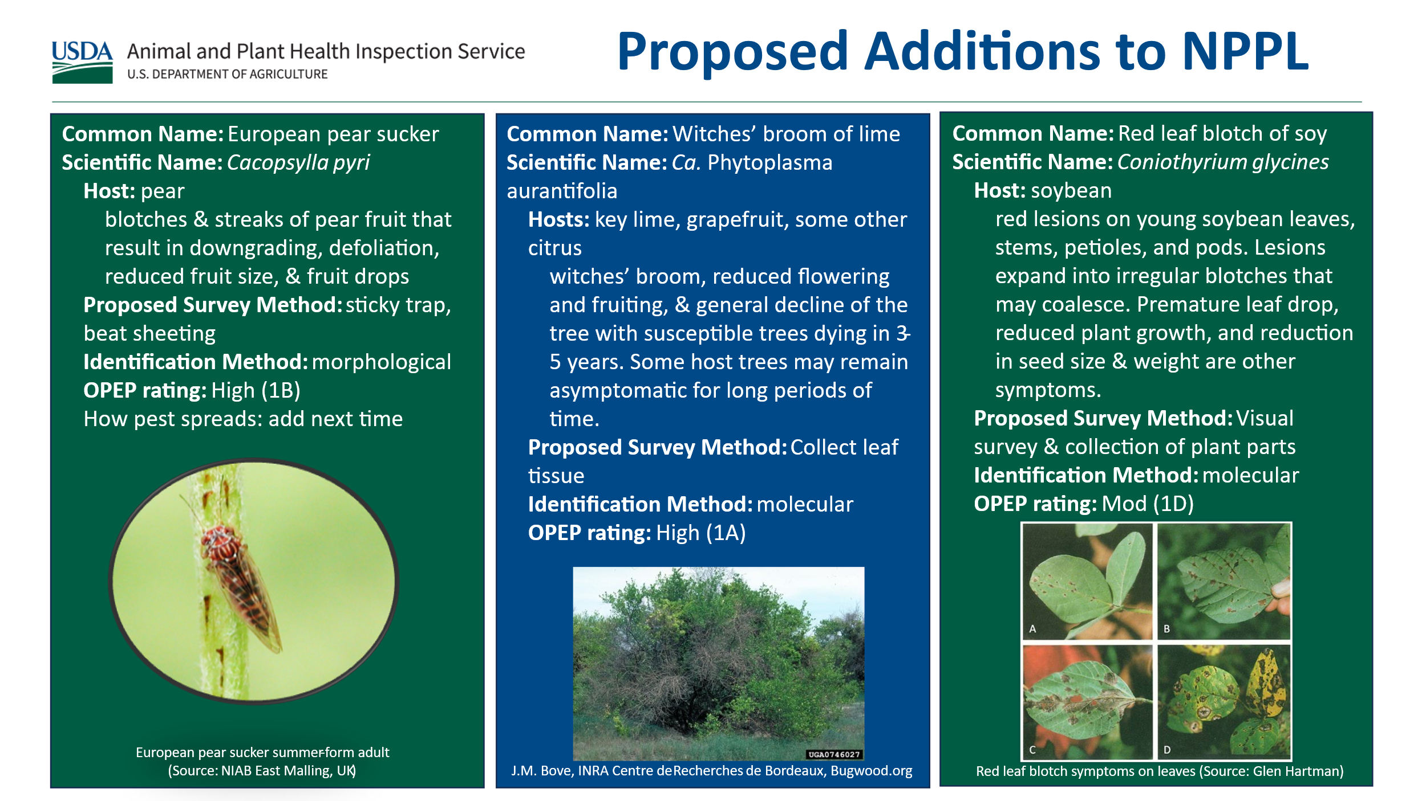
European pear sucker, Cacopsylla pyri: OPEP rating high (1B). Present in Europe and temperate Asia where it is a major pest of pear. Infestations can lead to weakening and dieback of pear trees and reduced fruit weight and yield. Adults can transmit Ca. phytoplasma pyri, which causes pear decline disease. Proposed survey methods are sticky trap and beat sheeting. Another pear psyllid, C. pyricola, was previously introduced to North America in the 1800s and is widely distributed in United States pear-growing regions and can be separated by genital dissection.
Witches’ broom of lime, Ca. Phytoplasma aurantifolia: OPEP rating high (1A). 1AKey lime is the major host, but other citrus species have been infected naturally and experimentally. Symptoms include witches’ broom, reduced flowering and fruiting and general decline of the tree. The proposed survey method is collecting symptomatic leaves, when present, or asymptomatic leaves when symptoms are not present. Identification would be molecular similar to other phytoplasmas on the list.
- Where is witches’ broom currently found and what is it vectored by?
  - Current distribution: Middle East (Oman, United Arab Emirates, Iran)
  - Vector: the leafhopper Hishimonus phycitis, which is not present in the US
Red leaf blotch of soy, Coniothyrium glycines: OPEP rating moderate (1D). Select agent. Early symptoms include dark red to brown, circular to angular lesions that first appear during the seedling stage on unifoliolate leaves. These may be confused with other fungal infections. As the disease progresses, lesions expand and become more distinct. Older lesions may be surrounded by a yellow halo and cover the majority of the leaf surface. The dead brown centers of the lesions may disintegrate leaving holes in the leaf. In addition, older lesions may contain spores and sclerotia. Coniothyrium glycines causes premature leaf senescence, resulting in up to 75% defoliation, and up to 50% yield loss. The proposed survey method is visual collecting symptomatic plant material for molecular identification.
- Question: How does Coniothyrium glycines spread? Answer: Through rain splash over short distances
- Question: What is the survey area for red leaf botch? Answer: Methods have not been developed yet. When it comes to documenting survey area, Darrell commented that the goal of using site descriptors is to accurately document survey locations. How to define a survey site still needs more work, as guidance can be different depending on the pest
- Question: Where should surveyors look in a field for red leaf blotch; how should they conduct survey, on the outer edge or inside the field? Including information such as “likely to be introduced on” in survey methods would be helpful to the survey community. Answer: Long-distance spread could occur through transport of infected plant material including debris accompanying seed or infested soil
There were general questions about the select agents listed on the NPPL. Answers: Select agents are identified in the code of federal regulations as bioterrorism targets. There are currently six select agents and three of them are on the 2025 NPPL (four if you count Peronosclerospora phillipensis, which was recently removed from the select agent list). Detections of select agents are investigated by the Federal Bureau of Investigations (FBI).

Changes to mollusks on the NPPL
The current NPPL includes 12 mollusk species. At the 2024 NCC meeting, we talked about creating a more generalized snail and slug survey due to snail and slug surveys being similar in methodology and identification.
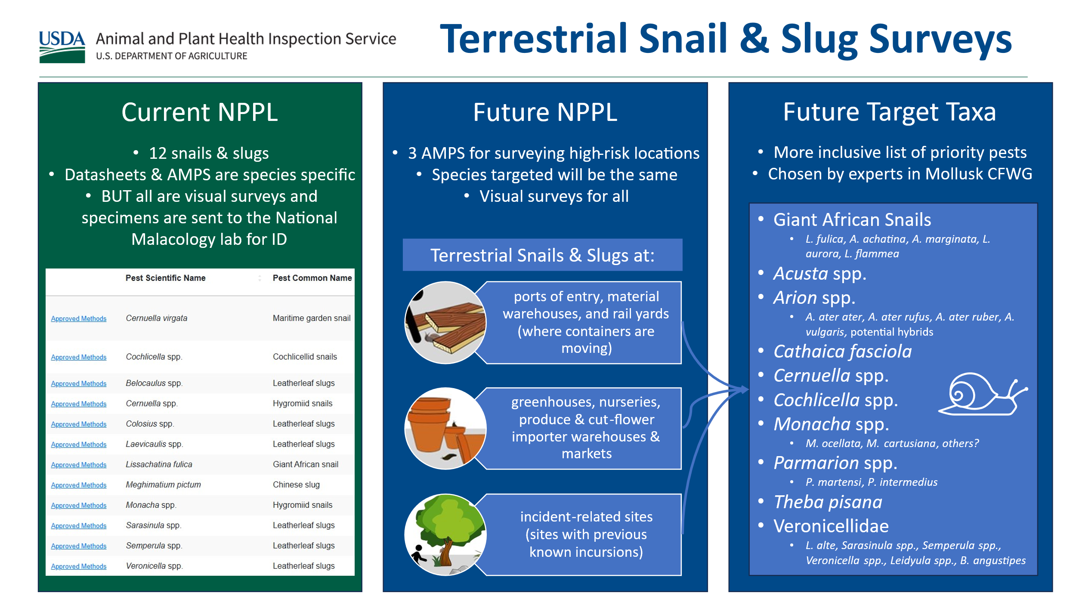
We collaborated with the mollusk CFWG to refine this idea. For 2026, we are proposing three groupings, one for each high-risk location for terrestrial snails and slugs. These are for 1) shipping container locations (ports of entry, material warehouses, and rail yards), 2) plant production locations (greenhouses, nurseries, produce/cut flower importer warehouses and markets), and 3) previous find locations (incident-related sites with previous known detections). The species targeted will be common to all three surveys and will continue to be visual surveys with all specimens sent to the National Malacology lab for expert identification.
Since we do not have an objective model to prioritize relative risk of exotic terrestrial snails and slugs, the target groups and species were chosen by experts in the mollusk CFWG.
- Question: Why don’t we do pitfall trapping or use bread baits for mollusk surveys, in addition to visual surveys? Answer: Trapping will be addressed in the AMPS that are being created for the new mollusk groupings
A lively discussion followed about the proposed groupings for terrestrial slug and snail surveys. Spichiger’s argument was why have three groupings if all species can be selected for each of the three new groups. He said this is misleading to the survey community and might result in people surveying for a species in the wrong place and time of year. S&T said the updated AMPS will provide surveyors with the proper species-specific guidance for when/where they should conduct surveys.

Proposed removals
We considered removing the following pests from the NPPL for 2026 or 2027 due to their establishment in the U.S. and/or their low OPEP risk score. We would like help to understand the impacts on CAPS cooperators from removing these pests from the NPPL.
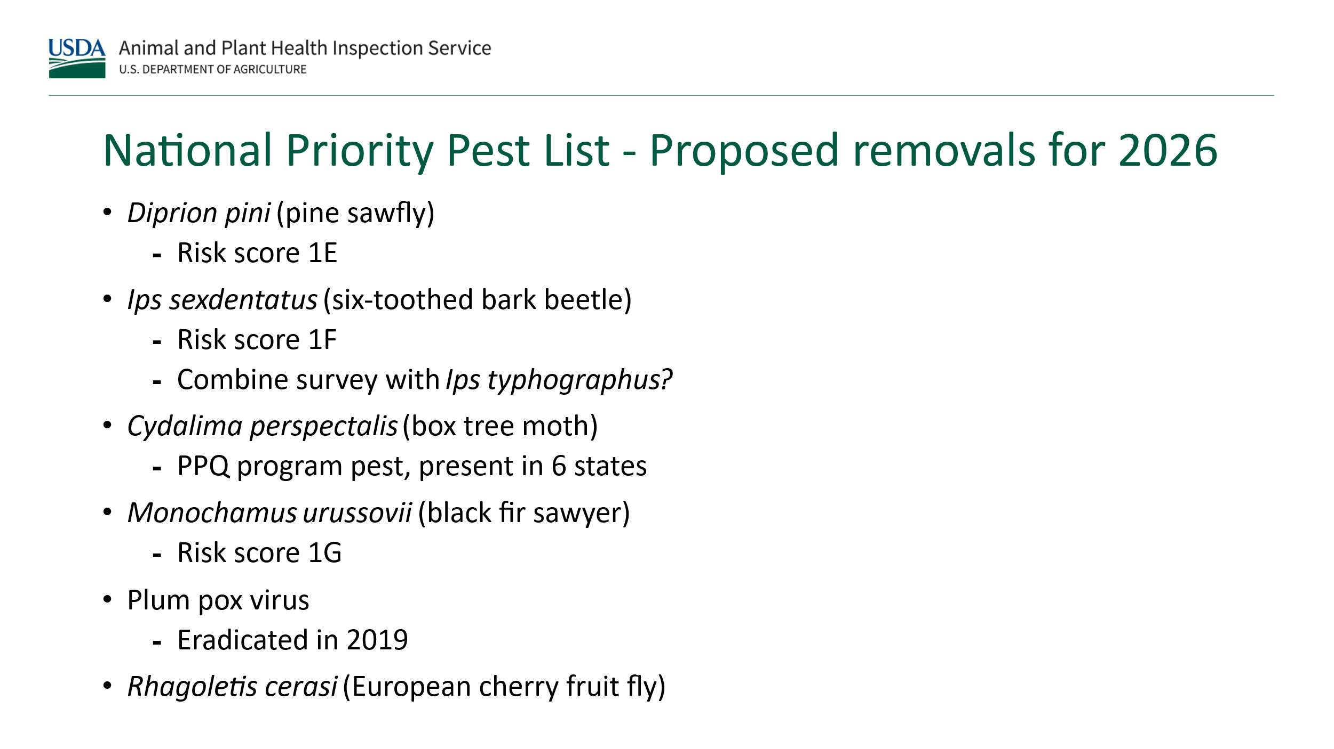
Questions and comments from the group discussion:
- Question to cooperators: What is the impact on states’ ability to export commodities if Diprion pini is removed from the NPPL? Are we collecting survey data for this pest that supports trade agreements? Would removal from the NPPL impact softwood exports?
- Ips sexdentatus: We should keep this pest on the list, despite its low OPEP risk score, because it would be detected when surveying for Ips typographus. By leaving it on the list, there is a ‘two for one’ benefit when surveying for I. typographus
- Question: Is Monochamus urussovii detected by a general cerambycid survey? Answer: We followed up with PPQ S&T Biological Scientist Joe Francese. He confirmed this pest can be detected using the general cerambycid 6-component lure; however, trap recommendations differ for M. urussovii and the general Cerambycid survey. PPQ will continue gathering information to support a decision for the 2027 survey year to either leave M. urussovii on the NPPL or combine it into the general Cerambycid survey
- Plum pox virus – This is important to CA and WA. The plum pox program doesn’t support surveys. Industry wants this survey data in support of pest free areas
  - Question: Are these areas going through the pest freedom recognition process? Who has recognized these areas?
- Question: Could ECFF go under PPA 7721 rapid response for fruit fly? Answer from the PPA 7721 national policy manager: Typically, rapid response funds are available for projects with an immediate need for mitigation or treatment. The project may also include survey, outreach, or other activities in direct support of an emergency response. For non-emergency response, ECFF could submit under individual goal areas
- Port environs (PE) surveys are another possible outlet for ECFF fruit fly pathway pest surveys in WA. We are working to clarify parameters for PPQ-funded surveys, if they should focus on NPPL pests only, or a combination of NPPs and pests of local concern. If removed from NPPL, and PE surveys become limited to only priority pests, then these surveys would not be covered by PE surveys and would have to be surveyed through CAPS as a non-priority pest. WA votes for ECFF to remain on the NPPL as this survey is important to stone fruit exports
- Question: Can pests still be considered actionable and have quarantine status but not be included on the NPPL?
- Question: What are the states’ pests of interest for exports? What is the value of related export commodities?
- WA and ME support removing SLF and BTM from the priority pest list as long as national program surveys continue
- Established pests should not stay on the NPPL. Once a pest has moved from its point of incursion, it is considered established in the United States. By statute, CAPS surveys are intended to be early detection pest surveys, not monitoring surveys
- Question: What commodity has an additional declaration on the phytosanitary certificate that requires surveys? Answer: Bentz-Blanco recommends checking PDEx/PCIT for commodity conditions of entry

Other proposed changes to the NPPL
We considered removing SLF and BTM from the priority pest list for 2026 but may need to take a more phased approach by giving notice in 2026 and removing for 2027. An idea for 2026 is to limit surveys to states with no prior detections, including FSMC. We also considered creating a general potato cyst nematode entry on the NPPL that would encompass pale cyst nematode and golden cyst nematode. This would be consistent with our approach to general Cerambycid survey on the list.
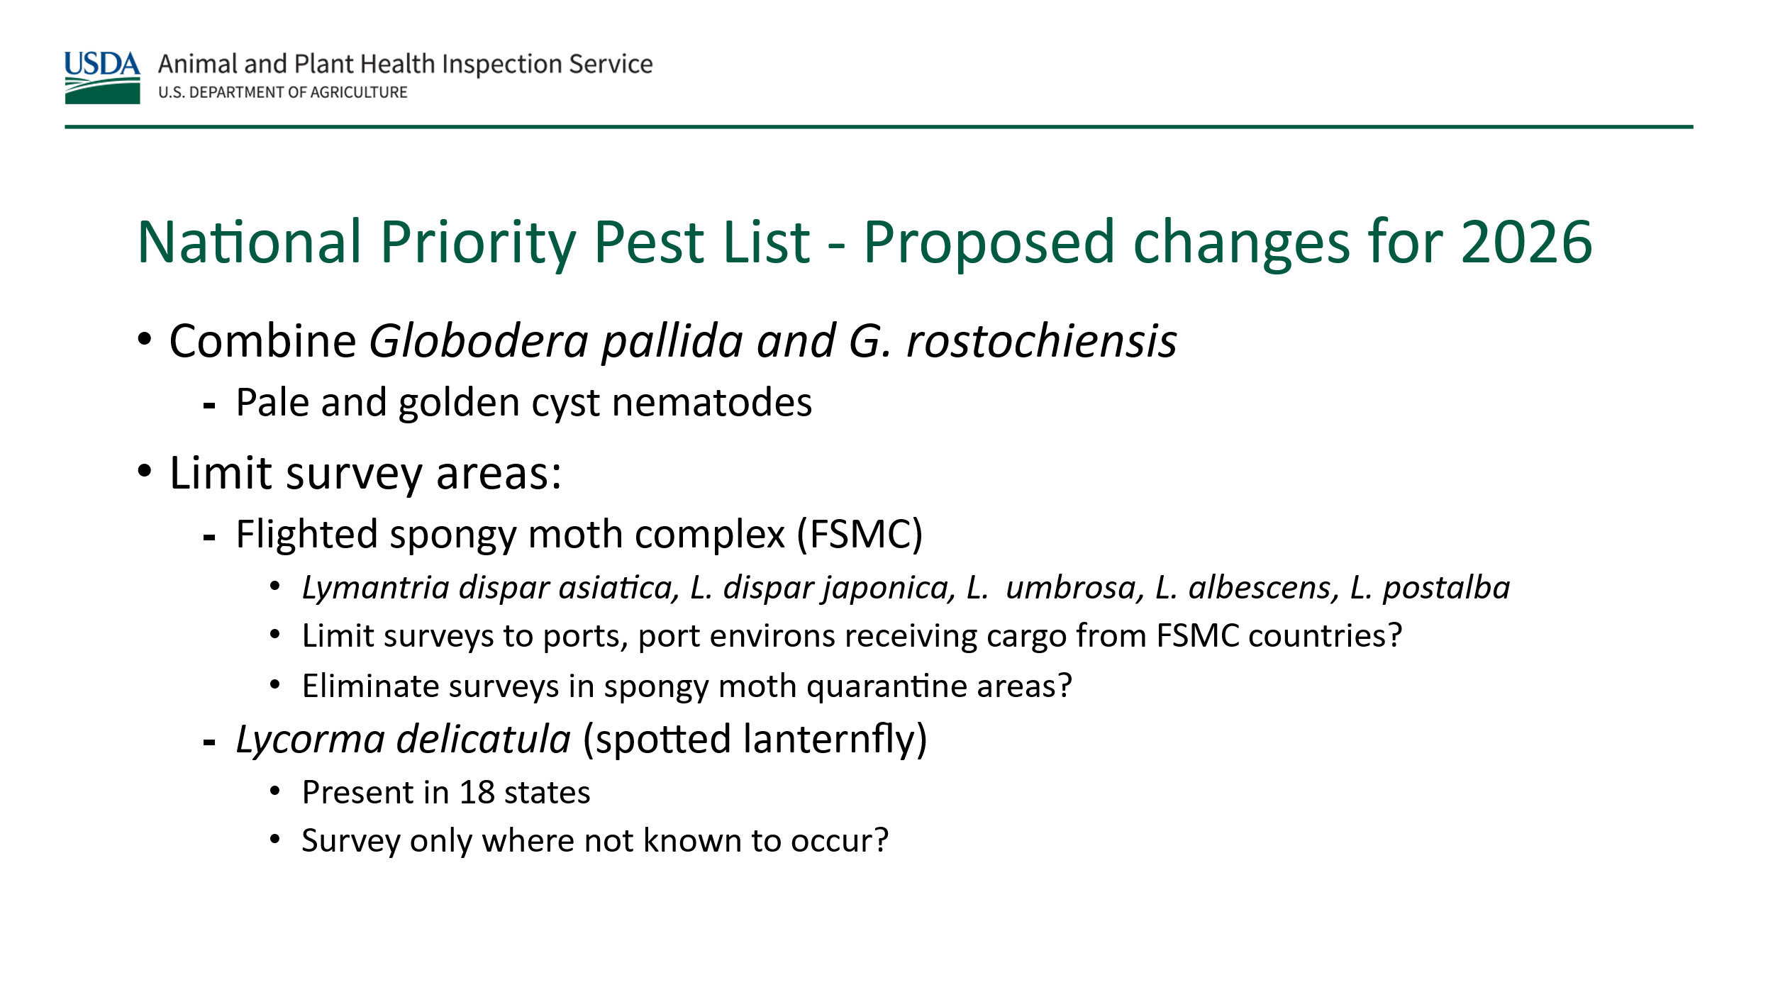

CAPS Performance Measures

Review of current measures and priority pest survey percentage
- Current performance measure – 60% NPPs and 40% non-priority pests
- Discussion questions for the group to consider:
  - How is this working for us? Average across all states and territories in 2024 was 83%. Could we consider increasing the threshold to 70% NPPs?
  - Does this performance measure influence how you plan surveys?
  - Are there other ways we can monitor program performance?
  - Show what we are getting for the money
  - Besides using the current performance measures, what are other ways to drive the program forward in the future? How can we innovate?
  - Where can we find efficiencies in the program?
- Discussion feedback and comments:
  - Hungry Pests example – Can we manage the priority pest list by state or by region? If we managed the pest list by region based on pest area suitability for establishment, how would we account for pests in tunnel and greenhouse surveys? This complicates the regional pest list approach
  - Could we manage program performance by pest area suitability for establishment? By USDA zone? By aligning priority pests with the commodities produced in each state?
  - What is the value of what we are protecting? This is a potential performance measure. Look at commodity list and calculate the value of CAPS survey on a national level
  - The group generally agreed we should keep allowing, providing for the 40% non-priority pest surveys (do not decrease) through CAPS so cooperators can access survey locations for other things on the NPPL. Surveys for pests of local concern can be the gateway for gaining access for NPPL surveys. This is a possible justification for using funds for non-federally quarantine pests
  - Can we (PPQ) request accomplishment reports that are uploaded into ezFedGrants (eFG)? How can we better document state contributions in eFG?
  - Accomplishment reports – planned number of traps versus actual number of traps. States are estimating cost per trap by dividing number of traps by total budget which can be skewing actual costs and, in many cases, make it appear that the cost per sample is unreasonably high
    - How is this cost data even used by USDA, if it is used at all? Do ADODRs use it?
    - Do we (PPQ) need to provide better guidance for filling out this section? More realistic numbers, better consistency between states
  - PPA 7721 – Much ability to provide information lost when the suggestion template changed from a narrative to spreadsheet format
  - Will there be a feedback session for cooperators regarding the PPA 7721 suggestion process? Anyone with feedback is encouraged to submit their comments and ideas to ppa-projects@usda.gov
  - Fisher: We need to have a bigger discussion about how state cooperators are coming with good intentions for their CAPS surveys
  - Howle: We need a better standardized message for lending support about the CAPS program and its importance. Update the CAPS outreach brochure (it’s from circa 2009)
    - We have this kind of information, but it’s distributed across multiple resources. PPQ would need to assemble it into a new resource and share it with NCC to disseminate to state constituents
    - It would be helpful if we developed a sign template for cooperators to post/publicize their cooperation with and support for CAPS surveys. (Positive peer pressure)
    - Bentz-Blanco noted that we cannot use funding to produce hard copy materials.
    - Can Hungry Pests resources be used for outreach rather than updating the old CAPS brochure?
    - One suggestion for improving outreach is to target industries through commodity sector meetings - PPQ use time to promote CAPS
  - Fisher provided an example of CA working with their nursery industry to help CDFA craft messaging supporting survey cooperation in their preferred language. This worked well and helped the message sound less like government/regulatory jargon
    - Howle said using their email distribution for industry network was useful as well.
  - The term no-cost pests is misleading as there is a cost, albeit small, associated with most of these surveys. The NCC should have a follow up discussion to consider whether a different term would more accurately describe these surveys. Consider how to document justification for no cost pest surveys based on their potential impacts to industry and/or trade

Support Services Updates

CAPSIS
Bonnie Dietrich presented the new CAPS Resource and Collaboration Website that will be going live in the next couple months. It looks very much like the existing site, so users are not likely to notice or experience a big change. The biggest changes are occurring behind the scenes and should make maintaining the site more efficient for the developers. Screenshot of the new landing page:
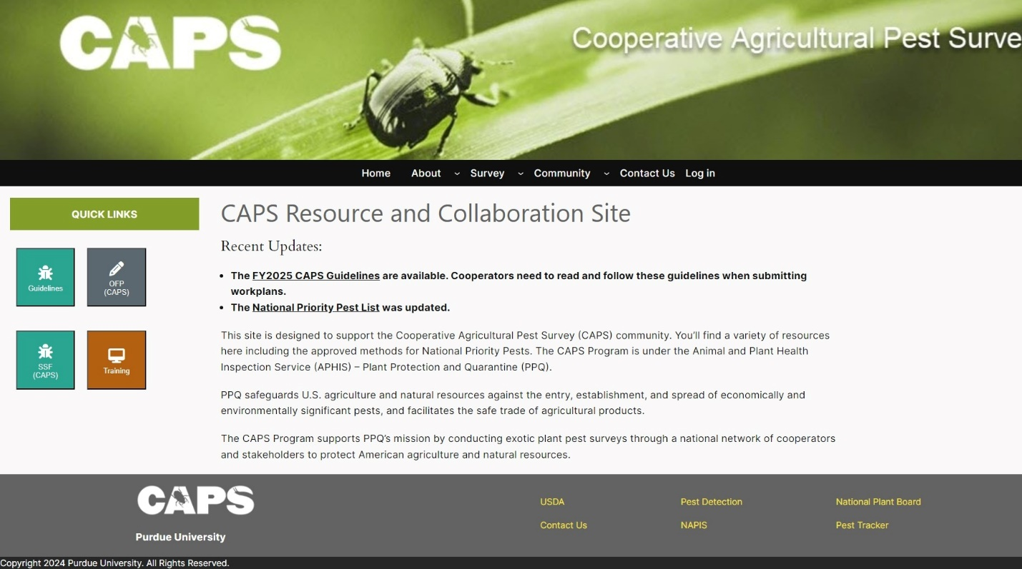
The CAPSIS team needs help with maintaining directories for the SPHDs, state plant regulatory officials (SPRO), pest survey specialists (PSS), and state survey coordinators (SCC). Deitrich proposed sending a quarterly callout to NCC members to submit updates.
The CAPSIS team is planning to develop a new tool for summarizing trap and lure needs for a survey plan. The idea is that the system will generate a trap and lure list that eventually can be used to streamline submitting your supply order. The NCC will be called upon to help test the new feature when the time comes.

Preliminary Identification
Patrick Haslem presented information about PPQ’s four preliminary identification institutions and their areas of expertise:
- Carnegie Museum of Natural History (Coleoptera)
- Mississippi State University (Coleoptera, Hemiptera, Lepidoptera)
- Oregon Department of Agriculture (Coleoptera, Hemiptera, Orthoptera)
- Washington State Department of Agriculture (Diptera, Hymenoptera, Lepidoptera)
Together, these institutions processed 101,000 samples in 2024. Preliminary identification institutions report the following challenges:
- Samples are sent to institutions late in the survey season, usually all at once. Request that samples are sent in smaller batches throughout the season
- Samples arrive in very poor condition. Sending samples on a more frequent basis would help solve this problem
- Sample slots reserved by cooperators are not ultimately fulfilled. Please communicate with the pest detection National Operations manager (Darrell.A.Bays@usda.gov) any changes in your survey plan that will result in fewer samples being submitted
When submitting samples for preliminary identification, it is very important that submitters indicate the correct funding source for the survey.
Significant first specimen/sample detections must be confirmed by PPQ or its partner national specialists to be officially recognized. When submitting the sample to PPQ using the Agricultural Risk Management (ARM) system, it is important that the submitter indicate if they think the sample may be a ‘range extension’ such as new in county, new in state, or new in the continental United States (CONUS). For more information, visit http://caps.ceris.purdue.edu/procedures-techniques/
Results are communicated back to a state’s SPHD and SPRO from the PPQ Emergency and Domestic Programs Pest Surveillance & Emergency Management Domestic Notifications & Confirmatory Results email account: ppq.edp.dncr@usda.gov. The National Plant Board president and the PPQ Management Team will also be notified of any significant new detections.
Suggestion: Develop preliminary identification best practices and share at regional plant board meetings.

Survey Supply and Procurement Program
Ramirez shared the following statistics for the survey supply and procurement program (SSPP), also known as traps and lures program.
- Manages an average of 150 trap, lure, and supply products in the Integrated Plant Health Information System (IPHIS) catalog
- 115 products purchased commercially, stored at Moore Airbase (MAB) warehouse
- 29 lure types manufactured by PPQ Forest Pest Methods Laboratory (FPML)
- Approximate annual inventory managed at MAB 3.94 million items
- Annual product value = $3.47 million
There are two main ordering periods for survey supplies. We appreciate your efforts to place orders only during these periods.
- Period 1: Fall (September - November)
  - Supporting CAPS and PPQ program surveys
- Period 2: Winter (January to March)
  - Supporting PPA 7721 Goal 1S surveys and any residual supply ordering needs
  - Currently open until March 14th, 2025

SSPP best practices reminders
- Login to IPHIS frequently (at least every 60 days) to maintain access. If your account is disabled, you must email Darrell.A.Bays@usda.gov or help@usda.gov. Be sure to indicate you need help with IPHIS account access in your request
- Adhere to supply ordering periods. Ordering outside these periods complicate the supply purchasing projections process and there is no guarantee we will fill orders placed outside of the official ordering periods
- Open supply deliveries immediately upon receipt to ensure your order is accurate. It is unacceptable to wait weeks or months before checking your order and then expecting a correction overnight
- If you don’t have room to store all of your supplies for the season, consider having your order shipped in more than one delivery (2 or 3 deliveries throughout the season)
- Beginning in February 2025, the main point of contact (POC) for each survey supply shipment, as identified in the IPHIS order, will receive an email from the Moore Airbase survey supply team requesting they sign (ink or digital) and return the packing slip upon receipt. This is a new administrative requirement for reconciling all shipping transactions initiated by PPQ
- PPQ is looking to replace the IPHIS supply ordering and fulfillment system within the next 2 to 3 years. The IPHIS platform is approximately 12 years old. We will keep the user community updated regarding this process. We anticipate the replacement system to be ServiceNow, currently also used for PPA 7721 suggestion submissions. We are making every effort to ensure the new system maintains all essential functions and is more intuitive and user friendly
Question: Now that the black funnel traps are not coming preassembled, could the SSPP program put the loose parts inside a sealed bag and possibly tape it to the inside of the box, so they don’t get lost during shipping? Answer: Yes, Ramirez will follow up with the Moore Airbase survey supply team to make these changes.
Question: How do you deal with storing flammable lures? Answer: You can opt to purchase explosion-proof refrigerators and freezers to address safety concerns related to flammable survey supplies. Lure storage requirements may vary by facility; the pest detection CFWG is working with PPQ Safety and Health to clarify requirements for PPQ facilities.

Pest Detection Cross-Functional Working Group Updates

S&T Updates
Leah Granke and Colin Funaro are the S&T representatives for pest detection, but many labs/units work on pest detection research and routine activities. With S&T, there are 6 labs/units, each of which specializes in a different type of research:
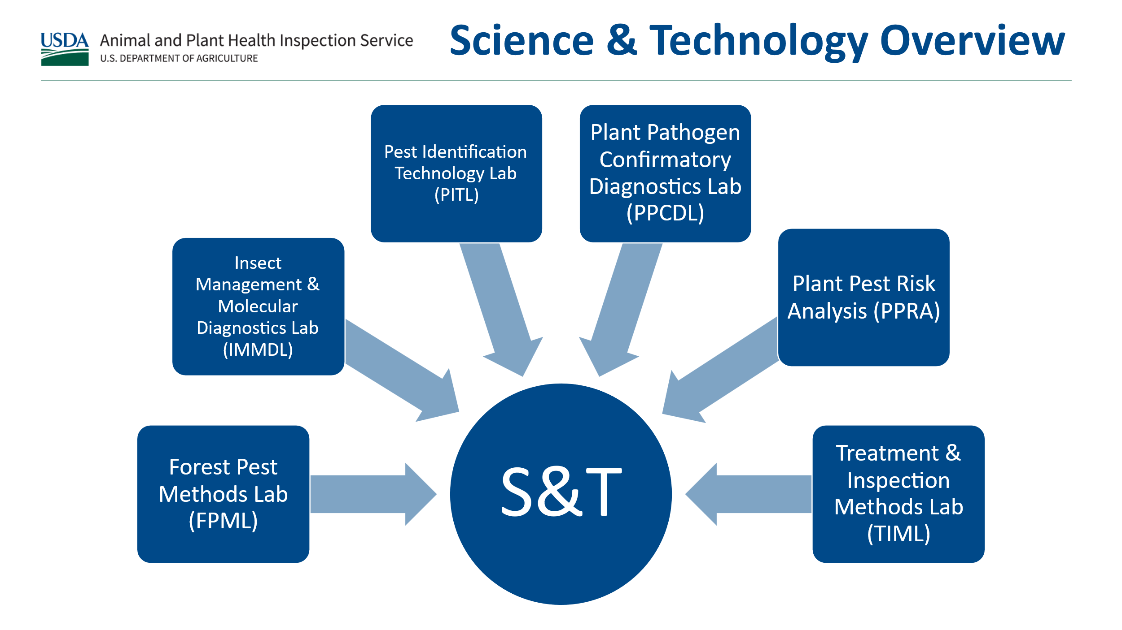
- FPML provides survey supply support for non-commercial lures and conducts research to identify, test, and improve survey tools for insects
- Insect Management and Molecular Diagnostics Laboratory (IMMDL) and the Pest Identification Technology Laboratory (PITL) provide insect molecular identification including processing mass trap samples, testing new and improved methods, and developing methods for insect pests that fail the S/D assessment
- Plant Pathogen Confirmatory Diagnostics Laboratory (PPCDL) provide pathogen molecular identification including confirmatory identification, testing new and improved methods, and developing methods for pathogens that fail the S/D assessment
- Plant Pest Risk Analysis (PPRA) coordinates support for new candidate pests including Objective Prioritization of Exotic Pests (OPEP), S/D assessments, and datasheet and approved methods (AMPS) creation/updates, and area suitability for establishment maps. We collaborate with these labs for methods, reviews, and recommendations regarding S/D assessments.
Suggestion: Do a PPQ lab-specific presentation on monthly NCC calls to dive into more details of what each of the S&T labs do. Response: PPQ S&T has arranged a speaker series for the monthly NCC calls.

Cotton jassid – Amrasca biguttula update
Colin presented a brief overview of S&T’s review of Amrasca biguttula (cotton jassid), leading up to its addition to the NPPL for 2025. The updated datasheet and AMPS are coming to the CAPS Resource and Collaboration site soon.
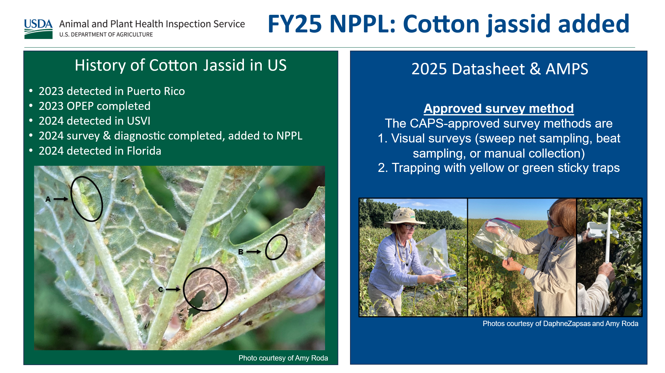

2026 Meeting Planning
- Reserve the week of February 9, 2026; most likely meeting dates are February 10-11
- NCC members were tasked with submitting meeting location nominations to the pest detection working group with meeting room and hotel location suggestions

Group photo - Meeting attendees
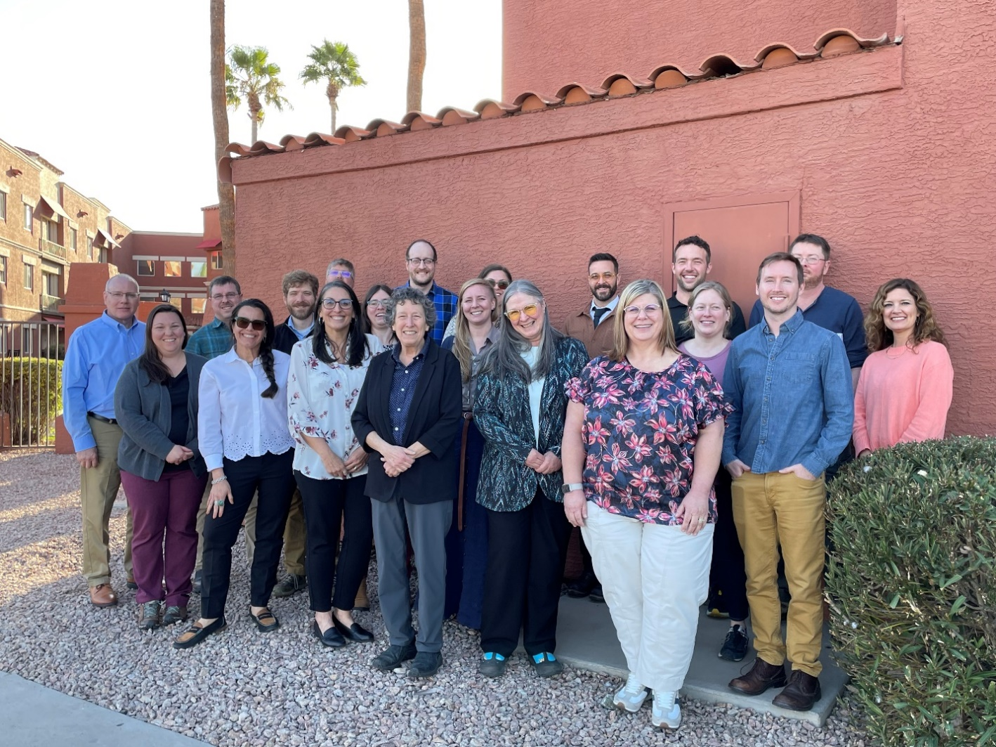
Front row from left to right: Cynthia Kwolek, Waleska Ramirez, Tina Gresham, Judy Rosovsky, Jo-Ann Bentz-Blanco, Tina Peltier, Jake Bodart
Back row from left to right: Jeff Hash, Patrick Haslem, Matthew Howle, Darrell Bays, Joanna Fisher, Colin Funaro, Emily Hagen, Leah Granke, Isaac Powell, Charles Elhard, Sven Spichiger, Bonnie Dietrich

Appendix 1 – Meeting Agenda
Tuesday, February 11, 2025 – Meeting Day 1
Location: Hotel Conference Room, Hyatt Place Phoenix/Chandler Fashion Center
Day 1 | Topics
Morning session  8:00 AM – 12:00 PM | Opening Remarks  - Facility overview and safety  - Meeting purpose, expected outcomes  - Introductions  - Agenda review  - Ice breaker activity  2024 Highlights and 2025 Survey Plans  - CAPS by the numbers (report current program stats)  - Regional updates  FY 2026 Planning and Discussion  - Proposed changes to National Priority Pest List  - How to Submit a National Priority Pest candidate  - CAPS Survey Guidance 2026
Lunch  12:00 PM – 1:00 PM | Lunch at nearby restaurants (walking distance)
Afternoon Session  1:00 PM – 4:30 PM | Program Performance Measures  - Review of current measures  - Priority pest survey percentage  - Brainstorming/discussion session  Program Administration/Cooperator Support  - Review available resources  - Maintaining consistent program delivery  - Brainstorming/discussion session
Wednesday, February 12, 2025 – Meeting Day 2
Location: Hotel Conference Room, Hyatt Place Phoenix/Chandler Fashion Center
Day 2 | Topics
Morning session  8:00 AM – 12:30 PM | - Opening Remarks/Recap of Meeting Day 1  - CAPSIS update  - Preliminary identification update  - Survey supply program update  - PPQ Pest Detection cross-functional working group update  - FY 2026 meeting: potential locations, dates, and format
Lunch  12:30 PM – 1:30 PM | Lunch at nearby restaurants (walking distance)
Afternoon Session  1:30 PM – 4:30 PM | - Learning opportunity/field trip to ARS Arid Lands Agricultural Research Center (transportation provided)

Appendix 2 – Notable detections in 2024
The following notable detections were reported to the NAPIS database in 2024:
- New in Nation (2) – 1 of 2 were on the NPPL
  - White spotted flower chafer
  - Strawberry blossom weevil
- New in State (12) – 4 of 12 were on the NPPL
  - Dark legged goldenrod aphid
  - Elm zigzag sawfly
  - Longhorned beetle (Dere thoracica)
  - Leaf spot
  - Euro red slug
  - Tomato brown rugose fruit virus (ToBRFV)
  - Cereal cyst nematode
  - Eriophyid gall mite
  - Bark borer (Phymatodes nitidus)
  - Spotted lanternfly (3)
- New in County (124) 25 of 124 were on the NPPL

