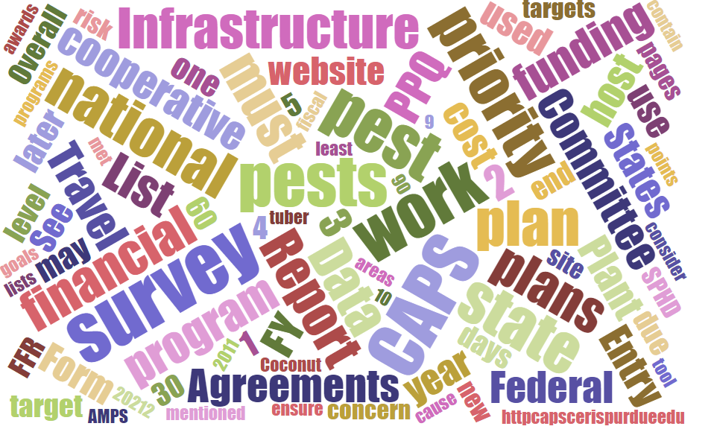



## Participants

# **National CAPS Committee (NCC) Monthly Conference Call**

May 1, 2025

|  |  |  |  |  |  |  |  |
| --- | --- | --- | --- | --- | --- | --- | --- |
|  | Darrell Bays |  | Leah Granke |  | Cynthia Kwolek |  | Isaac Powell |
|  | Jake Bodart |  | Tina Gresham |  | Kim Dean |  | Judy Rosovsky |
|  | Charles Elhard |  | Emily Hagan |  | Tina Peltier |  | Sven Spichiger |
|  | Joanna Fisher |  | Matthew Howle |  | Chelsey Penuel |  |  |
|  |  |  |  |  |  |  |  |
|  | Bonnie Dietrich |  | Mike Hill |  | Colin Funaro |  |  |

## Pest Detection Cross-Functional Working Group Updates

* (Tina) The 2026 CAPS Guidelines document and templates are in progress. We have finalized the 2026 priority pest list. As previously discussed:
  + No pests were removed
  + Three new pests were added (*Cacopsylla pyri* (European pear sucker), *Coniothyrium glycines* (red leaf blotch of soy), and *Candidatus* Phytoplasma aurantifolia (witches’ broom of lime)
  + Twelve terrestrial snails and slugs were combined into three new groups
  + With these changes, there will be 99 entries on the priority pest list for 2026.
* (Colin) The Approved Methods for Pest Survey (AMPS) for *Cydalima perspectalis* (box tree moth) will soon be updated to include a new trap option: red large plastic delta trap (LPDT). The red LPDT may be used in areas where the plastic bucket cannot be used due to restrictions on the insecticidal strip or endangered species concerns such as the rusty patched bumble bee (RPBB). Use of the red LPDT also requires doubling the lure.
  + States with RPBB are IA, IL, IN, MA, MD, ME, MN, OH, VA, WI, and WV
  + Updated RPBB map showing RPBB low and high potential zones can be found [here](https://www.arcgis.com/home/webmap/viewer.html?webmap=2716d871f88042a2a56b8001a1f1acae&extent=-100.6667%2c29.7389%2c-48.8551%2c50.9676).
* (Darrell) CAPS Agreements, Survey Supply, and Preliminary Identification updates
  + Joanna asked about orders that have not been delivered yet. She will follow up with specific order #s for Darrell to troubleshoot.
  + Cindy asked about geranyl acetol missing from her order – is it acceptable to trap without it and use the other five lure components? Darrell recommends trapping with the other five components, and we will have the debate about how to report negative data in the fall.
  + Charles asked when agreement opportunities will be posted, and Darrell answered in June.
  + Matt asked about the agreement opportunities process and Darrell recommended he follow up with Agreements Specialist Carrie Croy-Owen ([Carrie.V.Croy-Owen@usda.gov](mailto:Carrie.V.Croy-Owen@usda.gov))
  + Chelsey asked about pre-awards status. Darrell commented that CAPS and PPQ 7721 agreements should be approved and going through the system now.

## Cooperative Agricultural Pest Survey Information Services (CAPSIS) updates

* No CAPSIS updates this month; Bonnie was on leave and Mike was on travel this week.

## Science &Technology Guest Speakers

* We were treated to informal talks led by Allard Cosse from the PPQ Forest Pest Methods Laboratory (FPML) and Tyler Raszick from the PPQ Insect Molecular Methods and Diagnostic Laboratory (IMMDL). We appreciated learning more about the work done at these facilities and how it supports the CAPS pest surveillance mission.

## Regional plant board meeting updates

* Eastern Plant Board (March 31-April 3, 2025): Cindy reported they were able to offer a virtual option this year since in person attendance was much smaller. She was able to bring updates from the February NCC meeting which was helpful in the absence of PPQ attendees. She was also able to meet three State Survey Cooperators who are new to the region. It is always valuable to be together in person.
* Central Plant Board (April 14-18, 2025) Chelsey and Charles reported they didn’t have an opportunity for virtual attendance in the CAPS breakout session but did in the main session. There were no federal employee attendees in the CAPS breakout session, so the meeting was quieter than usual. Bonnie was there and provided very helpful CAPSIS updates. Customs and Border Protection was well represented at the meeting. There was discussion about how PPQ manages the national priority pest list which may result in the National Plant Board requesting a meeting with PPQ to learn more and express concerns about certain pests being removed from the list in the future, such as box tree moth.

## Next NCC call

* The next NCC monthly call is scheduled for June 5, 2025, at 2 PM EDT. In addition to the recurring topical updates, we will also be treated to an informal talk by Joe Francese to tell us more about his work at the FPML.