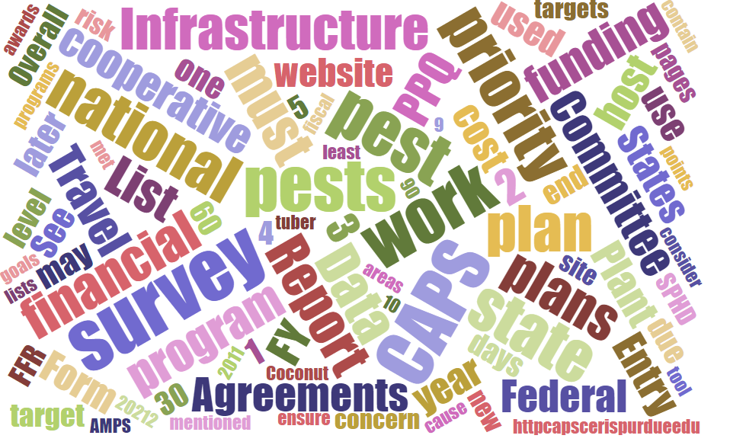



## Participants

# **National CAPS Committee (NCC) Monthly Conference Call**

June 5, 2025

|  |  |  |  |  |  |  |  |
| --- | --- | --- | --- | --- | --- | --- | --- |
|  | Darrell Bays |  | Leah Granke |  | Cynthia Kwolek |  | Isaac Powell |
|  | Jake Bodart |  | Tina Gresham |  | Kim Dean |  | Judy Rosovsky |
|  | Charles Elhard |  | Emily Hagan |  | Tina Peltier |  | Sven Spichiger |
|  | Joanna Fisher |  | Matthew Howle |  | Chelsey Penuel |  |  |
|  |  |  |  |  |  |  |  |
|  | Bonnie Dietrich |  | Mike Hill |  | Colin Funaro |  |  |

## Science & Technology Guest Speaker

We were treated to an informal talk led by Joe Francese from the PPQ Forest Pest Methods Laboratory (FPML). We appreciated learning more about the great work Joe’s team is doing to develop new, and improve existing, insect traps and lures to support PPQ’s pest surveillance efforts.

## Science & Technology (S&T) Updates

* S&T is rearranging the order of topics presented in pest datasheets. The new arrangement should provide a more logical flow of information and make it easier to find topics of interest.
* We have three new Likelihood of Establishment maps available - ash dieback (*Hymenoscyphus fraxineus)*, Guatemalan potato moth (*Tecia solanivora)*, and red ring nematode (*Bursaphelenchus cocophilus*). Reach out to [Colin.F.Funaro@usda.gov](mailto:Colin.F.Funaro@usda.gov) or [Amber.Tripodi@usda.gov](mailto:Amber.Tripodi@usda.gov) if you have questions about how to use the maps in your survey planning.
* We have a new survey/diagnostic review in progress for the black fig weevil (*Aclees taiwanensis*), which is a possible addition for the 2027 national priority pest list (NPPL). Black fig weevil is primarily a pest of common fig but has also been seen infesting ornamental Ficus. Most of the damage reported has been on figs in Italy.
* S&T also recently closed an Objective Prioritization of Exotic Pests (OPEP) assessment that is available in PestLens.

## Pest Detection Cross-Functional Working Group Updates

* Reminder – please check the 2024 CAPS data accountability report at <https://caps.ceris.purdue.edu/accountability-report/>. Bonnie will be sending reminder emails soon, but you can get ahead the reminder by checking for your state and updating your data now.
* The 2026 CAPS Guidelines document is in the clearance process and will be posted to the CAPS website as soon as possible.
* Question for the NCC, as a follow up to our NCC in-person meeting in February: Would ‘Cooperator Cost Share Pest’ be a suitable replacement for the term ‘No Cost Pest’? We previously discussed finding a more descriptive term to describe survey targets that can be added onto a survey plan without a cost to the CAPS program. Several NCC members commented that ‘Cooperator Cost Share Pest’ would be confusing for their local agreements staff and could cause delays with workplan approvals. Oregon suggested the term ‘Cooperator Bundle Pest’ and Washington suggested ‘Bonus Data Pest’. Thank you for the feedback. We will consider these options.
* 2025 CAPS agreements are still working their way through the PPQ approval process. PPQ agreements staff is shorthanded and working through a backlog. We will share any new information we can as it becomes available. We appreciate your patience.

## Cooperative Agricultural Pest Survey Information Services (CAPSIS) updates

* Bonnie asked the NCC to watch for an email coming soon with updated SPHD, SPRO, SSC, and PSS information. Please respond with any corrections that are necessary.

## Regional plant board meeting updates

* Southern Plant Board (May 12-15, 2025): We had a good CAPS breakout session and productive icebreakers for getting to know the new State Survey Coordinators in the region. Matt reported giving a report out from the NCC annual meeting and recap of the national priority pest list (NPPL) management process. The round table discussion was focused primarily on imported fire ant. There was a really good presentation about how different states do nursery and citrus inspections.
* Western Plant Board (2025): This year’s meeting had a smaller turnout than usual but had great virtual presentations from PPQ in the CAPS breakout session. A lot of the meeting was focused on grasshoppers, as this is a concern for Wyoming. The tone of discussions was different due to the recent loss of many APHIS colleagues.

## Survey Supply Program Update

Please take note of the following lures that come packed in multiples from the manufacturer, and round up your orders accordingly. This will help the survey supply program maintain better inventory records and ensure enough product is available to fill all orders.

|  |  |  |
| --- | --- | --- |
| **IPHIS ID NO.** | **Product Name** | **Notes** |
| 74 | Alpha pinene UHR lure | NOTE: This product is packed in multiples of 20. **Please order in multiples of 20, round up your desired quantity to the nearest multiple of 20** i.e. if you need 45 units, you should order 60 units. |
| 1261 | Ammonium Acetate Lure, Bait Enhancer | NOTE: This product is packed in multiples of 10. **Please order in multiples of 10, round up your desired quantity to the nearest multiple of 10** i.e. if you need 45 units, you should order 50 units. |
| 59 | Ethanol lure | NOTE: This product is packed in multiples of 20. **Please order in multiples of 20, round up your desired quantity to the nearest multiple of 20** i.e. if you need 45 units, you should order 60 units. |
| 105 | Ips sp. lure | NOTE: This product is packed in multiples of 10. **Please order in multiples of 10, round up your desired quantity to the nearest multiple of 10** i.e. if you need 45 units, you should order 50 units. |
| 703 | Palm weevil lure, ethyl acetate | NOTE: This product is packed in multiples of 25. **Please order in multiples of 25, round up your desired quantity to the nearest multiple of 25** i.e. if you need 45 units, you should order 50 units. |
| 138 | Pesticide Strip - DDVP, Large | NOTE: This product is packed in multiples of 50. **Please order in multiples of 50, round up your desired quantity to the nearest multiple of 50** i.e. if you need 175 units, you should order 200 units. |
| 144 | Pesticide Strip - DDVP, Small | NOTE: This product is packed in multiples of 25. **Please order in multiples of 25, round up your desired quantity to the nearest multiple of 25** i.e. if you need 45 units, you should order 50 units. |
| 77 | Spruce blend lure | NOTE: This product is packed in multiples of 20. **Please order in multiples of 20, round up your desired quantity to the nearest multiple of 20** i.e. if you need 45 units, you should order 60 units. |
| 67 | Torula yeast pellets | NOTE: Unit of measure for this product is pounds, **please order this product in pounds.** There are approximately 32 Torula yeast pellets in one pound. |

## Next NCC call

* The next NCC monthly call is scheduled for July 3, 2025, at 2 PM EDT.