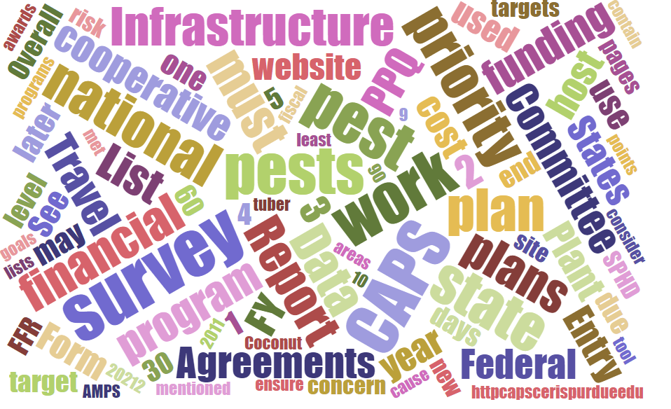

Participants

National Cooperative Agricultural Pest Survey Committee (NCC) Monthly Conference Call
January 8, 2026

☒ | Darrell Bays | ☒ | Leah Granke | ☒ | Cynthia Kwolek | ☒ | Isaac Powell
☒ | Jake Bodart | ☒ | Tina Gresham | ☒ | Kim Dean | ☐ | Judy Rosovsky
☒ | Charles Elhard | ☐ | Emily Hagen | ☒ | Tina Peltier | ☒ | Sven Spichiger
☒ | Joanna Fisher | ☒ | Matthew Howle | ☒ | Chelsey Penuel
☒ | Bonnie Dietrich | ☐ | Mike Hill | ☐ | Jeff Hash | ☐

Prep for NCC meeting in Raleigh (March 10-11, 2026)
- Information about travel authorizations for state cooperators should be coming through Kenny Naylor with National Plant Board
- Tina sent travel approvals and supporting information for PPQ travel authorizations.
- We will need a few PPQ folks to drive GOVs between the hotel and meeting room. Tina will share parking information the week before the meeting.
- Please think about and canvas your constituents for their input on the following discussion topics:
  - What if we had to reduce the pest list 25%, 50%, or 75%? How would we prioritize pests?
  - What if we could not support a CAPS website-type system for sharing and gathering survey information? What are the minimum functions we would need to get by?

PPQ S&T updates
- S&T updated the Cooperative Agricultural Pest Survey (CAPS) datasheets and approved methods for pest surveillance (AMPS) for twelve pests: Tetropium fuscum (brown spruce longhorned beetle), Meloidogyne artiellia (British root knot nematode), Rhabdoscelus obscurus (New Guinea sugarcane weevil), Pyricularia oryzae Triticum pathotype (wheat blast), Ceroplastes japonicus (Japanese wax scale), Autographa gamma (Silver Y moth), plum pox virus, groundnut bud necrosis virus, Platypus quercivorus (oak ambrosia beetle), Gymnandrosoma aurantianum (citrus fruit borer), Thaumetopoea processionea (oak processionary moth), and Stenoma catenifer (avocado seed moth)

PPQ Pest Detection Working Group updates
- Plant Protection Act (PPA) 7721 update – The spending plan announcement will be delayed due to the government shutdown. The team is estimating mid to late March for releasing the plan.

CAPSIS updates
- Bonnie will send out the quarterly CAPS directory update email soon. Please review and let Bonnie know if any directory changes are needed.
- Thank you to PPQ S&T for supplying new CAPS logos. Colin Funaro designed the new logos.

Round robin updates

Eastern Region (Judy)
- On December 3, 2025, Virginia put Clarke and Frederick Counties and the City of Winchester under a box tree moth quarantine. West Virgina has put the whole state under quarantine – we received that notice on January 5, 2026.
Eastern Region (Cindy)
- State survey coordinators (SSCs) met today. Much discussion about spotted lanternfly (SLF) egg mass scraping, and about box tree moth (BTM) being a regional concern.
- Regional plant board meetings coming up. They are looking for people to provide CAPS updates, such as Darrell, Bonnie, Leah, or Colin.
- Not a lot else to report right now because it is winter. A few states had non-priority pest detections. Found bay laurel wilt in Long Island.
Central Region (Chelsey)
- Reporting for herself and Charles. This is a quiet time, mostly working on NAPIS reporting and planning next season.
- They’ve seen significant expansion of SLF in Indiana and Ohio. BTM is also becoming a larger problem in Ohio counties bordering Lake Eerie.
- Chelsey shared this example of a pest introduction: A pallet arrived and was stashed in a greenhouse. When they revisited it later, they found a lot of dead SLF. This is a good example of why we do what we do.
- What is anyone expecting for attendees at regional plant board meetings? PPQ is considering 20 PPQ each regional plant board – Nicole Russo, Tracy Svalina, State Plant Health Directors, and Pest Survey Specialists will be prioritized but don't have travel approvals yet. National Operations Managers not expected to be approved. What is the best messaging strategy got more information about PPQ participate at these meetings? Work through National Plant Board to Matt Rhoads.
Western Region (Joanna)
- Not too many updates from SSCs right now. Colorado has confirmed a detection of jumping worm and is focusing on public awareness to slow the spread.
- The largest med fly infestation in California right now is in Santa Clara County. Still finding some but it's slowing down. They are conducting delimitation surveys, trapping, treatments, and fruit removals. Another Z. tau detection, which has fewer tools for eradication. Detection was native female, seems to be a one-off.
- A lot of concerns about getting SLF in the west. Discussions with rail companies ongoing to prevent the pest coming in via rail. Some success in Utah working with the rail industry. California is doing table top exercises focused on an SLF detection in a difficult location. They already have an action plan but are looking at complicating factors and brainstorming how they would handle them.
- California also concerned about Japanese beetle (JB) because they don't receive federal funding for it. Oregon lost funding for their JB program. Making bid to state legislation.

Western Region (Sven)
- Personnel updates - Richard Kim in Hawaii has stepped down. The Oregon SSC, Cody Holthouse, has moved on, they are in the process of hiring his replacement now. Washington has a new noxious weed coordinator. Sven has a new supervisor who is restructuring the department, which will likely impact NCC/CAPS. Sven will supervise the person doing CAPS surveys.
- The white spotted flower chafer incident is considered a one and done. A CAPS trap found it and they were able to address the issue quickly. There is a new weed risk assessment for sunflower broomrape. This detection is likely also a one off, as they have not found it elsewhere yet.
- They are still seeing a quality issue with the translucent crass-vane panel traps supplied by PPQ. They disintegrate after one year field use. PPQ should consider a different clear panel trap. Some of them placed on east-facing slopes don’t even last one season.

Southern Region (Matt)
- South Carolina is looking at SLF lampshade traps today. Has anyone else found eggs hatching in January? Is this normal? Isaac commented he’s never heard of SLF hatching anywhere in January. He advised Matt let Greg Parra and Brianna Flonc know about this. Sven commented there is some evidence of early hatch, even in same season that the egg mass was laid, with in places with much higher temperatures. Chinese literature suggests there could be as many as five generations per year.
- Two spot cotton leafhopper was initially identified in Florida and is now being found all throughout the south. It is moving with nursery stock as well as cotton and okra.
- Yellow legged hornet (YLH) activity was reported 150 miles away from the known contained area. Inspectors confirmed the sighting, located and killed the nest. This was an opportunity to use all their learning from the past couple years to see if eradication is possible within the first year. They will trap for emerging queens in the spring, set traps early, conduct public outreach. They hope to do a lot more work with YLH next year with funding.

Southern Region (Tina P)
- SLF remains a hot topic. Dead SLF found in nursery stock, believed to have come from Pennsylvania. Pasture mealy bug was detected in TX which is keeping them busy. They are busy with regional plant board meeting planning. She was told to expect 10 PPQ attendees only 1-2 CPB attendees at the Southern Plant Board meeting. It is tough to plan a meeting when you don’t know how many people will be attending.

Next call – February 5, 2026
- Guest speaker is Brittany Barker – Brittany would like to share information about her PPA 7721 project and seek your input and feedback.
- Brittany is an Assistant Research Professor at the Oregon IPM Center and Department of Horticulture at Oregon State University. She develops ecological models that can help agricultural decision makers with managing and monitoring pests, their crop hosts, and their natural enemies. Much of her recent work has focused on developing spatial models that predict the phenology and potential distribution of insects, including invasive pests and biological control agents (see https://uspest.org/CAPS).

Next, next call - February 24, 2026
- We’ll hold an extra call in February to share preliminary information regarding candidates for addition to the 2027 national priority pest list. We wanted to preview the information with you so you have time to digest and prepare for our in-depth discussion at the in-person NCC meeting in March.

