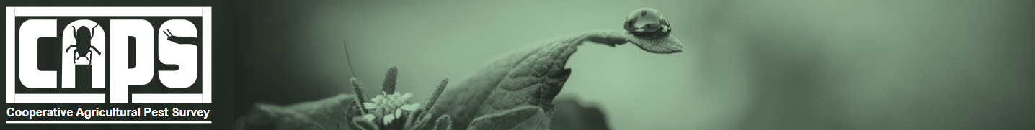

National CAPS Committee (NCC) Monthly Call Minutes

February 5, 2026

Participants
☒ | Darrell Bays | ☒ | Jeff Hash
☒ | Jake Bodart | ☒ | Mike Hill
☒ | Kim Dean | ☒ | Matthew Howle
☒ | Bonnie Dietrich | ☒ | Cynthia Kwolek
☒ | Charles Elhard | ☒ | Tina Peltier
☒ | Joanna Fisher | ☒ | Chelsey Penuel
☐ | Leah Granke | ☒ | Isaac Powell
☒ | Tina Gresham | ☒ | Judy Rosovsky
☒ | Emily Hagen | ☒ | Sven Spichiger

Guest Presentation
Speaker: Dr. Brittany Barker, Oregon Integrated Pest Management Center & Department of Horticulture, Oregon State University
Topic: Dr. Barker develops ecological models that can help agricultural decision makers with managing and monitoring pests, their crop hosts, and their natural enemies. Much of her recent work has focused on developing spatial models that predict the phenology and potential distribution of insects, including invasive pests and biological control agents (see https://uspest.org/CAPS).
Team: Len Coop (Decision-Support Systems), Maxine Cruz (Web App Dev), PPQ Science and Technology Risk Analysts - Jarrod Morrice and Glenn Fowler
Key Questions for NCC Feedback:
- Is 4-km² map resolution sufficient, or would you prefer high resolution such as 800m²?
- Current trend maps span a 45-year timeframe. Would you like to see trend maps in small increments, such as two 20-year increments?
- Interest in later-generation trends (e.g., 2nd adult emergence)?
- Would Cooperative Agricultural Pest Survey (CAPS) cooperators be interested in having summaries of results for entire counties, such as the overall trends and amount of change in phenological events and climate suitability? Or are they okay with simply zooming in and visualizing results for the county (what the app currently does)?
Send feedback to: brittany.barker@oregonstate.edu

Pest Detection Working Group Updates
- CAPS funding - PPQ is drafting program allocations for fiscal year 2026. We are expecting the same level of CAPS funding as last year, although budgets have not yet been finalized. We will share information as it become available.

S&T Updates
- S&T updated the CAPS datasheets and approved methods for pest surveillance (AMPS) for one pest: Tetropium castaneum (black spruce beetle) https://approvedmethods.ceris.purdue.edu/sheet/47

CAPSIS updates
- Bonnie is holding CAPS Information Services (CAPSIS) Office Hours on Friday, February 6th and the next three Fridays (February 13, 20, and 27).
- Accountability report reminder emails will be coming out soon. March 1st is the deadline for entering NAPIS data for PPQ Pest Detection and PPQ Port Environs surveys.
- Reminder: Please send new CAPS Information Services account requests to CERIS for access and orientation.
- Question - What is the County column for on the accountability report? Answer – A check in this column means data has been entered for every county listed on the survey summary form. A dash means data has not been uploaded for all counties. Country count was added to the survey workplan in 2023. The new column on the accountability report is the visualization of the county data already being collected.
- Data from CAPS and Plant Protection Act (PPA) 7721 surveys must be entered into NAPIS within two years. For PPA 7721, data reminder emails will begin around mid-March.

Next call
February 24th @ 11 AM EST
- S&T will preview the pests we are considering for the 2027 national priority pest list.
- We will cancel the March monthly call since we’ll be together in Raleigh the following week.

