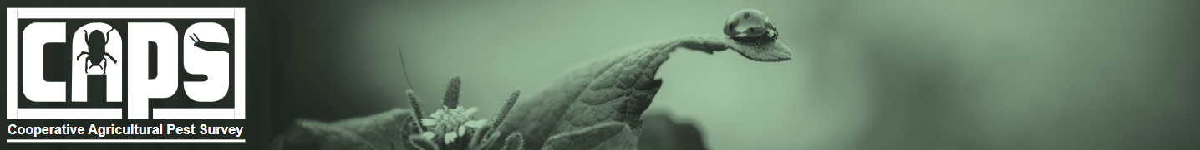

National CAPS Committee (NCC) Monthly Call Minutes

February 24, 2026

Participants
☐ | Darrell Bays | ☒ | Jeff Hash
☒ | Jake Bodart | ☐ | Mike Hill
☒ | Kim Dean | ☒ | Matthew Howle
☒ | Bonnie Dietrich | ☐ | Cynthia Kwolek
☒ | Charles Elhard | ☒ | Tina Peltier
☒ | Joanna Fisher | ☒ | Chelsey Penuel
☒ | Leah Granke | ☒ | Isaac Powell
☒ | Tina Gresham | ☐ | Judy Rosovsky
☒ | Emily Hagen | ☒ | Sven Spichiger

Annual review of the National Priority Pest List (NPPL)
The PPQ Pest Detection cross-functional working group is conducting its annual review of the NPPL. We are presenting for NCC constituent feedback the following proposed additions, removals, and combinations for the 2027 NPPL. We seek your feedback to understand the importance of these pests in your states and regions. Cooperator feedback is a very important part of our evaluation process and we appreciate all the input you can provide.
We plan to discuss these proposed changes again during the NCC meeting in Raleigh, NC next month, and collect any additional feedback you have about the proposed addition, removals, and combinations. We will publish the 2027 NPPL in late May 2026. During your discussions with constituents, please remind them the minimum threshold for national priority pests on CAPS survey plans will increase from 60% to 70% beginning in 2027.

Reminder of process to submit a candidate for the NPPL
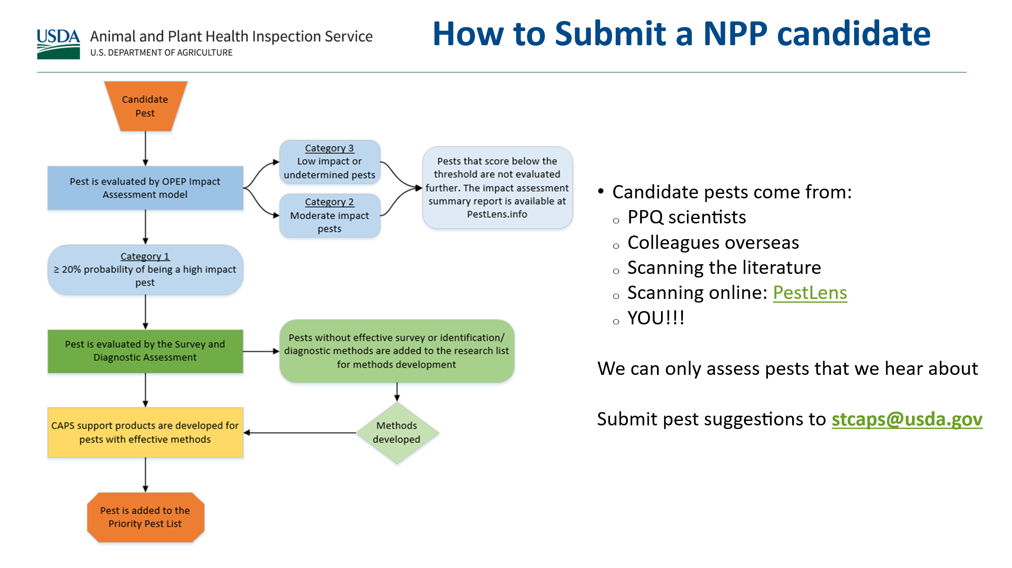

Proposed addition to the 2027 NPPL
Leah Granke presented the following slides describing sunflower broomrape, a candidate for addition to the 2027 priority pest list:
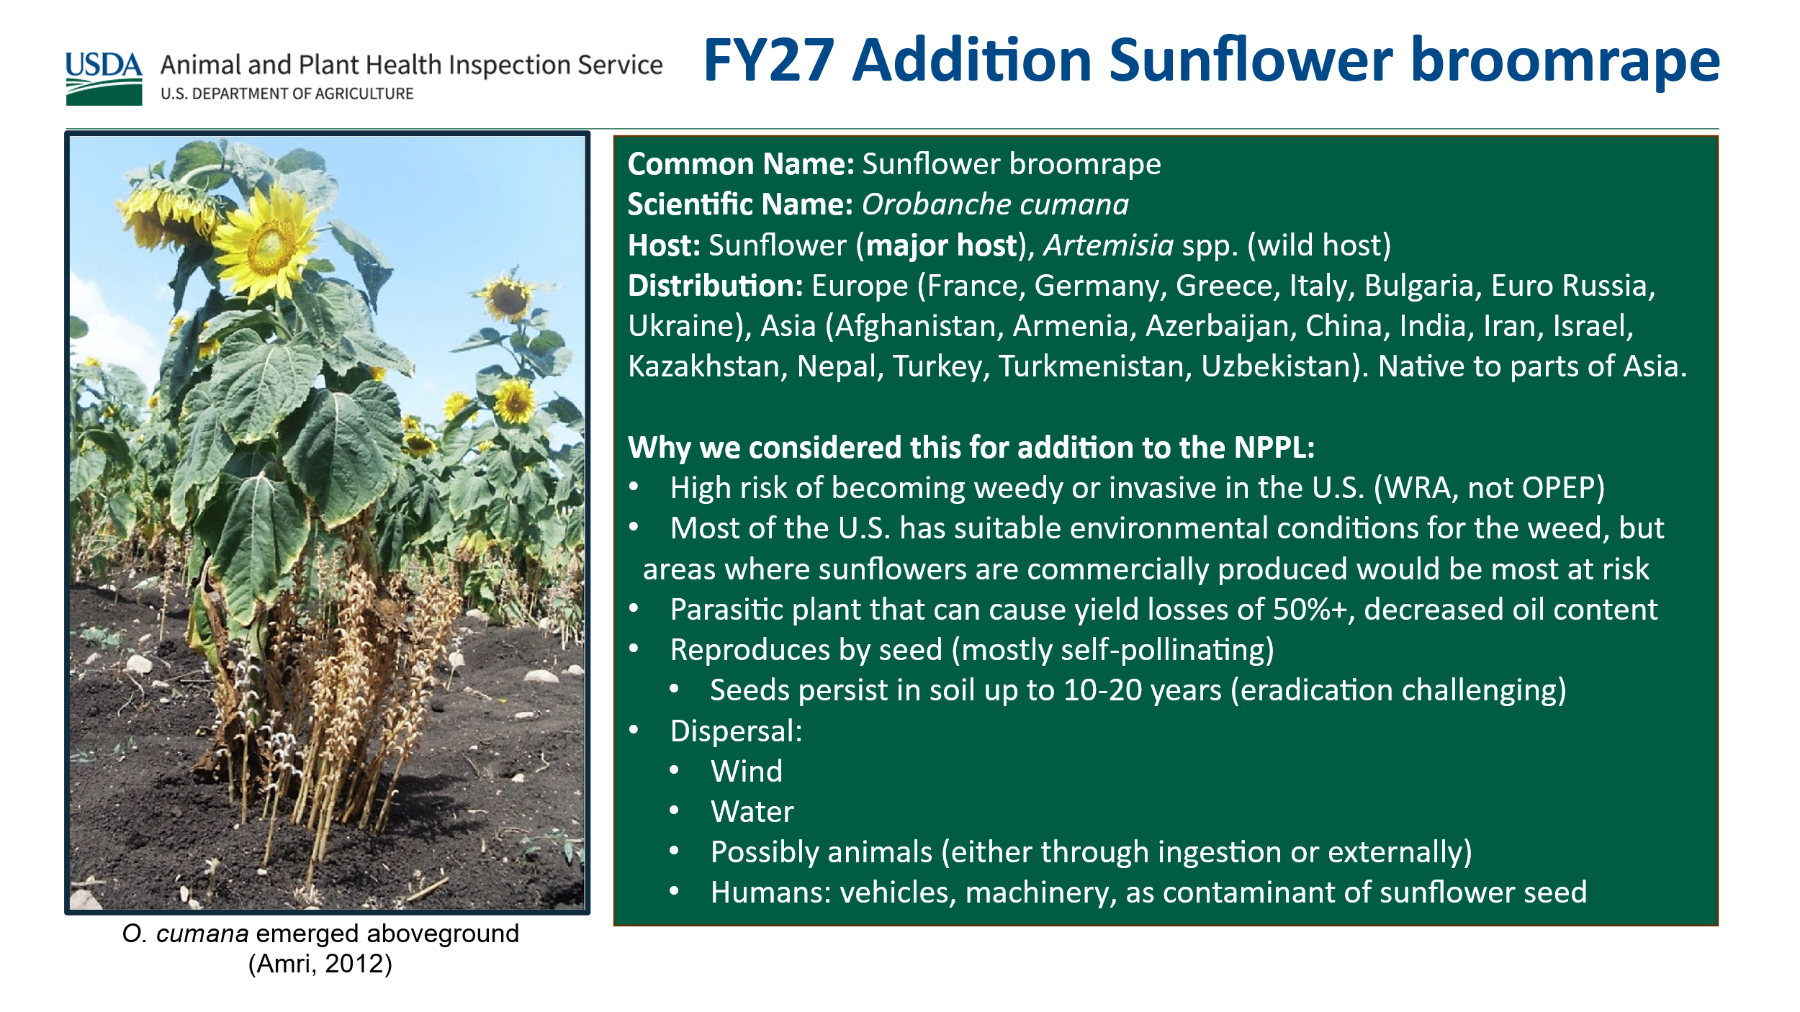

Other pests considered for the 2027 NPPL
Leah also presented information about pests we considered for the 2027 NPPL, but for which we need more information or additional research. We would appreciate any feedback about the importance of these pests to your states and regions. If multiple pests are important to you, understanding your priority ranking would also be helpful. We request your feedback about these pests to by late June to help us prioritize research needs.
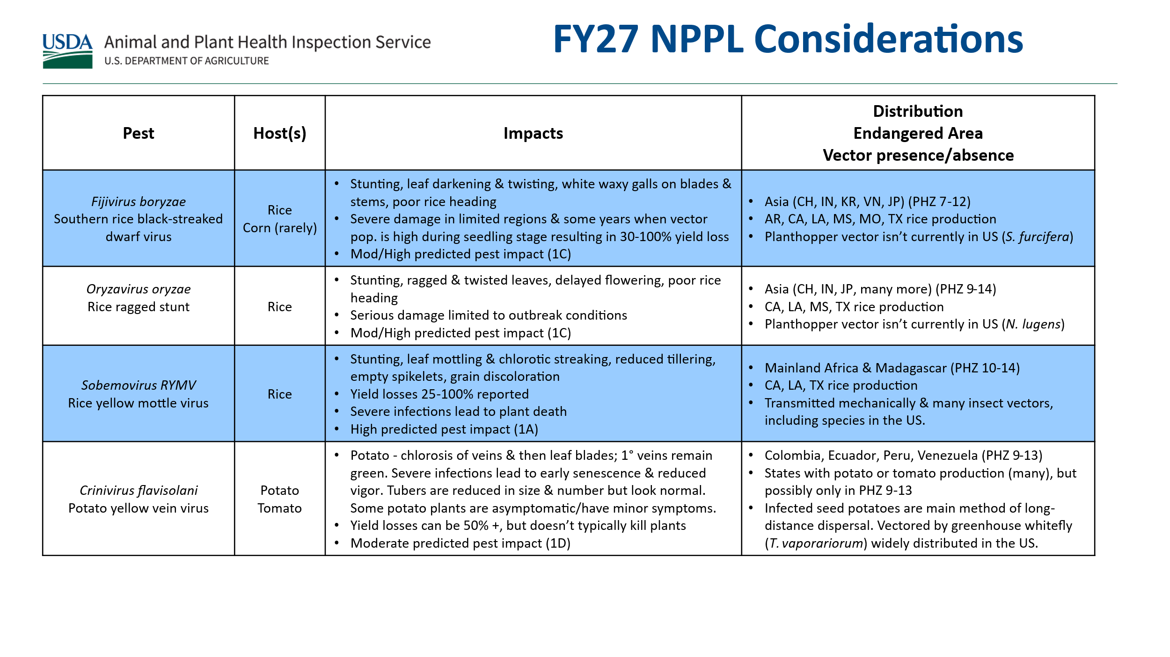
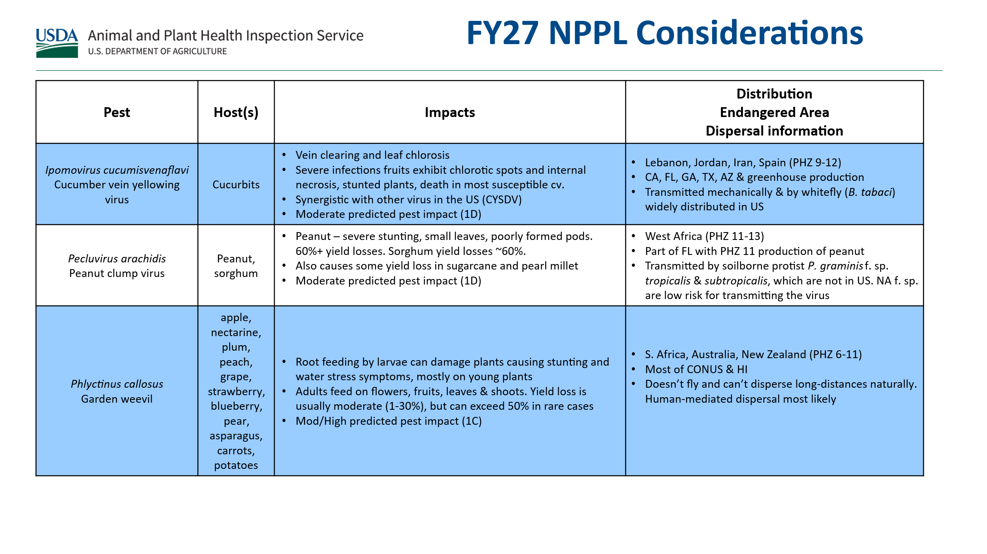

Proposed removals from the 2027 NPPL
Tina Gresham presented the following candidate pests for removal. We request your feedback about 1) the importance of these pest surveys to your state, and 2) the impact if CAPS no longer supported these pests as national priority pests.
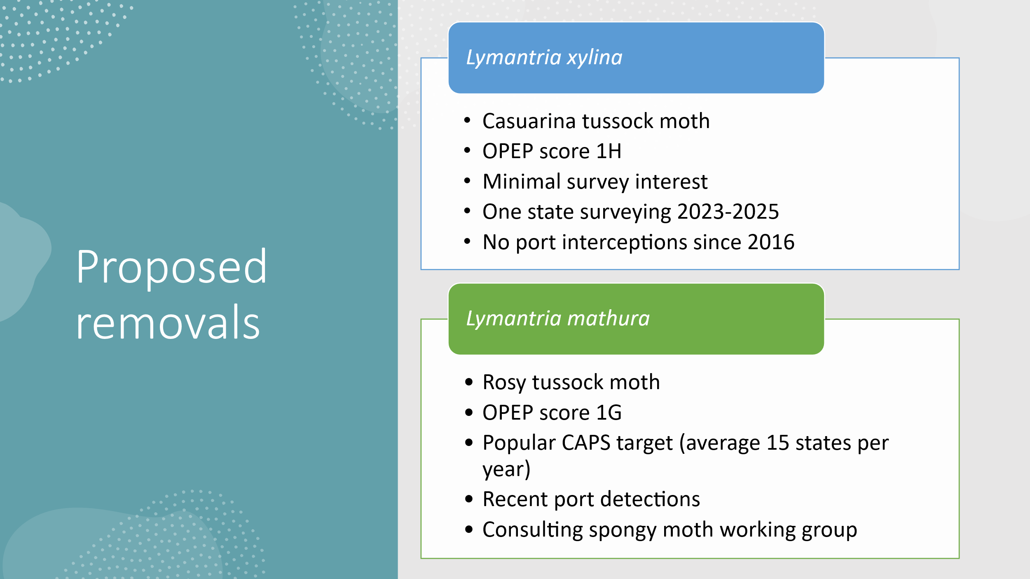
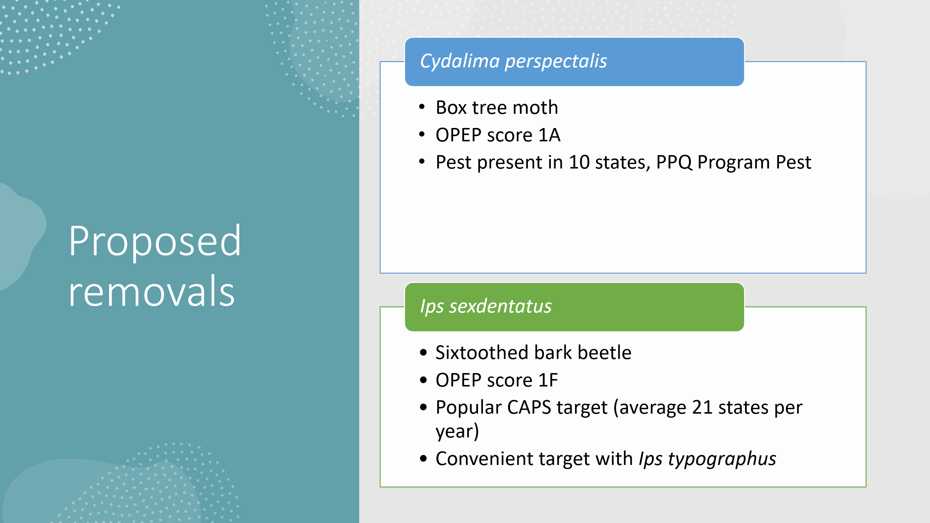

Proposed combinations for the 2027 NPPL
Tina G also presented the following suggestions for creating new combined pest entries on the 2027 NPPL.
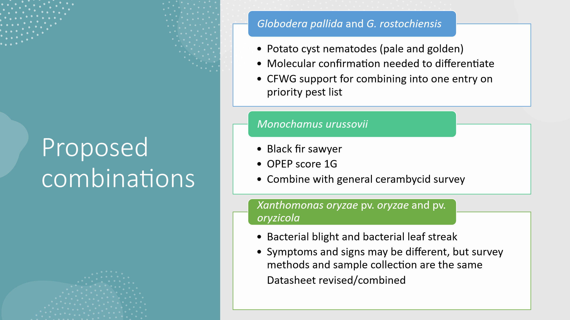

Questions, answers, and comments from today’s discussion:
Pests considered but need more research:
- Regarding potato yellow vein virus - What would be the infection route for tomatoes? We will research this question and follow up.
- We would like to learn more about hosts of the potato yellow vein virus and garden weevil. This information is available in the objective prioritization of pests (OPEP) assessments.
Proposed addition to NPPL:
- Regarding sunflower broomrape, are there other wild hosts of concern? Yes, there are other wild hosts; however, we would recommend survey in sunflower only. More information from the weed risk assessment:
  - Other hosts found to be naturally infected include Cirsium arvense (Canada thistle, Asteraceae) and Karelinia caspia (a desert perennial, Asteraceae) growing adjacent to infected sunflower (Cao et al., 2022; Ma et al., 2023), and Plectranthus scutellarioides (coleus, Lamiaceae) in a greenhouse (Cao et al., 2023) in China. In Israel, a new local race of O. cumana has adapted to Solanum lycopersicum (tomato, Solanaceae), although in other regions tomato is not normally affected (Dor et al., 2020). Nicotiana tabacum (tobacco, Solanaceae) was found to be an experimental host of the new race of O. cumana in Israel (Dor et al., 2020), and a report from China about control of O. cumana on tobacco (Wang et al., 2021) suggests it has adapted to and damages tobacco there. These examples show that local populations of O. cumana may occasionally adapt to other hosts, although it is well demonstrated in the literature (e.g., Fernández-Martínez et al., 2015; Martín-Sanz et al., 2016; Molinero-Ruiz et al., 2015) that sunflower is the main host of economic concern.
- Who nominated sunflower broomrape for the NPPL? We received a request from WA state and the PPQ weed cross-functional working group.
- Has sunflower broomrape been detected at ports of entry? Very unlikely as the seeds are very tiny.
Proposed removals from the NPPL:
- Regarding Lymantria xylina – why does it have the low OPEP score it has? It rarely causes damage. It is capable of some defoliation by does not cause as much damage as other Lymantrias.
- Regarding Lymantria mathura – there have been massive detections on west coast, often mixed with other Lymantria species. It is considered an indicator of other Lymantria pressure/presence at ports, on ships. What is the reason for the low score? It can cause damage in outbreak situations. Described as "minor" more often than a "major" pest.
- Ips sexdentatus – We need to look at ratio of bark beetles on the NPPL and non-priority pests for it to make sense and get the most out of survey efforts.
- Cydalima perspectalis – We would need more time to prepare industry for this pest’s removal from the NPPL. Pose this question to the box tree moth cross-functional working group.
Proposed combinations:
- Potato cyst nematodes – several states support this move.
- Monochamus urussovii – We believe this one stayed on the NPPL in spite of a low OPEP score because of the pinewood nematode. We will investigate further.
- Monochamus urussovii – We would welcome this change in the field as it would make surveys more efficient. Even if the general cerambycid 6-component lure is less sensitive, the overall survey effort is more efficient.

Upcoming NCC meeting planning (Raleigh, NC - March 10-11)
- Tina will send out the final agenda and meeting logistics package by Friday, February 27th.
  - Note you need a QR code to park in the parking structure next to the Raleigh meeting location. Tina will email the code.
  - PPQ employees should already have LincPass access to the meeting location.
  - State cooperators should already have guest access, but please keep your state-issued ID on you in case you need to show it. We also requested guest WIFI access for you.
- We cancelled the monthly NCC call on March 5th since we will all be together the following week.
- We found value in the regional report outs from last year. We’ve scheduled 15 minutes for each region to provide a report out, share important information for PPQ and other regions, raise concerns, share ideas, and ask questions.

