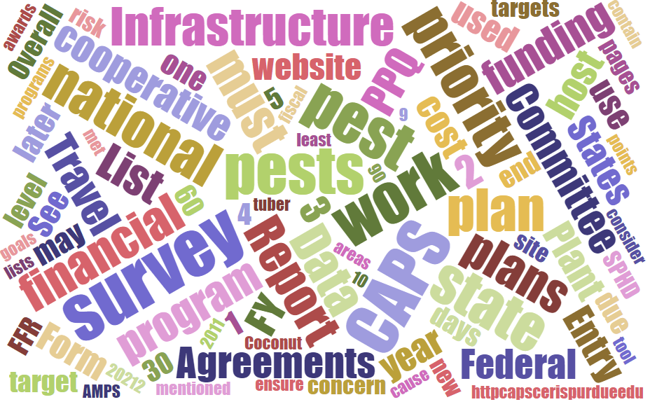



## Participants

# **National Cooperative Agricultural Pest Survey Committee (NCC) Monthly Conference Call**

July 3, 2025

|  |  |  |  |  |  |  |  |
| --- | --- | --- | --- | --- | --- | --- | --- |
|  | Darrell Bays |  | Leah Granke |  | Cynthia Kwolek |  | Isaac Powell |
|  | Jake Bodart |  | Tina Gresham |  | Kim Dean |  | Judy Rosovsky |
|  | Charles Elhard |  | Emily Hagan |  | Tina Peltier |  | Sven Spichiger |
|  | Joanna Fisher |  | Matthew Howle |  | Chelsey Penuel |  |  |
|  |  |  |  |  |  |  |  |
|  | Bonnie Dietrich |  | Mike Hill |  | Colin Funaro |  |  |

## 2026 CAPS Guidelines

The 2026 Cooperative Agricultural Pest Survey (CAPS) Guidelines were announced earlier today and went live on the CAPS Resource and Collaboration website: <https://caps.ceris.purdue.edu/guidelines-2026/>

Joanna asked if PPQ has any idea of what the budget will look like for 2026. Will there be further cuts to CAPS agreements? Unfortunately, we (PPQ) have no insight into what the 2026 budget will be just yet. As always, we will share relevant information once it becomes available and we are cleared to do so.

## 2025 CAPS agreements

## PPQ agreements staff report that opportunities for 109 of 112 CAPS agreements have been published now. Of those 112, 28 have been fully executed, and the remainder are pending an application or recipient action to move forward. Please ask your constituents to check the status of their agreement(s), complete any pending actions as soon as possible, and follow up with their agreements specialist if they have any questions. Required actions are time-sensitive, so the sooner they can complete their part, the more likely they are to receive their award before the end of the fiscal year.

## Science & Technology (S&T) Updates

S&T completed an Objective Prioritization of Exotic Pests (OPEP) assessment for *Oxya chinensis* (rice grasshopper). S&T delivered a likelihood of establishment map for a CAPS priority pest *Stenoma catenifer*, avocado seed moth. S&T updated CAPS datasheets and approved methods for pest surveillance (AMPS) for *Fusarium oxysporum* f.sp. *cubense* Tropical Race 4 (TR4), which causes Fusarium wilt of banana, and *Candidatus* Phytoplasma solani, which is associated with Bois noir disease in grapevine and maize redness disease in corn.

## Cooperative Agricultural Pest Survey Information Services (CAPSIS) updates

## Bonnie demoed new search boxes that have been added to the NAPIS dictionary pages.

## Rusty-patched bumble bee reminders

Please remind your constituents of Endangered Species Act requirements for surveys funded by CAPS or PPA 7721 in states known to have the rusty patched bumble bee (*Bombus affinis*, RPBB), which are: Iowa, Illinois, Indiana, Maine, Maryland, Massachusetts, Minnesota, Ohio, Wisconsin, West Virginia, and Virginia. These eleven states have special survey and reporting requirements based on the type of trap used and where surveys take place. See <https://download.ceris.purdue.edu/file/4358>. More information about endangered species act, trapping, and bycatch considerations for CAPS surveys can be found at <https://caps.ceris.purdue.edu/esa/>.

A map of RPBB high and low potential zones is available from U.S. Fish and Wildlife Service (USFWS) here: <https://www.arcgis.com/home/webmap/viewer.html?webmap=2716d871f88042a2a56b8001a1f1acae&extent=-100.6667%2c29.7389%2c-48.8551%2c50.9676>. General information about RPBB is also available here: <https://www.fws.gov/species/rusty-patched-bumble-bee-bombus-affinis>

PPQ is obligated to report to USFWS on an annual basis about CAPS and PPA 7721 surveys in RPBB states, and we typically begin contacting the impacted states in the December/January timeframe to collect survey and bycatch data from cooperators.

## Survey Supply Program

PPQ is still working on getting geranyl acetol lures in stock. One shipment was lost, and other is currently going through U.S. Customs. We will fill existing orders as soon as possible, if there is enough survey season left once they become available.

Cindy asked how effective is trapping using the other lures (ethanol and spruce blend) without the geranyl acetol? S&T responded that the other components work well for the genus Tetropium in general. The range of species targeted is limited without the geranyl acetol but still effective. In the post season we’ll have to discuss how to handle reporting negative data for these surveys where geranyl acetol was not used.

## Round Robin

NCC members reported this being a busy time with surveys underway, preparing PPA 7721 suggestions, and carrying out ‘business as usual’.

Kim asked how CAPS Asian longhorned beetle (ALB) surveys are documented. Cindy replied that they record data in NAPIS only, others concurred. Kim asked if there was any interest in using a FieldMaps app for ALB surveys or if that would only add an extra step; the general response was that people were not sure how much more helpful that would be for CAPS surveys. Tina G offered to walk Kim through the data is collected in NAPIS to help answer questions about where and how CAPS survey data is collected.

Next NCC call: August 7, 2025, at 2 PM EDT