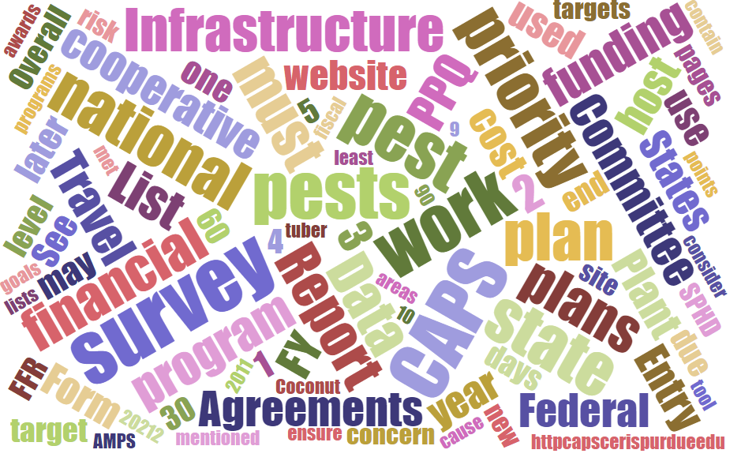



## Participants

# **National Cooperative Agricultural Pest Survey Committee (NCC) Monthly Conference Call**

August 7, 2025

|  |  |  |  |  |  |  |  |
| --- | --- | --- | --- | --- | --- | --- | --- |
|  | Darrell Bays |  | Leah Granke |  | Cynthia Kwolek |  | Isaac Powell |
|  | Jake Bodart |  | Tina Gresham |  | Kim Dean |  | Judy Rosovsky |
|  | Charles Elhard |  | Emily Hagan |  | Tina Peltier |  | Sven Spichiger |
|  | Joanna Fisher |  | Matthew Howle |  | Chelsey Penuel |  |  |
|  |  |  |  |  |  |  |  |
|  | Bonnie Dietrich |  | Mike Hill |  | Colin Funaro |  | Jeff Hash |

## Special guest speakers

Two guest speakers join the call:

* Amber Tripodi, Risk Analyst, PPQ Science and Technology (S&T) Plant Pest Risk Analysis group – Amber provided updates on SAFARIS CAPS maps:
  + Recent maps published - small brown plant hopper, Guatemalan potato moth, red ring nematode, ash dieback, and avocado seed moth.
  + Highlighted revisions to the spotted lanternfly and oak processionary moth maps, including the addition of Alaska.
  + Pest maps currently being worked on - such as European cherry fruit fly and two Lymantria species.
  + Amber welcomed questions or feedback on the CAPS maps any time. Wants to make sure the maps meet needs and are easy to use and understand. She will check back in with the NCC every quarter or so. If you want to contact her in the interim, her email address is [Amber.Tripodi@usda.gov](mailto:Amber.Tripodi@usda.gov)
* John Bienapfl, Assistant Lab Director, PPQ S&T Plant Pathogen Confirmatory Diagnostics Laboratory (PPCDL) – Jon provided an overview of the laboratory’s work:
  + PPCDL mission and areas of support - confirmatory diagnostics, proficiency testing, and method development.
  + Detailed their work on wheat blast, including the development and validation of diagnostic methods. Mentioned the need for additional work due to new data showing potential false positives and negatives in current tests.

## S&T Updates

* Colin provided updates on the CAPS program, including the addition of Alaska to the oak processionary moth map
* S&T updated a CAPS datasheet and approved methods for pest surveillance (AMPS) for *Chilo suppressalis* (Asiatic rice borer), *Tecia solanivora* (Guatemala potato moth), and *Ips typographus* (European spruce bark beetle). AMPS are fully updated; revised datasheets will be uploaded soon.
  + [Guatemalan potato moth (*Tecia solanivora*): Revised datasheet.](https://approvedmethods.ceris.purdue.edu/sheet/1228)
  + [European spruce bark beetle (*Ips typographus*): Revised datasheet.](https://approvedmethods.ceris.purdue.edu/sheet/2111)
  + [*Asiatic rice borer (Chilo suppressalis): Revised datasheet.*](https://approvedmethods.ceris.purdue.edu/sheet/110)
* S&T developed a datasheet and AMPS for *Cacopsylla pyri*, the pear sucker psyllid, a pest that was added to the national priority pest list (NPPL) for fiscal year (FY) 2026. In addition, AMPS were added for new pests added to the NPPL for FY 2026: *Coniothyrium glycines* (red leaf blotch of soy), *Ca.* Phytoplasma aurantifolia (Witches' broom disease of lime), and terrestrial snails and slugs by pathway (plant production, Previous find(s), and Shipping Containers). CAPS datasheets for these pests are in progress.
  + [European pear sucker (*Cacopsylla pyri*): New datasheet.](https://approvedmethods.ceris.purdue.edu/sheet/2121)
  + [Red leaf blotch of soybean (*Coniothyrium glycines*): New datasheet.](https://approvedmethods.ceris.purdue.edu/sheet/2120)
  + [Witches broom disease of lime (Ca. *Phytoplasma aurantifolia*): New datasheet.](https://approvedmethods.ceris.purdue.edu/sheet/2119)
  + Terrestrial snails and slugs - [Plant Production](https://approvedmethods.ceris.purdue.edu/sheet/2116), [Previous find(s)](https://approvedmethods.ceris.purdue.edu/sheet/2117), [Shipping Containers](https://approvedmethods.ceris.purdue.edu/sheet/2115)

## Pest Detection CFWG updates:

* Darrell provided updates on the 2026 survey planning cycle, the SSF is currently open (closes September 5)
* Several states still have missing 2024 CAPS NAPIS survey data, please upload asap
* CAPS office hours invitations
  + Office hours for the State Survey Coordinators (SSCs) and State Plant Regulatory Officials (SPROs) are scheduled for August 12th, 13th, and 14th.
  + Office hours for the State Plant Health Directors (SPHDs) and Pest Survey Specialists (PSSs) are scheduled for August 25th, 27th, and September 2nd
* Tina addressed NCC annual meeting plans for 2026 – request the in-person meeting submitted for the week of February 9th, most likely to be held in a USDA hub such as Raleigh, NC. Uncertain if an in-person meeting is possible but we will to try our best.

## CAPSIS updates:

* Bonnie asked NCC members for assistance with keeping core four contact information up to date. She will follow up with an email to NCC members to review on a quarterly basis.

## Next call:

* September 4, 2025 – Special guest speaker will be Todd Gilligan, Laboratory Director, PPQ Pest Identification Technology Laboratory (PITL)