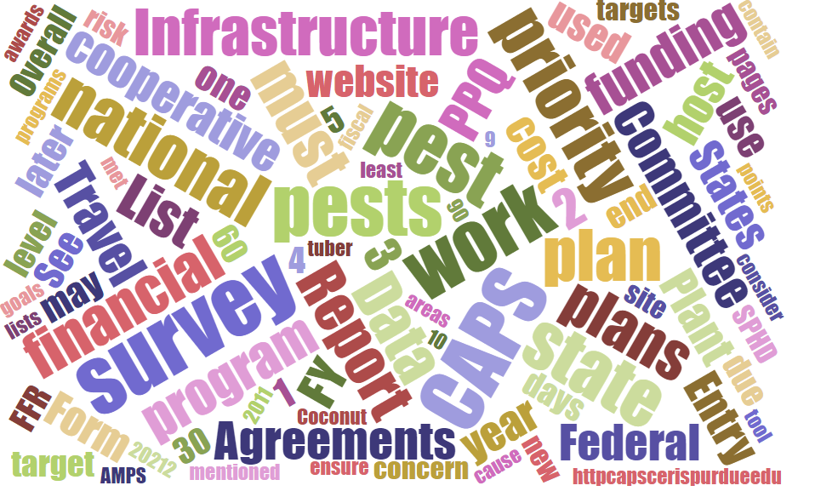



## Participants

# **National Cooperative Agricultural Pest Survey Committee (NCC) Monthly Conference Call**

September 4, 2025

|  |  |  |  |  |  |  |  |
| --- | --- | --- | --- | --- | --- | --- | --- |
|  | Darrell Bays |  | Leah Granke |  | Cynthia Kwolek |  | Isaac Powell |
|  | Jake Bodart |  | Tina Gresham |  | Kim Dean |  | Judy Rosovsky |
|  | Charles Elhard |  | Emily Hagan |  | Tina Peltier |  | Sven Spichiger |
|  | Joanna Fisher |  | Matthew Howle |  | Chelsey Penuel |  |  |
|  |  |  |  |  |  |  |  |
|  | Bonnie Dietrich |  | Mike Hill |  | Colin Funaro |  | Jeff Hash |

## Special guest speaker

Todd Gilligan, Laboratory Director, PPQ Science and Technology (S&T) Pest Identification Technology Laboratory (PITL) – Shared information about the work being done at the PITL.

## S&T updates

* S&T updated pest datasheets and approved methods pages (AMPS) for *Ips* *typographus* (European spruce bark beetle) and *Tecia* *solanivora* (Guatemalan potato tuber moth).

## Pest Detection Working Group updates:

* Reminder – The CAPS survey summary form submission period closes September 5th
* We are aware some states are having a problem finding the link to their online financial plan – the CAPSIS team working on fixing this.
* Survey supply ordering best practices – When you place your trap and lure orders, please round up your FY 2026 order by 5% (instead of 10%, as in past years) – This applies to all traps and lures, regardless of whether they originate from the Moore Airbase warehouse or the Forest Pest Methods Laboratory.
* Waleska Ramirez will be out of office Sept 15 - October 3; Tina will be filling in for survey supply program needs.

## CAPSIS updates:

* Bonnie is fixing the online financial plan link issue on some states’ survey summary forms.
* So far, 24 states’ survey summary forms are at the state survey coordinator data entry stage. Bonnie will email reminders in mid- and late-September for any states who have not completed the survey summary form submission process.

## Round robin updates:

* Southern region –
  + Cotton jassid (*Amrasca biguttula* was detected in Louisiana on hibiscus plants (out of state shipments) at retail nursery locations. Nine locations have been confirmed positive and inspections are ongoing.
  + Cotton jassid has been detected in at least one retail location in Texas.
  + South Carolina, Alabama, Georgia, and Florida detected cotton jassid in commercial cotton and okra fields.
  + Yellow legged hornet (YLH) work is ongoing in South Carolina and Georgia. They have detected about 30 nests and could probably find about 30 more. Be on the lookout for YLH in your states as it moves quickly. Employees from Florida and Georgia are traveling to the United Kingdom to learn from their YLH response experiences.
* Western region –
  + Investigating an iNaturalist report of sunflower broomrape
  + Confirmed detection of *Crytosporiopsis tarraconensis* on hazelnut in two states; they are evaluating a response.
  + Several vessels have had high counts of flighted spongy moth complex (FSMC) (mostly *Lymantria umbrosa* and *Lymantria dispar japonica*). One ship had live female adults.  Customs and Border Protection (CBP), Washington State Department of Agriculture (WSDA), and Animal and Plant Health Inspection Service (APHIS) have formed a strike force to respond.
  + An iNaturalist report of spotted lanternfly in Portland, Oregon has been thoroughly investigated with multiple visits and no detections confirmed.
  + WSDA provided hornet tracking training in Guam for Pacific islands.
  + Pacific northwest (PNW) state plant regulatory officials will participate in the PNW rail summit this October.
  + To date, all response traps for white-spotted flower chafer are negative.
* Eastern region –
  + Box tree moth has been detected in Maryland and West Virginia now.
* Central region –
  + No SPRO updates. South Dakota has a new state survey coordinator. They are wrapping up survey activities and will start screening samples soon. More pale cyst nematode (PCN) surveys are expected in the central region this year.

## Next call:

* October 2, 2025