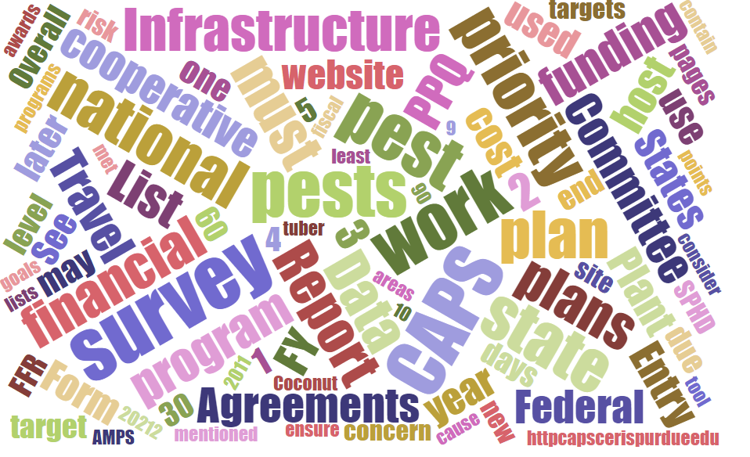

Participants

National Cooperative Agricultural Pest Survey Committee (NCC) Monthly Conference Call
December 4, 2025

☒ | Darrell Bays | ☒ | Leah Granke | ☒ | Cynthia Kwolek | ☒ | Isaac Powell
☒ | Jake Bodart | ☒ | Tina Gresham | ☒ | Kim Dean | ☒ | Judy Rosovsky
☒ | Charles Elhard | ☒ | Emily Hagen | ☒ | Tina Peltier | ☒ | Sven Spichiger
☐ | Joanna Fisher | ☒ | Matthew Howle | ☒ | Chelsey Penuel
☒ | Bonnie Dietrich | ☒ | Mike Hill | ☒ | Colin Funaro | ☒ | Jeff Hash

PPQ S&T updates
- Cotton seed bug SAFARIS map – New, check it out! https://safaris.cipm.info/safarispestmodel/StartupServlet?caps&pid=CSB
- S&T has completed 12 new survey/diagnostic (S/D) assessments and 7 objective prioritization of exotic pest (OPEP) assessments for select agents.
- Datasheet is now available for Coniothyrium glycines (red leaf blotch of soybean).

PPQ Pest Detection Working Group updates
- National CAPS Committee meeting planning for 2026 is underway.
  - Our new dates are March 10-11 in Raleigh, NC (March 9 and 12 travel days).
  - We reviewed a list of draft agenda topics on today’s call and incorporated input and suggestions from NCC members. We will likely have more topics than time to cover them at the in-person meeting, so we will likely move some topics to the monthly NCC calls.
  - Brainstorming sessions:
    - The Cooperative Agriculture Pest Survey Information System (CAPSIS) includes Cooperative Agriculture Pest Survey Resource & Collaboration (CAPS R&C) site and the National Agriculture Pest Information System (NAPIS) data repository managed by Purdue University. During the National CAPS Call, PPQ introduced a CAPSIS data system contingency planning thought exercise. As part of this exercise, PPQ is asking you to think about the following questions as it pertains to CAPSIS;
      - What are minimal essential functions needed if we are unable to fund a cooperative agreement for CAPSIS data system resources?
      - How could we continue with collecting data, data repository etc. (Note - this exercise does not include the Cooperative Agricultural Pest Survey (CAPS) Program which supports state cooperator’s infrastructure and survey cooperative agreements.)
      - National Priority Pest list contingency planning: what if we had to cut the NPPL by 25, 50, or 75%? What would we prioritize and why?

PPQ is still working on getting its final approval for this event from the USDA Secretary’s office (OSEC). Be aware, the finish line for approvals is fluctuating. PPQ understands cooperators need their travel authorizations asap; we are doing everything we can to give you the most planning time possible.
- CAPSIS updates
  - We are working on creating a popup box in the survey summary form that would alert survey planners when they add a pest that has already been added in their state under a different funding source. The popup is meant to create awareness of surveys under other funding sources and avoid duplication of effort. The popup was live briefly, but we have disabled it while we fine-tune the messaging.
  - Note there is a new column for County in the accountability report.
- National priority pest list
  - The government shutdown caused delays with PPQ’s evaluations of new pests for the FY 2027 national priority pest list. Our new timeline for presenting information about new candidate pests (and proposed removals from the list) is mid-February.
- In FY 2025 we created templates for the ‘one workplan’ option. In FY 2026 we would like to also create an online financial interface that is compatible with this option. We asked for subcommittee volunteers to lend their expertise to this effort. Brad Danner and Jake Bodart have already volunteered, but we are open to more participants if you are interested.
- The PPA 7721 spending plan will be delayed in 2026. The team is targeting March to early April for release.

CAPSIS updates
- Bonnie will begin offering CAPSIS office hours every Friday starting on December 5th. She will send invitations with a Teams link by email, and will also advertise these sessions on the CAPS Resource and Collaboration website.

Round robin updates
- We didn’t have time for round robin updates but we will prioritize this for our next meeting.

Next call
- January 8, 2025

