Cooperative Agricultural Pest Survey (CAPS)

INTRODUCTORY GUIDEBOOK


Updated October 2024



Contents

Acknowledgements I
Foreword II
Common Acronyms III
CAPS ORGANIZATION
Origin of CAPS Funding 1
CAPS Communication Network 2
National CAPS Program 3
STATE CAPS PROGRAM COMPONENTS
Determining Pest Targets 4
Appendix 1: Resources for CAPS-Related Information………………..….9
Appendix 2: Contact List for CAPS Support…………………………………9
Work/Financial Plans & Reports 10
Pest Survey Details 14
Data Management 21
State Survey Committees 23
Community Communications 27

Revision History:
10/17/2024: Updated links in Appendix A, updated contacts in Appendix B, updated Center for Plant Health Science and Technology (CPHST) to Science and Technology throughout document, and updated link for U.S. Forest Service Forest Inventory and Analysis Program on page 16. Updated font and graphics to be accessibility compliant.


Acknowledgements

The compilation of the CAPS Guidebook was a collaborative effort. Many individuals contributed their time and talents to this project. We wish to thank the following people who made this project possible:

PROJECT TEAM
ADRIAN BARTA — Wisconsin Department of Agriculture, Trade and Consumer Protection
DARRELL BAYS — USDA, APHIS, Plant Protection & Quarantine
EMILIE INOUE — Vermont Agency of Agriculture
LISA JACKSON — USDA, APHIS, Plant Protection & Quarantine
SOO-HOON (SAM) KIM — USDA, APHIS, Plant Protection & Quarantine
DAN MACKESY — USDA, APHIS, Plant Protection & Quarantine
TIFFANY MAURO — USDA, APHIS, Plant Protection & Quarantine
ERIN STIERS — USDA, APHIS, Plant Protection & Quarantine
JOHN BOWERS — Champion, USDA, APHIS, Plant Protection & Quarantine
LISA KEEFE — Project Lead, Texas A&M University
SUZANNE KABAT — Graphic Design, Texas A&M University





This material was developed at Texas A&M University, College of Veterinary Medicine & Biomedical Sciences in collaboration with USDA through a cooperative agreement with the Farm Bill, under Award No. AP17PPQHQ000C006

Copyright 2018 by United States Department of Agriculture. All rights reserved.

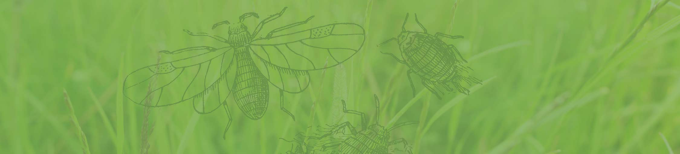

Common Acronyms

CAPS | Cooperative Agricultural Pest Survey
NAPIS | National Agricultural Pest Information System
NASS | The National Agricultural Statistics Service
NCC | National CAPS Committee
OPEP | Objective Prioritization of Exotic Pests
PPQ | Plant Protection and Quarantine
PSS | Pest Survey Specialist
ROAR | Recipient Organization Authorized Representative
SPHD | State Plant Health Director
SPRO | State Plant Regulatory Official
SSC | State Survey Coordinator

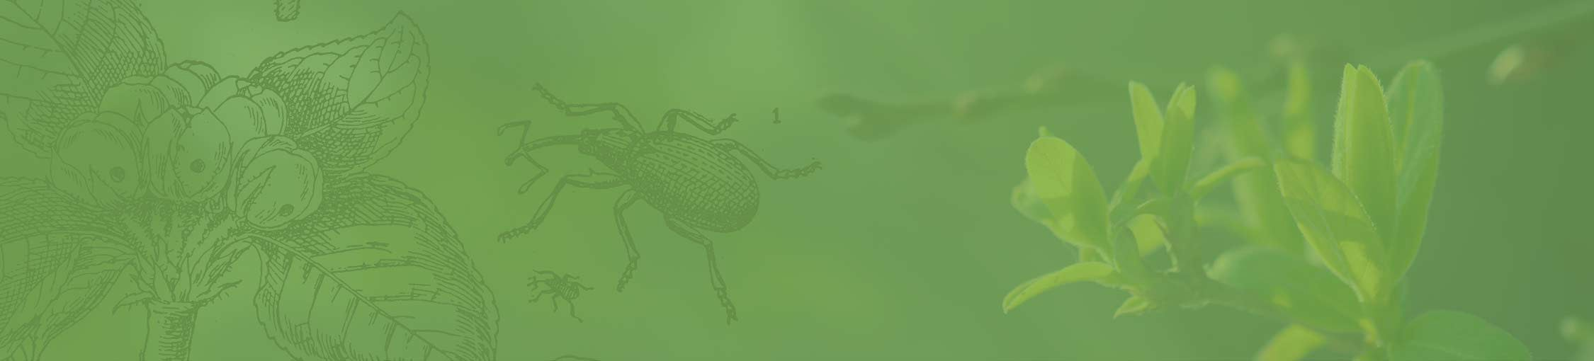

Foreword

The mission of the Cooperative Agricultural Pest Survey (CAPS) Program is to provide a coordinated survey profile of exotic and regulatory significant plant pests detected in every state of the United States through early surveillance activities. These surveillance efforts are funded through the USDA and directly support Animal and Plant Health Inspection Service (APHIS) safeguarding efforts to protect U.S. agricultural and environmental resources both locally and nationally. Surveys conducted through the CAPS Program are a coordinated effort to provide a second line of defense behind port inspections against the entry of harmful plant pests and weeds.

Surveillance activities are accomplished primarily through USDA funding provided by cooperative agreements with state departments of agriculture, universities, tribes, and other entities. The main activities undertaken through these funding streams include:
- conducting pest surveys using scientifically sound pest survey methodology
- timely reporting of pest survey results through the National Agricultural Pest Information System (NAPIS)
- ensuring collection of valid and high-quality data
- notification of significant pest detections through established protocols

The purpose of this guide is to provide an overview of CAPS operations including: the funding stream, organizational structure, general workflow, and various required tasks necessary to successful operation of a CAPS Program in your state. In each section of the guide, you will find descriptions of the tasks and suggestions for best practices in accomplishing those tasks. Thank you for becoming part of the line of defense of state and national agriculture and natural resources!



CAPS Organization

ORIGIN OF CAPS FUNDING


President’s budget due first Monday
in February
Congressional appropriation1 hearings
President signs the budget bill
APHIS reports to Congress as required
APHIS allocates3
& disseminates funding to programs
APHIS prepares & submits apportionment2 through USDA Office of Budget
& Program Analysis

Cooperative Agreements with States
$
$

1 Appropriation – provision of funds from Congress
2 Apportionment – distribution of the Appropriated funds by OMB to a Federal Agency
3 Allocation – dissemination of the funds to an Agency’s Programs

CAPS COMMUNICATION NETWORK

NATIONAL PEST DETECTION MANAGEMENT TEAM

POLICY
FIELD
SCIENCE &
MANAGEMENT OPERATIONS TECHNOLOGY
National CAPS Committee (NCC)
PPQ & STATE REPRESENTATIVES

The NCC represents PPQ and State Cooperators at the national and state level, and provides
guidance for APHIS’ Pest Detection Program.

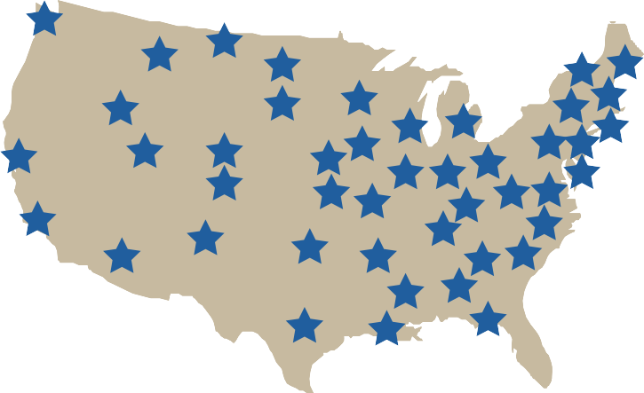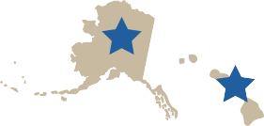

State CAPS Program
STATE PPQ
SPRO SPHD
SSC PSS

The core constituencies of the CAPS Program in the States are:
- State Plant Health Director (SPHD)
- State Plant Regulatory Official (SPRO)
- Pest Survey Specialist (PSS)
- State Survey Coordinator (SSC)

NATIONAL CAPS PROGRAM

Data Management

Community Communication
Develop Work/Financial Plans and Reports

State CAPS

Determine Pest Targets

Pest Survey Details

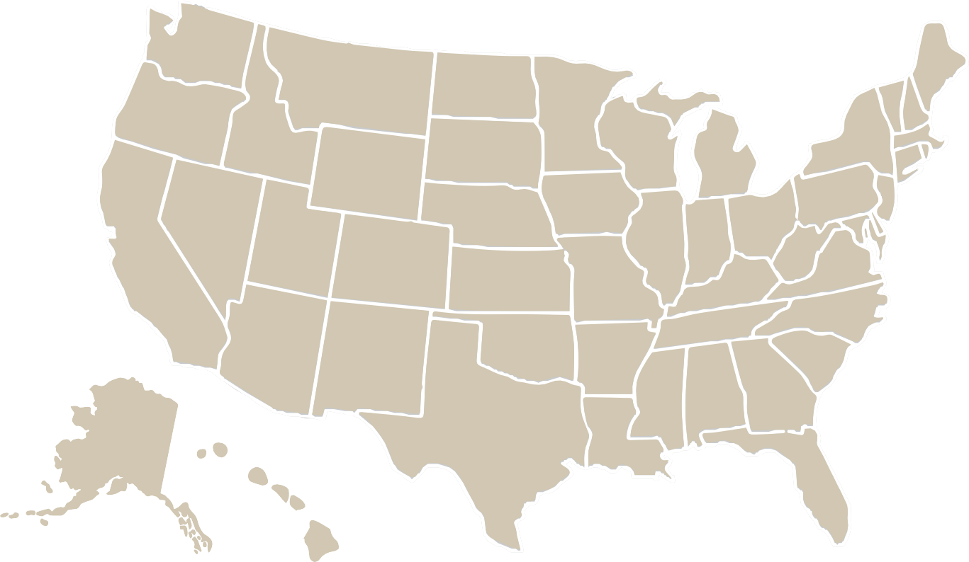
State Survey Committees


State CAPS
Program Components

DETERMINING PEST TARGETS
What encompasses the determining of pest targets?
?

CAPS Program surveys are a primary line of defense against the establishment of harmful plant pests and weeds that enter the United States. An early detection through these surveys can significantly reduce the economic costs of addressing the pest. However, with so many potential pests spread out over a large geographic region such as the
United States, the CAPS Program has developed a method for targeting only the most important pests to survey from season to season.

State surveyors begin choosing pest targets in a two-step process:
- First, they consult the National CAPS Priority Pest List (see the end of this section for information on how this list is created). This list contains a wide variety of pests that may cause significant damage if they become established in the United States.
- Second, they must consider potential target pests with maximum survey effectiveness and efficiency in mind.

All CAPS surveys use a bundled survey approach. In bundled surveys, groups of exotic pests are surveyed concurrently. Bundling can be commodity-based (pests with the same host plant), taxon-based (similar pest taxa), or pathway- based (pests that follow the same pathway).
How does this exercise support CAPS Programs efforts?

  - Prioritizing resources
No program has unlimited means for surveying every potential pest. Determining pest targets early on helps state surveyors choose the highest risk pests locally; thus, prioritizing resources used for local survey needs.
  - Seasonal planning
Pest targets must be determined before any planning can be done for annual CAPS Program activities. Work and financial plans are created around the target pest list for the state.
  - State/local evaluation
Determining pest targets provides opportunity for states to evaluate their current pest risks and report any new pest threats that could be added to the National CAPS priority list.


Who leads efforts for determining pest targets?

The research for, and creation of, state pest target lists is directed primarily by the State Survey Coordinator (SSC) on a yearly basis with assistance from other CAPS stakeholders in the state. In particular, be sure to utilize the expertise of other state plant health roles as needed:
  - State Plant Health Director (SPHD),
  - Pest Survey Specialist (PSS),
  - State Plant Regulatory Official (SPRO).

GENERAL STEPS FOR DETERMINING PEST TARGETS
The following steps should be taken when determining your survey targets. These steps do not necessarily need to be performed in a specific order. However, all of the following should be considered and performed for best survey planning results.
 Identify important commodities and local environmental flora in the state. The National Agricultural Statistics Service (NASS) database or local extension publications may be useful resources for this step. The PSS has access to this information.
Identify CAPS pests that impact important local plant hosts for the state. The National CAPS Priority Pest List and the Host Matrix on the CAPS Resource and Collaboration website are a good starting point for information. To maximize resources, surveys must be bundled and should include as many priority pests as possible. Assistance in maximizing use of the pest list can be found by contacting the CAPS Science and Technology Support Team (stcaps@usda.gov).
Identify pests with regulatory or trade significance that may affect the state. Utilize the SPHD or PSS to help with this. These pests are high survey priorities.
 Identify any CAPS pests with a demonstrated pathway of entry to the state. Pests that have been intercepted at U.S. ports of entry are important survey targets, especially pests that have been intercepted in the state or bordering states. Records of shipments or interceptions of host material also show potential pathways. (Note: Pest interception records are not always public. The PSS can provide more information).
Create a rough draft of potential pests for survey.
Determine current distribution and potential survivability of pests in the likelihood of establishment zones of the state by reviewing the CAPS Pest datasheets. Pests that have been found in nearby states should be of particular interest. The National Agricultural Pest Information System (NAPIS) database is a good source of U.S. pest detection information.
Whenever possible, identify pests of significance to the state that may be added to an already planned survey. Consult local resources for information on these pests. While this is not required, the inclusion of locally important pests increases interest from landowners to participate in surveys, and it can act as a bridge for public engagement about national CAPS pests. Sources of information on important pests to the state include local university experts, industry experts, or extension publications.


Create a list of possible surveys based on all information gathered and choose the final survey targets. If the state cannot survey for every important pest in the same year, consider rotating surveys.
Check the approved methods for pests of interest and determine if the approved trap and lure attracts multiple CAPS pests. This is most common in pests on the Exotic Wood Borer/Bark Beetle (EWB/BB) survey list (Example: The Ips lure is the approved method for Ips sexdentatus, Ips typographus, and Orthotomicus erosus). If a trap attracts multiple pests, all attracted pests should be included in the survey and listed in the work plan and the Survey Summary Form (SSF). (The Survey Summary Form is located on the CAPS Resource & Collaboration website and must be filled in when work plans are submitted).
Consider the resources needed for completing the survey and taxonomic assistance required for pest identification (both preliminary identification and confirmatory identification services). Review CAPS Pest datasheets and document the approved methods for each potential CAPS survey target.
» Find out what assistance is needed. Reach out to the National Operations Manager - Pest Detection, or the Domestic Diagnostic Coordinator at Plant Protection Quarantine-National Identification Services PPQ-NIS, for support.

How is the National CAPS Priority Pest List determined and maintained?

The PPQ Science and Technology CAPS Support Team develops and maintains the National CAPS Priority Pest List. Both pest lists and approved survey methods are updated annually and published on the CAPS Resource & Collaboration website.
Information is gathered throughout the year, and pests are consistently being evaluated for CAPS. Any stakeholder in the CAPS Program can also suggest potential new CAPS pests. Pests that pass through these three steps are added to the CAPS Priority Pest List.
The Priority Pest List for the CAPS Program is developed using a three-step pest assessment process:
1 QUESTIONNAIRE
PRE-ASSESSMENT
The pre-assessment questionnaire is used to assess potential new CAPS pests before the pests are run through the extensive prioritization model. This step helps determine if the organism is a plant pest and if there is enough information available to make an assessment.
2
PEST PRIORITIZATION MODEL
Objective Prioritization of Exotic Pests (OPEP)
The model thoroughly evaluates the potential CAPS pest using a set of evidence-based questions and determines the pest’s likely impact in the United States.
3
POST-ASSESSMENT QUESTIONNAIRE
The post-assessment questionnaire evaluates the feasibility of available survey and diagnostic/ identification methods of pests that pass through the pre-assessment and the prioritization model.

Pests that pass through these three steps are added to the CAPS Priority Pest List.

Example of a CAPS Program State List
The following is an example of a pest list for a grape-commodity-based survey. This list contains a good mix of arthropods and pathogens, and it combines a visual survey (phytoplasmas, rotbrenner) with trap and lure surveys (arthropods). The list also includes an additional pest of local interest (grapevine phylloxera).

If your table has room, it is also a good idea to include columns the provide a short description of why the pest is a survey target, the time frame for survey, and how long the lure lasts.

SCIENTIFIC NAME | COMMON NAME | METHOD | TRAP | LURE | HOST/HABITAT
Autographa gamma | Silver Y moth | Trapping | Bucket | Autographa gamma | grape
Candidatus Phytoplasma australiense 16SrXII-B | Australian grape- vine yellows | Visual | n/a | n/a | grape
Candidatus Phytoplasma solani 16SrXII-A | Bois noir/Stolbur | Visual | n/a | n/a | grape
Candidatus Phytoplasma vitis 16SrV-C | Flavescence dorée | Visual | n/a | n/a | grape
Cryptoblabes gnidiella | Christmas berry webworm | Trapping | Bucket | Cryptoblabes gnidiella | grape
Daktulosphaira vitifoliae | Grapevine phylloxera | Root sampling | n/a | n/a | grape
Epiphyas postvittana | Light brown apple moth | Trapping | Large Plastic Delta-White | Epiphyas post- vittana | grape
Eupoecilia ambiguella | European grape berry moth | Trapping | Wing-plastic | Eupoecilia am- biguella | grape
Lobesia botrana | European grapevine moth | Trapping | Paper delta trap | Lobesia botrana | grape
Pseudopezicula tracheiphila | Rotbrenner | Visual | n/a | n/a | grape
Spodoptera littoralis | Egyptian cottonworm | Trapping | Bucket | Spodoptera lit- toralis | grape
Spodoptera litura | Cotton cutworm | Trapping | Bucket | Spodoptera litura | grape

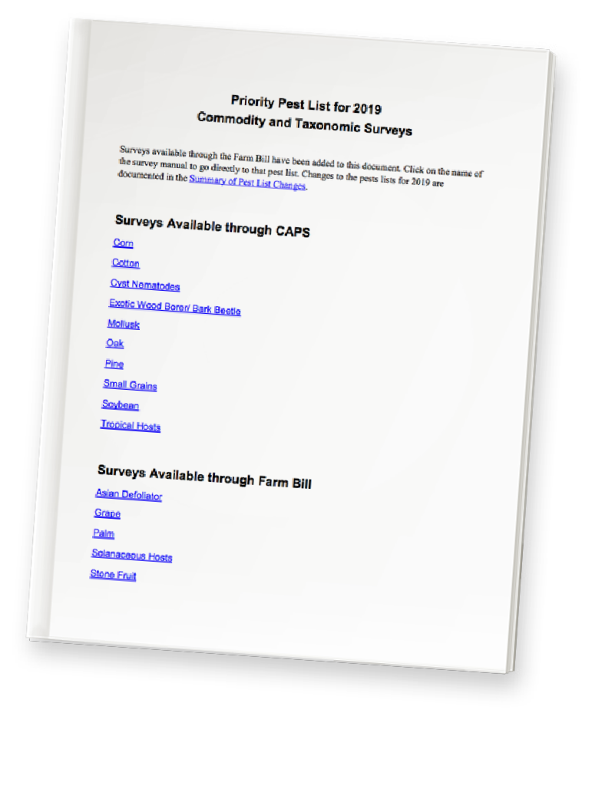
CAPS pests are then grouped into categories and grouped by commodity (same hosts e.g. grape, solanaceous, stone fruit), taxon (similar pest taxa, e.g., cyst nematodes, bark beetles), or pathway (pests that follow the same pathway, e.g., Asian defoliators).
The final product/outcome of this process is the National CAPS Priority Pest List, a searchable list of all plant pest concerns and targets placed on the CAPS website.

Example from the Priority Pest List

Grape Commodity Survey

Scientific Name Common Name Priority Pest

‘Candidatus Phytoplasma australiense’ 16SrXII-B

‘Candidatus Phytoplasma solani’ 16SrXII-A
Australian grapevine yellows Yes
Bois noir/stolbur Yes

‘Candidatus Phytoplasma vitis’ 16SrV-C Flavescence dorée Yes
Cryptoblabes gnidiella Christmas berry webworm Yes
Eupoecilia ambiguella European grape berry moth No
Heteronychus arator Black maize beetle No
Lobesia botrana European grapevine moth No
Lycorma delicatula Spotted lanternfly No
Pseudopezicula tracheiphila Rotbrenner Yes

APPENDIX A: RESOURCES FOR CAPS-RELATED INFORMATION

RESOURCE | LOCATION | USES
CAPS Resource & Collaboration Website | https://caps.ceris.purdue.edu/ | The most up to date source for CAPS information
CAPS Guidelines | https://caps.ceris.purdue.edu/guidelines | CAPS survey guidelines
CAPS Pest Lists | https://approvedmethods.ceris.purdue.edu/ | Current CAPS pest lists
CAPS Approved Methods | https://approvedmethods.ceris.purdue.edu/ | Approved Methods for Surveillance of CAPS pests, datasheets
CAPS Host Matrix | https://caps.ceris.purdue.edu/host-matrix | Information on important hosts and the pests that threaten them
NAPIS | https://napis.ceris.purdue.edu/ | Survey results and pest distribution information
NASS | https://www.nass.usda.gov/ | Agricultural data
ezFedGrants | https://caps.ceris.purdue.edu/pest-surveillance-guidelines/ezfedgrants | System for completing a funding application via cooperative agreement,  agreement reporting, and reimbursement requests (claims)

APPENDIX B: CONTACT LIST FOR CAPS SUPPORT

CONTACT | ROLE | EMAIL
Tina Gresham | National Policy Manager, Pest Detection | tina.gresham@usda.gov
Darrell Bays | National Operations Manager, Pest Detection | darrell.a.bays@usda.gov
Leah Granke | Assistant Director, PPQ Science & Technology Plant Pest Risk Analysis | leah.granke@usda.gov
Colin Funaro | CAPS Support Lead, PPQ Science & Technology | colin.f.funaro@usda.gov
Waleska Ramirez | National Policy Manager, Survey Supplies | waleska.v.ramirez@usda.gov
Steve Bullington | National Domestic Diagnostic Coordinator | stephen.w.bullington@usda.gov

WORK/FINANCIAL PLANS AND REPORTS
What are work/financial plans and reports?
?

Work and financial plans are the official documents prepared and submitted at the beginning of every new funding cycle. These plans provide a detailed breakdown of specific objectives, as well as budget allocations for completing the state CAPS objectives within a defined timeline. To confirm the work plan is being followed as agreed upon, official reports must also be submitted by specified dates that usually occur semi-annually and sometimes quarterly.
How does creating the work/financial plans and submitting narrative and financial reports support the CAPS Program’s efforts?

Work/financial plans provide an official, concrete record for survey work to be undertaken during the fiscal year. Reports (completed in ezFedGrants) are a legal requirement for the funds provided toward doing the work as outlined in the plan. The following lists provide more detail on how these efforts specifically support the CAPS Program.

WORK PLAN
- The official framework for all state plans funded by CAPS.

- Provides a detailed breakdown of specific State CAPS objectives to be completed within a defined period of time.

- A critical communication tool used to inform others (CAPS employees, volunteers and stake- holders) of what will be done and when.

- Ensures consistency across the nation by defining the exact CAPS work each state is attempting to complete.

- Confirms all aspects of program operations have been considered and planned for. (e.g., individual roles, required supplies and equipment, budget, timelines, and reporting deadlines).

- Necessary tool for monitoring and evaluation ensuring that goals are being met and work plan processes are followed as agreed upon.
FINANCIAL PLAN
- An official record of the amount of money al- located to CAPS operations, and details of how those funds will be spent.

- Creates accountability and transparency for federally funded work plans.

- Allows both state and federal agencies to predict funding needs each quarter.

ACCOMPLISHMENT REPORTS
(semi-annual, annual)

- Delivers consolidated, factual and up-to-date information about progress of implementing the work plans to CAPS Program Managers and other stake holders.

- Provides accountability and transparency for outcomes of the CAPS Program.

- Offers justification for continued funding.

- Opportunity to highlight achievements and compare accomplishments both quantitatively and qualitatively with objectives proposed in the work plan.
FINANCIAL REPORTS
(SF425 and SF270)

- Provides accountability and transparency that funds are being utilized as described in the detailed financial plan.

- Indicates whether allocated funds were completely spent.

- Allows for states to be reimbursed at regular intervals.


Who leads efforts for developing work plans, financial plans and reports?

Although the State Survey Coordinator (SSC) leads this effort, they must ask for input and feedback from the SPRO, SPHD and the state assigned PSS to develop financial plans and protocols for financial reports.

The State Survey Coordinator’s general responsibilities include performing the following tasks:

WORK/FINANCIAL PLANS
- Prepare and submit CAPS work plans to SPHD.

- Create and submit detailed financial plans.
» Depending on resources available, the SSC or the department administrators may delegate the financial reporting to their department’s business office. (Note: reporting for these two aspects is separate.)
REPORTS
- Prepare and submit semi-annual and final accomplishment work plan reports to the Recipient Organization Authorized Representative (ROAR) and SPHD.

- Complete and submit financial reports to an authorized representative of the state agency. (Note: financial reporting may be delegated by the SCC or the department administrators to the department’s administrative or business office.)

What is the annual SCC task timeline?

These tasks will need to be completed on a regular and recurring basis from year to year. Although the specific due dates change year to year for submitting paperwork, the timing in relation to the year is roughly the same. The following is a general timeline. You will need to plan well in advance in order to meet Program due dates.

Year 1: Planning for the following year’s survey season/agreement
- APRIL: National Pest Surveillance Guidelines are published on the CAPS Resource and Collaboration website.
- Late August/Early September: Work and financial plans for next year due to Field Operations. SPHDs upload the work and financial plans into SharePoint. The Survey Summary Form must be completed on the CAPS R&C before the plans will be reviewed.
- September 1 – October 15: The Field Operations National Operations Manager (NOM) reviews work and financial plans for alignment with CAPS mission, policies, and priorities. The NOM requests any revisions of plans to the SPHD. The NOM reviews work and financial plans and sends the SPHD an email notification once the plan has been unofficially approved.
- October 18: Final revisions to work and financial plans due to Field Operations.
- Late September - November: The Survey Supply Ordering System in the Integrated Plant Health Information System (IPHIS) is open for ordering next year’s survey supplies.
- Early December: The NOM officially approves work and financial plans in SharePoint. The PPQ Agreements Staff begins entering the information’ into ezFedGrants and develops the Opportunity.
- Late December to early January: The cooperator responds to the Opportunity and completes the application in ezFedGrants (one-month deadline on applications). This does not apply to states with Pre-Awards (Pre-Awards are completed outside of ezFedGrants). Cooperative agreements are signed and finalized in ezFedGrants; work begins.

Year 2: Surveys occur/ timeframe of agreement
- Survey activities conducted.

Year 3: Data entry and completion of all reporting activities:
- March: All survey data for the previous season to be entered in NAPIS database before March 31 (or no more than 90 days after the conclusion of the cooperative agreement). ADODRs review CAPS Accountability Report for data entry requirements.
- March 31: Annual Accomplishment Report due to Field Operations, SF425 Federal Financial Report (annual financial status report) due, SF270 Request for Advance or Reimbursement (final request for funds) due. Referred to as a ‘Claim’ in ezFedGrants.

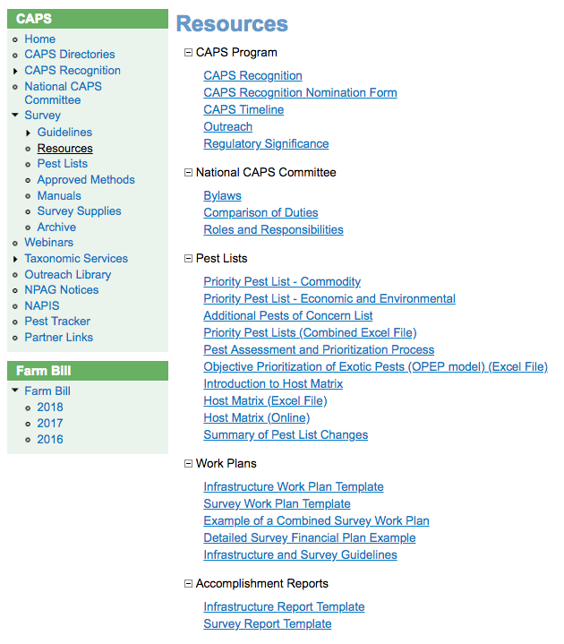
Work Plan Templates for CAPS Programs
To help you begin, templates for these important documents are found at the official CAPS Resource & Collaboration website:
http://caps.ceris.purdue.edu/home

Templates are currently listed with Resources under the Survey option in the navigation bar.

Examples of a completed work plan can also be found in this section of the website.

The Resources page lists the most up-to-date documents, while the Guidelines pages list the documents that are or were current in that particular year.

PEST SURVEY DETAILS
What are pest surveys?
?

Pest surveys are the foundation for early detection of invasive pests. Effective pest surveillance results in quicker, and thus more successful, responses to pest threats. Conducting a pest survey means, in a nutshell, looking for a pest where the pest is likely to be. To this end, CAPS surveys generally fall into one of two types:

PATHWAY SURVEYS
A likely mechanism of introduction is known or assumed. These surveys typically are associated with a particular commodity (e.g., tile) or within a transportation corridor, and the emphasis is placed along the pathway from point/port of origination to final destination.
DETECTION SURVEYS
No particular pathway for pest entry has been identified. These surveys usually take place near hosts where the target pest(s) is most likely to be found and can be the endpoint along a pathway.

All pest surveys require both logistical planning and budgeting for supplies and resources required to conduct the survey. Survey planning is performed during the development of work and financial plans at the beginning of every fiscal year. Once plans have been approved and funds have been transferred, then operations for survey can begin.

How do pest surveys support CAPS Programs efforts?

The primary purpose of the CAPS Program is to operate pest surveys with the goal of achieving early pest detection.
In fact, every element of CAPS is designed to support collection of comprehensive pest data and observations to reveal pest threats. Accurate survey information is vital to making important regulatory decisions at both the state and national level.


Who leads efforts for determining pest survey details?

The State Survey Coordinator (SSC) and Pest Survey Specialist (PSS) work together, combining their areas of expertise and networks to conduct comprehensive and effective pest surveys.

The PPQ State Plant Health Director (SPHD) and State Plant Regulatory Official (SPRO) assist in determining suitable pest survey targets and effort, through their approval of CAPS work plans.

What are general survey effort expectations and responsibilities?

There are four main areas to consider when planning and conducting surveys:
LOGISTICAL COORDINATION
4
3
IDENTIFYING COLLECTION METHODS
SITE
SELECTION
2
1
PRIORITIZING TARGET PESTS

1 PRIORITIZING TARGET PESTS
This is covered in more detail in the first section of this guidebook and is an important step as it forms the base for what follows below. A survey cannot be performed until the target pests have been identified.

2 SITE SELECTION
First you must select sites to monitor based on the pest targets list, and the type of survey best suited for your current situation: pathway, or detection.
Pathway Surveys
- Identify and locate relevant hubs or industries that are likely pest pathways.
» Begin by using port pest interception information and PPQ Emergency Action Notification (EAN) data to identify locations for survey activity. The PSS can assist with this information.
» EAN data can also be used to select target industries such as marble and stone importers for mollusk surveys, sawmills for surveying exotic bark beetles, or organic soybeans imports with surveys for Federal noxious weeds.
- Select sites directly on pathway-related properties for traps and/or conducting survey observations.
» Gaining permission to conduct surveillance on these properties provides an opportunity to add more valuable survey data.
» If the selected pathway-related property is dangerous, or otherwise difficult to access, another good option for survey work is to choose likely pest habitat in the near vicinity (e.g. parks or wildland).

Detection Surveys
States vary on the actual methodologies used to determine survey sites. However, the following are common steps for determining survey sites when a specific mode of pest introduction is unknown, pests spread through non-point- specific means (e.g. movement of hay bales from farm to farm), or by natural dispersal.
- Determine likely areas to intercept the target pest. This is done by considering host prevalence by host acreage or host density.
» For agricultural crops, the USDA National Agricultural Statistics Survey, through state-based Field Offices, provides acreage information for many crops on a county basis (www.nass.usda.gov). A good source of host information in a forest setting is the U.S. Forest Service Forest Inventory and Analysis (FIA) Program (https://research.fs.usda.gov/programs/fia).
- Distribute sites throughout the identified host area(s) to provide good coverage, and efficiency as resources allow. Do not leave large geographic areas within the target host areas without coverage.
- Check distribution and possible sites by placing points on a map, with either ESRI’s ArcGIS “Create Random Points” function or the USDA-supported Visual Sample Plan software providing random placement.
» Surveys may also be conducted by assuring a minimum distance between observations, without pre-placement of target sites.
- Check that all selected sites are accessible for trap placement. This includes ensuring permission from private property owners, checking the safety of the area, and/or verifying the area is physically accessible to personnel.

3 IDENTIFYING COLLECTION METHODS
There are many ways to collect surveillance data, and the pests you are targeting will always dictate your collection methods. Once your state has finalized a list of target pests, you should consult the Approved Methods for Pest Surveillance (AMPS) located on the CAPS Resource & Collaboration website. These guidelines provide all of the details on approved collection methods from the best traps to sample storage requirements. These details are available for most pests of concern in the U.S. If you cannot find the pest you need, please contact PPQ CAPS Support.
Survey supplies for the pests on the CAPS Priority Pest List are available at no cost to the states through PPQ’s Survey Supply Procurement Program (SSPP). Once the specific traps and sample collection supplies have been identified,
a survey supply order can be made through the Integrated Plant Health Information System (IPHIS) Survey Supply Ordering Module. States will receive notification when the ordering system is open to submit survey supply orders. Additional information can be found on the Survey Supplies page on the CAPS website. The volume of required supplies to order will be determined by the number of sampling sites you selected. When the supplies arrive, it is a good idea to check the contents against the packing list and make sure all needed supplies are on hand and properly stored until needed (e.g., putting lures in a freezer). It also will be necessary to train any new surveyors the proper way to prepare traps and demonstrate any other relevant collecting techniques required for the current survey.

4 LOGISTICAL COORDINATION
For these survey activities to succeed, the SSC and PSS must provide clear communication and effective coordination. Effective coordination and communication creates a robust and successful pest survey program by eliminating misunderstandings that lead to data gaps, or duplication of efforts. Here are a few tips for getting started:
- Build and maintain relationships with a network of state contacts. These contacts must include government agriculture employees, University and Extension personnel, Federal and State forest service personnel, and a variety of stakeholders, producers, shippers, and educators.
» Network relationships are critical to finding acceptable sites for maximum pest surveillance effectiveness.
These relationships also help persuade landowners and volunteers to assist with trap placement and monitoring.
- Aim for thorough coverage of the state. Pest survey sites should be selected based on local data and information about where the pest risk is highest, but you should also consider other statewide needs and potential trapping sites. Selected survey sites must be coordinated in a way that achieves the most coverage for the finite resources available to reach pest data collection goals.


TIPS FOR COORDINATING PEST SURVEY SITES
At the beginning of every new pest surveillance cycle, those involved with CAPS pest survey coordination should answer the following questions:

who? The State Survey Coordinator or Pest Survey Specialist

This person should be identified, and everyone should be aware of who is leading this year’s coordination efforts. Sometimes it is best to utilize the most senior person available regardless to role in the CAPS Program. Coordination is key as the SSC and PSS likely will be leading the effort in their respective organizations.

what? Clearly identify data and information that must be collected and what platforms it will be shared on.
The annual CAPS Guidelines and Approved Methods found on the CAPS website provide the guidance needed to collect this information, as well as the requirements of the data repository (NAPIS).

If you do not clarify all essential information before going out in the field, personnel will not know to collect it and you will have gaps in your data. Also, make sure your collaborators have access to the platform, and know how to use it correctly.

when? The dates when traps for all planned surveys will be deployed and collected throughout the season.

Determine locations and coordinate this before you deploy traps for the season.

where? The methods of communication you will employ to handle coordinating pest surveillance activities with various groups.

Communication can occur in whatever way is most effective and comfortable for you and your stakeholders. Information can be exchanged through social media, document sharing platforms (e.g. Google docs), email, phone calls, in person meetings, or any other effective method for your situation.

why? Rationale for why those sites were selected. This includes not only how the pest and host biology factors influenced decision-making, but also human factors where stakeholders allow placement and monitoring of traps.

Remember! Coordination includes discussing information that was used to decide where traps need to be placed. Trap placement is determined by the pest biology, host location, relationship to the property owner, access to the area, and the potential pathway into the state.


While the following example is not for a Priority Pest, the plan does show the many considerations and type of information required for planning a survey. The majority of surveys will also need to include trapping plans.

Example of a Pest Survey
Wisconsin Plant Pest Survey
2017 SURVEY: PHYTOPHTHORA ROOT ROT ON SOYBEAN
Wisconsin Department of Agriculture, Trade and Consumer Protection • Plant Industry Bureau • Madison
O B J E C T I V E
Assess the prevalence of Oomycete-caused root rot on soybean seedlings. Collect samples for testing for Phytophthora and Pythium spp.
- Determine the percent of surveyed fields that are infected with Oomycetes.
- Estimate the extent of affected plants in sampled fields.
- Make collections of plants for pathogen testing in the lab.
T I M E F R A M E
Survey fields Late May to late June. Early vegetative stages.

P R O T O C O L
  - Take an overview of the field for areas of stunting and discoloration.
  - If areas of stunting are found, check for signs of obvious flooding.
  - Survey for the characteristic "shepherd's crook" symptom of Phytophthora infection or living plants with stem discoloration at or near the soil line. Often, symptoms will appear in plants around the obvious ponded area. Since Phytophthora infection is also favored by compacted soil, headlands and field access areas are also likely to show symptoms.
  - If symptomatic plants are encountered, collect whole plant samples. If no symptomatic plants are evident, collect plants from four sites separated by 30 or more paces, favoring low-lying and wet areas.
  - DIG up plants, DO NOT PULL. Collect 5 plants at each of 4 sites around the suspect area.
  - Bag plants in plastic (ziploc if possible) to prevent drying out. Label with Observation ID number, County and growth stage.
  - Avoid sampling dead plants in the center of flooded areas; preferentially collect plants that are still living.
  - Keep plants on ice until delivered to the laboratory.
  - Track sample information on spreadsheet.
  - Estimate percent of field in the area with symptoms.

S U R V E Y S I T E S
  - Locate a soybean field: Drive to the target point on the GPS, or as near as the road will allow. If a soybean field is visible from that point, sample that field. If no soybean field is visible, enter the next target waypoint in the GPS and begin driving, following the GPS turn-by-turn instructions (set for "shortest distance"). Stop and survey the first accessible soybean field encountered. If no suitable field is found by the second waypoint, the first field is an omit.
  - SAMPLE 55 fields randomly. Map attached.
SYMPTOMS
Symptoms of Phytophthora generally appear shortly after emergence. There are some early- season symptoms which are characteristic of infection by Phytophthora. Stem discoloration reaching up from the soil line is one (photo 1). A "shepherd's crook" at the top of the dead stem (photo 2) is another. Dead plants will generally keep their leaves (photo 3). Symptoms of P. sansomeana are classic root rot, generally without discoloration or shepherd’s crook.

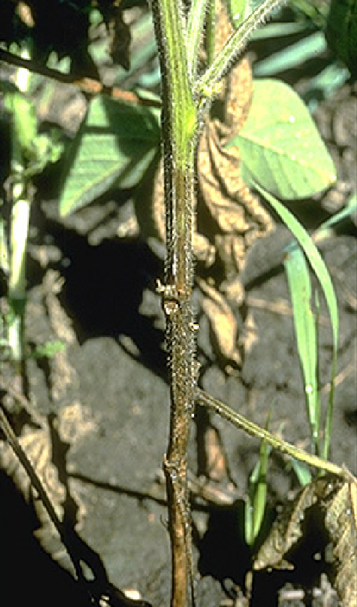
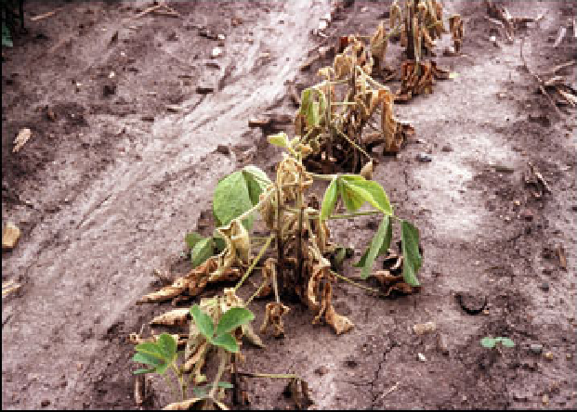
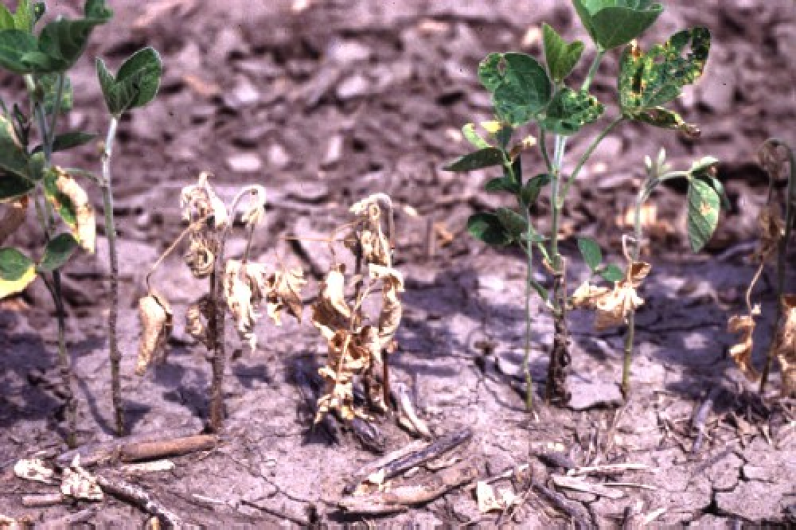

Photo 1 Photo 2

Photo 3

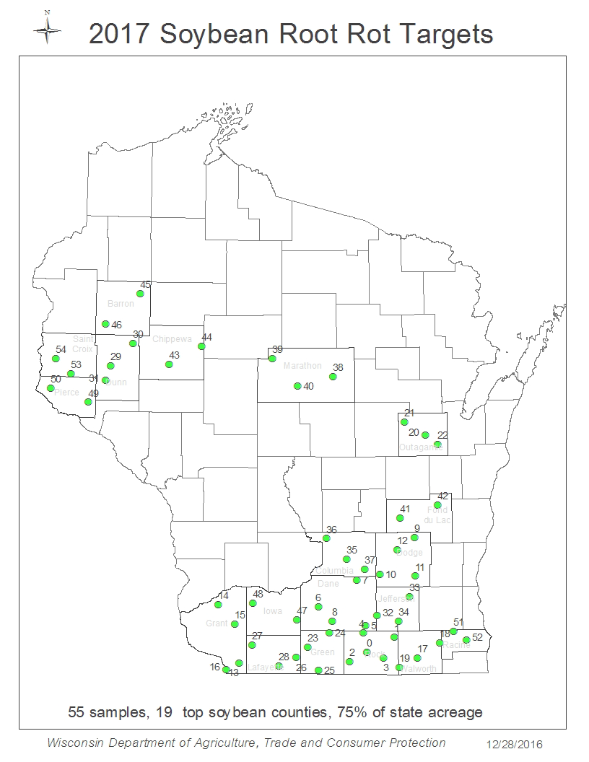

DATA MANAGEMENT
What data needs to be managed, and what does management look like?
?

All information collected from Pest Detection and CAPS surveys must be carefully managed from initial recording, to reporting, and finally storage. The final storage place for all of this data is the National Agricultural Pest Information System (NAPIS). The results, including both positive and negative records, from CAPS and Farm Bill Goal 1 Survey must be entered into NAPIS as soon as identification or diagnostic results are available so that the national records are timely and up to date. The NAPIS database summarizes survey data at the county level for insects, pathogens, weeds, mollusks, and biological control organisms across all 50 states and three territories emphasizing exotic pests that may impact U.S. agricultural exports or harm agricultural production and/or natural resources.

Negative data from national surveys supports trade and exports, and benefits American agriculture; therefore, the documentation of negative data is extremely important and valuable. The CAPS Program strives to ensure that all negative data is valid and results from active survey efforts. The CAPS Program has developed guidelines to assist in data entry of valid negative data. The Approved Methods for Pest Surveillance (AMPS) enables one to determine
the appropriate pests that can be considered negative for a survey effort based on the survey methodology, trap/lure combination, etc. Data entry will be checked and validated against the approved survey method for each pest on the Priority Pest List. Data not conforming to the approved method will not be accepted into the database. All positive records should be at the species level.
Why are data management practices so important to the CAPS Program?

Gathering valid survey data is the entire mission of the CAPS Program. Regulatory and trade decisions, as well as mitigation actions, are dictated by interpreting the most current data. Therefore, it is critical to the mission of CAPS for data to be accurate, current, and easy to find. The only way to accomplish this is to keep data collection and
reporting organized throughout the entire survey process. The state program can assist individuals responsible for data collection by implementing best practices for handling data that are carried out consistently by all CAPS personnel
in the state. If the data is not kept organized from the beginning, delays in reporting and mistakes are more likely to occur. These delays in detecting pests due to poor data management could result in disastrous costs to U.S. agriculture production, natural resources, and/or interstate and international trade.
Who leads the data management policies and procedures?

It is ultimately the State Survey Coordinator’s (SSC) responsibility to ensure data is correctly and promptly entered into NAPIS by the appointed deadlines for each survey effort. This may involve personally entering data; however, it could also mean training and supervising others to enter the data. Ultimately, only the SSC, or their designee, has data entry rights. Training and help with data entry, as well as other IT facets of the CAPS Program, are available from the CAPS Information Services staff at Purdue University (napis@purdue.edu).

The State Plant Regulatory Official (SPRO) usually is responsible for supervising these efforts. They should be prepared to answer any questions, assist with complications that arise, and manage personnel workload so that data entry is completed in a timely manner. However, a best practice may be to share the data with both the SPRO and PSS and ask that they also review the data to verify that valid data will be entered into NAPIS. Just be sure to make the practice consistent for everyone in the state from year to year.

EXPECTATIONS AND HELPFUL TIPS FOR MANAGING DATA
 Available Training
Take advantage of one-on-one training provided by the CAPS Information Services group at Purdue University. Upon request, the Purdue group offers training to help on-board new SSCs or for any other situation that may require additional instruction. Requests for training can be sent to napis@purdue.edu.
Deadlines
- Be familiar with work plans and signed notice of awards (NOAs) from the cooperative agreement regarding specific expectations and timelines associated with your surveys.
- All pest survey results (positive and negative) must be entered into NAPIS by the end of the agreement period (usually 90 days after the agreement ends when the Accomplishment Report is due).
- If the survey collects the first ever recorded detection of a federally regulated pest for the nation or state, this data must be entered into NAPIS within 48 hours of confirmation.
Required Information
- The minimum information required for NAPIS data entry include:
» Observation Number
» Observation Date
» Data Source
» State County
» Site
» Funding Year
» Funding Source
» Survey Name
» Pest
» Pest Status
» Survey Method
- Other fields may be required based on the information entered in these fields.
- As of January 2024, all records require funding information and survey name to support the Accountability Report.
- Further information may be found under ‘Data Definitions’ in the NAPIS database.
- Additional data that may be important to capture in the field for the state records include:
» GPS coordinates (for local use only, not necessary for NAPIS data entry)
» Trap type (required with General Trapping Procedure)
» Lure used (required with General Trapping Procedure)
» Dates of specific activities (e.g. lure change, sample collection)
» Contact information of landowner if available
» Individual sample identification numbers
» General notes
Quality Control
States can refer to their Accountability Reports (https://caps.ceris.purdue.edu/accountability-report; CAPS login required) to make sure all required data has been entered at the end of the agreement period. The Accountability Report provides a quick summary of NAPIS data entered for each state.
States are responsible for deciding how they keep track of data collected before entering final results into NAPIS. Keep in mind, clean data cannot be entered into NAPIS if it was not clean and clear while handling the data during collection. It is a good idea to periodically review the data handling procedures in place for your state program to ensure high-quality data.

STATE SURVEY COMMITTEES
What is a State Survey Committee?
?

The State Survey Committee is an official forum for members to recommend and identify state survey priorities for pests of concern. State CAPS Committees include both CAPS personnel and stakeholders with a vested interest in state surveillance of invasive species. Although not an exhaustive list, here are some stakeholders often included:
- State and Federal Forest Service,
- Wildlife management,
- University extension,
- Industry representatives (horticulture, lumber, etc.),
- Corps of Engineers,
- State and Municipal Parks
- Producers.

In addition to assigning pest survey priorities, this forum also provides an opportunity to communicate critical information. Participating committee members can reliably receive updates on new pest threats as well as reports on results of completed and on-going surveys.

How does this committee support CAPS Programs?
- The State Survey Committee provides an official avenue for the voices of all stakeholders potentially impacted by invasive pests to be heard. Successfully including these voices in survey decision-making fosters beneficial collaborations to gather more complete information and implement efficient and robust surveys.
- Advice from the State Survey Committee is a necessary source of information for selecting target pests for survey. The State Plant Health Director (SPHD) and State Plant Regulatory Official (SPRO), in consultation with the Pest Survey Specialist (PSS) and State Survey Coordinator (SSC), consider recommendations and advice of the State CAPS Committee, along with CAPS guidelines to finalize selection of pests most important to the state.
- Official meetings help committee members align the state goals and plans so that everyone is on the same page as to what surveys are taking place. These meetings are also an efficient method for providing new information, and informing members of upcoming public engagement events.
- Well organized and inclusive committees ultimately result in better protection for all stakeholders potentially impacted by invasive pests.


Who leads efforts to organize the committee and provide timely updates of survey results?

The State Survey Coordinator (SSC) should drive and finalize selection of committee members. However, given the need for a variede network of stakeholders, the SPHD, SPRO and PSS should provide guidance on identifying potential members they think would benefit the committee and state CAPS Program. Selected stakeholders should reflect the unique needs of each state; however, PPQ always encourages industry-state partnerships for pest survey.

EXPECTATIONS AND SUGGESTIONS FOR OPERATING A STATE SURVEY COMMITTEE
Meeting Frequency
Minimum one meeting a year must be held. One meeting a year in April, or May, allows for pest suggestions on new surveys for next year for August submission of work plans, and also an opportunity to review planned surveys for the current year and survey results for the previous year.
There are benefits to having two meetings a year. Two meetings a year allows separating the solicitation of pest suggestions for new surveys from reporting survey results. In March or April, the meeting would focus on providing suggestions for surveys for next year through to the August submission (through email). A winter meeting can then focus on reporting results of the current year survey and if there is time and gather information on other pests of concern or pest suggestions for next year.
 Old Business
Consider topics, discussions and results from recent committee meetings. Is there anything from past meetings that should be followed up with more information or dialogue?
 Set Goals
Clearly identify the goals for the meeting. What knowledge and skills should the attendees to walk away with? For example, attendees may need to be updated on new information. Does new information need to be disseminated at the meeting, or could dissemination be done through email? If it can be done ahead of time, then there is more time to spend on questions, or practice exercises related to the information. Are there procedures that require training better done in person, such as building and placing traps, or correct sample documentation and recording? Do survey volunteers need to be recruited, or does the state need to gain access to specific sites? Is it important to discover local community pest concerns? If so, save some time for a discussion forum, or other avenue to solicit this information. Let the goals dictate the agenda.
Prepare an Agenda
Have an agenda ready and sent out to participants before the annual or semi-annual meeting. This allows for committee members to prepare better questions and comments for the meeting. It is also a good planning tool to ensure nothing important has been left out of the meeting.
Establish Working Norms
Treat every member with respect and listen to their views and concerns before dismissing them or moving on. The CAPS Program is meant to serve as many stakeholders with pest threat concerns as possible.

Example agenda A for a successful annual meeting

2017 CAPS Committee Meeting Agenda
JUNE 7TH, 2017 • 10 AM TO 12PM
Plant Board, 123 Invasive Rd, Commodity, US 12345 Commissioner Conference Room

  - Welcome

  - Introductions

  - Planned Upcoming Surveys: Come with your questions prepared Sudden Oak Death Survey (2016, 2017)
Citrus Commodity Survey (2016 / 2017)
Citrus Tree Removal Program Honey Bee Survey
Pine Commodity Survey (2016, 2017) Plant Board Update
  - Other Pest Detection Activities (Plant Board)

  - Current Status Reports:
Pest Detection Report (Forestry) Pest Detection Report (USFS) Pest Detection Report (NRCS) Pest Detection Report (Extension) Pest Detection Report (Extension)
Pest Detection Report [Roseau Cane Scale] (Extension) Pest Detection Report (PPQ)
Pest Detection Report (PPQ) Pest Detection Report (PPQ)
  - New Pest Threats
Apple Snail Update from Surveyor

  - Open Discussion

  - Closing Remarks

Example agenda B for a successful annual meeting

State CAPS Committee Meeting
JULY 26, 2017 AT 10:00 AM
Plant Board, 123 Invasive Rd, Commodity, US 12345

MEETING AGENDA
Welcome: State Survey Coordinator Introductions: Roundtable introductions CAPS Program overview: SSC
    - Review of 2016 accomplishments (CAPS and Farm Bill)
    - 2017 ongoing activities (CAPS and Farm Bill)

Discussion: Committee participation
    - Comments on past and ongoing survey work
    - Pest of concern to State (commodity or pathway)
    - Proposals for 2018 survey program (CAPS and Farm Bill)

Other invasive species news or topics of concern
    - Noxious Weeds (Benghal Dayflower, Cogongrass, Itchgrass, TSA, Water Spinach)
    - EAB and TCD (other insects of concern?)
    - Channeled Apple Snail
    - Plant Pathogens (Citrus Greening, Laurel Wilt, Oak Wilt)
    - Tawny Crazy Ant

Adjourn by 12:30 PM

COMMUNITY COMMUNICATIONS
Who are the community members CAPS should communicate with, and what does this communication look like?
?

Preventing the establishment of new exotic plant pests is a common goal in every state. This is often accomplished through early detection activities that involve targeted and/or ongoing surveys. A well-informed local pest surveillance community plays an important role in the success of early pest detection efforts and safeguarding state agriculture.
Any community members with a stake in protecting plant health should be included. For example, producers, sellers, forestry service, parks and recreation, industry representatives, importers, and even the public may all need to
be included for various initiatives. The audiences to target will depend on the current goals for attaining support, engagement, and participation for the CAPS Program. Some common ways to bring these audiences in and build a community are through communication activities such as public engagement workshops, targeted emails and/or phone calls with industry representatives, meetings with government officials, and networking at conferences and trade shows. However, this is not a mandatory list of activities because every communication effort should be tailored to the unique needs and goals of each state program.
How do communication activities support CAPS Programs?

Early pest detection leads to quick and timely responses which are crucial to effectively mitigating invasive pest threats. Pest detection and response efforts are improved by utilizing public engagement as a mechanism to improve existing survey initiatives and strengthening the network of state-wide cooperators. In other words, targeted communication can improve CAPS Programs because such efforts often enlist more resources without necessarily expanding budget and personnel. Any member of the public interested in excluding invasive pests could provide assistance in many forms if only they are made aware of the current circumstances and needs. Thus, successful communication efforts better enable CAPS Programs to:
- identify exotic pest threats,
- determine and implement the most effective means of preventing, detecting, and responding to new exotic pests, and
- report risks and needs to land management personnel, relevant industries, and the public.

Here are some ways the CAPS Program directly benefits from community partners:
  - Public support for CAPS in the form of time, resources, surveillance assistance, tax allocation, access to property for trapping, and compliance with instituted mitigation measures.
  - Readily available industry partner resources to gather current information on potential pest pathways for their goods.
  - More precise coordination across federal, state, and local government entities for resources
Who leads efforts to keep stakeholders and the community informed?

The State Survey Coordinator (SSC) is in the unique position to lead efforts in building community connections. However, given the various goals for the CAPS Program and audience needs, all CAPS personnel in the state should provide input and volunteer assistance in whatever way best serves the communication efforts.

EXPECTATIONS AND SUGGESTIONS FOR COMMUNITY COMMUNICATIONS

Inherent Public Engagement
Public engagement is encouraged and generally supported through program infrastructure as a means to assist the State Survey Coordinator (SSC) in obtaining support, engagement and participation from key stakeholders where pests of significant concern to the state are involved. It is understood that public engagement activities inherently occur during routine survey planning and preparations, attendance at industry and stakeholder meetings, and various training and seminar events.

Supplemental Budget Public Engagement
Additional activities can be planned and budgeted for if necessary. Qualification for additional public engagement funding is contingent on direct support of existing survey initiatives within the state. Funding through PPA 7721 Goal 5 Public engagement & Education also may be an option worth considering, especially for larger projects

Target Audiences
Both inherent and budgeted communication efforts must be carefully thought out because each state is composed of various stakeholders with different pest interests, goals and needs. Therefore, no single method for communicating, educating and recruiting partners will suffice. First, determine the CAPS Program goals for reaching out to the community, and identify the target stakeholder audiences to help reach those goals. In other words, what do you hope to accomplish by communicating with each target audience? Then, begin planning communication methods and public engagement activities to reach these various target audiences based on these goals.
GOAL | TARGET AUDIENCE | METHODS
Gaining public support, engagement, and participation | - K-12 students  - College undergraduates  - Interested people not directly affiliated with growers or industry | - FFA workshops  - Presentations at county and state fairs  - Targeted websites and social media  - Classroom presentations at school
Increasing industry support, engagement, and participation | - Growers  - Producers  - Sellers  - Other parties involved in the production and sale of plant-based products or other goods along surveyed pathways | - Booths at trade shows  - Consulting appointments with greenhouses, orchards, gardening centers and other producers  - Targeted email blasts
Fostering communication and coordination of related federal, state, and local government agencies | - Federal and State legislature representatives  - Forestry  - Parks and recreation  - Fish and Wildlife  - Amateur nature societies | - Networking through contacts  - Targeted email blasts
Networking with key government, community, and industry personnel | - Any stakeholder that assists, or could assist, with CAPS Program efforts | - Offer survey/pest-based training via webinar during slow parts of the year  - Web based resources
Identifying potential volunteers to assist with various surveillance activities | - Growers  - Public  - Select schools and universities | - In-person presentations to schools  - Public engagement workshops for students  - Demonstrations at fair booths  - Create incentive/achievement level activities to identify potential survey leaders
Utilizing the public to report pest sightings | - Public at large | - Local and state media news spots  - Social media campaigns  - YouTube videos  - Specific websites

Sample Communication Efforts

To help better visualize different methods and ignite ideas for your community public engagement efforts, we have provided a few real-world examples.

Educational Public Engagement

FFA Camp Activities – Wildlife Camp: This camp was designed for high school students to explore careers in plant health protection. The following are a list of materials and activities included in the camp experience.

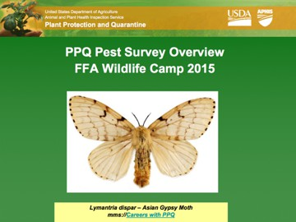
Example Activity

Overview of Trapping

SUPPLY LIST
    - EWBB traps
    - EAB traps: Purple & Green
    - Gypsy Moth traps
    - Bucket traps
    - Light trap
    - Car Battery: power inverter
    - Sweep nets
    - Microscopes: GSB & RDU
    - Insect mounting supplies
    - GPS units
    - Table
    - Chairs
    - Insect keys: tree key
    - Binoculars
    - Trap pole

DIRECTIONS
- PowerPoint presentation: Overview of Trapping
- Break into two groups: Team #1 (EAB) and Team #2 (EWBB & Gypsy Moth)
- Demonstrate trap service

TEAM #1:
- Supplies: two backpacks or supply packs containing pole, filters, funnels, tweezers, trash bags, gloves, GPS, trap card, Ziplock bag
- Retrieve traps
- Give mobile #

TEAM #2:
- Supplies: sweep nets, acetone, cotton balls
- Screen samples using keys
- Do insect pinning demo
- Visual survey with GPS and binoculars
- Baseball diamond – bio-surveillance
- Walk to lake to talk about invasive weeds

National Public Awareness Campaign

Mass public campaigns often require large budgets, marketing personnel and other resources that may not be available to a state program. However, the state can take advantage of USDA information and branding by driving public traffic to the appropriate websites and handing out the resources freely available on those websites.

Don’t Move Firewood: This campaign has free messaging resources that can be downloaded and distributed.

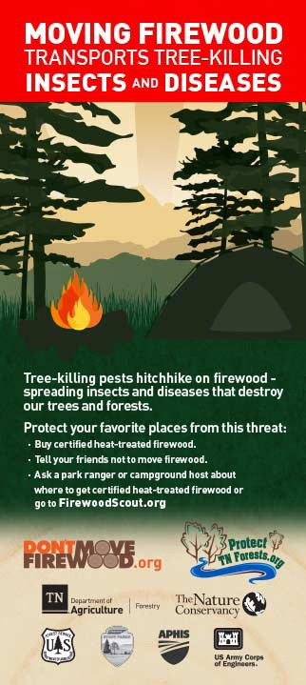
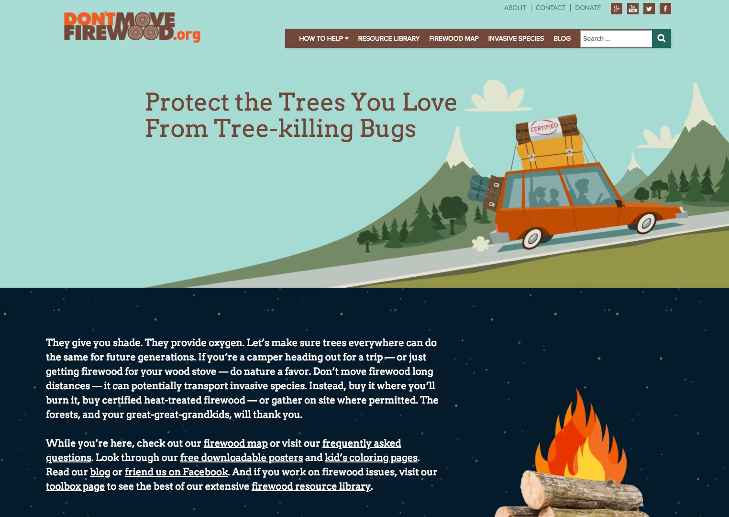

Example Materials

Brochure Website

Billboard

State Coordinated Public Engagement

Junior Invasive Inspectors Program: A citizen science initiative that equips middle school youth, and their adult leaders, with the knowledge and supplies to conduct visual surveys for regulated invasive forest pests. In 2012, the program used the first round of Farm Bill funding to assemble and distribute 65 survey backpacks with all necessary equipment for participants to use in the field. With additional years of Farm Bill funding, Clemson staff further developed the program by writing a curriculum covering: invasion biology, tree identification and insect identification. This instruction is paired with distribution of spiral-bound identification cards for recording target pests and specific hosts. The curriculum provides the knowledge foundation that participants need to successfully conduct a visual forest pest survey. Participants then go home to observe and report the GPS coordinates and health status of the surveyed host trees in the program’s dedicated online database. A tiered award system rewards returning participants for multiple reports, culminating in their very own survey backpack.

Over 2000 Junior Invasive Inspectors from 20 South Carolina counties have conducted visual forest pest surveys with this program. Public schools began to show considerable interest in the program after an invasion biology component was added to the new state middle school science standards. Clemson staff also provided train-the-trainer workshops for teachers and 4H leaders who were interested in utilizing the Junior Invasive Inspector Program.

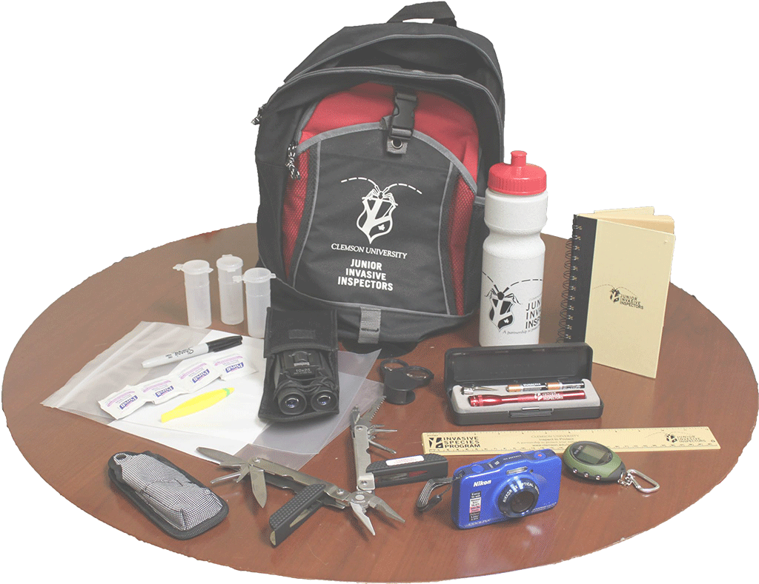
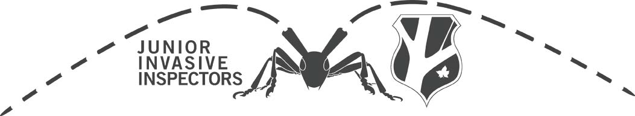
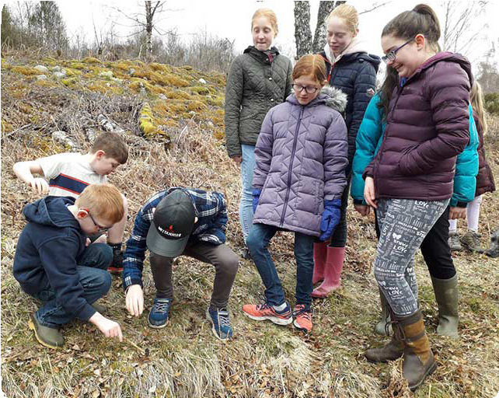
Example Materials

Forest Pest Public engagement and Survey Project: The Connecticut Agricultural Experiment Station (CAES) worked with the CT Department of Environmental Protection to obtain a Governor’s Proclamation declaring August 2010 as Forest Pest Awareness Month. Two communities, Sharon and Plainville, CT, were selected for targeted high risk visual surveys for ALB and EAB and the surveys were conducted in November 2010. Results were negative and were entered into ISIS. CAES held 17 train the trainer sessions and trained 346 people in signs, symptoms, and where to report both ALB and EAB. CAES directly conducted public engagement at 33 garden centers, more than a dozen fairs and other outdoor events; gave professional talks to forest landowners, library lecture series, school nature days, summer kids camps and at boy/girl scout meetings; provided details for all the tabling events they participated in; and they created public engagement kits including glass top displays that were placed in the 8 county extension offices for further public engagement by locally trained personnel.

They engaged volunteers in conducting training and tabling events around the state. CAES personnel were involved in media public engagement and were quoted in a number of newspapers around the state as well as on TV. CAES showed “Lurking in the Trees” to multiple groups. They developed incentives as giveaways including pencils, post card and full-page sized look-a-likes for ALB and EAB, as well as developing the “cootie catcher” for pests, bags, etc. They continued to grow their email lists of volunteers and communicated with them on a monthly basis with pest updates and requests for public engagement assistance. Finally, CAES participated in most monthly conference calls and posted monthly reports on the Google Share Site as well as conducted an annual project review and participating in the multi-state project review.

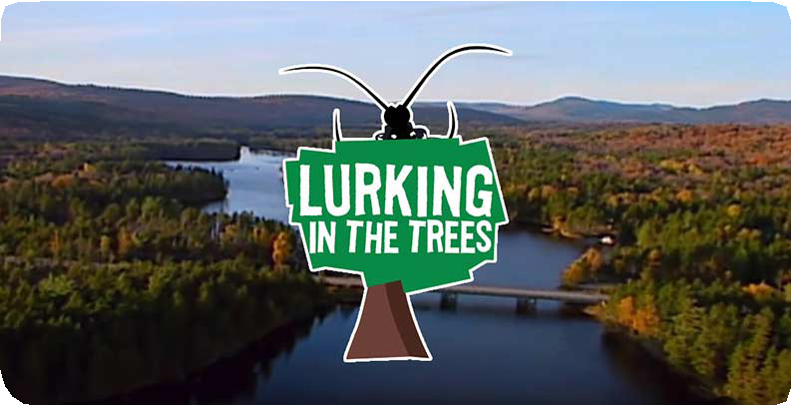
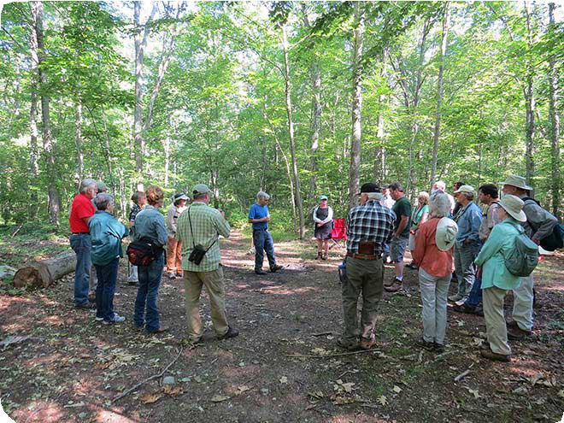
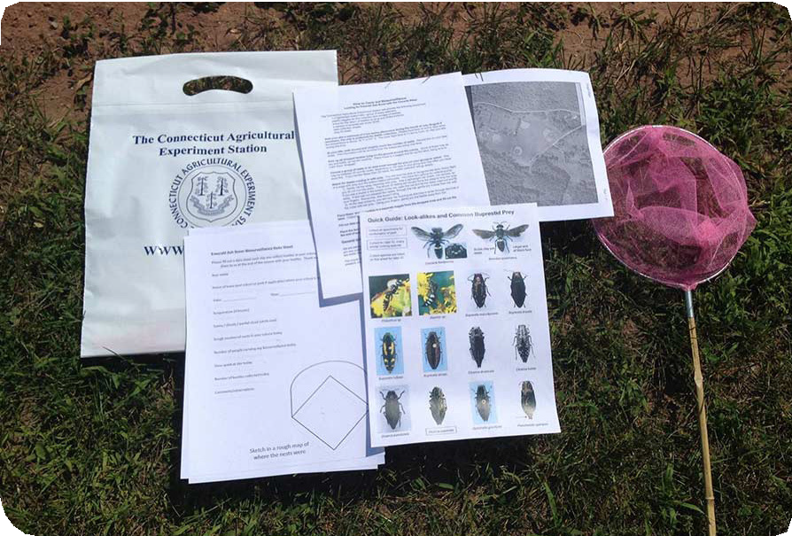
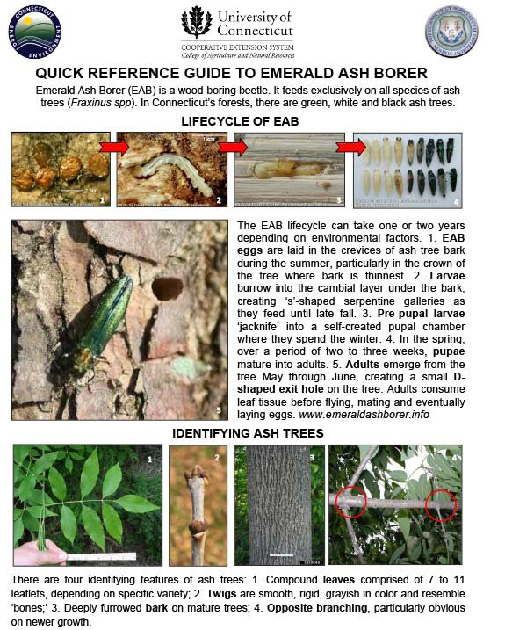
Example Materials

Online Public Engagement

Pest Tracker: The Pest Tracker website is a great source of information on CAPS surveys for public engagement communications. The site includes videos, pest information, pest maps, state pages with current year survey targets, directories of CAPS constituencies, and other links that may be of interest. https://pest.ceris.purdue.edu
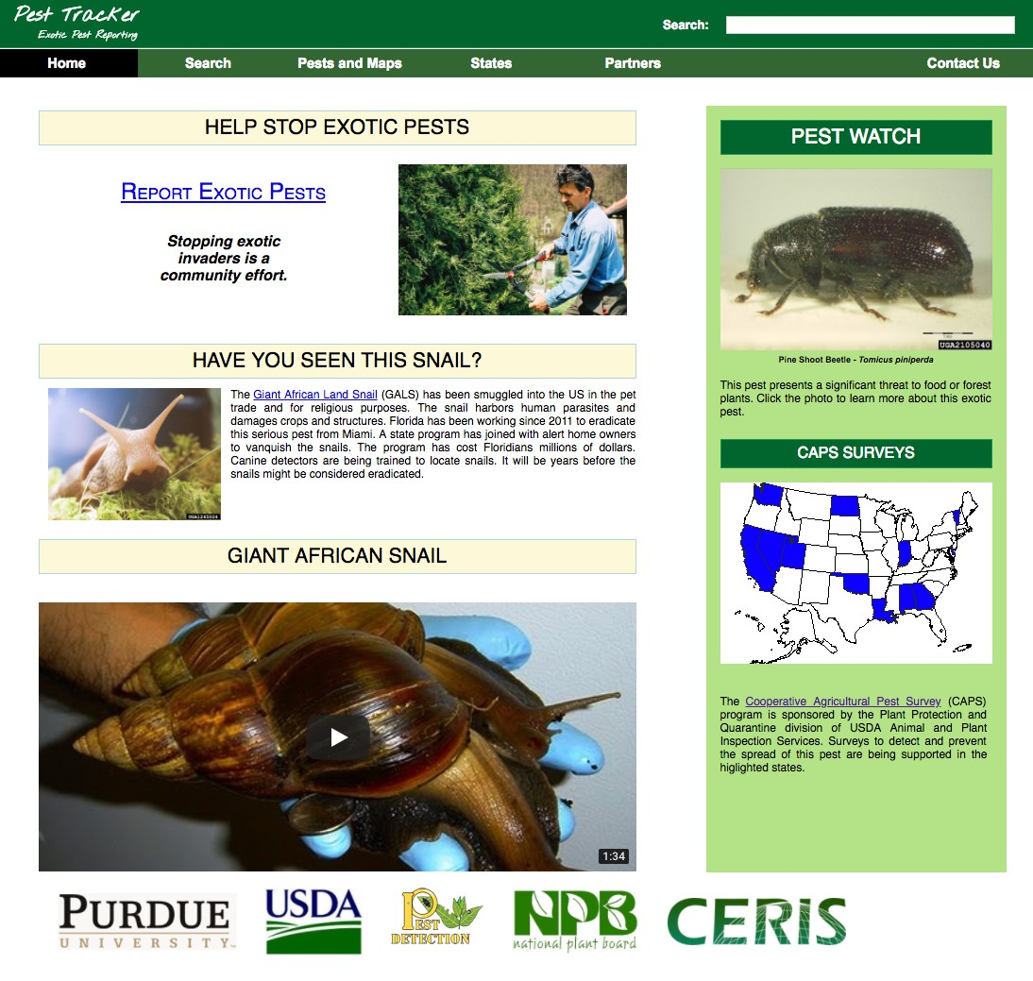
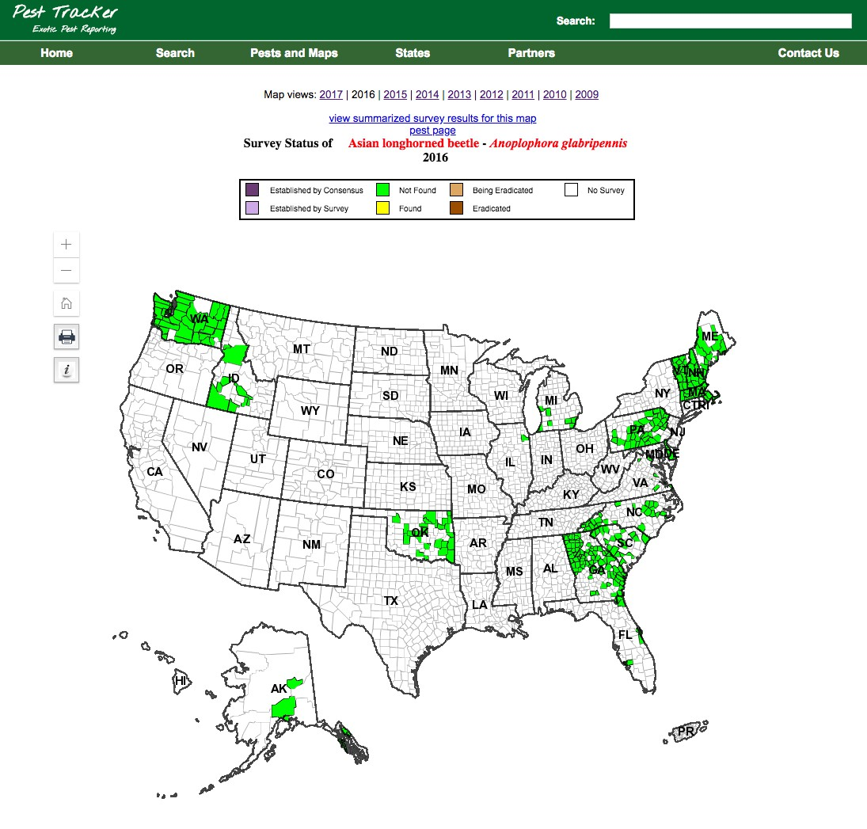

Hungry Pests: The Hungry Pests website was created by the USDA’s Animal and Plant Health Inspection Service (APHIS) to promote April as Invasive Species Awareness Month. Visitors can access the interactive Pest Tracker to see what pests are threatening in a selected state, and to learn how to report suspected invasive pests. The public can also engage on the invasive pests issue via Facebook and Twitter. APHIS actively collaborated with a number of state partners who conducted targeted stakeholder engagement on invasive pest issues with state-specific public engagement materials. www.HungryPests.com
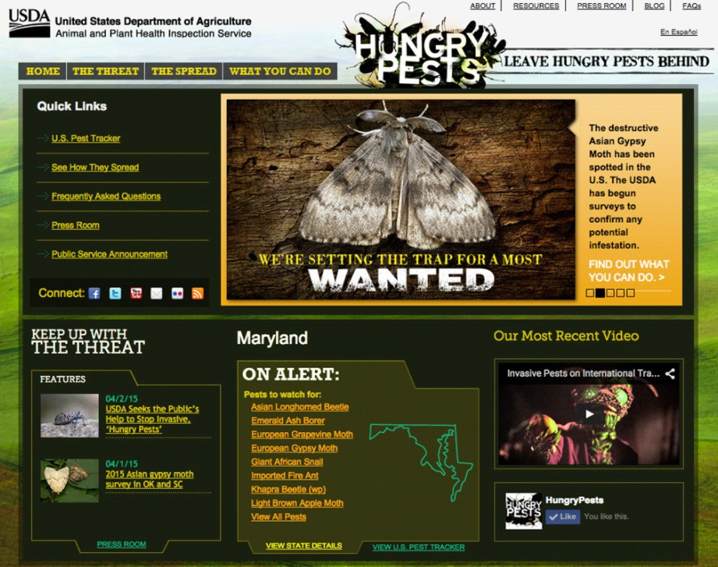
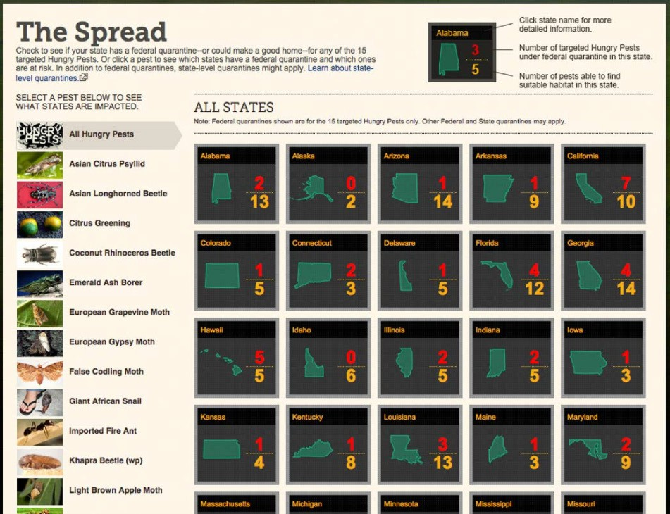

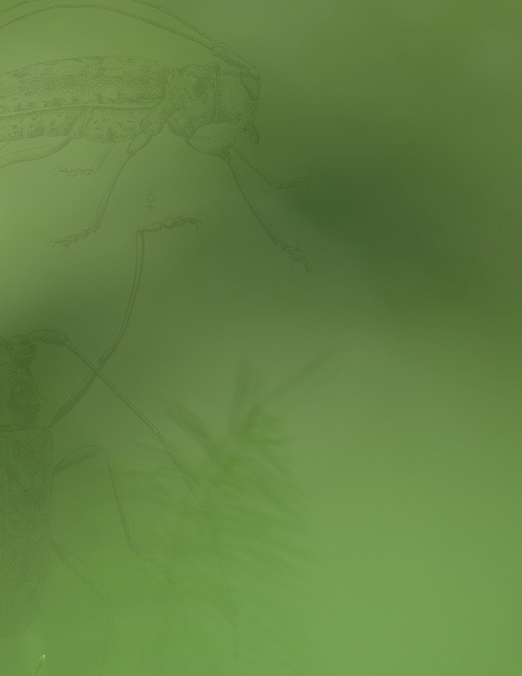

Cooperative Agricultural Pest Survey (CAPS

