Spongy Moth Molecular Diagnostic Methods & Submission Guidelines

Contact Information
Shipping address:
Forest Pest Methods Laboratory Spongy Moth Diagnostics
1398 W. Truck Rd Buzzards Bay, MA 02542

FPML Spongy Moth Diagnostic Inbox: Lymantria.diagnostics@usda.gov All inquiries regarding spongy moth diagnostics can be directed here.

Submission Guidelines
The flighted spongy moth complex (FSMC) includes Lymantria dispar asiatica, L. d. japonica, L. umbrosa, L. albescens and L. postalba (the latter two are likely conspecific and hereafter treated as L. albescens/postalba). Specimens that are suspected of being members of FSMC as well as any L. d. dispar (the North American population) outside the current spongy moth quarantine area and the population leading edge should be submitted to the Plant Protection and Quarantine (PPQ) Science and Technology (S&T) Forest Pest Methods Laboratory (FPML) for molecular diagnostics.

All specimens collected in high-risk areas for FSMC and from outside the natural distribution of L. d. dispar will be analyzed. High-risk areas are defined as international ports and associated areas that have a high concentration of warehouses, intermodal transfer stations, and other key transport infrastructure where pests associated with imported goods may disperse into the environment for the first time. This includes areas where imported material is moved for unloading, transfer, storage and distribution (e.g., import storage warehouses, land borders, international airports, maritime port terminals, roadways or railways between ports, etc.). The natural distribution of L. d. dispar is defined as the current quarantine area plus the population leading edge.

Submitting specimens collected in low-risk areas (e.g., natural forests or nurseries within the quarantine area or at the population leading edge) is strongly discouraged. Specimens collected in low-risk areas will be subject to subsampling (maximum 10 specimens per trap). Submit specimens if there is a reasonable possibility that they may be a member of the FSMC.

Documentation
All traps must be submitted with collection information, such as the PPQ Form 391 (Item A) or an Excel template (Item B), emailed to the FPML Spongy Moth Diagnostic Inbox. To request a copy of the PPQ Form 391 or the Excel template, send an email to the inbox. Make sure that the Trap Number listed on either/both form(s) matches with that submitted to the National Agriculture Pest Information System (NAPIS). Only list traps that are included with the shipment and make sure that all traps included in a given shipment are listed.
The SPHD has the option to submit a spongy moth diagnostic request through the Agricultural Risk Management (ARM) system, but it is important to also include the Excel template with each shipment.

Submission Deadline
Domestic survey samples will be accepted for analysis until November 30th of each survey year. Port interceptions will be accepted at any time.

Collection, Storage and Shipment
It is recommended that traps are checked and/or collected every two weeks to ensure that the highest quality samples are received for processing. In states where the new hard-glue traps are deployed this is especially important as moth samples can be consumed by spiders and ants if left too long on the trap.

It is critical that collected samples are stored in a freezer prior to shipment and submitted for diagnostics as soon as possible. Otherwise, DNA degrades quickly when exposed to ambient conditions, negatively impacting specimen condition and leading to diagnostic assay failure and the inability to identify specimens. Prompt submission also ensures that participating states receive survey results as soon as possible and that there are no delays in generating the Lymantria dispar Risk Model.
Do not submit empty traps.

Specimens should be shipped via next-day delivery for arrival Monday through Friday to the address listed above. Email shipment tracking information to the FPML Spongy Moth Diagnostic Inbox listed above.

Egg Mass Shipment Requirements
- A permit to move live pests is required in all shipments of egg masses. Request permit by emailing the FPML Spongy Moth Diagnostic Inbox.
- Ship individual egg masses separately—do not mix egg masses. All material in a given container will be considered one egg mass.
- Egg masses should not be treated with oil.
- Egg masses should be shipped dry in a double-sealed container.
- For port interceptions, provide the corresponding Agricultural Risk Management System (ARM) Diagnostic Request form either with the shipment or via email.
- For domestic samples, label each egg mass with the collection number that corresponds to the Excel template.

Larvae/Pupae Shipment Requirements
- Package one specimen per container (glass vial or snap-cap tube), unless it is reasonable to believe that all larvae came from the same egg mass. Please email the FPML Spongy Moth Diagnostic Inbox if you have questions.
- If possible, store in at least 95% ethanol and freeze for a minimum of three days at -20C prior to shipping. Ethanol can be drained prior to shipping, as the residue will sufficiently maintain sample integrity and prevent DNA degradation.

Delta Traps
- Do not disassemble the traps or remove moths from the trap.
- Package traps to avoid crushing during shipment.
- Label each trap with the Trap Number that corresponds to the Excel template.

Milk Carton Trap
- Empty milk carton traps into a paper bag—plastic bags retain moisture and promote DNA degradation.
- Label paper bag with the Trap Number that corresponds to the Excel template.

Molecular Diagnostics

Processing Priority Levels
Upon arrival, specimens will be processed using the priority system below:
- Port interceptions: Urgent
- Outside quarantine: Prompt
- Inside quarantine: Routine

Spongy Moth Real-time PCR Diagnostic Assay
Real-time PCR is an advanced technique that monitors the amplification of a target DNA molecule during the DNA replication process. A DNA probe binds to the target DNA and emits a fluorescence that is captured by a sensor on the real-time PCR machine. The terms “real-time PCR” and “qPCR” can be used interchangeably.

Currently, four real-time PCR assays can be used to distinguish the FSMC from L. d. dispar.

Standard Double-Duplex qPCR Assay
The double-duplex assay allows for distinguishing within the FSMC, namely between four target species/subspecies: L. d. asiatica, L. d. japonica, L. umbrosa, and L. d. dispar. This assay is more costly and thus mainly used for samples of regulatory significance (e.g., port interceptions, samples trapped on the west coast).

Simplified Dual-Probe qPCR Assay
The dual-probe assay detects FSMC from the background of L. d. dispar but does not distinguish within the FSMC. It is specifically designed for analysis of samples trapped during the domestic survey. A specimen that fails the assay is either not a spongy moth species or failed to amplify due to DNA degradation.

Supplementary Ldaj Cytb qPCR Assay
Due to natural mutations in the spongy moth populations, the first two assays may occasionally produce false positive or false negative results. Although this happens at very low frequencies (<5% in Asian samples and
<0.1% in North American samples), a supplementary assay, known as the Ldaj cytb assay, can be used to address the issue and identify the sample correctly.

Additional Lalb Assay
Starting in 2026, an additional assay, known as the Lalb assay, targeting L. albescens/postalba, will be implemented to complement the Asian Defoliator Survey. Unlike the other assays that work on individual samples, the Lalb assay will be performed on groups of 80 pooled spongy moth DNA extracts. All domestically trapped samples that are analyzed on the dual probe assay will be subsequently analyzed on the Lalb assay in groups of 80.

Secondary Analysis of Significant Regulatory Samples
Specimens of regulatory significance that fail the real-time PCR assays can be analyzed using DNA barcoding by a third party vendor. Specimens received from within the quarantine that fail the assay will not be DNA barcoded, except upon direct request. The processing timeline for DNA barcoding is dependent on the turnaround time of the sequencing company but can typically be expected in 1–3 weeks.
DNA barcoding uses the mitochondrial COI gene to distinguish different species. The technique relies on obtaining the unknown specimen’s COI sequence and comparing it to sequences of voucher species that are deposited in BOLD (BARCODE OF LIFE DATA SYSTEM, http://www.boldsystems.org/).

Result Reporting
Results will be reported in accordance with the priority levels listed above and the guidelines detailed below.

Port Interceptions and Specimens of Regulatory Significance
Final determinations will be reported to the National Identification Service (NIS) Urgents email group. Results provided to NIS will be copied to the following individuals: State Plant Health Director, State Plant Regulatory Official, original submitter, Forest Pest Methods Laboratory Director, National Policy Manager, Assistant National Policy Manager, National Operations Manager, and Offshore Program Director.

DNA barcoding results will be provided by forwarding the original correspondence and listing the final determination based on DNA barcoding in red. Molecular determinations will also be updated in the ARM Database (when applicable).
Exception: If a suspect domestic sample is determined to be the flighted spongy moth, the result will be directly reported to the Domestic Diagnostic Coordinator ( PPQ.Domestic.Diagnostic.Coordinator@usda.gov), National Identification Services, who will disseminate the result to relevant parties.

Result Templates
Diagnostic results will be reported using the template below:
Lab ID:
Interception # or Collection #:
Life Stage:
Viability: (Note: all egg masses are assumed to be likely viable unless the sample consists of all empty shells or if there are no eggs present in the sample.)
Date Intercepted:
Date Received:
Determination:
Determination Method:
Attachment: PPQ Form 391 or associated ARM Diagnostic Request form.

DNA Barcoding results will be reported using the template below:
Updated DNA Barcoding Result Lab ID:
Interception # or Collection #:
Life Stage:
Viability: (Note: all egg masses are assumed to be likely viable unless the sample consists of all empty shells or if there are no eggs present in the sample.)
Date Collected:
Date Received:
Determination:
Determination Method: DNA barcoding
Attachment: PPQ Form 391 or associated ARM Diagnostic Request form.

Domestically Trapped Specimens
Real-time PCR results will be reported to the State Plant Health Director, State Plant Regulatory Official, Forest Pest Methods Laboratory Director, National Policy Manager, Assistant National Policy Manager, and National Operations Manager once all processing of specimens from within a given state is completed. Final results summarizing all states will be sent to NIS upon the completion of the survey.

Results will be returned in an Excel file and will include the following fields: (Note: Collection No. is replaced by Trap Number)

- Lab Identification Number
- Trap Number
- Date Received
- Date Collection
- State
- County
- City
- Latitude
- Longitude
- Life Stage
- Final Determination
- Determination Method

This document has been reviewed and approved by: Spongy Moth Cross Functional Working Group.

Item A: PPQ Form 391
In the Remarks, please add type of funding that supports the survey. For example:

- PPA 7721 - Goal 1S
- AQI - Port Environs
- Pest Detection - CAPS
- Spongy Moth Program - Detection
- Spongy Moth Program - Delimitation
- Others

Make sure to fill in Type of Property (e.g., Port Environ, Forested Area, Industrial, Commercial, Residential, Roadside, Railyard/Railside, Park, Farm, Nursery, Others).
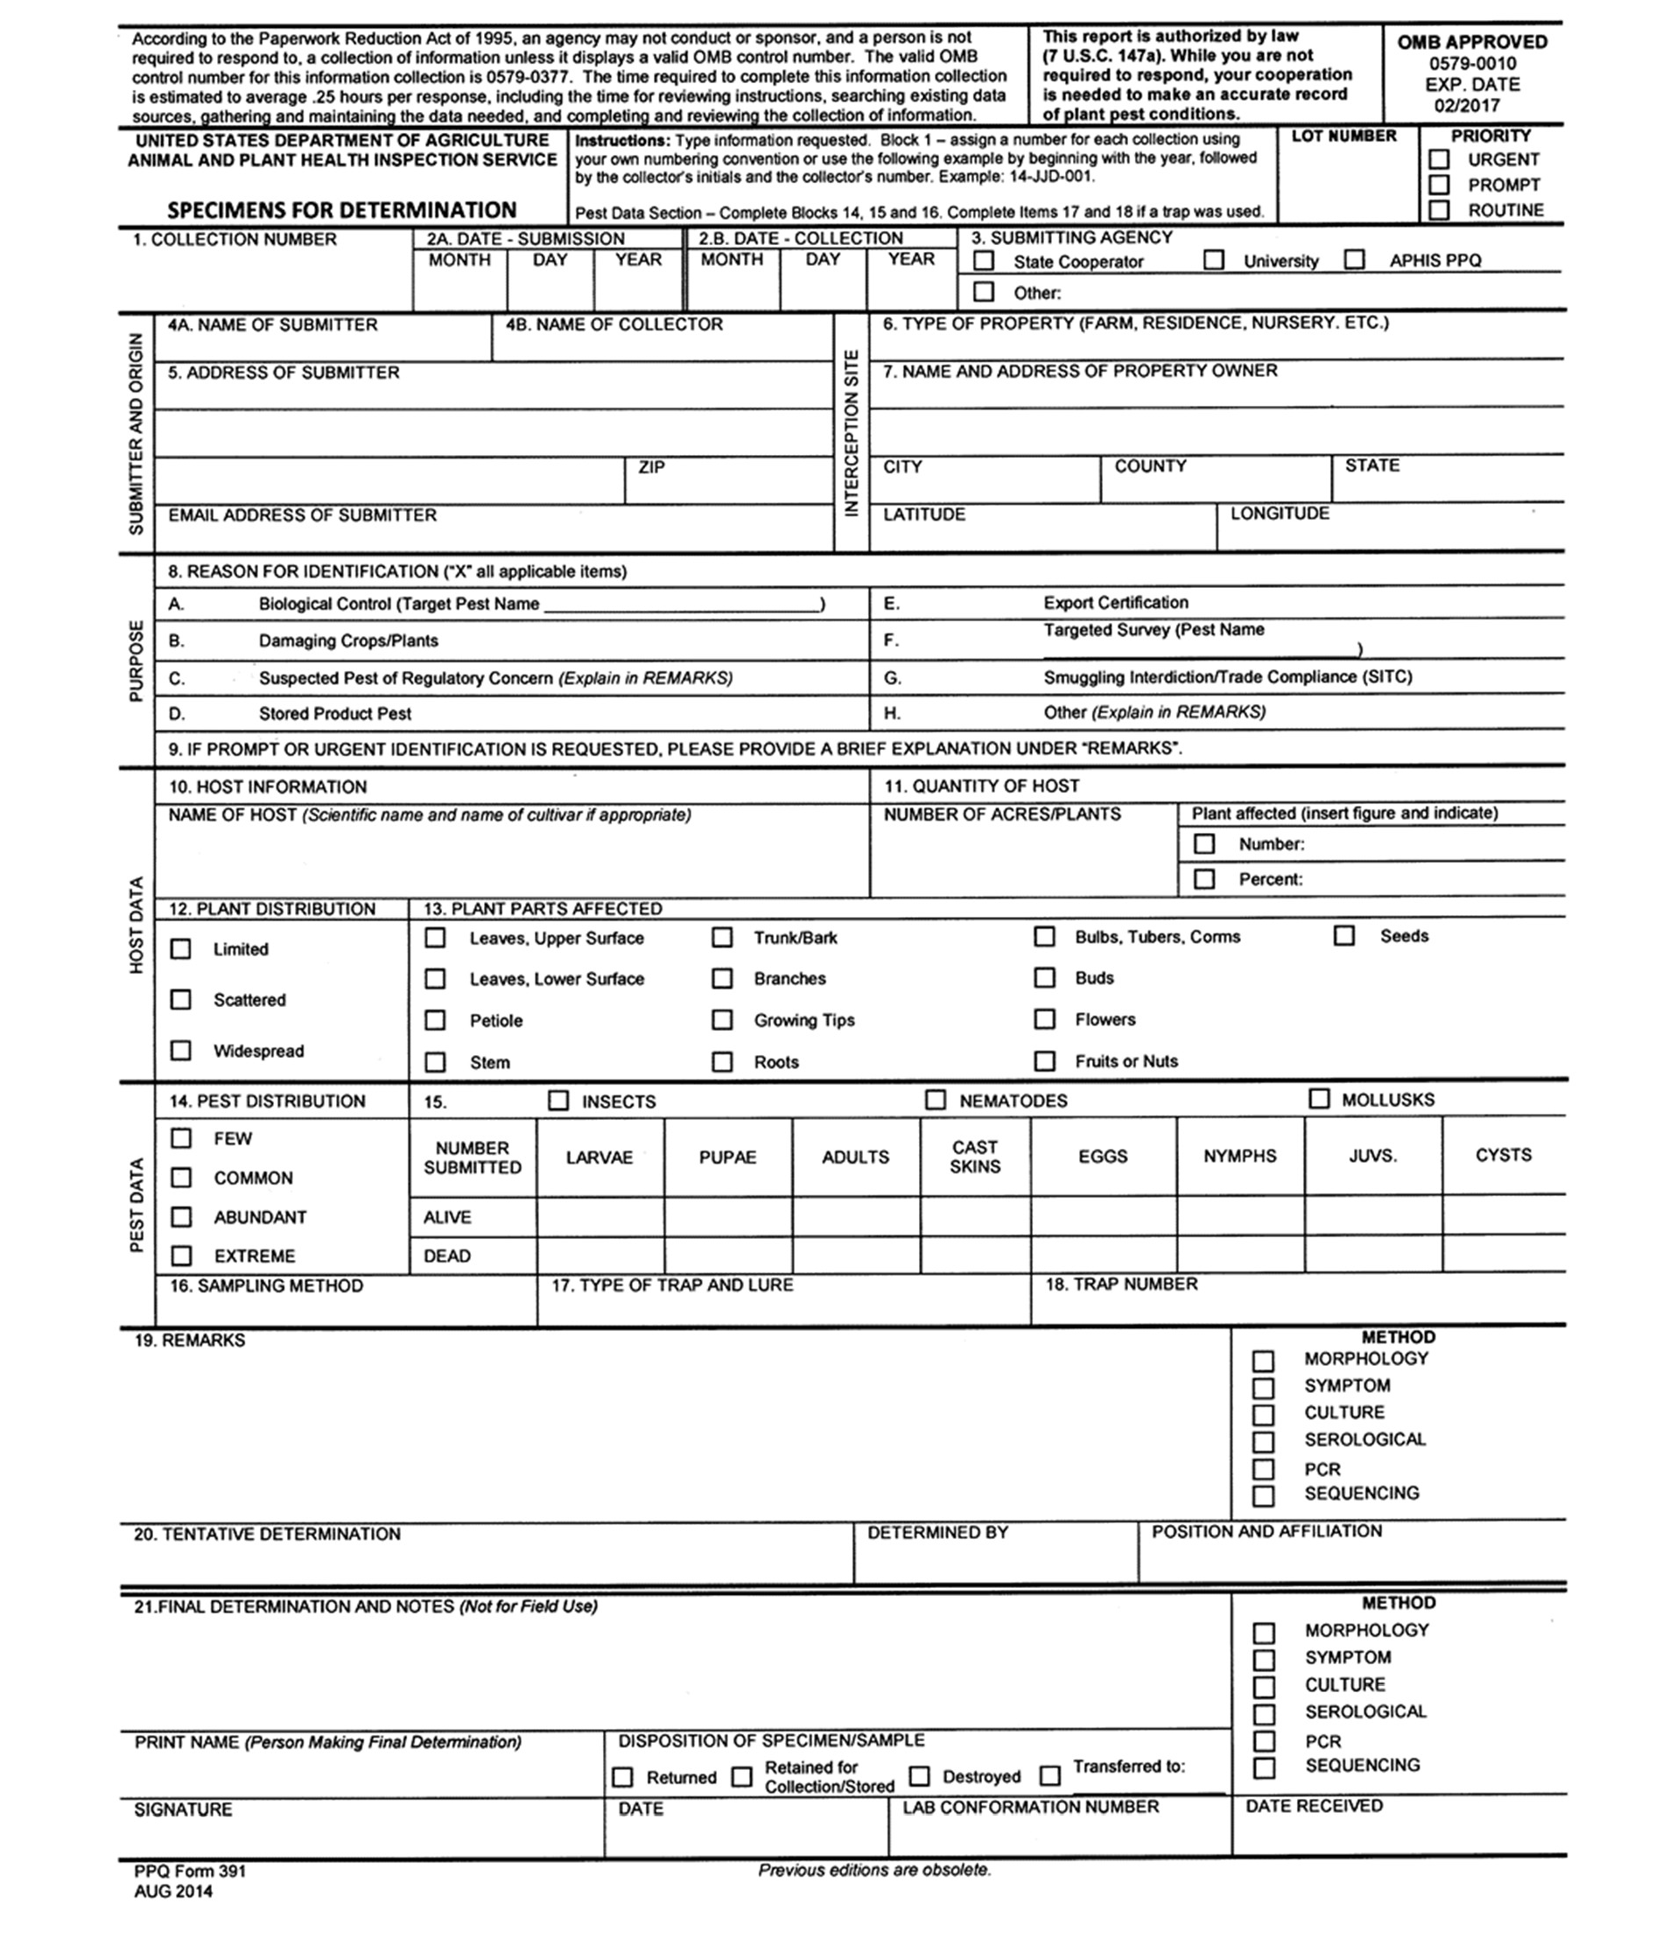

Item B: Excel Template for Spongy Moth Trap Submission
- Note recently added fields in red.
  - Trap Type, Survey Funding Source and Type of Property have drop-down options.
  - Type of Property can be Port Environ, Forested Area, Industrial, Commercial, Residential, Roadside, Railyard/Railside, Park, Farm, Nursery, Others.
